3 DoF Parallel robot manipulators with gyroscope trajectory generation
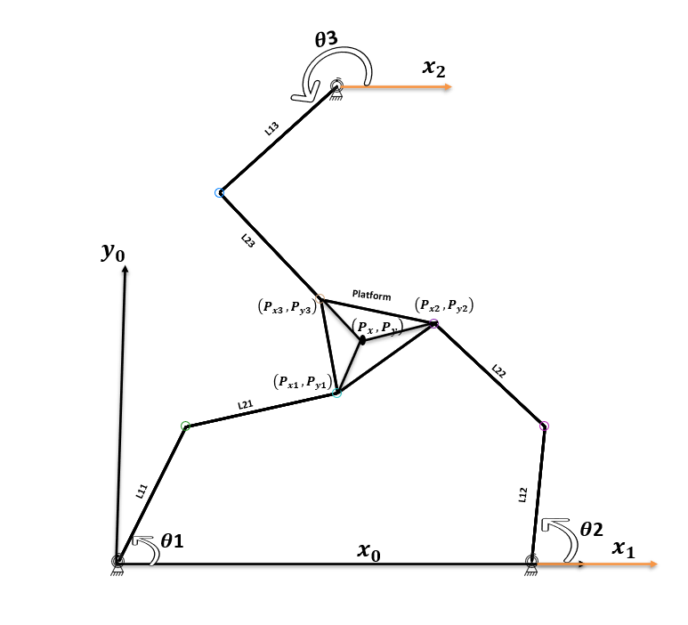
Figure (1)

Inverse kinematic of 3DoF parallel manipulator geometrically
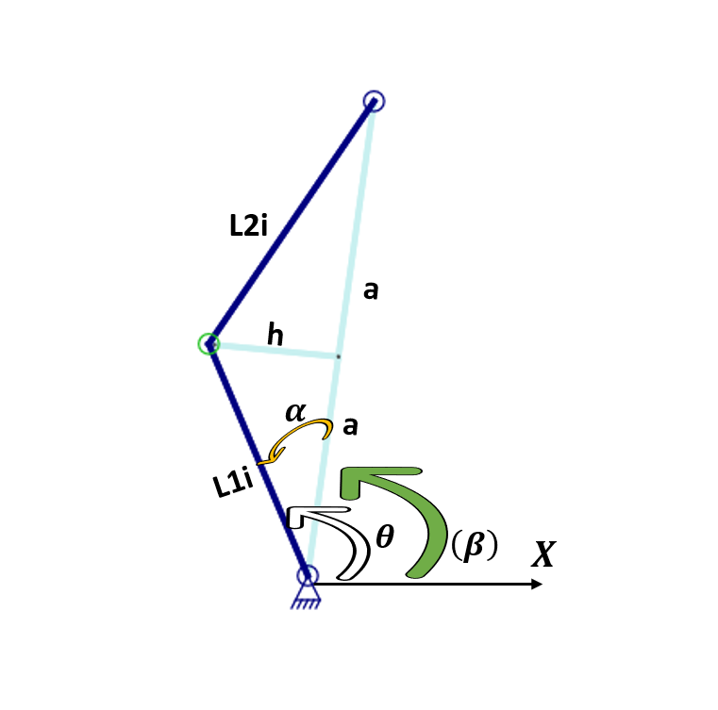 | 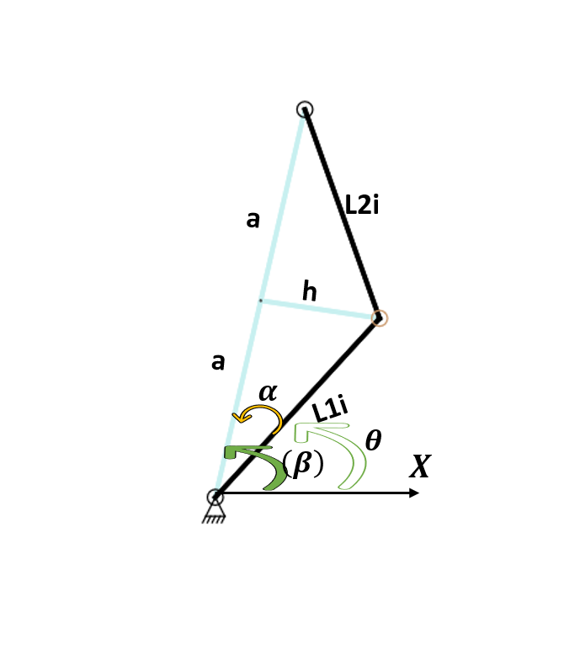
$$θ_{i}=β_{i}{+ α}_{i}$$ | $$θ_{i}=β_{i}{- α}_{i}$$
Figure (2) | Figure (3)

Like it shown in figure (1) the compact shape will be like that. However, it will have that different nine working mode regions with different enclosed areas .In addition to that ,like it shown in figure 2,and 3 respectively the amount of joint rotation will have two different solutions that we can use them in our inverse kinematics calculations ,These solutions are generated from our geometric analyzations that we done before .

Working mode regions
Depending to working dependencies of every singular manipulator, we end up with nine working mode region as a compact shape for all three manipulators. In between that regions, we will have crossing singularities which can occur when the working mode region go from one to other. Those singularities are mixed between serial and parallel singularities.
1st manipulator | 2nd manipulator | 3rd manipulator
+ | + | +
+ | + | -
+ | - | +
+ | - | -
- | + | +
- | + | -
- | - | +
- | - | -

Geometric inverse kinematic
By using trigonometric analyzation and looking at figures 1,and 2 we can obtain the following formulations:
$a^{2}+h^{2}=L^{2}$ (1)
${(a+a)}^{2}={P_{x_{i}}}^{2}+{P_{y_{i}}}^{2}$ (2)
$a=\frac{\sqrt{{P_{x_{i}}}^{2}+{P_{y_{i}}}^{2}}}{2}$ (3)
$h=\sqrt{L^{2}+a^{2}}$ (4)
$α_{i}=ATAN2\left(h,a\right)$ (5)
$β_{i}=ATAN2(P_{y_{i }},P_{x_{i }})$ (6)
$θ_{i}=β_{i}{± α}_{i}$ (7)

