Open CM Microcontroller
It is an open source microcontroller based on 32bit ARM. It has three types which are A,B,and C. The difference between type A,Type B ,and type C is the availability of the connectors.

Specifications
Item | Description
Operation Voltage | 5V ~ 16V
I/O | GPIO x 26
Timer | 4 (16bit)
Analog Input(ADC) | 10 (12bit)
Clock | 72Mhz
SPI | 2
I2C(TWI) | 2
Dimensions | 27mm x 66.5mm
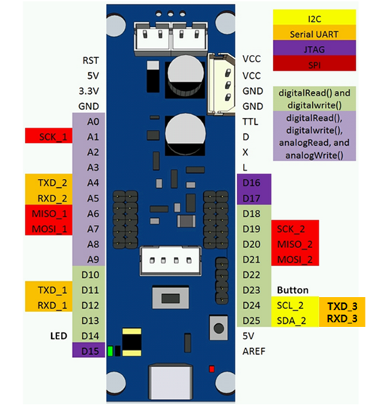
The Dynamixel XL-320 servo motor
The brand new Dynamixel XL-320 servo motor in Robotis aims to propose a digital Dynamixel servo motor that can be used by the DIY community and for all those interested in rapid prototyping, in particular using 3D printing.The Dynamixel XL-320 servo motor is the one used for the Darwin Mini robot. It is important not to confuse the XL-320 with the Ollo servo motors, which are different. The Dynamixel XL-320 servo motor uses Dynamixel 3-pin cables as the control signal used is TTL.
Item | Description
Weight | 16.7 g
Dimensions | 24 mm × 36 mm × 27 mm
Resolution | 0.29°
Reduction ratio | 238:1
No-load speed | 114 rpm
Control signal | Digital
Communication speed | 7,343 bps – 1 Mbps
Dimensions | 27mm x 66.5mm
The specification of servo motor(Cost 240TL)
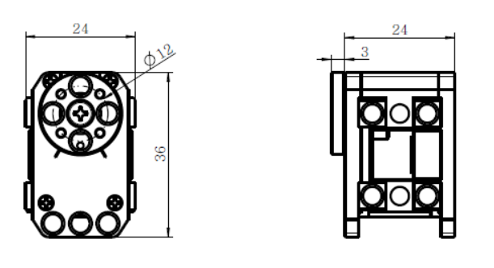

Baud Rate

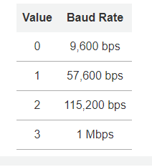
Return Delay Time
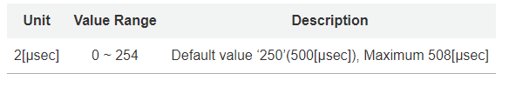
CW/CCW Angle Limit(6, 8)
- CW Angle Limit: the minimum value of Goal Position(Address 30, 31)
- CCW Angle Limit: the maximum value of Goal Position(Address 30, 31)

Control Mode(11)
