

**Department of Information Technology**

**ENCS5341**

**MACHINE LEARNING AND DATA SCIENCE**

**Homework #1**

**Name: Basheer Rjoub**

**ID: 1180291**

**Instructor: Dr. Yazan Abu Farha**

**9 December 2022**

# Q1)

First part using excel and using the formula =ROUND (AVERAGE(Column),0) and rounding the missing values to the average of the current column.

# Q2)

Here I used the Pearson Correlation to measure how strong the variables to the final exam’s mark and which have the strongest relationship with the final exam.

From the following equation we can calculate the relationship’s strength between an independent variable x and a dependent variable y and using the result to compute how strong the relationship is (which is r varies between 0 which indicates no relationship to 1 which is identical strong relationship).

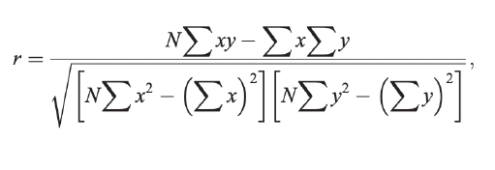

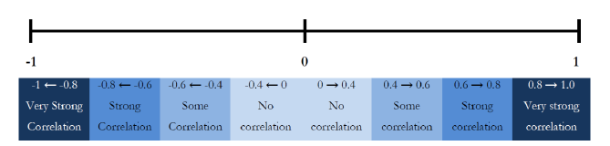

First, using **Scipy** package from Python to compute it, then computing it manually. And from the code below we can see that the midterm has the highest **Pearson’s** parameter so it should be the best parameter to represent the relationship to the final.

**Code**

|  |
| --- |
| import numpy as np  import matplotlib.pyplot as plt  from scipy import stats  hw1 = [67,83,63,70,50,43,67,47,97,50,40,57,23,63,77,57,57,63,80,83,100,67,70,17,97,73,80,80,80,80,80,93]  hw2 = [78,37,100,93,75,83,47,80,97,67,83,87,100,50,93,83,87,50,97,100,95,73,87,80,97,87,100,90,93,100,100,47]  mid = [32,25,34,35,20,26,22,26,30,21,18,28,29,26,29,28,28,27,40,57,56,34,32,34,44,25,46,43,48,41,47,38]  proj = [87,91,92,92,76,55,86,94,92,76,94,76,75,75,71,72,72,85,85,98,98,71,95,85,95,85,98,94,94,94,94,92]  final = [71,48,59,64,42,54,37,56,60,38,35,47,44,58,52,62,45,44,68,94,85,62,58,59,68,53,81,64,77,78,81,59]  print("HW1, Final:", stats.pearsonr(hw1, final).statistic)  print("HW2, Final:", stats.pearsonr(hw2, final).statistic)  print("Mid, Final:", stats.pearsonr(mid, final).statistic)  print("Proj, Final:", stats.pearsonr(proj, final).statistic) |

**Results**

|  |
| --- |
| **HW1, Final: 0.5604545951738554**  **HW2, Final: 0.5154555963860965**  **Mid, Final: 0.9177834900015012**  **Proj, Final: 0.49871770680707844** |

**Calculations**

For example, calculating the Mid and Final Pearson’s correlation using the previous example we can find that:

$$r= \frac{32*67798-\left(1069*1903\right)}{\sqrt{\left(\left(32*38855- 1,142,761\right)*\left(32*119913-3,621,409\right)\right)}}$$

$$r=\frac{135229}{147343}=0.91778349$$

Also, another way to observe the best variable to predict the final mark, using the visual plots, as in the following plots we can observe clearly that the Mid’s grades gives the best linear curve that can be formed with the least square errors.

|  |  |
| --- | --- |
|  |  |
|  |  |

# Q3)

We have to find a linear regression equation that minimizes the square error, meaning that it will give us the least square error, and the equation will be at the form of:



Using the variable x = midterm mark, as we previously find that it is the best measure to predict the final exam’s mark.

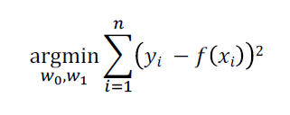

Taking the partial derivatives for both W0 and W1 then we have the two listed equations:

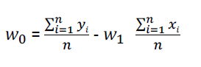

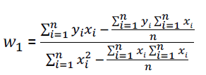

$$W_{0}=\frac{1903}{32}- W_{1}*\frac{1069}{32}$$

$$W_{1}=\frac{67798- \frac{1903*1069}{32}}{38855- \frac{1069*1069}{32}} =\frac{4226}{3143.7}=1.344$$

Then substituting $W_{1}$ value in $W_{0} equation$ we get:

$$W_{0}=14.58$$

Which implies the following Linear regression equation:

$$f\left(x\right)=14.58+1.344x$$

The plot for the Linear regression function that we implemented and the real values with the mid and final marks as in the following plot.

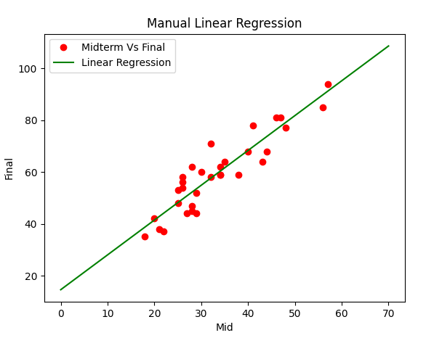

4) For the gradient decent we need to minimize the costs (errors) for every iteration the error will have the least squares error between the predicted and the actual value as in the following formula.

$$error= \frac{1}{n}\sum_{i=1}^{n}{{(y_{i}-(w_{1}x_{i}+w_{0}))}^{2}}$$

Then taking the partial differential equations for the bias $w_{0}$ and weight $w_{1}$:

$$\frac{d(error)}{dw1}= \frac{-2}{n}\sum_{i=1}^{n}{x_{i}(y_{i}-(w_{1}x_{i}+w_{0}))}$$

$$\frac{d(error)}{dw0}= \frac{-2}{n}\sum_{i=1}^{n}{(y_{i}-(w_{1}x_{i}+w_{0}))}$$

Here we have n=32.

The following code implements the equations above and do many iterations to get the values for the weights $w_{0}$ and $w_{1}$:

## Code

|  |
| --- |
| import numpy as np  import matplotlib.pyplot as plt  def gd(x, y, iterations, learning_rate = 0.0001):        w1 = 0.1      w0 = 0.01      costs = []      weights = []      prev_error = None      for i in range(iterations):            predict = (w1 * x) + w0          err  = np.sum((y-predict)**2) / 32            if prev_error and abs(prev_error-err)<=0.0000001:              break            prev_error = err          costs.append(err)          weights.append(w1)            w1_der = -(2/32) * sum(x * (y-predict))          w0_der = -(2/32) * sum(y-predict)            w1 = w1 - (learning_rate * w1_der)          w0 = w0 - (learning_rate * w0_der)        return w1, w0  X = np.array([32,25,34,35,20,26,22,26,30,21,18,28,29,26,29,28,28,27,40,57,56,34,32,34,44,25,46,43,48,41,47,38])  Y = np.array([71,48,59,64,42,54,37,56,60,38,35,47,44,58,52,62,45,44,68,94,85,62,58,59,68,53,81,64,77,78,81,59])  w1, w0 = gd(X, Y, iterations=10000000)  print(f"W1: {w1}\nW0: {w0}")  F = w1*X + w0  plt.scatter(X, Y, marker='o', color='red')  plt.plot([min(X), max(X)], [min(F), max(F)], color='blue',markerfacecolor='green')  plt.xlabel("Mid")  plt.ylabel("Final")  plt.show() |

## Results

For 10m iteration

|  |
| --- |
| **W1: 1.349616842038272**  **W0: 14.367307313681252** |

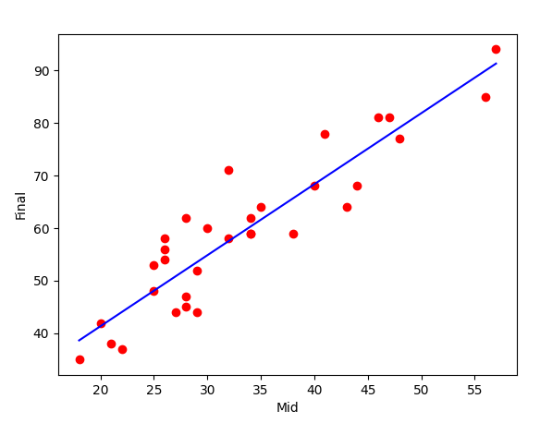

# Q5)

Using a 0.1 of data to test the model and 0.9 to train it, we conclude to the following results:

|  |
| --- |
| W0: [14.57784825]  W1: [[1.3520225]] |

Which is quite close to the previous results we obtained by calculations.

## Code

|  |
| --- |
| import numpy as np  import matplotlib.pyplot as plt  from sklearn.linear_model import LinearRegression  from sklearn.model_selection import train_test_split  x = np.array([32,25,34,35,20,26,22,26,30,21,18,28,29,26,29,28,28,27,40,57,56,34,32,34,44,25,46,43,48,41,47,38]).reshape(-1, 1)  y = np.array([71,48,59,64,42,54,37,56,60,38,35,47,44,58,52,62,45,44,68,94,85,62,58,59,68,53,81,64,77,78,81,59]).reshape(-1, 1)    SEED = 42  X_train, X_test, y_train, y_test = train_test_split(x, y, test_size = 0.1)  reg = LinearRegression()  reg.fit(X_train, y_train)  print("W0: ", reg.intercept_)  print("W1: ", reg.coef_) |

Using the following code to predict new values using the previous regression code we get the following:

|  |
| --- |
| **W0: [14.65950235]**  **W1: [[1.33603188]]**  **Predicted for 10: [[28.01982114]]**  **Predicted for 15: [[34.69998053]]**  **Predicted for 20: [[41.38013993]]**  **Predicted for 30: [[54.74045871]]**  **Predicted for 14: [[33.36394866]]** |

## Code

|  |
| --- |
| def predict(w1, w0, mid):      return w0 + w1*mid  vals = [10, 15, 20, 30, 14]  for val in vals:      print(f"Predicted for {val}:", predict(reg.coef_, reg.intercept_, val))*;* |

## Code to plot the Linear Regression:

|  |
| --- |
| mid = np.array([32,25,34,35,20,26,22,26,30,21,18,28,29,26,29,28,28,27,40,57,56,34,32,34,44,25,46,43,48,41,47,38])  final = np.array([71,48,59,64,42,54,37,56,60,38,35,47,44,58,52,62,45,44,68,94,85,62,58,59,68,53,81,64,77,78,81,59])  #fit data to the model  model = LinearRegression(normalize=True)  x = np.expand_dims(mid, 1)  y = final  model.fit(x,y)  print("w1: ", model.coef_, "w0: ", model.intercept_)  plt.scatter(mid, final)  x = mid  f = model.coef_*x + model.intercept_  plt.plot(x, f, 'r')  plt.xlabel("Midterm marks")  plt.ylabel("Final marks")  plt.show() |

**For w1: 1.34423801 w0: 14.56279883497848 the Plot for Linear Regression:**

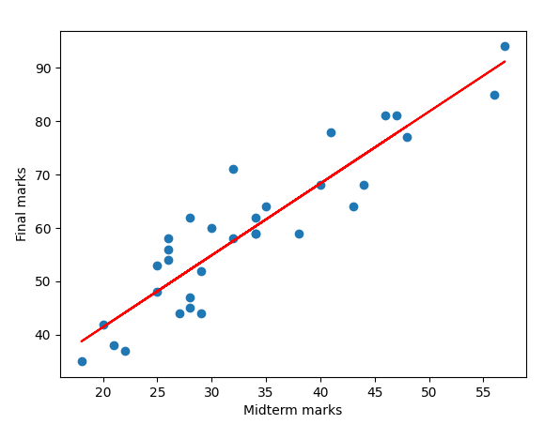

**The plot w0 and w1 are pretty close for what we have achieved in calculations.**

# Conclusion

After all we got the following three equations:

Calculated Linear Regression:

$f\left(x\right)=14.58+1.344$ x

Gradient Decent:

$$f\left(x\right)=14.3673+1.3496x$$

Scikit-Learn:

$$f\left(x\right)=14.5778+1.352x$$

I used the following code to get the square root difference of the predicted and the actual value to measure how good is the algorithm for the training values that we have.

|  |
| --- |
| # code to compare the three implementations of the regression  #using the least squares method  import numpy as np  X = np.array([32,25,34,35,20,26,22,26,30,21,18,28,29,26,29,28,28,27,40,57,56,34,32,34,44,25,46,43,48,41,47,38])  Y = np.array([71,48,59,64,42,54,37,56,60,38,35,47,44,58,52,62,45,44,68,94,85,62,58,59,68,53,81,64,77,78,81,59])  def calculated_LR(x):      return 14.58 + 1.344*x  def gradient_decent(x):      return 14.3673 + 1.3496*x  def scikit_learn(x):      return 14.5778 + 1.352*x  def total_error(function, X, Y):      s = 0      for i in range(0, 32):          err = abs(function(X[i]) - Y[i])          sq_err = err**2          s += sq_err      return s/ 32  print("SR Manual Regression: ",total_error(calculated_LR, X, Y))  print("SR Gradient Decent: ",total_error(gradient_decent, X, Y))  print("SR Scikit Learn: ",total_error(scikit_learn, X, Y)) |

# Results

|  |
| --- |
| SR Manual Regression: 33.229620000000004  SR Gradient Decent: 33.232621535  SR Scikit Learn: 33.31068824000002 |

As the values we got from results, it is clear that the first method is slightly better than the others, but the difference here can be ignored, because it is very small regarding the sum of the squared errors for tall the values.