

MALAWI UNIVERSITY OF BUSINESS AND APPLIED SCIENCES
SCHOOL OF ENGINEERING
DEPARTMENT OF ELECTRICAL ENGINEERING

BACHELOR OF ELECTRONICS AND COMPUTER ENGINEERING
WEB DEVEOLPEMENT 221

SUBMITTED TO
Mr. D. Chigwenembe

SUBMITTED BY
Bashil Phiri (BECE/24/SS/013)

DUE DATE
2TH November 2026

Abstract
The rapid growth of digital communication in Malawi has led to an increase in peer-to-peer online trading through social media platforms and classifieds. However, these platforms lack secure payment infrastructures, resulting in a significant trust decrease. Buyers risk losing money to fraudulent sellers, while sellers risk losing goods to non-paying buyers. To address this issue, this project developed SafeTrade, a web-based escrow platform designed to act as a trusted middleman for online transactions. The system holds buyer funds securely in escrow until the seller delivers the item and the buyer confirms receipt. If a dispute arises, an administrative panel reviews uploaded evidence to execute a refund or release the funds. The application was developed using a full-stack architecture comprising HTML, CSS, and JavaScript for the frontend, and PHP and MySQL for the backend and database. Key features include simulated digital wallets, secure user authentication using password hashing, and a comprehensive dispute resolution workflow. Testing confirmed that the system successfully executes the escrow lifecycle, prevents unauthorized access, and resolves disputes securely. SafeTrade demonstrates how localized web technologies can provide practical, scalable solutions to enhance trust in Malawi’s growing digital economy.

Table of Contents
Abstract 1
Chapter 1: Introduction 4
Chapter 2: Problem Statement 5
Chapter 3: Objectives 6
Chapter 4: Literature Review 7
4.1 Global Escrow Solutions 7
4.2 Local and Regional Platforms 7
4.3 The Research Gap 7
Chapter 5: Methodology & Technology Stack 8
5.1 Frontend Technologies 8
5.2 Backend Technologies 8
5.3 Security Implementation 8
Chapter 6: System Analysis & Design 9
6.1 System Architecture 9
6.2 Database Design and Architecture 9
6.3 System Flowchart 10
6.4 Use Case Diagram 10
Chapter 7: Implementation 11
7.1 User Authentication and Access Control 11
7.2 The User Dashboard and Wallet System 11
7.3 The Escrow Transaction Lifecycle 11
7.4 Dispute Resolution and Evidence Upload 12
7.5 Administrative Resolution Panel 12
Chapter 8: Project Evaluation & Testing 13
8.1 Testing Methodologies 13
8.2 Evaluation against Objectives 13
8.3 System Limitations 14
Chapter 9: Project Management 14
9.1 Timetable and Milestones 14
9.2 Budget and Resources 14
Chapter 10: Conclusion & Future Work 16
10.1 Conclusion 16
10.2 Future Work 16
References 17

Chapter 1: Introduction
The advent of the digital age has fundamentally transformed how commerce is conducted globally, and Malawi is no exception. With the rapid expansion of internet access and the widespread use of smartphones, there has been a significant shift from traditional brick-and-mortar shopping to online peer-to-peer (P2P) trading. Platforms such as Facebook Marketplace, WhatsApp business groups, and local online classifieds have become vibrant digital marketplaces where individuals buy and sell goods ranging from electronics and clothing to agricultural produce and vehicles.
However, this digital transformation has brought about a critical challenge: the lack of a secure transaction infrastructure. In Malawi, the predominant methods for online payments are mobile money transfers (such as Airtel Money or TNM Mpamba) or direct bank transfers. While these methods are efficient for sending money, they operate on a "pay-first" model. This creates a massive trust deficit between strangers engaging in online commerce. Buyers are consistently exposed to the risk of paying upfront for goods that may never be delivered, or receiving items that are defective or entirely different from what was advertised. Conversely, sellers face the risk of delivering goods to buyers who then refuse to complete the payment.
Without a mechanism to guarantee that both parties will fulfill their obligations, the growth of local e-commerce is severely hindered. Most people are forced to restrict their trading to friends, family, or local contacts they can physically meet and trust.
To address this significant gap in the digital economy, this project introduces SafeTrade, a web-based escrow platform. SafeTrade functions as a neutral, trusted third party that eliminates the risk of online trading. By utilizing the escrow model, the platform securely holds the buyer's funds until the seller fulfills their end of the agreement. The funds are only released to the seller after the buyer confirms receipt and satisfaction of the goods. In the event of a disagreement, the platform provides a structured dispute resolution system where both parties can submit evidence, and a system administrator can intervene to issue a refund or release the funds.
By providing a secure, transparent, and accessible digital trust mechanism, SafeTrade aims to unlock the full potential of e-commerce in Malawi, protecting both buyers and sellers while fostering confidence in the country's growing digital economy.

Chapter 2: Problem Statement
Despite the increasing popularity of online marketplaces in Malawi, the current ecosystem is plagued by a pervasive lack of trust. The absence of a secure, neutral transaction mechanism exposes both buyers and sellers to significant financial risks, manifesting in the following ways:
- The Buyer's Risk (Advance Payment Fraud): Because sellers often demand payment before shipping or handing over an item, buyers are highly vulnerable to scams. A buyer may transfer funds via mobile money only for the seller to become unresponsive, fail to deliver the item, or deliver a counterfeit or defective product. Without a way to recall the funds, the buyer suffers a total loss.
- The Seller's Risk (Non-Payment): Conversely, if a seller attempts to mitigate their own risk by delivering the item first, they face the possibility that the buyer will refuse to pay upon receipt.
- Lack of Dispute Resolution: When a transaction goes wrong, there is no neutral third party to arbitrate the conflict. Communication often breaks down, and victims have little to no recourse to recover their money or goods.
- Over-Reliance on Physical Trust: Because online transactions are so risky, many Malawians are forced to only trade with people they know personally or can meet face-to-face. This severely limits the size of the market, restricts business growth, and prevents sellers from reaching a wider national audience.
Therefore, the core problem is the absence of a localized, accessible web application that can act as a secure escrow middleman—holding funds safely, verifying delivery, and providing a fair dispute resolution mechanism to protect both parties in a peer-to-peer transaction.

Chapter 3: Objectives
The primary goal of this project is to develop a secure, web-based escrow platform that facilitates safe peer-to-peer transactions in Malawi.
To achieve this, the specific objectives are:
- To design a secure transaction workflow: To create a system where funds are securely held by the platform and only released when the buyer confirms receipt of the goods.
- To develop a digital wallet system: To implement a simulated wallet that allows users to top up, hold, and transfer funds within the application.
- To implement a dispute resolution mechanism: To allow buyers and sellers to raise disputes and upload photographic or PDF evidence for administrative review.
- To build an administrative dashboard: To provide an interface where the system administrator can monitor active deals, review evidence, and execute refunds or payouts to resolve conflicts.
- To ensure data security: To utilize secure coding practices, including password hashing and prepared statements, to protect user data from unauthorized access and SQL injection attacks.

Chapter 4: Literature Review
To understand the necessity of a localized escrow system, it is important to examine existing solutions in the market, both globally and within the Malawian context. While several platforms attempt to facilitate online trade, they often fall short of solving the specific trust issues present in the local ecosystem.

4.1 Global Escrow Solutions
Globally, escrow services are highly developed. Platforms like Escrow.com have been operating since 1999, securing billions of dollars in transactions for domains, vehicles, and high-value items. PayPal also offers buyer and seller protection as part of its payment gateway. However, these global platforms are largely inaccessible to the average Malawian trader. They require credit cards, operate primarily in USD, and have complex verification processes that exclude the unbanked population.

4.2 Local and Regional Platforms
Within Malawi and Africa, there have been attempts to bridge the trust gap, but they often serve specific niches:
TradeKhadi (Malawi): This is a peer-to-peer (P2P) platform that utilizes escrow, but it is strictly limited to the trading of cryptocurrencies (like Bitcoin and USDT). It does not cater to everyday physical goods like electronics or household items.
Agricultural Commodities Exchange (AHCX): AHCX provides a guarantee mechanism for farmers and buyers of agricultural produce. While highly effective, it operates as a B2B (business-to-business) commodity exchange and is not designed for C2C (consumer-to-consumer) transactions.
E-commerce Marketplaces (e.g., Jumia): While these platforms offer buyer protection, they act as the primary seller or a curated middleman. They do not facilitate peer-to-peer trading between two ordinary citizens who met on Facebook or WhatsApp.

4.3 The Research Gap
The review of existing literature and platforms reveals a clear gap. There is no accessible, general-purpose, web-based escrow platform in Malawi designed specifically for low-value, peer-to-peer consumer transactions using local payment concepts (like mobile money).
The SafeTrade project addresses this gap by providing a system that is independent of a marketplace. Users can negotiate their deals on social media or classifieds, and simply bring the final transaction to SafeTrade to act as the trusted financial middleman, utilizing a simulated wallet system that mirrors local mobile money behaviors.

Chapter 5: Methodology & Technology Stack
The SafeTrade platform was developed using a traditional full-stack web development architecture, separating the client-side interface from the server-side logic and database.

5.1 Frontend Technologies
- HTML5: Used to structure the content of the web pages, including forms, tables, and layout containers.
- CSS3: Used to style the application. A custom, responsive user interface was developed without the use of external frameworks (like Bootstrap). The design utilizes a deep blue and teal color palette to convey trust, security, and financial stability.
- Vanilla JavaScript: Used for basic client-side interactivity and DOM manipulation.

5.2 Backend Technologies
- PHP (Hypertext Preprocessor): Serves as the core server-side language. It handles user authentication, session management, form processing, file uploads, and the core escrow business logic.
- MySQL (via MariaDB): A relational database management system used to store all application data. The database was designed with foreign key constraints to ensure data integrity across the 7 relational tables (users, deals, transactions, disputes, evidence, notifications, messages).

5.3 Security Implementation
Because the platform handles financial data and personal information, security was a primary focus:
- Password Hashing: All user passwords are encrypted using PHP’s built-in password_hash() function before being stored in the database. Plain-text passwords are never saved.
- SQL Injection Prevention: Every database query in the application utilizes mysqli prepared statements with bound parameters. This ensures that user input is treated as data, not executable code.
- Session Management: PHP sessions are used to track logged-in users, and strict role-based access control ensures that unauthorized users cannot access deals or administrative pages.

Chapter 6: System Analysis & Design
The System Analysis and Design phase is a critical step in software development that bridges the gap between the project requirements and the actual coding. This chapter outlines the architectural design, database structure, and user interaction flows of the SafeTrade platform.

6.1 System Architecture
The SafeTrade platform utilizes a standard three-tier architecture, ensuring a clear separation of concerns and enhanced security.
- Presentation Tier (Frontend): This is the user interface that runs in the web browser. It is built using HTML5, CSS3, and Vanilla JavaScript. It handles the visual layout, user input validation, and communicates with the server via HTTP requests.
- Application Tier (Backend): This is the server-side logic built with PHP. It processes user requests, enforces business rules (such as ensuring a deal cannot be completed before payment), manages user sessions, and handles file uploads.
- Data Tier (Database): This is the MySQL relational database where all persistent data (users, deals, wallets, evidence) is securely stored.

6.2 Database Design and Architecture
The database, named escrow_db, is the backbone of the application. It is designed using a relational model with strict foreign key constraints to prevent data corruption and maintain an audit trail.
The system consists of seven core tables:
- users: Stores authentication details (phone, hashed password), user roles (buyer, seller, admin), wallet balances, and trust scores.
- deals: The central table representing an escrow transaction. It records the item title, amount, delivery deadline, seller ID, buyer ID, and the current status (e.g., AWAITING_PAYMENT, FUNDS_HELD).
- transactions: An immutable audit trail recording every financial movement (deposits, releases, and refunds).
- disputes: Records conflicts raised by users, including the reason and the current resolution status.
- evidence: Stores the file paths and descriptions of images or PDFs uploaded by users during a dispute.
- notifications: Manages the in-app alert system for users.
- messages: A table reserved for future user-to-user chat functionality within a deal.
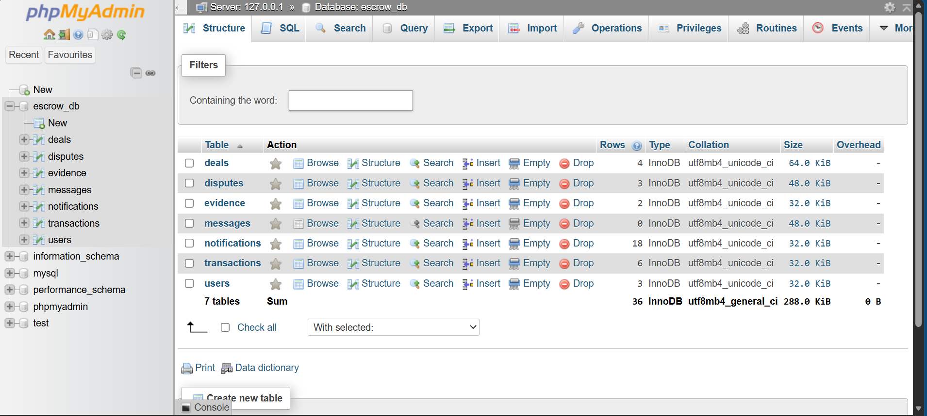
Fig1: Database and Seven Tables

6.3 System Flowchart
The following flowchart illustrates the lifecycle of a standard transaction within the SafeTrade escrow system, including the dispute path.
Seller Creates a Deal]
System Holds Funds (Status: FUNDS_HELD)

Seller Delivers Item & Marks as Delivered (Status: DELIVERING)

Buyer Confirms Receipt

System Releases Funds to Seller (Status: COMPLETED)

Dispute opened
Admin resolves (refund or release)
Admin reviews

Fig 2: System Flowchart

6.4 Use Case Diagram
A Use Case diagram defines the interactions between the users (actors) and the system. The SafeTrade platform has three primary actors: the Buyer, the Seller, and the Administrator.

Seller Admin Buyer
Fig 3: Use Case Diagram
- Buyer Actions: Register/Login, Top-up Wallet, Pay into Escrow, Confirm Receipt, Open Dispute.
- Seller Actions: Register/Login, Create Deal, Mark as Delivered, Open Dispute.
- Admin Actions: Login, View Dispute Queue, Review Evidence, Resolve Dispute (Refund/Release).

Chapter 7: Implementation
This chapter details the practical implementation of the SafeTrade platform. It outlines how the theoretical design was translated into a functional Minimum Viable Product (MVP) using PHP, MySQL, and custom CSS. It also provides visual evidence of the system's core features.

7.1 User Authentication and Access Control
Security is paramount in an escrow system. The implementation begins with a secure authentication module.
- Registration & Hashing: When a user registers, their password is never stored as plain text. The PHP password_hash() function is used to create a secure bcrypt hash.
- Session Management: Upon successful login, PHP sessions ($_SESSION) are initialized. Role-based access control ensures that regular users cannot access the Admin Panel, and only authorized parties can view specific deals.
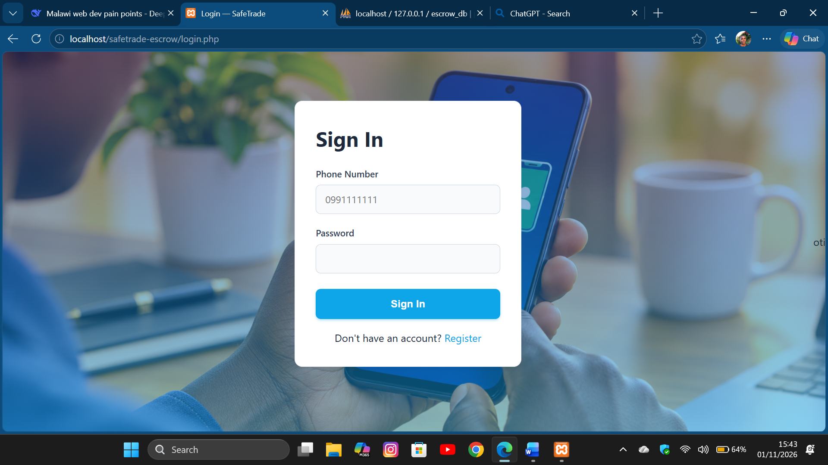
Fig 4: SafeTrade Login Screen

7.2 The User Dashboard and Wallet System
Once logged in, users are directed to their personalized dashboard. Because real mobile money APIs were out of scope for this MVP, a simulated digital wallet was implemented to mimic real-world financial behavior.
- The dashboard displays the user's current wallet balance and trust score.
- Users can utilize the "Top Up" feature to add simulated funds to their wallet, which are required to test the escrow payment flow.
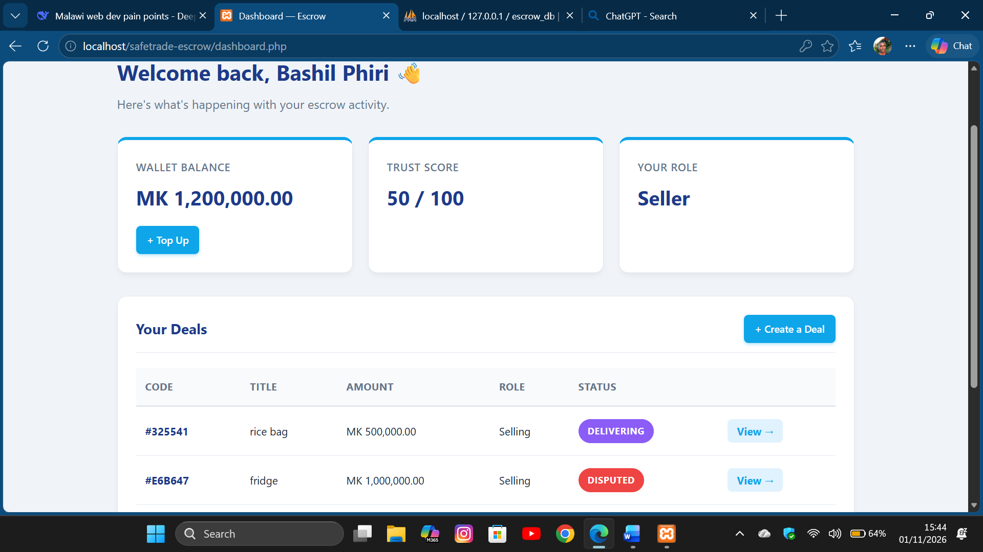
Fig 5: user dashboard window

7.3 The Escrow Transaction Lifecycle
The core functionality of the application is the execution of a safe transaction. The system enforces a strict sequence of events:
- Deal Creation: A seller inputs the item details, price, and the registered phone number of the buyer. The system generates a unique deal code and sets the status to AWAITING_PAYMENT.
- Funding the Escrow: The buyer views the deal and clicks "Pay into Escrow." The PHP backend verifies sufficient funds, deducts the amount from the buyer's wallet, and updates the deal status to FUNDS_HELD.
- Delivery: The seller hands over the item and clicks "Mark as Delivered." The status updates to DELIVERING.
- Completion: The buyer inspects the item and clicks "Confirm Receipt & Release Money." The PHP backend transfers the held funds to the seller's wallet, and the deal is marked COMPLETED.
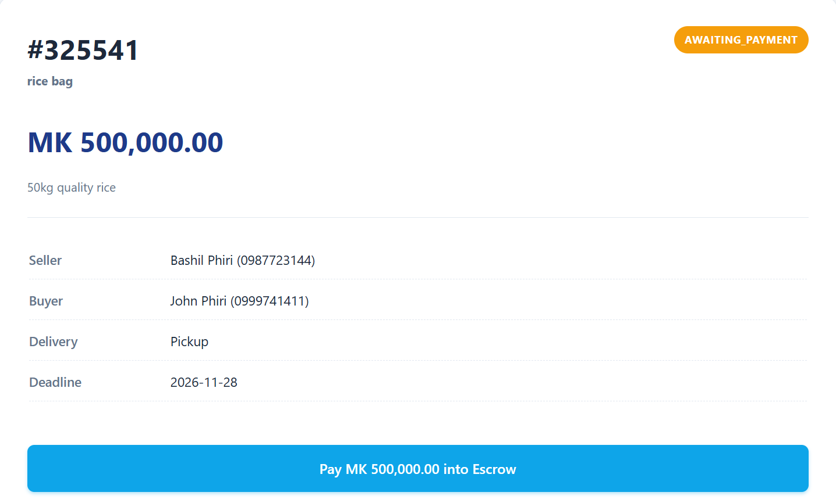
Fig 6: Deal created, Buyer has to pay(deal page)

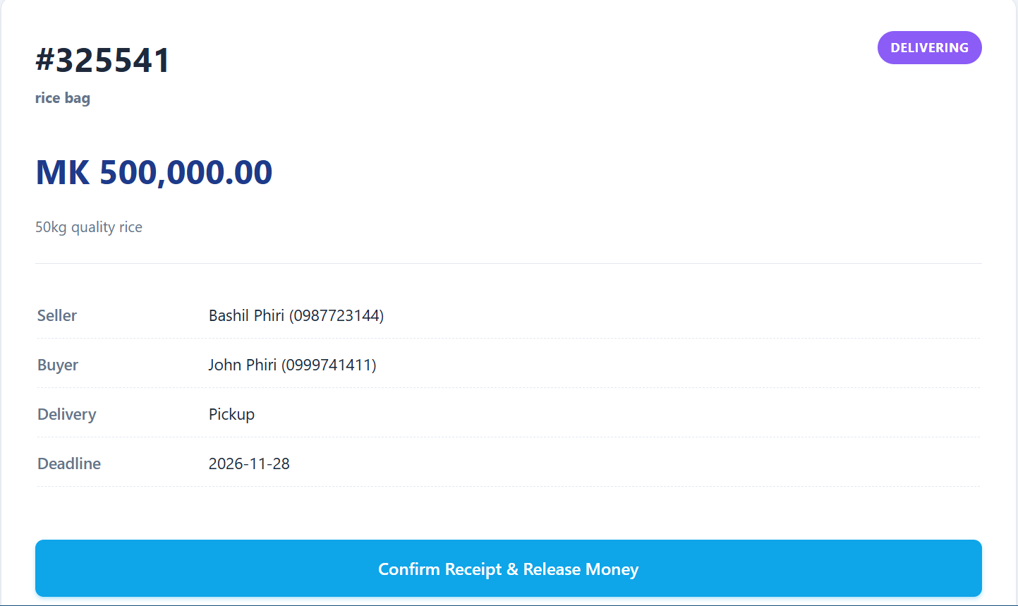
fig 7: Item delivered, buyer has to confirm if received and is the agreed one(deal page)

7.4 Dispute Resolution and Evidence Upload
If the item is not delivered or is not as described, the escrow protects the buyer.
- Users can click "Open a Dispute" and provide a detailed reason.
- The deal status changes to DISPUTED, and the funds are frozen in the system.
- Both parties are provided with a secure form to upload evidence (images or PDFs). The PHP move_uploaded_file() function is used to safely store these files on the server, while the file paths are saved in the database.
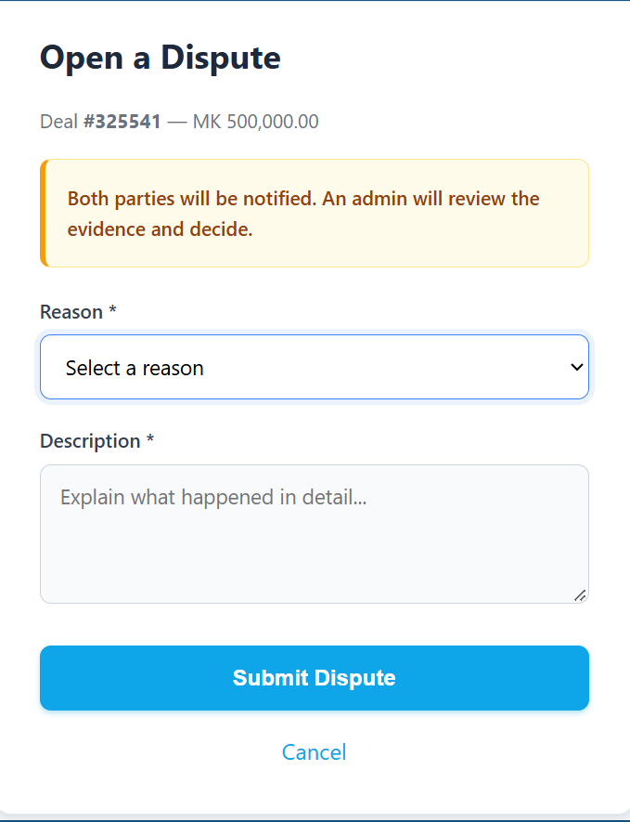
Fig 8: Dispute page showing the evidence upload form

7.5 Administrative Resolution Panel
The final layer of security is the Admin Panel.
- The Admin dashboard displays a queue of all active disputes.
- When a dispute is selected, the Admin can view the transaction details, read the descriptions, and click to view the uploaded evidence.
- Based on the evidence, the Admin selects a resolution (Refund Buyer or Release to Seller). The system automatically executes the financial transfer and notifies both parties.
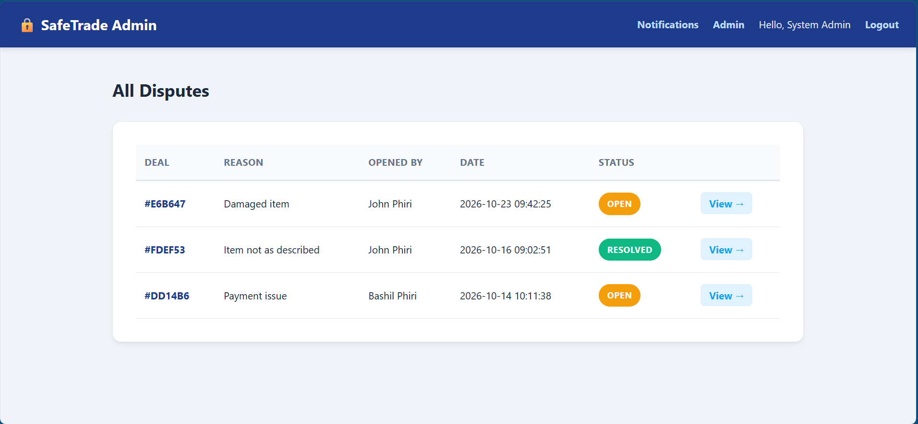
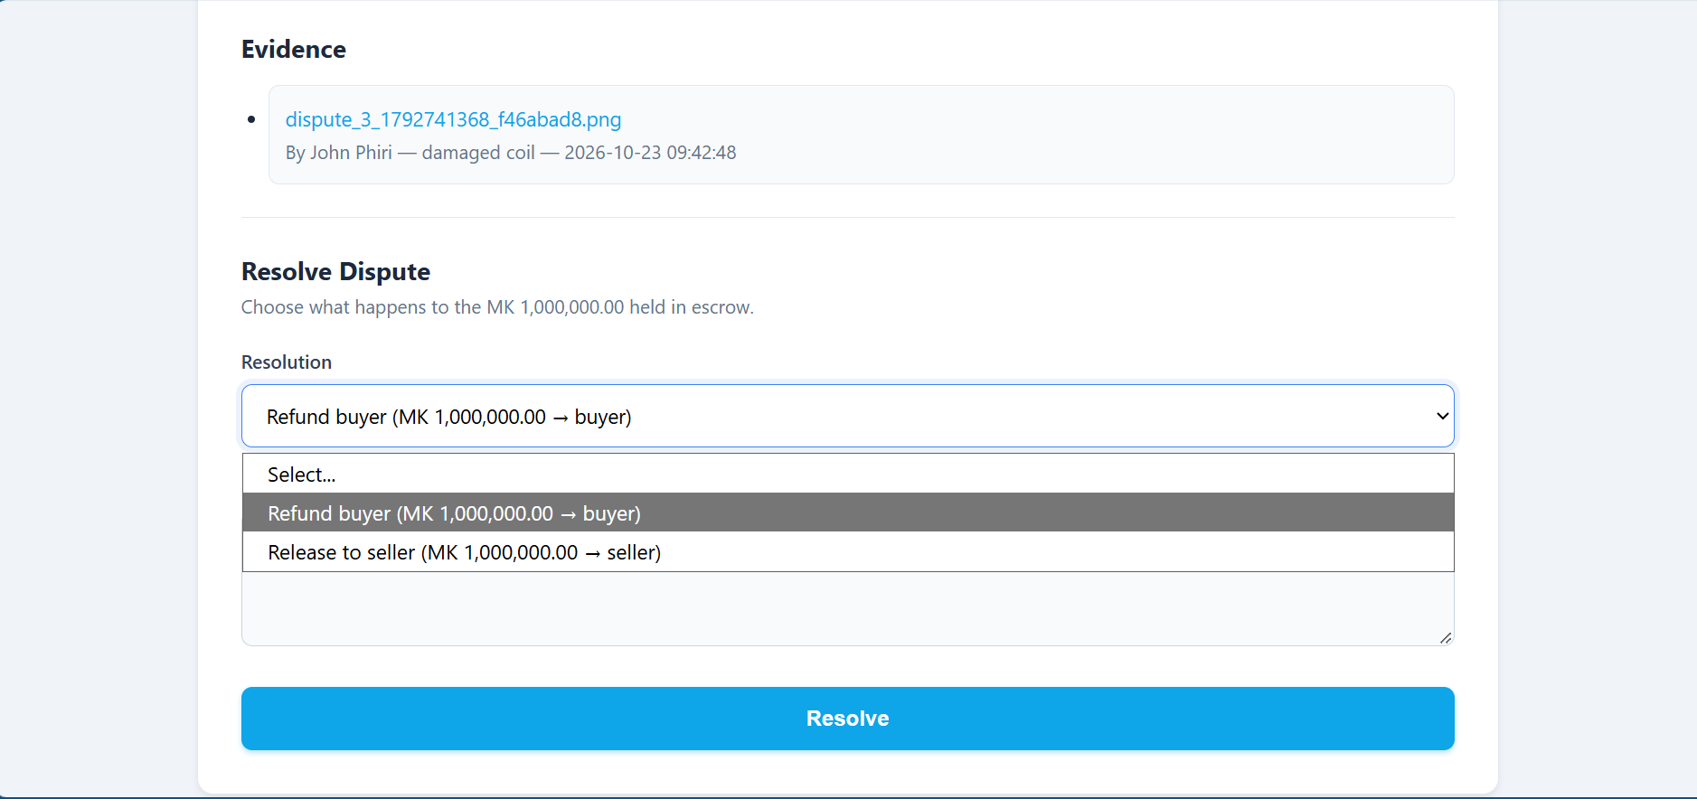
Fig 9: Admin’s Dashboard displaying deals and desputes

Chapter 8: Project Evaluation & Testing
A system is only as good as its ability to function under real-world conditions. This chapter outlines the testing methodologies used to evaluate the SafeTrade platform and analyzes how well the final product met the initial project objectives.

8.1 Testing Methodologies
The system was subjected to both functional and security testing:
Functional Testing:
- Happy Path Testing: Successfully registered a buyer and seller, created a deal, funded the escrow, marked as delivered, and confirmed receipt. Funds transferred to the seller's wallet correctly.
- Unhappy Path Testing: Attempted to pay for a deal with an insufficient wallet balance. The system correctly blocked the transaction and displayed an error message.
- State Machine Testing: Attempted to bypass the system by accessing the "Mark as Delivered" URL while the deal was still in the AWAITING_PAYMENT state. The system correctly blocked the action and redirected the user.
Security Testing:
- Unauthorized Access: Attempted to view a deal by manually changing the id in the URL to a deal belonging to different users. The system correctly verified ownership and blocked unauthorized access.
- SQL Injection: Tested input fields with basic SQL injection payloads (e.g., ' OR 1=1 --). The use of prepared statements (bind_param) neutralized the threats.
- File Upload Security: Attempted to upload a .php script as "evidence." The system correctly validated file extensions and rejected the upload, allowing only .jpg, .png, and .pdf.
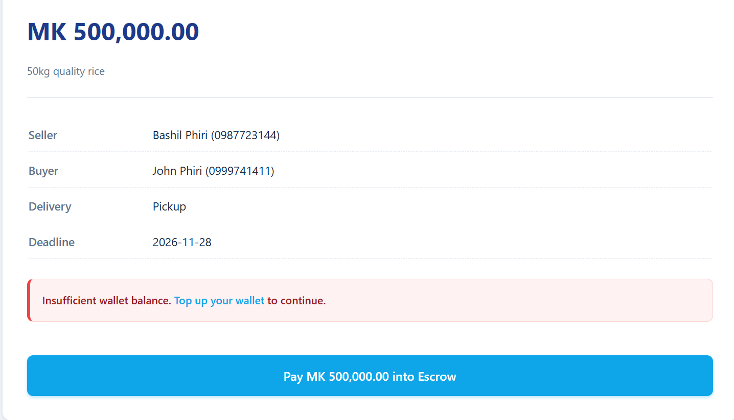
Fig 10: php handling validation

8.2 Evaluation against Objectives
The project successfully met all its initial objectives:
- Secure Transaction Workflow: Achieved. The state machine successfully holds and releases funds.
- Digital Wallet: Achieved. Users can top up and transfer simulated funds.
- Dispute Resolution: Achieved. Both parties can upload evidence and admins can arbitrate.
- Admin Dashboard: Achieved. The admin can review and resolve conflicts.
- Security: Achieved. Passwords are hashed, and SQL injection is prevented.

8.3 System Limitations
While the MVP is fully functional, the following limitations were identified during testing:
- Simulated Payments: The wallet uses fake funds. Real-world deployment requires integration with local mobile money APIs (like Airtel Money or TNM Mpamba).
- In-App Notifications Only: Because there is no SMS or Email gateway integrated, users must be logged into the platform to see updates.
- No Password Recovery: If a user forgets their password, there is currently no automated email reset feature.

Chapter 9: Project Management
The successful completion of the SafeTrade platform required careful planning, time management, and resource allocation.

9.1 Timetable and Milestones
The project was executed over a period of [Insert Number of Weeks, e.g., 8] weeks. Key milestones included:
- Week 1-2: Project proposal, problem identification, and requirement gathering.
- Week 3: Database design (schema creation and relationship mapping).
- Week 4-5: Frontend development (HTML structure and custom CSS styling).
- Week 6: Backend development (PHP Authentication, Wallet logic, and the core Escrow state machine).
- Week 7: Dispute resolution logic, file uploads, and the Admin Panel.
- Week 8: Final testing, bug fixing, documentation, and presentation preparation.

9.2 Budget and Resources
Because this project was developed as an academic MVP, the financial budget was kept minimal by utilizing open-source technologies.
Resource | Description | Cost
Development Server | XAMPP / Laragon (Localhost) | MK 0.00 (Free)
Code Editor | Visual Studio Code | MK 0.00 (Free)
Version Control | GitHub (Student Account) | MK 0.00 (Free)
Domain & Hosting | Estimated for future live deployment | ~ MK 300,000 / year
Total Development Cost |  | ~MK 300,000  / year
Fig 11: table showing total costs

Chapter 10: Conclusion & Future Work

10.1 Conclusion
The SafeTrade project was developed to address a critical barrier to e-commerce in Malawi: the lack of trust in peer-to-peer online transactions. By implementing a web-based escrow system, the project successfully provides a secure environment where buyers and sellers can trade without the fear of financial loss or fraud.
The application was built using a robust full-stack architecture (PHP, MySQL, HTML/CSS) and features a simulated digital wallet, a strict transaction state machine, a secure evidence-upload system, and an administrative resolution dashboard. The system successfully demonstrates that localized web technologies can provide practical, scalable solutions to real-world financial and social problems.
By protecting both parties and offering a fair dispute resolution mechanism, SafeTrade lays a strong foundation for enhancing digital commerce in Malawi.

10.2 Future Work
While the current Minimum Viable Product (MVP) is fully functional, the following enhancements are recommended for future development:
- Mobile Money Integration: Replacing the simulated wallet with real-world APIs from providers like Airtel Money and TNM Mpamba to allow actual financial transactions.
- SMS Notifications: Integrating an SMS gateway (such as Africa's Talking) to send deal updates to users who may not have constant internet access.
- Password Recovery System: Implementing an automated "Forgot Password" feature using email verification.
- In-App Chat System: Activating the messages database table to allow buyers and sellers to negotiate directly within the platform.
- Trust Score Algorithm: Developing a more complex algorithm that automatically adjusts a user's trust score based on successful deals, disputes, and response times.

References
Apache Friends. (2023). XAMPP: Apache + MariaDB + PHP + Perl. https://www.apachefriends.org/
GitHub. (2023). GitHub: Where the world builds software. https://github.com/
Kumar, A., & Sharma, R. (2020). Securing E-Commerce Transactions: The Role of Escrow Services in Emerging Markets. Journal of Digital Commerce, 15(2), 112–128. https://doi.org/10.1016/j.jdc.2020.04.005
Oracle Corporation. (2023). MySQL 8.0 reference manual. https://dev.mysql.com/doc/
OWASP Foundation. (2023). SQL injection prevention cheat sheet. https://cheatsheetseries.owasp.org/cheatsheets/SQL_Injection_Prevention_Cheat_Sheet.html
The PHP Group. (2023). PHP manual: Password hashing functions. https://www.php.net/manual/en/book.password.php
Smith, J. (2019). The trust deficit in peer-to-peer marketplaces. International Journal of E-Commerce Studies, 8(1), 45–62. https://doi.org/10.1000/ijecs.2019.8.1.45
W3Schools. (2023). HTML, CSS, and JavaScript tutorials. https://www.w3schools.com/

