**AeroManageX**

**Database Management System**

**MSCS 542L-256**

**Aerotech Titans**



Marist College

School of Computer Science and Mathematics

Submitted To:

Dr. Reza Sadeghi

September 13, 2023

# **Project Report of AeroManageX**

**Team Name**

Aerotech Titans

**Team Members**

1. Bashir Dahir [bashir.dahir1@marist.edu](mailto:bashir.dahir1@marist.edu) (Team Head)
2. Nihar Lodaya [nihar.lodaya1@marist.edu](mailto:nihar.lodaya1@marist.edu) (Team Member)
3. Marguerite McGahay [marguerite.mcgahay@marist.edu](mailto:marguerite.mcgahay@marist.edu) (Team Member)

**Description of Team Members**

1. **Bashir Dahir**

I'm a Computer Science student at Marist College, Beacon, New York, in my fifth year, with just two semesters to go before graduation. My academic journey has sharpened my skills in programming and data structures, but my true passion lies in database management systems. Currently, I'm eagerly gearing up for a project focused on airline management systems, where I plan to apply my expertise in database management to create efficient and robust solutions for the aviation industry. Beyond academics, I enjoy problem-solving and community engagement.

1. **Nihar Lodaya**

Hey there, I'm Nihar Lodaya, and I come from India. I've got a bachelor's degree in computer science from back home, and right now, I'm in the middle of my master's program in Computer Science at Marist College. I'm stoked about working with this bunch of awesome folks on our current project. What really got me excited about my teammates Bashir & Marguerite is how dedicated they are to making this project a success.

1. **Marguerite McGahay**

I grew up in Poughkeepsie and then attended the University of Delaware, where I graduated in 2021 with a BS in Mathematics and a Minor in Computer Science. While I was there, I was a TA for multiple computer science classes and was also on the Women’s Rowing Team! I currently work at Marist as the Assistant Women’s Rowing Coach. This is my first semester in the Computer Science – Software Development program, so I don’t know many people, but I was excited when Bashir and Nihar extended an invitation for me to be a member of this group. We selected our team head, Bashir, since it was his initial idea to pursue this project, but I truly believe each member of this team has the capability to be able to step into that role if asked of us.

Table of Contents

AeroManageX 3

AeroManageX Objective 3

Review Related Works 4

The Merits of Our Project 4

GitHub Repository Address 5

Entity Relationship Model (ER Model) 5

Enhanced Entity Relationship Model (EER Model) 5

Provide a short description about keys and relationships. - Describe how you implemented these features on your EER model. 5

References 6

# **AeroManageX**

## **AeroManageX Objective**

The primary objective of the AeroManageX project is to elevate your airline’s existing database infrastructure to be able to better compete with the world’s top airlines. Our company will help you condense the mass amount of information needed to be able to have thousands of planes arrive and depart each day. Our system operates to help your airline in multiple ways, including but not limited to managing flight bookings, optimizing the cost of flights, making sure planes are in the necessary airports based on different flights’ place of departure and arrival, and efficiently assigning pilots to flights that make sense for your company and their schedules.

## **Review Related Works**

There are many competitions for our company including Ramco Aviation, Airline Suite, and AvPro. Each of these companies has positive and negative aspects. To begin with, Ramco Aviation published on their website that they provide the best aviation software for the following three reasons: “Proven technology champions, usability focus and in memory planning and optimization” (Ramco, *Aviation Maintenance Operations & Aircraft Management Software: RAMCO systems*). However, Ramco Aviation critics emphasize on their “Security and data control issues and difficulties of data migration” (*Pros and cons of Ramco ERP 2023* 2021). Second, Airline Suite promotes that their system is easy to use, scalable and affordable. On the other hand, however, Airline Suite is notorious for having “no history of previous or editions and no import options for Microsoft Excel or file” (Airline Suite, *Airline Suite Reviews - Pros & Cons, Ratings & More*). Finally, AvPro is famous for their “reliability reporting, budget forecasting, and inventory management” (AvPro, *Fly Safer. work smarter*). On the contrary, AvPro lacks the availability of “instruction manuals and system stability” as there are system glitches (AvPro, *Aircraft Maintenance Software: Wellington FL: AvPro software*).

## **The Merits of Our Project**

Our company will provide airlines with the ability to see and organize information which can be categorized into three principal operations:

Land Operations:

* Checked baggage
  + Each passenger has a bag that must be on their flight
* Staff management
  + Such as gate-workers, baggage handlers, custodial staff, etc.
* Times of arrival and departure of flights
* Fleet inventory

Air Operations:

* Flight plan
  + Including non-stop flights and layovers
* Assigning pilots and airline staff

Billing Operations:

* Bookings
  + Secure database for credit card numbers
* Cost of seats
* Checked luggage (including oversized)
  + If a passenger checks a bag that is over 50lbs, they must pay an extra fee on top of the base cost

An airline should choose AeroManageX to manage their data because we are security focused and can benefit any size airline, from companies with just a small fleet of planes to global “Aero-Titans"!

## **GitHub Repository Address**

<https://github.com/bashirad/MSCS-542L-256_AeroManageX_Aerotech-Titans.git>

## **Entity Relationship Diagram (ER Diagram)**

## 

## **Entity Relationship Model (ER Model)**

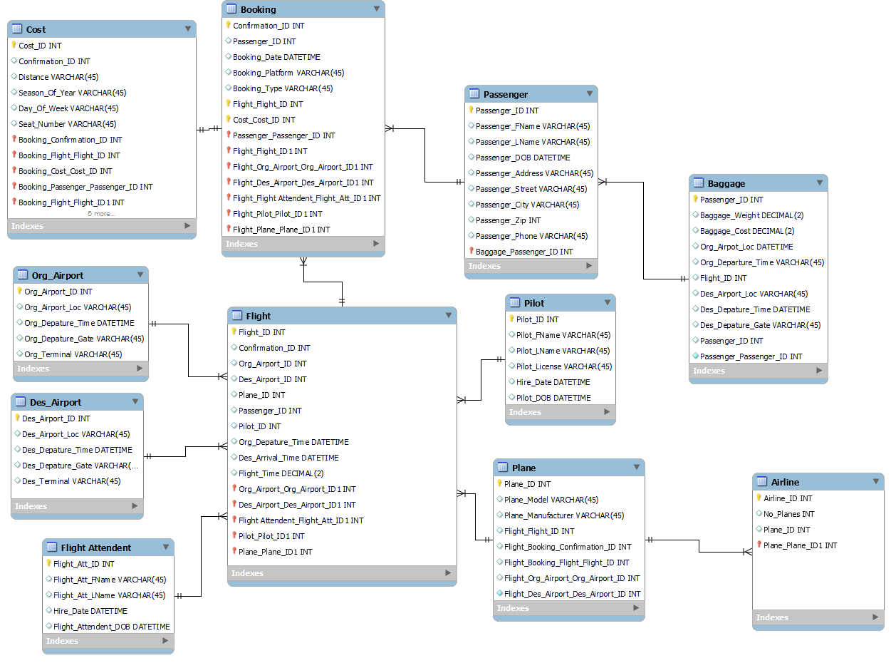

Creating this project involves a thoughtful selection of entities, attributes, relationships, participations, and cardinalities to represent a simplified domain. In this case, the chosen entities include "Cost," "Baggage," "Booking," "Plane," "Flight," "Flight_Attendant," "Org_Airport," "Des_Airport," "Pilot," "Passenger," and "Airline." Each of these entities represents key elements in the domain of Airline travel.

Attributes are then identified for each entity to capture relevant information; for instance, "Passenger" have attributes like Passenger_Fname, Passenger_Lname, Passenger_Address, etc. While "Cost" has attributes like Confirmation_ID, Distance, Season_Of_Year, etc. Relationships are established between entities to represent how they are connected, such as the relationship between "Booking" and "Passenger" to show that a passenger can make a booking.

## **Enhanced Entity Relationship Model (EER Model)**

|  |  |  |  |
| --- | --- | --- | --- |
| **#** | **Entity** | **Key** | **Relationships** |
| 1 | Flight | Flight_ID | Each flight has one origin airport, one destination airport, multiple bookings for their passengers, as well as a one plane, one pilot, and multiple flight attendants |
| 2 | Plane | Plane_ID | Each flight must have a plane, which owned by an airline |
| 3 | Airline | Airline_ID | Each airline has multiple planes in its fleet |
| 4 | Cost | Cost_ID | Cost is related to Booking via a 1-1 relationship. |
| 5 | Booking | Confirmation_ID | Each booking is related to a passenger, which results in a cost of booking. When a passenger books, they are then connected to a flight |
| 6 | Passenger | Passenger_ID | Each passenger can have one or more bags |
| 7 | Baggage | Baggage_ID | Each bag is related to one passenger |
| 8 | Org_Airport | Org_Airport_ID | Each flight must depart from one origin airport |
| 9 | Des_Airport | Des_Airport_ID | Each flight must arrive at one destination airport. |
| 10 | Pilot | Pilot_ID | Each flight must have one pilot. A pilot can have multiple flights in one day |
| 11 | Flight Attendant | Flight_Att_ID | Each flight can have multiple flight attendants and a flight attendant can have multiple flights in one day |

# **References**

Airline Suite. (n.d.). *Airline Suite Reviews - Pros & Cons, Ratings & More*. GetApp. <https://www.getapp.com/operations-management-software/a/airline-suite/reviews/>

*Aviation Maintenance Operations & Aircraft Management Software: RAMCO systems*. Aviation Maintenance Operations & Aircraft Management Software | Ramco Systems. (n.d.). <https://www.ramco.com/products/aviation-software/?utm_source=capterra&utm_medium=capterra_ppc&utm_campaign=capterra_aviation&utm_channel=capterra>

AvPro. (n.d.-a). *Aircraft Maintenance Software: Wellington FL: AvPro software*. avpro. <https://www.avprosoftware.com/>

AvPro. (n.d.). *Fly Safer. work smarter.* C.A.L.M. Systems | Airline Suite | Aviation Management Software. <https://info.gartnerdigitalmarkets.com/calm-systems-gdm-lp?utm_source=capterra>

Trustradius. (2021, June 16). *Pros and cons of Ramco ERP 2023*. TrustRadius. <https://www.trustradius.com/products/ramco-erp/reviews?qs=pros-and-cons#reviews>