**Steps and Tools:**

**Controller Node:**

Prometheus :-

Node Exporter:-

Grafana:-

[Install Grafana](https://docs.google.com/document/d/1peslsyuAVCAjvZE-aM3DXVG41X8ry9wDytElCcIjJmI/edit#bookmark=id.i7qhov7l9y2w)

[Install](https://docs.google.com/document/d/1peslsyuAVCAjvZE-aM3DXVG41X8ry9wDytElCcIjJmI/edit#bookmark=id.z8pielm29zj9)

[Configure to get metrics from multiple nodes](https://docs.google.com/document/d/1peslsyuAVCAjvZE-aM3DXVG41X8ry9wDytElCcIjJmI/edit#bookmark=id.6hxbuqp1dvua)

[Connect to grafana](https://docs.google.com/document/d/1peslsyuAVCAjvZE-aM3DXVG41X8ry9wDytElCcIjJmI/edit#bookmark=id.sea2iaaopc11)

**Target Node:**

Node Exporter:- on all the Target Nodes

Ntopng :-

[Install on each node](https://docs.google.com/document/d/1peslsyuAVCAjvZE-aM3DXVG41X8ry9wDytElCcIjJmI/edit#bookmark=id.47if9337tk01)

[Connect each ntopng to influxdb](https://docs.google.com/document/d/1peslsyuAVCAjvZE-aM3DXVG41X8ry9wDytElCcIjJmI/edit#bookmark=id.833tn9wussgd)

[Connect ntopng’s database in influxdb to grafana](https://docs.google.com/document/d/1peslsyuAVCAjvZE-aM3DXVG41X8ry9wDytElCcIjJmI/edit#bookmark=id.u391y4qyh0fj)

Netdata :-

[Install on each node](https://docs.google.com/document/d/1peslsyuAVCAjvZE-aM3DXVG41X8ry9wDytElCcIjJmI/edit#bookmark=id.nwzix8x7pu1d)

[Connect each netdata to different influxdb](https://docs.google.com/document/d/1peslsyuAVCAjvZE-aM3DXVG41X8ry9wDytElCcIjJmI/edit#bookmark=id.tjqr5so8cx65)

[Connect each netdata’s database in influxdb to grafana](https://docs.google.com/document/d/1peslsyuAVCAjvZE-aM3DXVG41X8ry9wDytElCcIjJmI/edit#bookmark=id.iuxxgnanvgko)

perfSONAR :-

[Install perfSONAR](https://docs.google.com/document/d/1peslsyuAVCAjvZE-aM3DXVG41X8ry9wDytElCcIjJmI/edit#bookmark=id.5ghtwj7647er)

Zabbix:-

[Install Zabbix](https://docs.google.com/document/d/1peslsyuAVCAjvZE-aM3DXVG41X8ry9wDytElCcIjJmI/edit#bookmark=id.5rojf27aejcq)

Confluo:-

[Install Confluo](https://ucbrise.github.io/confluo/install/)

Databases:-

[Configure Influxdb](https://docs.google.com/document/d/1peslsyuAVCAjvZE-aM3DXVG41X8ry9wDytElCcIjJmI/edit#bookmark=id.ubtyn6k7twyp)

[Configure PostgreSQL](https://docs.google.com/document/d/1peslsyuAVCAjvZE-aM3DXVG41X8ry9wDytElCcIjJmI/edit#bookmark=id.tligeeqd14br)

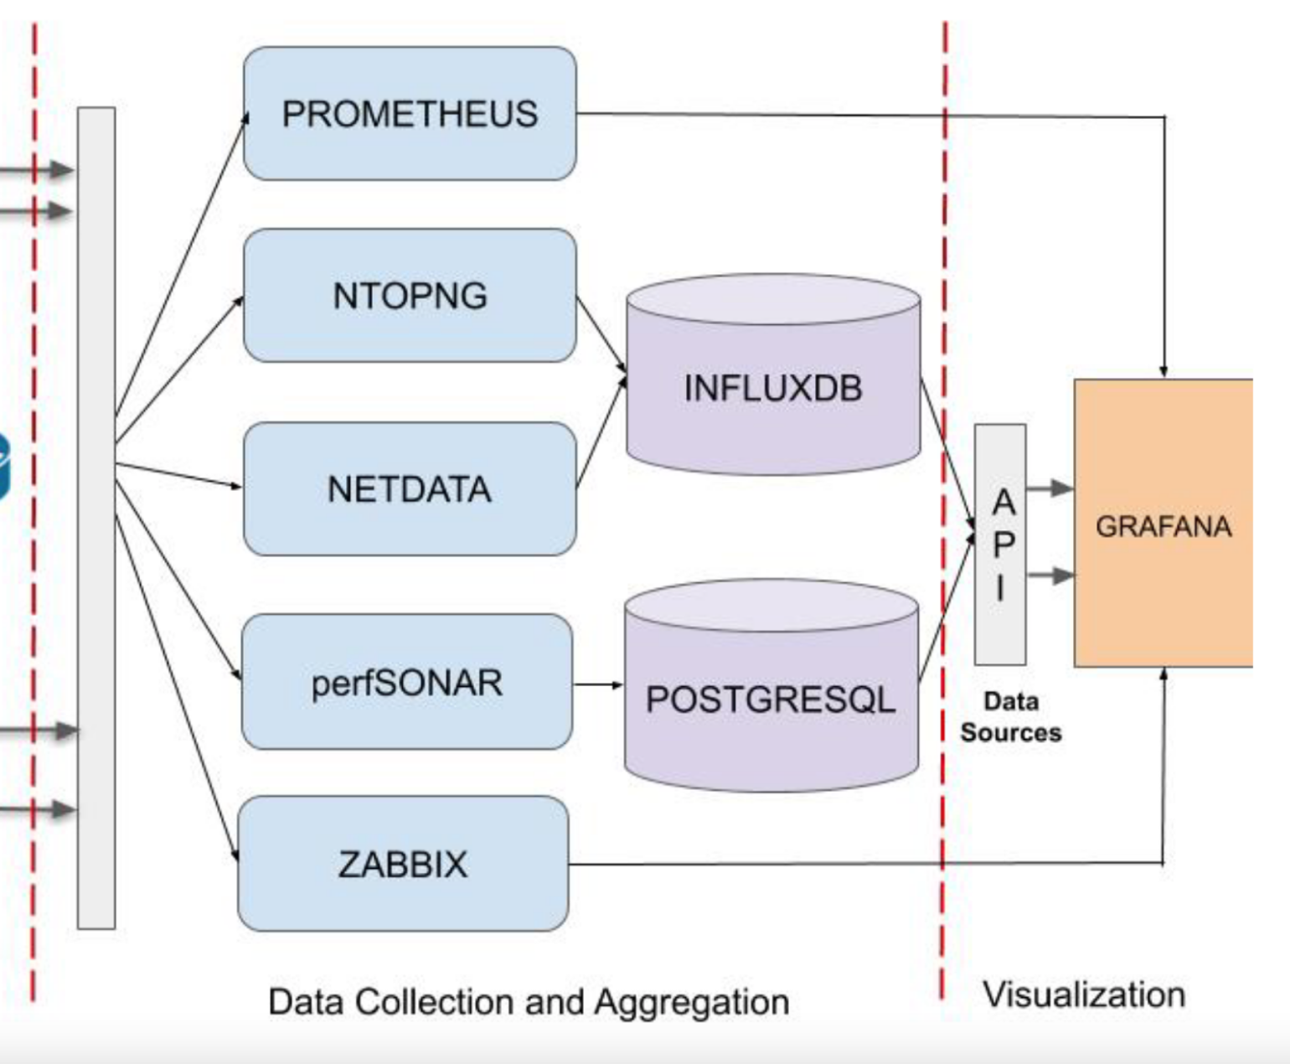

Digital Ocean Password: Username: **root**  **Password1Pass**

**138.68.17.64 CentOS**

**138.197.211.194 CentOS**

**138.68.53.161 Ubuntu**

**138.197.200.101 Ubuntu**

**138.68.59.206 Ubuntu**

**138.68.57.164 Ubuntu**

**138.68.59.50 Ubuntu**