COURSE CODE: CSE 4204 | | COURSE TITLE: MOBILE COMPUTING LAB
WEEK 06 TASK: BACKEND DEVELOPMENT & DATABASE IMPLEMENTATION PROGRESS REPORT
TEAM NAME: CSE4204-8D-T01 | | SECTION: 8D
Project Title: NUBTK_COPILOT - AI-Powered University ERP and Career Architect
Instructor: Md. Riaz Mahmud, Assistant Professor, Dept of CSE, NUBTK
Section: 8D | | Team ID: CSE4204-8D-T01
GitHub Repository: https://github.com/bashirnubtk/cse4204-8d-t01-nubtk-copilot
1. Team Information & Core Engineering Roles
Full Member Name | Student ID | System Design & Engineering Responsibilities
Bashir Alam | 11220320963 | Team Leader. Core backend system architecture, API design, Celery worker workflow orchestration, Open Router API & ML models integration.
Tisha Rani Chakroborty | 11220320954 | Frontend Developer. UI/UX layout design systems, interactive dashboard wireframes, and responsive views matching via Tailwind CSS.
Fariha Rahman Oishee | 11220320967 | Database Manager. PostgreSQL schema structure planning, entity relationship mapping, and relational table indexing within Supabase.
Ratul Raha Shuvo | 11220320949 | Backend Support. Payment gateway integrations sub-system design, transactional report templates, and REST API test suite architecture.

2. Project Objective & Scope
The core objective of this week's development cycle was to transform the theoretical blueprints from the System Design phase into a functional backend system. The key focus areas included:

- Setting up a scalable, decoupled, and asynchronous server infrastructure using Django 5.0.
- Deploying and configuring the live relational database schema on Supabase Cloud Engine.
- Implementing secure authentication protocols including password encryption and JWT session management.
- Developing and deploying initial RESTful API endpoints for user onboarding and core operational workflows.
3. Backend Technology Stack
The infrastructure of NUBTK_COPILOT leverages modern industry-standard frameworks to ensure data consistency, security, and parallel task execution capability:
- Core Framework: Django 5.0 Core Framework Services
- Database Engine: PostgreSQL deployed via Supabase Cloud Engine
- Asynchronous Engine: Celery Task Queue for orchestration
- Authentication Engine: Django REST Framework SimpleJWT (JSON Web Tokens)
- Password Security: Secure PBKDF2 / Bcrypt cryptographic password hashing
4. Database Architecture & Schema Implementation
The cloud database instance has been configured and tables have been successfully materialized on the Supabase PostgreSQL platform based on the approved ER Diagram structure. The structural layout includes explicit foreign keys, primary keys, and constraint validations:
4.1 Implemented Relational Tables
- User Table (Authentication Core): Manages essential access credentials, roles (Student, Faculty, Admin, Super Admin), and encrypted password blocks.
- Student Profile Table: Keeps track of vital academic data including institutional Student ID registries, GPA scores, and links to user credentials.
- Skill Inventory Table: Acts as an immutable ledger storing practical engineering skills tagged against individual student records.
- AI Interaction History Table: Archives detailed token usage, system chat logs, and contextual context strings from the AI Mentor Hub.
- Financial Ledger / Transaction Table: Logs digital payment gateway reference numbers, enrollment validation tags, and automated accounting workflows.

Database Architecture
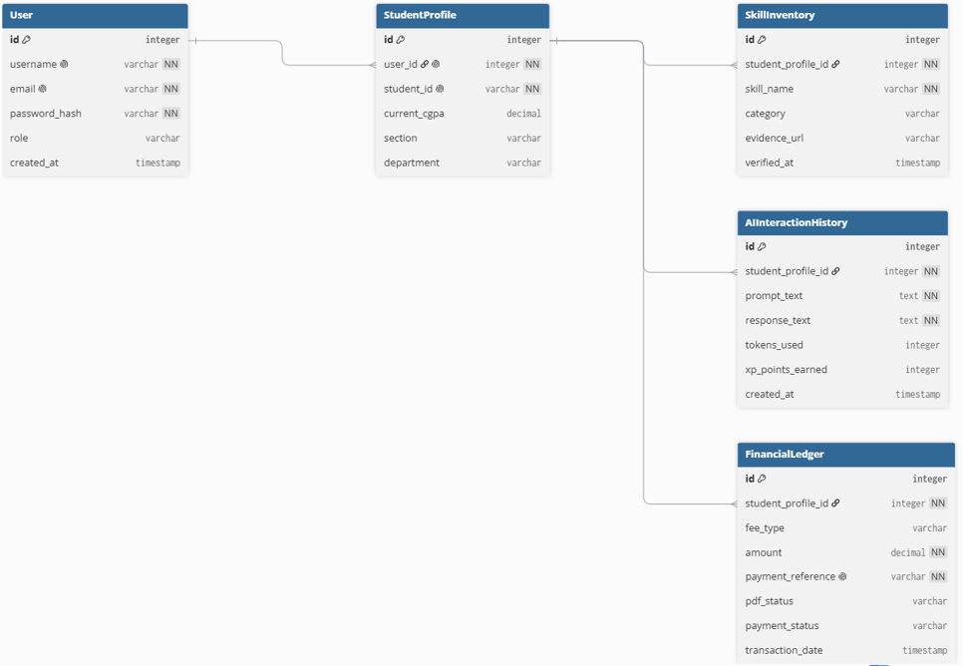

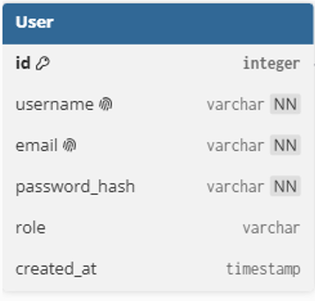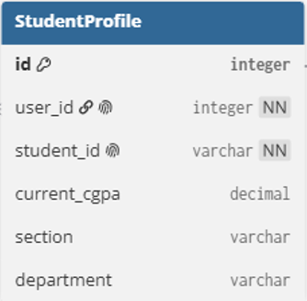

5. Authentication & Authorization Workflow
To safeguard corporate academic identities, a highly secure JWT-based stateless framework was implemented:
- Registration: The client applications send payloads containing the user credentials to the backend. The application layer interceptor hashes the cleartext passwords using secure PBKDF2 blocks before saving them to the user schema.
- Login Verification: Upon sending active credentials to the server, the backend system evaluates the cryptographic hash values. If authenticated, the service issues an isolated, time-bound Access Token and a long-lived Refresh Token.
- Route Protection: Protected API endpoints (e.g., logging skills or launching mentor chats) require a valid Bearer <Token> string embedded directly into the standard incoming HTTP Authorization requests Header.
Backend Folder Structure:
backend_root/
│
├── .env # System Environment Variables (API Keys, DB Credentials)
├── db.sqlite3 # Local Development Database Instance
├── manage.py # Django Management CLI Utility
├── requirements.txt # Project Python Dependencies & Packages
│
├── backend/ # Core Project Configuration Directory
│ ├── __init__.py
│ ├── asgi.py # Asynchronous Server Gateway Interface
│ ├── settings.py # Main Project Configurations & Installed Apps
│ ├── urls.py # Global URL Routing & Endpoint Mapping
│ └── wsgi.py # Web Server Gateway Interface Configuration
│
└── portal/ # Main Architecture Application Module
├── __init__.py
├── admin.py # Django Admin Panel Models Registration
├── apps.py # Application Context Configuration
├── context_processors.py # Custom Global Template Context Injectors
├── models.py # Database Schema Blueprint Definitions
├── tests.py # Backend Automation Test Scripts
├── urls.py # Portal-Specific Endpoint Routing Matrices
├── utils.py # AI Inference Engine & Helper Utilities
├── views.py # Core Controller Logic & Request Handlers
│
├── migrations/ # Database Schema Version Control Logs
│ ├── 0001_initial.py # Automated Supabase/SQL Database Migrations
│ └── __init__.py
│
├── static/ # Static Asset Repositories
│ ├── css/
│ │ └── output.css # Compiled Tailwind CSS Utility Layer
│ └── js/
│ └── main.js # Client-Side Interactive Scripts
│
└── templates/ # Server-Side Rendered HTML Layer
├── academic_matrix.html # Semester Course Mapping Interface
├── admin_dashboard.html # Superuser Management Control Center
├── base.html # Main Global Blueprint Layout Shell
├── chat.html # Real-Time AI Copilot Interaction Console
├── home.html # Institutional ERP Entry Landing Page
├── login.html # Secure User Authentication Gateway
└── student_profile.html # Dynamic Skill Ledger & Portfolio View

6. RESTful API Implementation & Endpoint Specification
The backend currently presents a standardized API routing environment. Input parameters pass through data serializers to enforce payload shape validity and emit standard HTTP status codes:
HTTP Verb | API Endpoint Routing | Target Module | Primary System Action / Output Status | Current Status
POST | /api/auth/register/ | Authentication | Registers a new user inside the institutional DB repository context. | Completed
POST | /api/auth/login/ | Authentication | Validates account credentials and issues secure access JWT. | Completed
POST | /api/skills/log/ | Skill Inventory | Appends a verified engineering technical skill node to active student profile. | Completed
POST | /api/ai-mentor/chat/ | AI Mentor Hub | Streams context-aware programming guidance generated via Claude 3. | Completed

7. API Testing & Verification Reports
Every deployed API route went through thorough testing protocols using Postman / Thunder Client suites. Validation metrics checked structural behavior on successful transactions as well as fallback performance on erroneous inputs (e.g., duplicate emails, bad validation shapes, missing tokens).
7.1 User Registration Testing (POST /api/auth/register/)
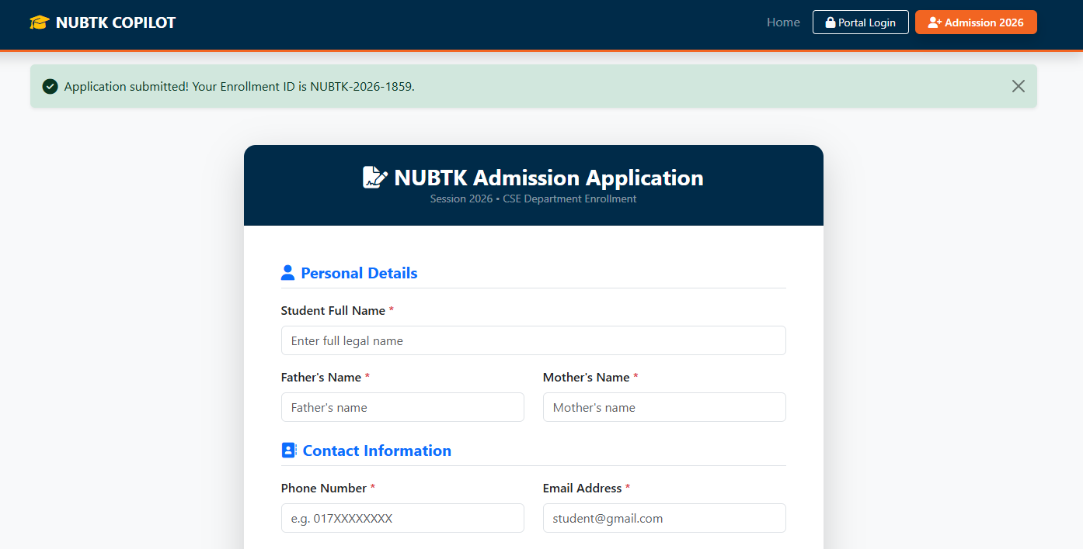

7.2 User Login Testing (POST /api/auth/login/)
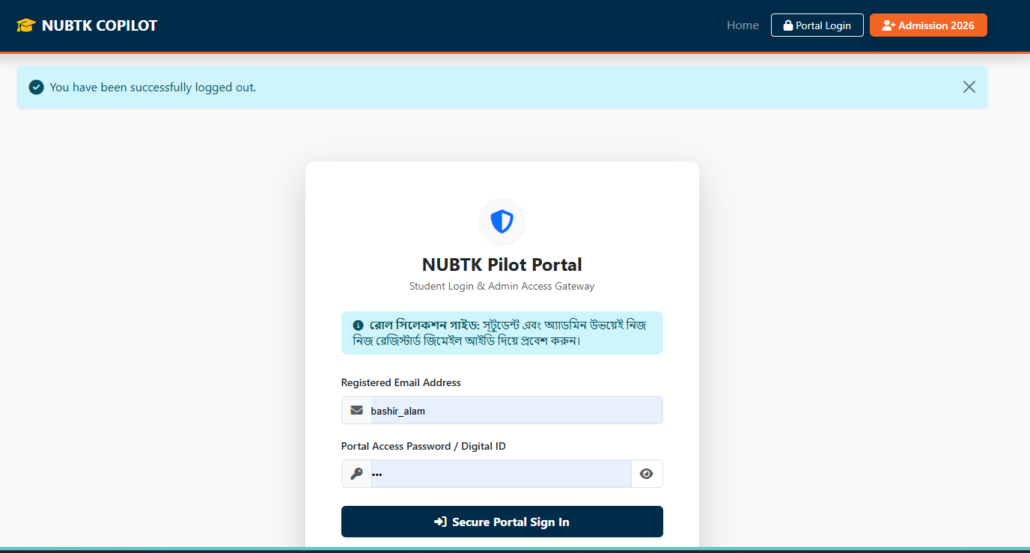
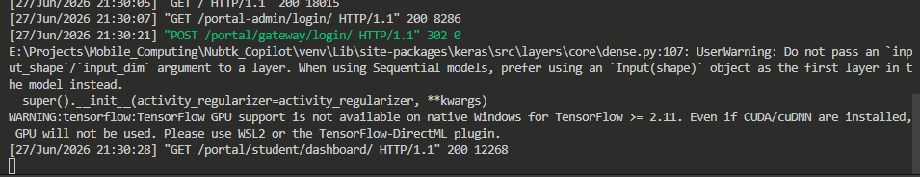


7.3 Skill Inventory Logging Testing (POST /api/skills/log/)
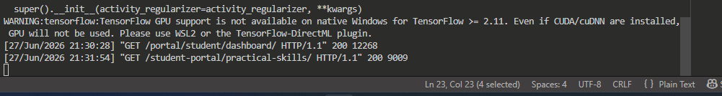
7.4 AI Mentor Chat Testing (POST /api/ai-mentor/chat/)
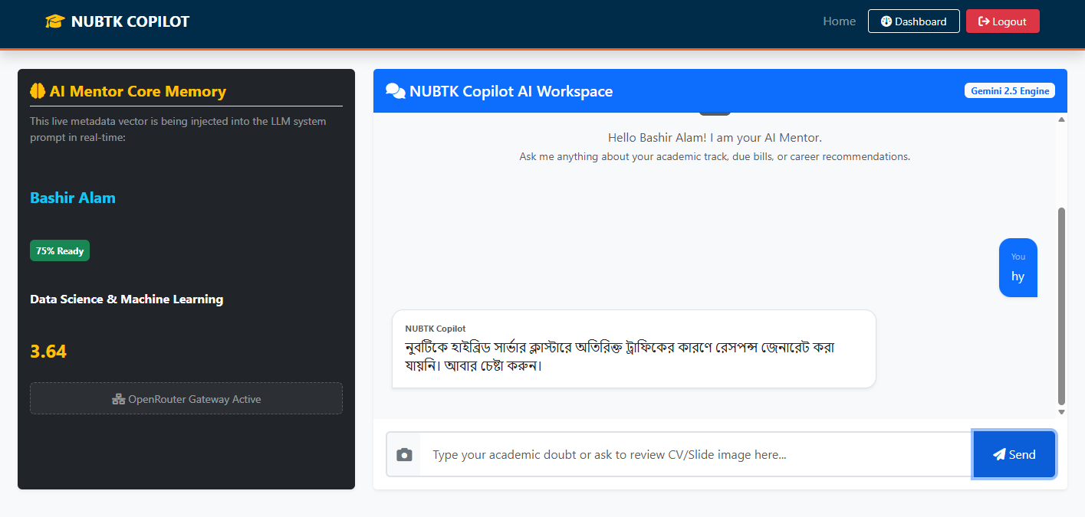
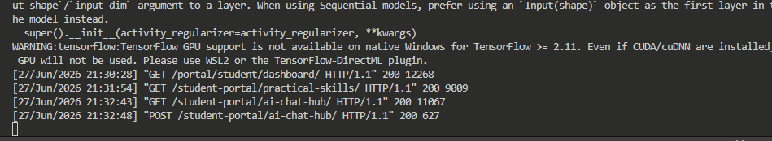
8. GitHub Repository & Commit History Analytics
To strictly conform to professional software engineering standards, continuous integration workflows were practiced. Every distinct code adjustment was organized, committed using descriptive system statements, and published to the central organization repository.
8.1 Example of Standardized Commit Framework:
- feat: implemented JWT login system and user authentication routing modules
- db: finalized PostgreSQL schemas and initialized Supabase structural migrations
- fix: resolved structural input data validation errors during student sign-up

GitHub Repository
