COURSE CODE: CSE 4204 | | COURSE TITLE: MOBILE COMPUTING LAB
WEEK 04 TASK: SYSTEM DESIGN DOCUMENTATION
TEAM NAME: CSE4204-8D-T01 | | SECTION: 8D
Project Title: NUBTK_COPILOT - AI-Powered University ERP and Career Architect
Instructor: Md. Riaz Mahmud, Assistant Professor, Dept of CSE, NUBTK
Section: 8D | | Team ID: CSE4204-8D-T01
GitHub Repository: https://github.com/bashirnubtk/cse4204-8d-t01-nubtk-copilot
1. Team Information & Core Engineering Roles
Full Member Name | Student ID | System Design & Engineering Responsibilities
Bashir Alam | 11220320963 | Team Leader. Core backend system architecture, API design, Celery worker workflow orchestration, Open Router API & ML models integration.
Tisha Rani Chakroborty | 11220320954 | Frontend Developer. UI/UX layout design systems, interactive dashboard wireframes, and responsive views matching via Tailwind CSS.
Fariha Rahman Oishee | 11220320967 | Database Manager. PostgreSQL schema structure planning, entity relationship mapping, and relational table indexing within Supabase.
Ratul Raha Shuvo | 11220320949 | Backend Support. Payment gateway integrations sub-system design, transactional report templates, and REST API test suite architecture.
2. System Architecture (Optimized Structural Format)
Following industry-standard design paradigms, NUBTK_COPILOT implements a completely decoupled, modular, and asynchronous full-stack architecture. The blueprint guarantees a clean isolation of concerns between front-end presentation templates, Django web controllers, background machine learning analytical processors, and the cloud data layer.

2.1 Visual System Architecture Map
The unified high-level abstract system flow layout is visually structured as follows:
[ CLIENT PRESENTATION LAYER ]
├── Web User Interfaces (Semantic HTML5 & Tailwind CSS Mobile Adaptive Viewports)
└── Asynchronous Client-side API Request Handlers
│
▼ (JSON Secure HTTPS REST Data Streams / Payload Delivery)
[ CORE BACKEND SERVER LAYER - DJANGO 5.0 CORE FRAMEWORK SERVICES ]
├── Global Security Policies & Request Serializer/Validation View Sets
├── Decoupled App Domain Modules
│ ├── Academics (Enrollment Lifecycle & Secure Payment Gateway Integration)
│ ├── AI Mentor Hub (Open Router API & Custom Prompt Context Engineering Manager)
│ └── Admin Analytics Engine (Scikit-Learn Predictive Pipeline Models)
└── Celery Asynchronous System Task Queue (Weekly Sunday Execution Logs)
│
├─────────────────────────────────────────┐
▼ (ACID Compliant Relational Queries) ▼ (Remote Semantic Context API Vectors)
[ CLOUD DATA PERSISTENCE LAYER ] [ INTELLIGENT COMPUTE LAYER ]
└── PostgreSQL DB (Sup abase Cloud Engine Engine) └── Open Router Infrastructure (Claude 3)

3. Entity Relationship (ER) Diagram Placeholders
The data layer architecture requires strong integrity controls to safely process institutional records, skill items, and transactions. Below is the blueprint of the required relational tables.
3.1 Core Database Schema Schema Blueprint & Definitions
- 1. User Table (Authentication Core): Stores account credentials, role types (Student, Faculty, Admin, Super Admin), and encrypted password hashes using secure PBKDF2.
- 2. Student Profile Table: Maintains primary academic attributes including explicit unique Student ID registers, Current Cumulative GPA tracking, and assigned Section mapping (Foreign Key to Section).
- 3. Skill Inventory Table: Stores student practical technical skill logs (e.g., 'SQL Joins', 'Python Loop Optimization'). Maps to Student Profile (1:M Relationship) and contains verification/evidence links.
- 4. AI Interaction History Table: Tracks conversational chat context streams with the AI Mentor Hub, prompt token calculations, and gamified experience point logs.
- 5. Financial Ledger/Transaction Table: Manages automated course enrollment registration fees, unique digital payment reference codes, and transactional PDF generation tracking status keys.

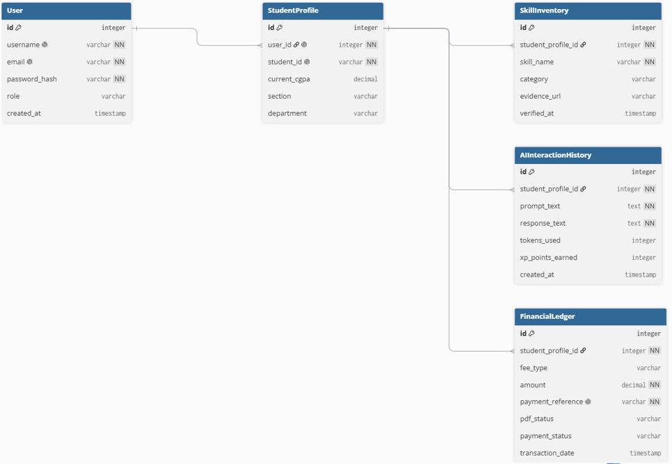

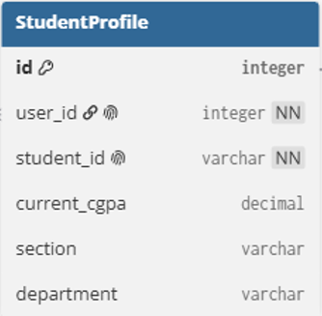
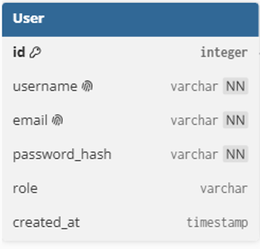

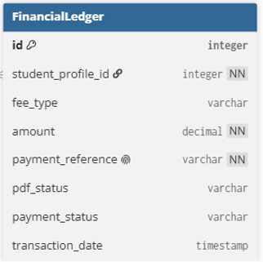
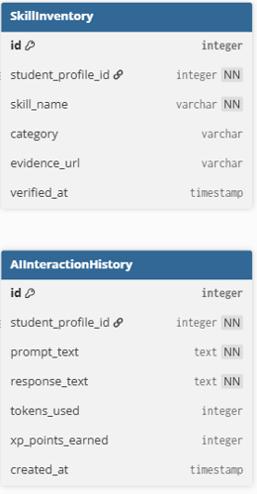

4. Use Case Diagram Placeholders
The operational interactions mapping system operations against the three fundamental actor scopes are formalized below. The corresponding design visual box is reserved blank for subsequent structural diagram drafting.
4.1 Functional Actor Scope Interactions Blueprint
- • Student Actions: Authenticate credentials, log acquired granular computer science skills with evidence verification links, consult the interactive AI Mentor Hub, and review the dynamically evaluated portfolio Career Readiness Score panel.
- • Faculty / Academic Admin Actions: Access analytics portal views, analyze macro skill matrices across entire classes, review predictive machine learning student danger charts, and receive proactive weekly alert emails.
- • Super Administrator Actions: Full system config management, institutional authentication global parameters maintenance, security token allocations, and end-to-end automated payment monitoring records.
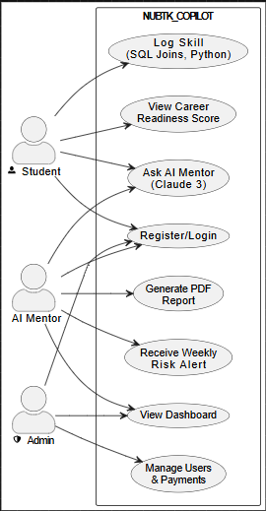

5. REST API Architecture & Endpoint Specification
To enable seamless full-stack programmatic interfaces, the backend services present a standardized RESTful API framework. All endpoint routing structures enforce standardized payload parameters, data validation formats, and return correct standard HTTP response codes.
HTTP Verb | API Endpoint Routing | Target Scope Module | Expected Input Payload | Primary System Action / Output
POST | /api/auth/register/ | Authentication | username, email, password, role | Registers a new system user account inside the institutional DB repository context.
POST | /api/auth/login/ | Authentication | email, password | Validates user account password; sets session logs and returns authentication token.
POST | /api/skills/log/ | Skill Inventory | course_id, skill_name, evidence_url | Appends a verified engineering technical skill node attached to the active student profile.
POST | /api/ai-mentor/chat/ | AI Mentor Hub | message_prompt, context_session | Streams context-aware programming guidance payloads generated via OpenRouter Claude 3 models.
GET | /api/analytics/career-score/ | Predictive Engine | None (Session Authenticated) | Dynamically calculates and returns the weighted 0-100 index Career Readiness Score array.
POST | /api/finance/pay-fee/ | Academics & Payments | student_id, amount, gateway_token | Processes payment transaction records and queues automated background PDF generation jobs.
GET | /api/faculty/dashboard/ | Academic Dashboard | None (Faculty Privileged) | Returns aggregated student technical skill inventory trends and machine learning risk graphs.
6. Architectural Deliverables Checklist
- Decoupled System Architecture Blueprint: Documented full-stack structural service routing configurations cleanly detailing interaction interfaces.
- Comprehensive Schema Design Blueprint: Finalized core relational persistence tables definitions mapping granular skills mapping models.
- Standardized RESTful Endpoints Mapping: Structured comprehensive routing matrices outlining correct request payloads validation rules.
- Multi-Section Submission Formats Adherence: Ensured proper naming rules conform explicitly to the institutional course guidelines handbook manual.

