COURSE CODE: CSE 4204 | | COURSE TITLE: MOBILE COMPUTING LAB
WEEK 05 TASK: USER INTERFACE (UI) DESIGN, USER EXPERIENCE (UX) FLOW, AND DEVELOPMENT PLANNING DOCUMENTATION
TEAM NAME: CSE4204-8D-T01 | | SECTION: 8D
Project Title: NUBTK_COPILOT - AI-Powered University ERP and Career Architect
Instructor: Md. Riaz Mahmud, Assistant Professor, Dept of CSE, NUBTK
Section: 8D | | Team ID: CSE4204-8D-T01
GitHub Repository: https://github.com/bashirnubtk/cse4204-8d-t01-nubtk-copilot
1. Team Information & Core Engineering Roles
Full Member Name | Student ID | System Design & Engineering Responsibilities
Bashir Alam | 11220320963 | Team Leader. Core backend system architecture, API design, Celery worker workflow orchestration, Open Router API & ML models integration.
Tisha Rani Chakroborty | 11220320954 | Frontend Developer. UI/UX layout design systems, interactive dashboard wireframes, and responsive views matching via Tailwind CSS.
Fariha Rahman Oishee | 11220320967 | Database Manager. PostgreSQL schema structure planning, entity relationship mapping, and relational table indexing within Supabase.
Ratul Raha Shuvo | 11220320949 | Backend Support. Payment gateway integrations sub-system design, transactional report templates, and REST API test suite architecture.

2. Finalized Technology Stack & Specifications
Based on the system requirements and decoupled architecture principles, the technology stack has been established as follows:
- Frontend Framework: Semantic HTML5 & Tailwind CSS Utility-First Framework (for lightweight, zero-bundle overhead, and fully responsive presentation layer matching mobile viewports).
- Backend Infrastructure: Django 5.0 Core Framework & Python 3.11 (utilizing Model-Template-View paradigm, integrated ORM security guarantees, and REST API routing policies).
- Database Management System: PostgreSQL hosted via Supabase Cloud (ensuring full ACID compliance for financial workflows and optimized schema architecture for granular technical skill logs).
- Intelligent Services Engine: OpenRouter API Integration (utilizing Claude 3 for semantic code assistance and diagnostic mentoring) paired with local Scikit-Learn pipelines for predictive academic performance analytics.
- Asynchronous Task Automation: Celery Automation Framework (integrated for handling background processes and periodic automated weekly insight reporting).

3. User Interface (UI) Wireframes & Screen Designs
This section contains the visual blueprint of the major screens designed for NUBTK_COPILOT. The layouts prioritize an uncluttered presentation, accessible navigation patterns, and a highly responsive grid structure designed via Figma to match utility-first Tailwind CSS configurations.
3.1 Landing / Home Page

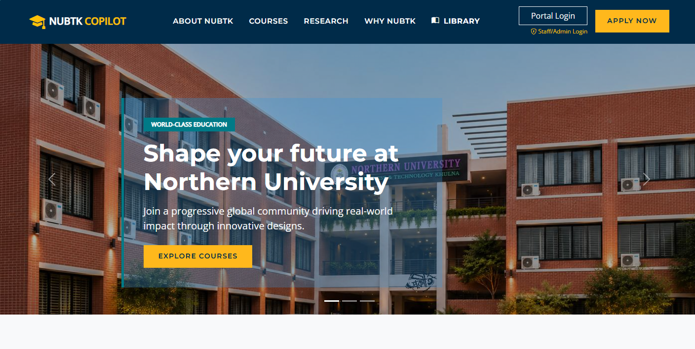
The public gateway explaining the system's core capabilities, featuring clean semantic layouts and dedicated call-to-action triggers for student and faculty access portals.

3.2 Login Page
A secure, centralized authentication panel built with strict request validation indicators, catering to single sign-on credentials for technical students and administrative evaluators.
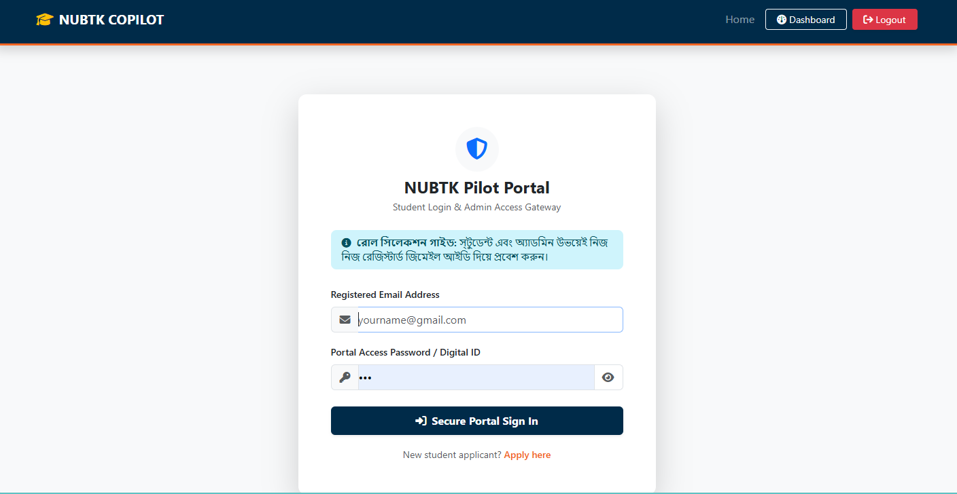
3.3 Registration Page
An optimized data-entry form designed to collect structured student identities, initial academic tracks, and department assignments with explicit real-time frontend validation states.
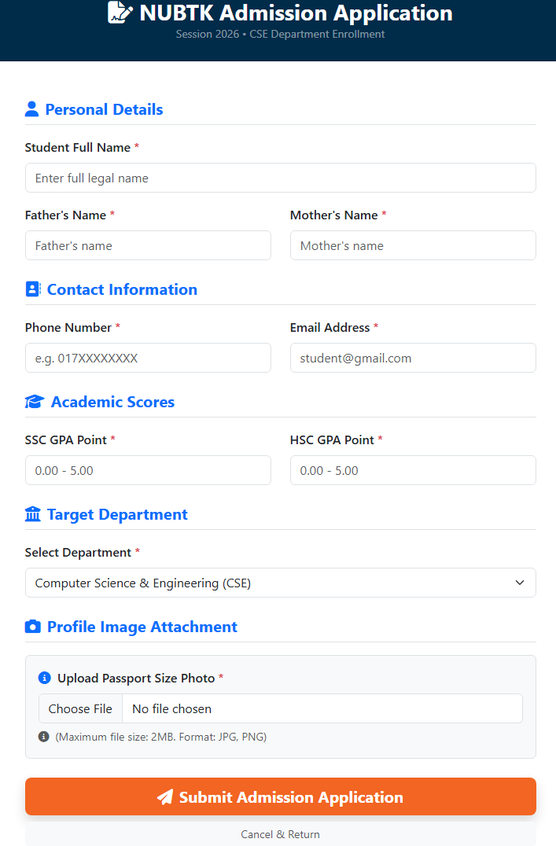
3.4 Student Dashboard
The central workspace displaying active cumulative GPA indexes, immediate skill counts, visual progress metrics, and upcoming administrative milestones.
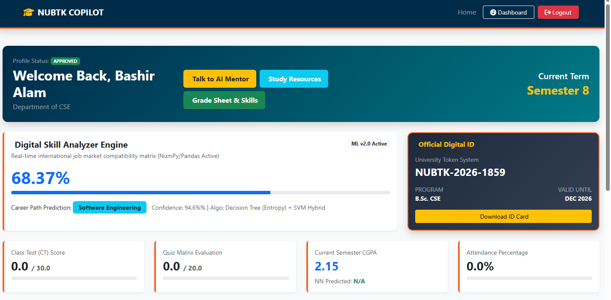

3.5 User Profile & Skill Inventory Page
A specialized interactive directory enabling students to log granular, course-specific competencies (e.g., 'Python Loop Optimization', 'Relational SQL Join Logic') linked directly to semester checkpoints.
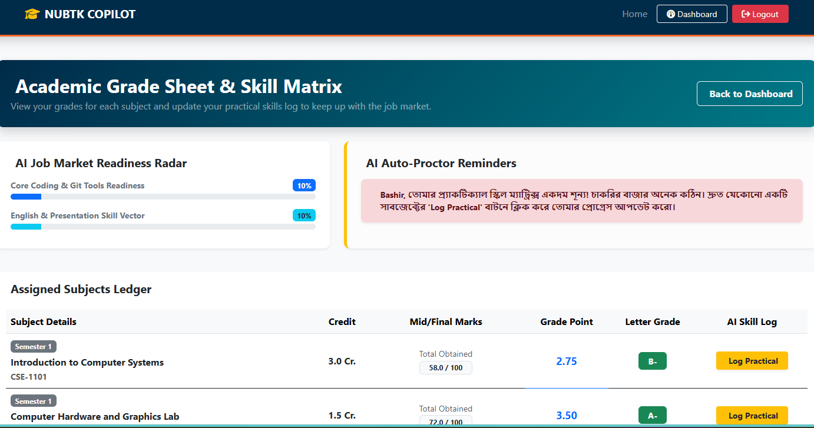

3.6 AI Mentor Hub (Interaction Page)
The conversational environment connecting the student client directly with Claude 3 through OpenRouter API, displaying custom code markdown syntax, gamified points, and debugging paths.
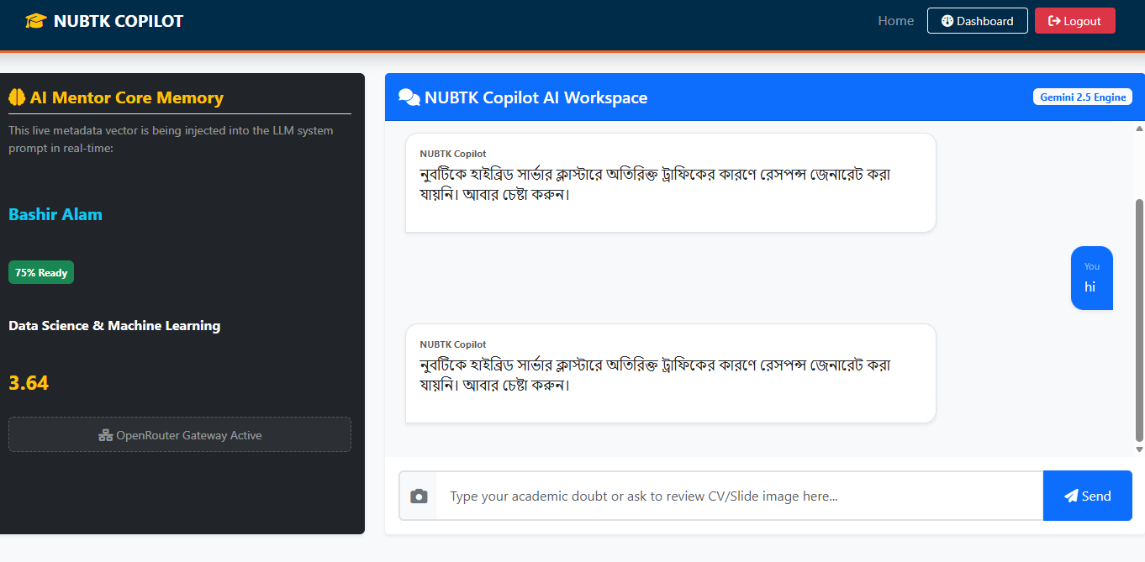
3.7 Career Readiness Analytics Engine Page
Visual layout dedicated to rendering the Algorithmic Career Readiness Index (0–100), combining empirical academic registers with active marketplace deficits (BDJobs/LinkedIn analytics).
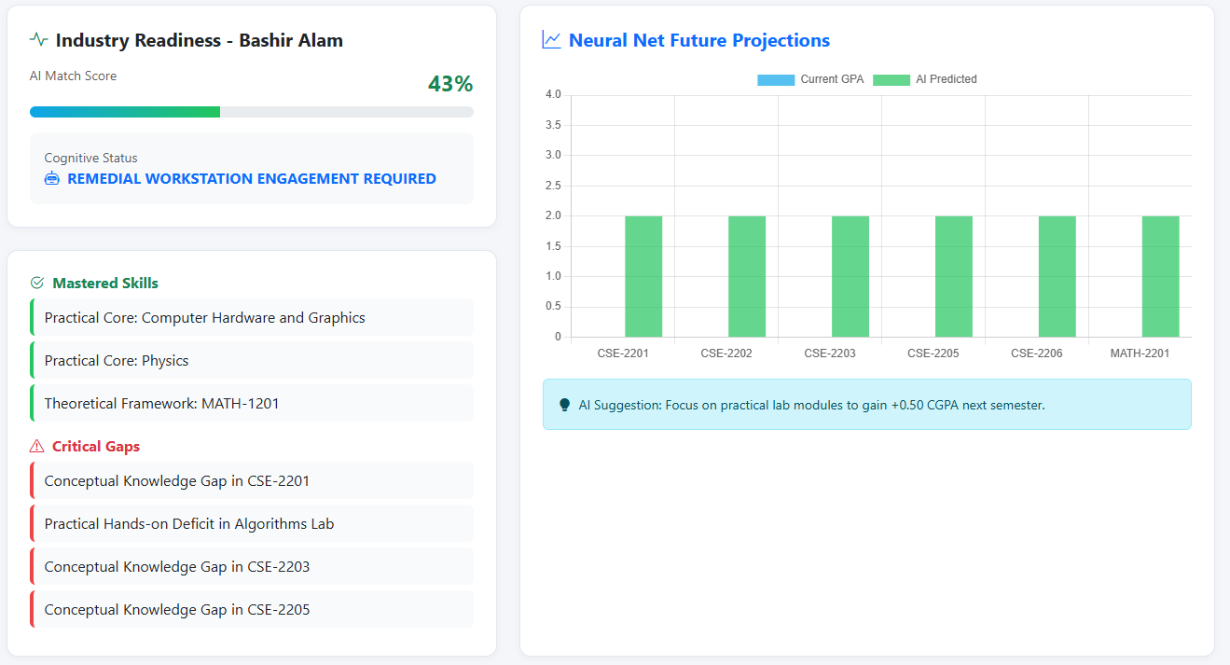
3.8 Admin Insight Engine Panel
A highly controlled administrative cockpit presenting scikit-learn regression insights, student performance risk parameters, and Celery background task automation states.
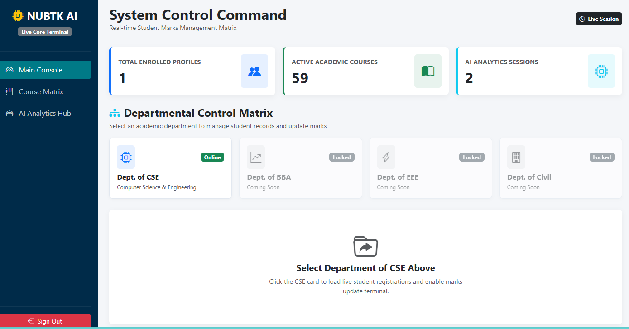
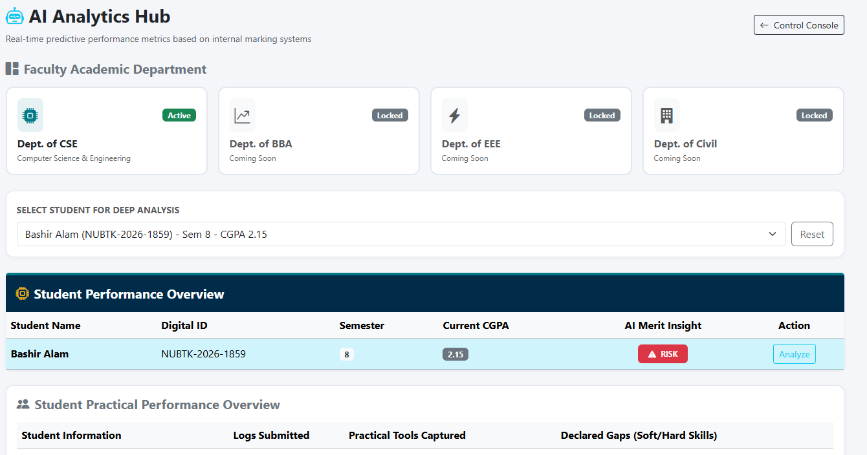
4. System User Experience (UX) Flow Design
The user flow diagram illustrates the end-to-end navigational routing matrix of the system. It maps the precise operational sequences a target user executes—from initial gateway validation through granular skill logging up to intelligent career diagnostic outcomes.

System User Experience (UX) Flow Design
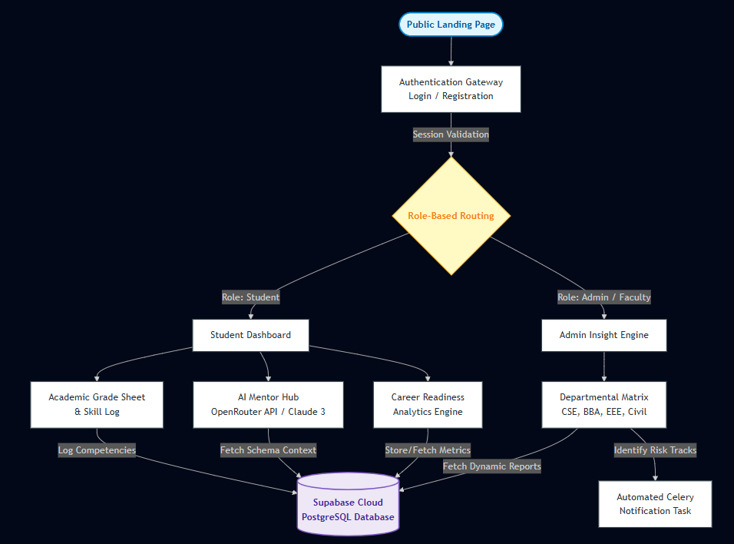
4.1 Step-by-Step Functional Routing Description
- Authentication Gateway: User initiates a connection via the landing layout, proceeding to validation interfaces (Login/Registration).
- Dashboard Allocation: Upon verified authentication, routing middleware checks user access policies to direct them to either the Student Portal or the Admin Insight Panel.
- Core Feature Exploration (Student Track):
- Skill Inventory Logging: Students input practical data points sequentially after course checkpoints.
- AI Mentor Querying: Inputs pass to the OpenRouter/Claude 3 engine to produce semantic code solutions.
- Analytical Calculations: The system compiles database metrics to output the real-time Career Readiness Index.
- Admin Monitoring Track: Academic supervisors examine statistical predictive registers to detect vulnerable tracks, triggering automated notifications handled via Celery.

5. Development Roadmap & Implementation Timeline
To assure timely project execution before the end of the academic term, the team will adhere to the following 6-week phased development sequence:
- Week 06: Core Architectural Setup & Database Migration
- Establishing local environment repositories and backend routing structures (backend/core/).
- Creating normalized PostgreSQL tables inside the Supabase cloud workspace (handled by Fariha Rahman Oishee).
- Week 07: Backend API Development & Authentication Models
- Building functional REST ViewSets and serialization modules in Django (handled by Bashir Alam).
- Integrating transaction-ready scripts and initial payment processing channels (handled by Ratul Raha Shuvo).
- Week 08: Frontend Layout Implementation & Design Mapping
- Converting layout screenshots into semantic HTML5/Tailwind CSS files within the portal_web/ module (handled by Tisha Rani Chakroborty).
- Connecting view layers with core Django views and data contexts.
- Week 09: Intelligent Engine Core API Integration
- Integrating OpenRouter API client endpoints for conversational AI debugging logs (handled by Bashir Alam).
- Coding predictive Scikit-Learn algorithms and tracking skill indexes from Supabase data.
- Week 10: Asynchronous Tasks, Reports & Comprehensive Testing
- Integrating Celery worker queues to schedule weekly automated emails to admins (handled by Bashir Alam & Ratul Raha Shuvo).
- Executing continuous automated functional test suites across API endpoints.
- Week 11: Deployment, Production Launch & Final Documentation
- Launching database endpoints, connecting server services to cloud environments, and completing the production setup instructions within the GitHub README.md.

6. GitHub Repository Structure Finalization
The project repository structure has been organized systematically to ensure a modular approach and smooth continuous integration workflows.
Official URL: https://github.com/bashirnubtk/cse4204-8d-t01-nubtk-copilot
Repository Directory Blueprint
nubtk_copilot/ [System Root Environment]
├── backend/ [Django 5.0 Core Framework Services]
│ ├── core/ [Global System Settings & Routing Policies]
│ ├── api/ [REST ViewSets & Standardized Data Serializers]
│ └── apps/ [Decoupled Domain Service Architectures]
│ ├── academics/ [Enrollments, Secure Gateway Payments, Records]
│ ├── ai_mentor/ [LLM Chat Interface & OpenRouter Integrations]
│ └── ai_ml_engine/ [Scikit-Learn Regression & Skill-Gap Matrix]
├── database/ [Supabase Table Schemas & SQL Migration Scripts]
├── portal_web/ [Lightweight Front-End Templates & Context Views]
├── static/ [Compiled Tailwind Design Tokens & Asset Blobs]
├── design/ [Figma Source Assets, User Flow Diagrams]
├── documentation/ [System Design, SRS, and Assignment Records]
└── README.md [Project Setup Instructions & System Guidelines]

