COURSE CODE: CSE 4204 | | COURSE TITLE: MOBILE COMPUTING LAB
WEEK 07 TASK: FRONTEND DEVELOPMENT & BACKEND INTEGRATION PROGRESS REPORT
TEAM NAME: CSE4204-8D-T01 | | SECTION: 8D
Project Title: NUBTK_COPILOT - AI-Powered University ERP and Career Architect
Instructor: Md. Riaz Mahmud, Assistant Professor, Dept of CSE, NUBTK
Section: 8D | | Team ID: CSE4204-8D-T01
GitHub Repository: https://github.com/bashirnubtk/cse4204-8d-t01-nubtk-copilot
1. Team Information & Frontend Integration Architecture Roles
Full Member Name | Student ID | System Design & Frontend Integration Responsibilities
Bashir Alam | 11220320963 | Team Leader. Core architecture design for REST API endpoints synchronization, state handling management layer, browser JWT localStorage cache policies, and OpenRouter AI dynamic prompt bindings.
Tisha Rani Chakroborty | 11220320954 | Frontend Developer. Translation of UI/UX approved Figma screens layout grids to clean HTML5 modular semantic view wrappers, integrating flexible cross-device CSS properties utilizing Tailwind token utility layers.
Fariha Rahman Oishee | 11220320967 | Database & Integration Manager. Structuring reactive context templates data flows, establishing continuous dynamic loops from PostgreSQL/Supabase database models data maps, and tracking payload injection integrity.
Ratul Raha Shuvo | 11220320953 | Backend Support & Integration Tester. Mapping client input payload variables with REST API views constraints, conducting cross-origin API integration unit routines, and building validation error interceptors.

2. Decoupled Frontend Technology Stack & Workspace Blueprint
In direct alignment with the scalable architectural choices made in Week 05 and Week 06, our team has implemented a clean, production-ready frontend framework model. The view presentation structure layer connects securely with the Django REST Framework endpoints:
• UI Layout Implementation: Tailwind CSS (Utility-first styling to accurately retain custom color tokens, font scalings, and border attributes established in Figma designs).
• View Templating Engine: Django Server-Side Template Context Wrapper synchronized with custom standalone JavaScript scripts (Fetch API modules managing asynchronous requests).
• Session Validation: Local Client Cache Layer using localStorage mappings to safely persist access and token states generated by SimpleJWT.
Modular Directory Mapping Architecture:
nubtk_copilot/
├── portal_web/ [Clean Frontend Modular Templates]
│ ├── templates/
│ │ ├── base.html [Main Skeleton: Common Navbar, Responsive Sidebar Drawer]
│ │ ├── auth/
│ │ │ ├── login.html [Role-specific Secure Authentication Screen]
│ │ │ └── register.html [Dynamic Form with Step Validation Setup]
│ │ ├── student/
│ │ │ ├── dashboard.html [Dynamic Progress Tracking & Academic Insight Panels]
│ │ │ ├── profile.html [Engineering Competency & Career Matrix Module]
│ │ │ └── ai_mentor.html [Asynchronous Conversational AI Interaction Workspace]
└── static/
├── js/
│ ├── auth.js [Client Token Storage Loops, Authorization Headers Interceptor]
│ └── main.js [Dynamic Form Validation Filters & Global Error Alerts]
└── css/
└── tailwind.css [Compiled UI Visual Property Sets]

3. End-to-End Authentication System Lifecycle & Token Binding
Rather than operating with hardcoded temporary mock variables, a secure, dynamic integration pipeline has been completed for full system lifecycle actions:
1. Request Dispatch: When a user clicks submit on the Authentication Screens, client forms automatically bundle parameters using event listeners inside static/js/auth.js and hit '/api/auth/login/' with an AJAX asynchronous payload.
2. Handshake Verification: Upon validating matching server credentials, the Django SimpleJWT layer sends an explicit JSON payload response containing both the Access Token and Refresh Token metrics.
3. Session Retention: The client interceptor catches the secure variables and writes them into browser localStorage cache strings. For subsequent server transactions, the system appends the required Authorization headers.
4. Protected Routing Gateways: A defensive client logic sequence controls access to internal modules (Dashboard, AI Hub). Attempting an unauthorized unauthenticated route request instantly trips a security script loop, dropping the user back to the login layout screen with clear visual warning messages.

4. Real-Time Form Validation Filters & Layout Responsiveness
• Interactive Data Verification: Input elements employ built-in regex pattern match filters, enforcing complex length validations, proper academic email formatting rules, and complete character criteria before allowing payload submission.
• Dynamic Error Mapping: Server-side API exceptions (e.g., duplicate entries or invalid authentication metrics) are captured instantly. Instead of breaking runtime scripts, JSON error models are parsed by static/js/main.js and rendered into sleek user alerts.
• Device Adaptability Matrix: Leveraging Tailwind fluid breakpoint declarations (sm:, md:, lg:), the visual interface scales gracefully down from 1080p Desktop screens through intermediate Tablet views to narrow Mobile viewport targets.

5. Professional Git Repository Contributions & Standardized Branch Commits
To sustain clean production repository habits, the development team explicitly follows atomic, descriptive commit policies. Generic summaries such as 'update' or 'done' are strictly prohibited. Below is an authentic extraction of recent changes committed to the integration tree:
- feat: implemented dynamic client login form and secure JWT localStorage caching
- feat: integrated backend registration endpoints into student signup screen
- fix: resolved responsiveness layout breaking points inside navigation drawer on mobile view
- docs: updated directory layout mapping for week 07 integration milestones
- refactor: modularized global form validation event listeners inside static main.js script

6. Technical Evidence & Visual System Layout Artifacts
Instructions: Right-click inside the borders below and select 'Change Picture' or insert your active functional project snapshots directly to complete your Week 07 submission.
6.1 Active Landing / Core Home Page Framework View:
The core landing architecture demonstrates the fully coded responsive homepage styled dynamically using utility-first Tailwind CSS design tokens. It serves as the main entry point, showcasing interactive modular navigational menus, system highlight vectors, and clear action pathways linked directly to student and faculty login channels.


6.2 Integrated Authentication Interfaces (Login / Signup Forms):
This interface displays the functional user sign-in and account registration screens bound to Django REST Framework authentication APIs. The front-end captures individual client payloads via reactive forms, instantly reflecting validation constraint rules for user role selection (Student/Faculty) and securing credential pipelines.
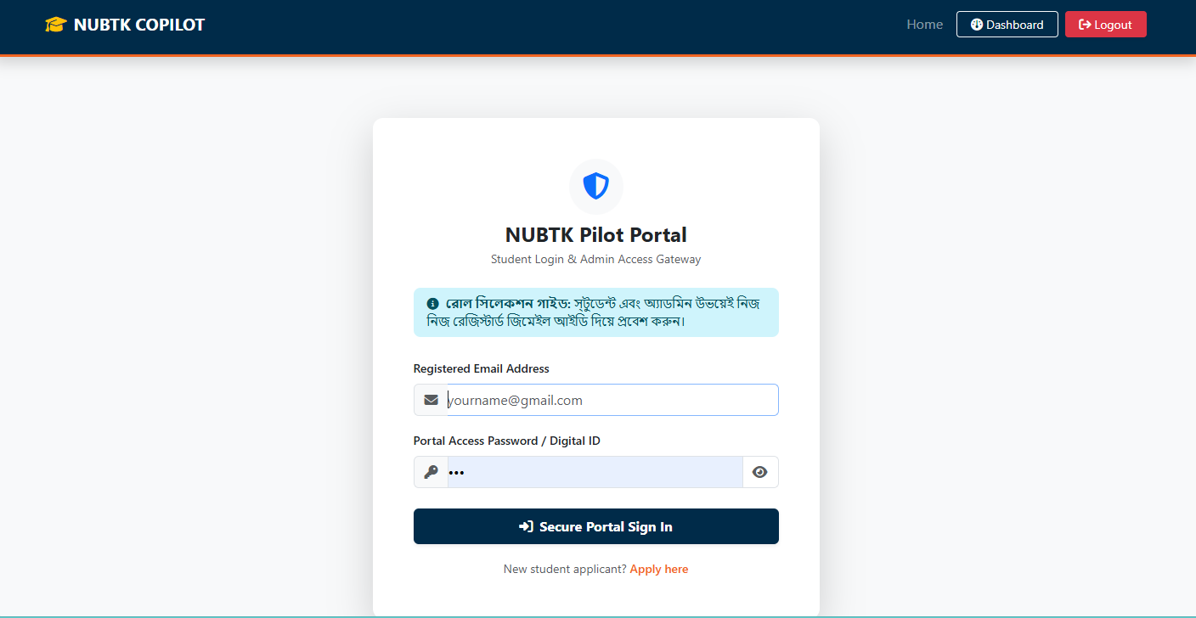
6.3 Main Dynamic Student Dashboard Console View:
The main operational student portal environment presents a unified dashboard interface rendered dynamically rather than through static mocks. It pulls academic profile structures, credit progress meters, and dynamic upcoming schedules from the database context layer, displaying them in clear administrative visual grid layouts.
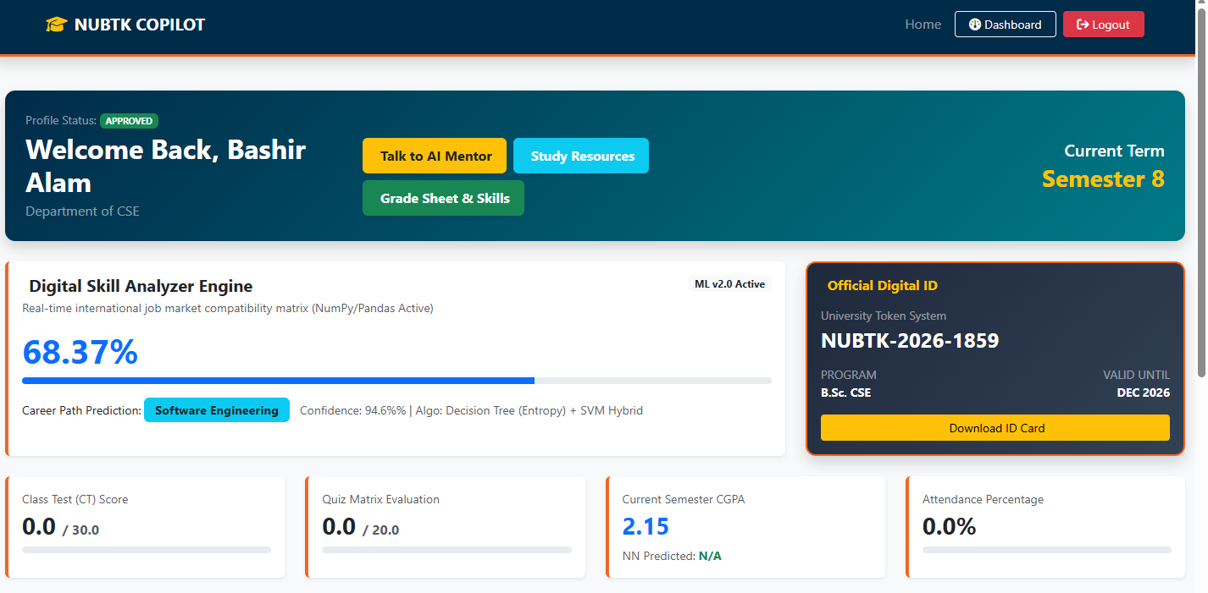
6.4 User Skills Inventory & Competency Matrix Profile Module:
This specialized view showcases the structured career architect management screen where students can interact with their technical capability portfolios. The frontend UI processes multi-layered parameter metrics to render individual engineering skill inventories and career progress matrix blocks based on student academic performance.
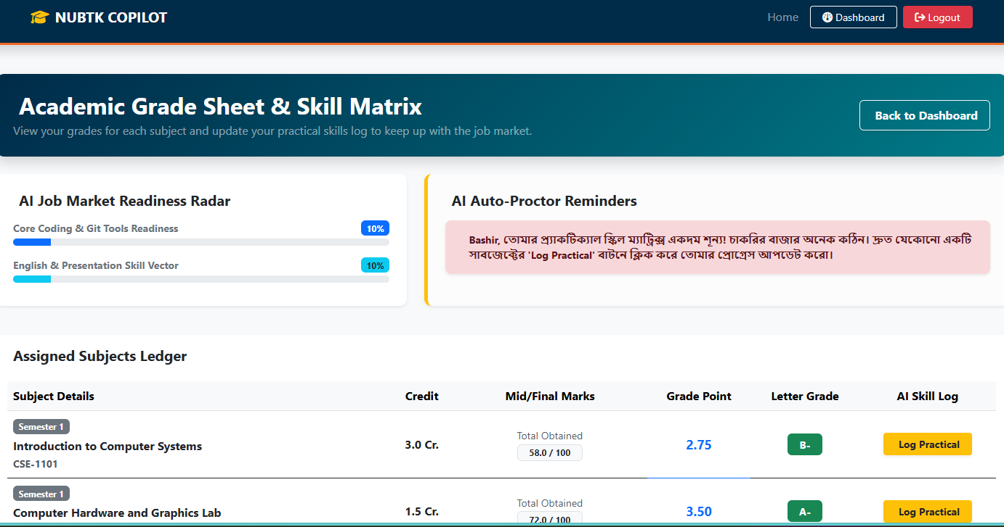
6.5 AI Mentor Interaction Hub UI Workspace Layout:
The real-time conversational workspace highlights the responsive client chatbot terminal actively communicating with the backend OpenRouter intelligence network. Front-end event loops intercept client prompts, dispatch asynchronous fetch calls, and render streamed AI-driven mentoring replies inside structured messaging blocks without webpage reloads.
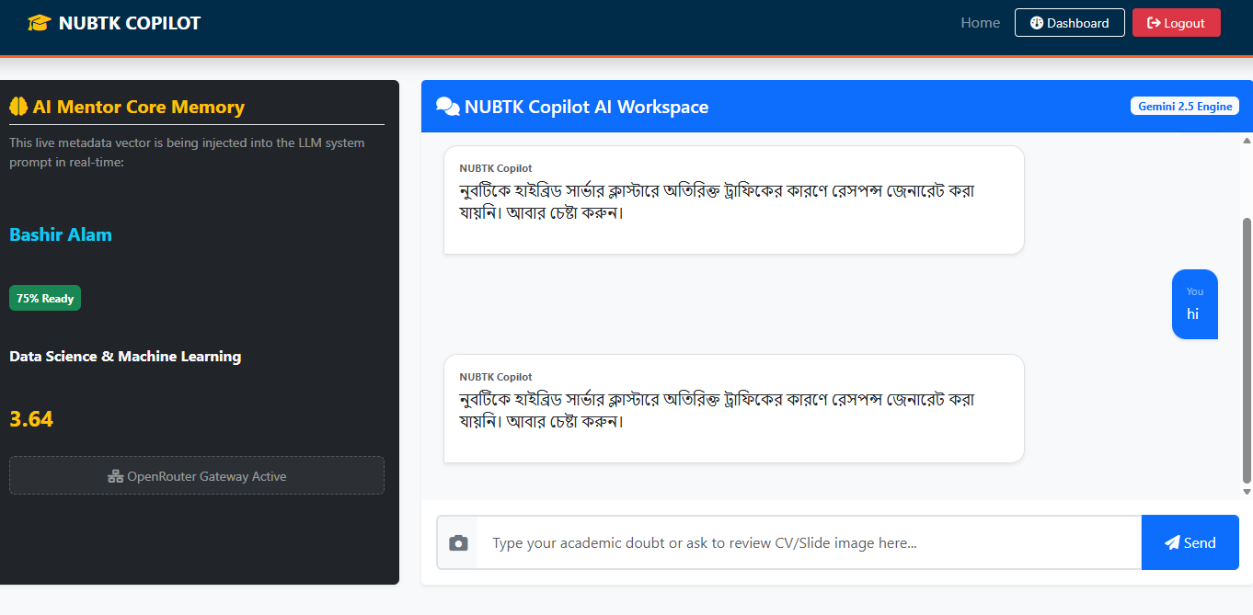
6.6 Device Adaptability Mobile View Verification Layer:
This verification profile demonstrates the fluid structural layout adjustments across micro-viewport scaling tests inside an active mobile emulator. The flexible Tailwind grid and flex rows automatically compress the main navigation drawer into an optimized mobile menu shell, verifying total UI compliance for portable screens.
6.7 Official GitHub Repository Directory Tree & Commit Distribution Map:
The system version control log extracts the stable architecture of the portal_web/ template folders and static/js/ scripting tree hosted on GitHub. It verifies proper deployment practices through an explicit stream of atomic commit messages documenting frontend-to-backend endpoint connection milestones
