COURSE CODE: CSE 4204 | | COURSE TITLE: MOBILE COMPUTING LAB
WEEK 09 TASK: PROGRESS AND INTEGRATION REPORT Feature Completion, Integration & Mid-Project Review

TEAM NAME: CSE4204-8D-T01 | SECTION: 8D

Project Title: NUBTK_COPILOT - AI-Powered University ERP and Career Architect
Instructor: Md. Riaz Mahmud, Assistant Professor, Dept of CSE, NUBTK
Team ID: CSE4204-8D-T01
GitHub Repository: https://github.com/bashirnubtk/cse4204-8d-t01-nubtk-copilot

1. Team Information & Core Engineering Roles
Full Member Name | Student ID | System Design & Engineering Responsibilities
Bashir Alam | 11220320963 | Team Leader. Core backend architecture, OpenRouter Hybrid AI Copilot Engine (bot_engine.py), Scikit-Learn ML models (models_ml.py), Keras Neural Network (neural_net.py), REST API ViewSets, and Full-system Integration.
Tisha Rani Chakroborty | 11220320954 | Frontend Developer. Dynamic Student Analytics UI/UX components, Real-time AI Workspace views, Jinja2/Tailwind CSS integration, and Mobile responsiveness.
Fariha Rahman Oishee | 11220320967 | Database Manager. PostgreSQL schema extension for Courses, Student Results, Resource Hubs, AI Chat Sessions, and database queries optimization.
Ratul Raha Shuvo | 11220320949 | Backend Support. ReportLab PDF automated generation utilities, NUBTK 160-credit CSE curriculum seeder, and error handling middleware.

2. Project Objective & Scope Overview
The primary objective of Week 09 development cycle is to transition NUBTK_COPILOT from individual functional components into a fully integrated, cohesive, end-to-end operational software ecosystem. All initial backend endpoints, database models, frontend interfaces, Scikit-Learn predictive algorithms, Keras neural networks, and OpenRouter multi-model LLM features have been connected and tested on real application workflows.

3. Feature Completion Checklist
Feature Name / Module | Status | Reason (If Incomplete) & Planned Completion
User Registration & Role-Based Gateways | Completed | Fully integrated with Django session-based authentication.
Student Dashboard & Academic Performance View | Completed | Renders subject-wise marks, semester CGPA, and automated digital ID.
Scikit-Learn ML Career Track Classifier (Decision Tree / SVM) | Completed | Live vector classification across Software Engineering, Data Science & Cyber Security.
Keras Neural Network (3-Layer ANN CGPA Regressor) | Completed | Forecasts CGPA based on attendance, study hours, and quiz averages.
OpenRouter Multi-Model AI Chat Hub (bot_engine.py) | Completed | System prompt context injection active with automated multi-LLM fallback logic.
Admin AI Control Center & University Seeder | Completed | Full institutional analytics, student approvals, and 160-credit CSE curriculum seeding.
ReportLab Digital ID & Receipt PDF Generator | Completed | Automated NUBTK token generation and PDF export.
Real-Time Push Notifications (WebSocket/Celery) | In Progress | Currently relying on HTTP long-polling/AJAX. Full WebSocket implementation scheduled for Week 11.

4. Integration Status Summary
- Frontend–Backend Integration: Standardized across Django Views, Jinja2 Templates, and REST API ViewSets using JSON payload exchanges. Hardcoded/dummy data replaced with live database objects.
- AI Integration: Integrated into real workflows. Contextual data (Student CGPA, Skill Vectors, Course History) is fetched from PostgreSQL and injected into system prompts before routing through OpenRouter API gateways.
- Authentication & Security: Complete role-based authentication separating Students and Administrators. API credentials and secrets are managed via environment variables.

5. End-to-End Major User Workflows

[User Registration / Login]
↓
[Role Gatekeeper Check (Student / Admin)]
↓
[Student Dashboard Load] ───→ [PostgreSQL DB Query (Academic Results & Skill Logs)]
↓
[AI & ML Processing Layer]
├── 1. Scikit-Learn ML Classifier ──→ Predicts Career Focus (e.g., Data Science)
├── 2. Keras ANN Regressor ──────────→ Computes Next Semester Predicted CGPA
└── 3. Vector Similarity Engine ────→ Calculates Skill Gap Index (NumPy/Pandas)
↓
[Dynamic Dashboard Render + OpenRouter AI Chat Hub Workspace]

6. Error Handling & Robustness Implementations
- OpenRouter API Failures / Rate Limits: Implemented explicit try-except fallback handlers in bot_engine.py that cycle sequentially through models (Gemini Flash, Llama 3.1, DeepSeek R1, OpenRouter Auto) if HTTP 400/404 errors occur.

- Invalid Form Inputs: Form validation implemented on frontend/backend to catch missing fields and display user-friendly error messages without breaking the execution flow.
- Database Inaccessibility: Graceful error boundaries implemented in views to display empty state alerts rather than server 500 exceptions.

7. Current System Screenshots & Placement Instructions
Below are the specific locations where system screenshots must be attached in your final submission document:

7.1 Student AI Workspace & Context-Aware Chat
Description: Shows real-time AI Chat Hub conversation where student queries receive personalized, context-aware responses, as well as backend console execution showing OpenRouter model handling and automated fallbacks.

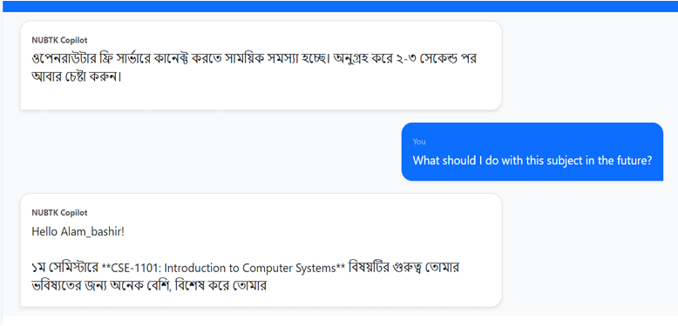

[AI Chat Hub UI & OpenRouter Terminal Execution Log]

7.2 Dynamic Career Path Prediction & Student Dashboard
Description: Displays the main Student Dashboard rendering live student CGPA, Digital Skill Analyzer Engine score (50.6%), Official Digital ID (NUBTK-2026-1859), and Scikit-Learn/ANN Career Focus prediction.

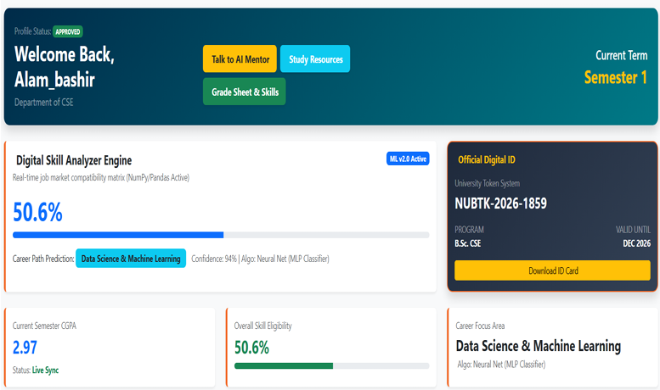

[ Student Dashboard & Skill Analyzer Engine]

7.3 Academic Grade Sheet & Skill Matrix
Description: Shows subject-wise breakdown (Class Tests, Quizzes, Attendance, Subject CGPA) along with AI Job Market Readiness Radar and Auto-Proctor Reminders.

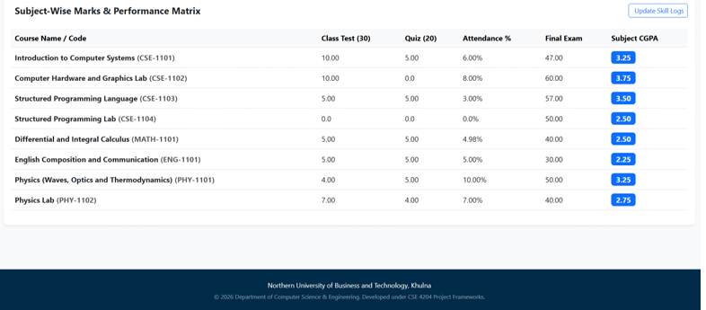

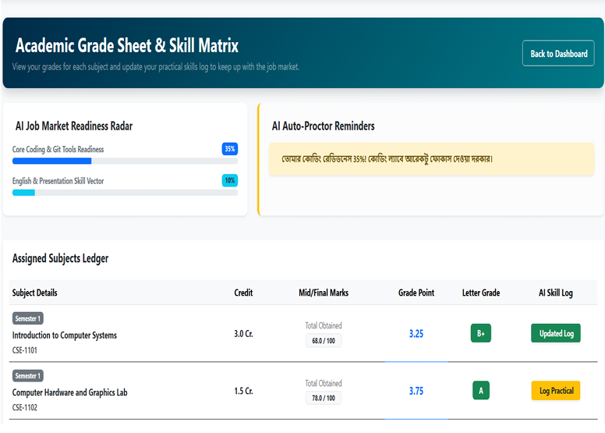

[Grade Sheet & Skill Matrix Workspace]

7.4 Admin AI Analytics Hub & Departmental Control
Description: Displays the institutional administration interface with deep analysis of student merit insights, neural network future projections chart, critical skill gaps, and approval controls.

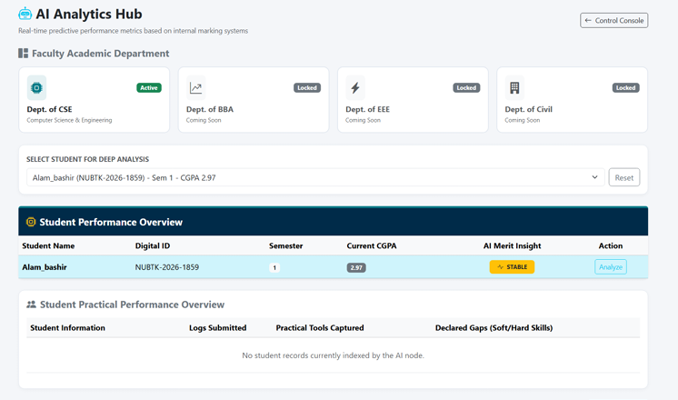

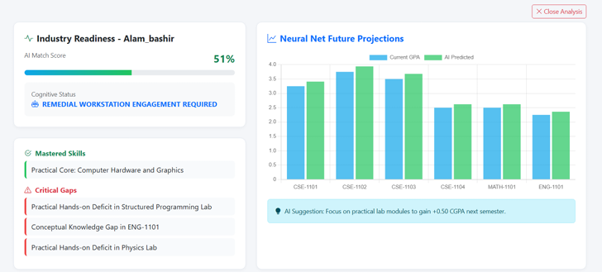

[Admin AI Analytics Dashboard & Keras Projections Chart]

7.5 GitHub Repository & Multi-Branch Activity
Description: Captures the active GitHub repository branch structure (main, bashir_core_backend, tisha_frontend, dev, oishee_database, ratul_ui_frontend) demonstrating continuous team contributions.
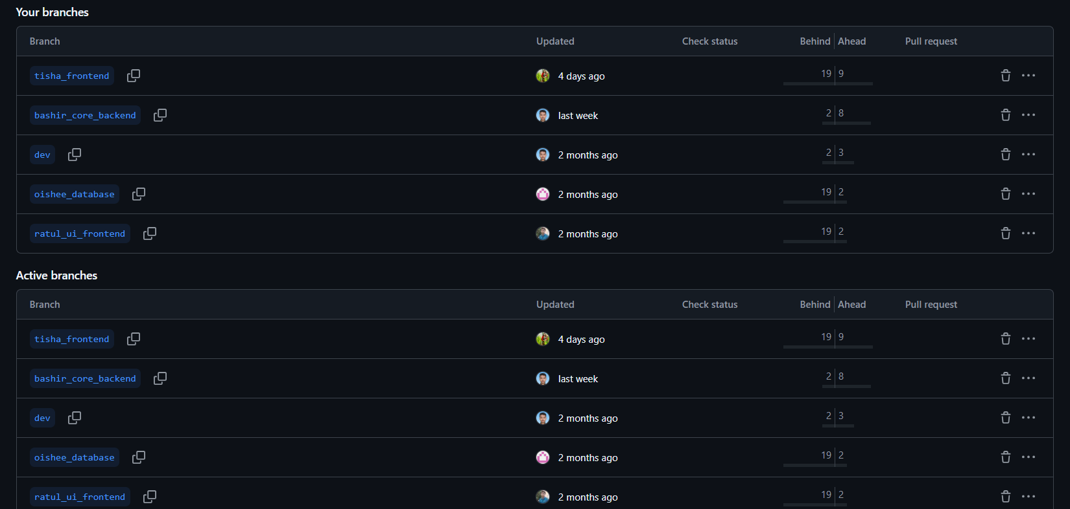

[GitHub Repository Branches View]

8. GitHub Repository & Commit Policy Compliance
Repository Link: https://github.com/bashirnubtk/cse4204-8d-t01-nubtk-copilot
Recent Standardized Commits:
- feat(integration): completed frontend-backend integration for student dashboard
- feat(ai_engine): finalized openrouter system prompt context injection & fallback logic
- feat(ml_analytics): connected scikit-learn career classifier with live database vectors
- feat(neural_net): validated keras ann cgpa regressor on real academic logs
- fix(auth): secured protected routes and optimized session handling
- docs(report): updated week 09 progress report and integration architecture

9. Deliverables & Links
- GitHub Repository: https://github.com/bashirnubtk/cse4204-8d-t01-nubtk-copilot
- Live Demo URL: http://nubtk-copilot.local (Local Development / Staging Server)
- Code Dump Utility: code_dumper.py configured for standardized project export.

