NATIONAL RENEWABLE ENERGY PLATFORM
Agri-Energy Desk Digital Platform

Agri-Energy Desk User Manual
A practical guide to the public site, the partner portal and the administration portal
Field | Detail
Document | Agri-Energy Desk User Manual
Document number | AED-03
Version | 1.0
Date | 29 September 2026
Status | For submission to NREP
Platform | Agri-Energy Desk Digital Platform
Prepared for | National Renewable Energy Platform (NREP)
Requirements baseline | Software Requirements Specification (SRS) Version 2.0

Table of Contents
This table of contents is a field. In Microsoft Word, press Ctrl+A then F9 (or right-click and choose "Update Field") to populate or refresh it.
TOC \h \o "1-3"

1. Introduction
The Agri-Energy Desk is Uganda's national digital platform for agri-energy knowledge, maintained by the National Renewable Energy Platform (NREP). It brings together, in one place, the projects being implemented across the country, the renewable energy technologies used in agricultural value chains, the organisations working in the sector, published research and guidance, events and training, funding calls, tenders and vacancies.
This manual explains how to use the platform. It covers the public site, which anyone may use without an account; the partner portal, used by registered organisations and individuals to contribute content; and the administration portal, used by NREP staff to manage and publish it.

2. Purpose of the Manual
The manual is written for the people who will actually use the system. It gives step-by-step instructions for each task, states which role may perform it, and shows what each screen looks like.
Where a task is performed differently by different roles, the difference is stated explicitly. Where a function is restricted, the manual says which role holds it rather than leaving the reader to discover a refusal.

3. System Overview
The platform has three areas. Which of them you use depends on who you are.
Area | Who uses it | What it is for
Public site | Anyone, no account required | Browsing and searching projects, technologies, themes, partners, resources, events, opportunities, tenders and news; viewing the map; downloading open data
Partner portal | Registered organisations and individuals | Submitting content for publication, tracking its progress, managing an organisation's team and profile
Administration portal | NREP staff | Managing all content, reviewing and publishing submissions, managing users, reporting, and system administration

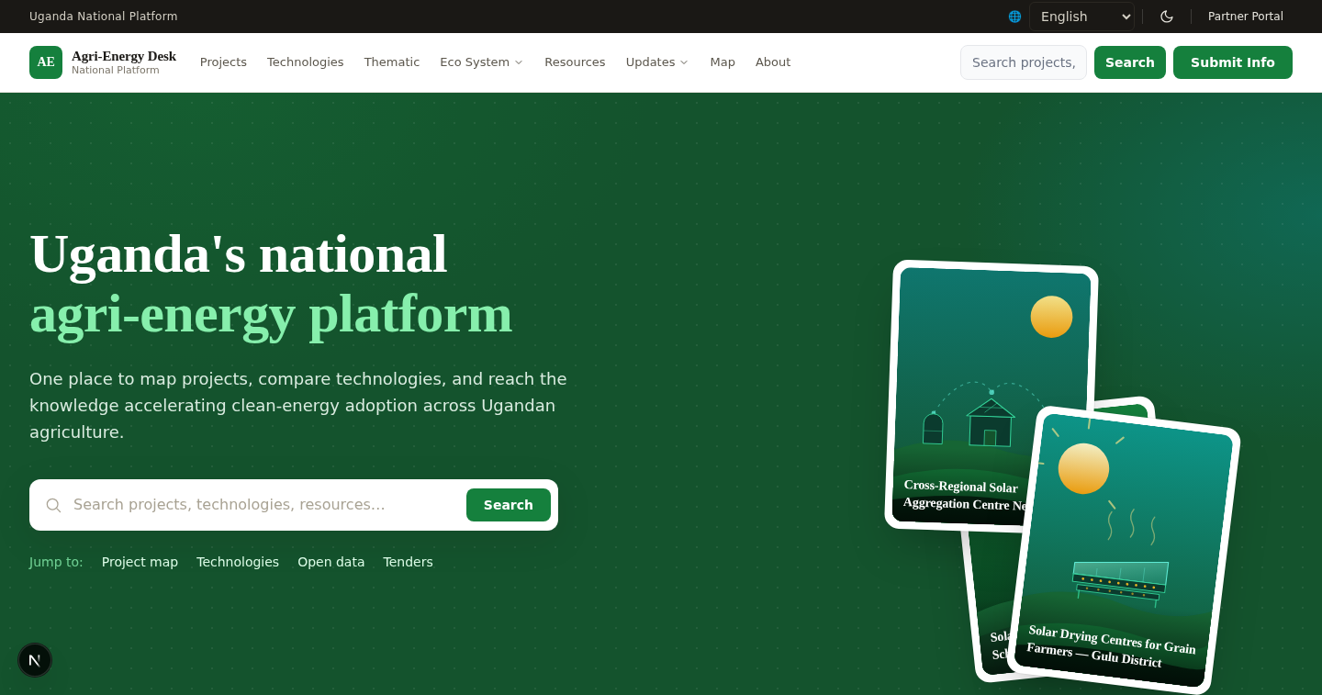
Figure 1: The public homepage, showing platform statistics, featured content and the search entry point.

4. System Requirements
- A current version of a major web browser: Chrome, Edge, Firefox or Safari. No software needs to be installed.
- An internet connection. The site is designed to remain usable on low-bandwidth mobile connections.
- A screen of any size. The public site and both portals adapt to desktop, tablet and mobile.
- For the portals, an account approved by NREP.
The interface is available in English, French and Kiswahili, with English as the default. It is designed to meet WCAG 2.1 Level AA, is operable by keyboard throughout, and provides a skip-to-content link on every page.

5. User Roles
There are nine roles. Six are platform roles held by NREP staff and individual contributors; three are organisation-scoped, meaning their powers apply only within the holder's own organisation.
Role | What you can do with content | What you can administer
Super administrator | Everything, including publishing directly | Everything, including system settings and the audit trail
Platform administrator | Everything, including publishing directly | Users, roles, taxonomy, site configuration, reports
Knowledge manager | Everything, including publishing directly | Reports and analytics. No user management
Reviewer | Nothing — a reviewer authors no content | The review queue only
Content contributor | Create and edit your own work, then submit it | Nothing
Partner | Create and edit your own work, then submit it | Nothing; partner portal only
Partner administrator | Your organisation's content | Your organisation's accounts and organisation-scoped roles
Partner knowledge manager | Your organisation's content; may endorse it to NREP | Nothing
Partner content contributor | Your organisation's content, submitted for review | Nothing

Two rules apply to everyone. You can never approve your own work — a second person must always review it. And content submitted by a contributor or a partner never publishes directly; it always passes through review.

6. Login and Authentication

6.1 Registering for an account
Registration is open to organisations and to individuals. Choose the route that matches you on the registration page.
- Open the site and choose Create account, or go to the partner portal and choose to register.
- Choose whether you are registering as an individual or as an organisation.
- Complete the steps presented. An individual gives name, email, username, telephone and a password. An organisation completes a longer profile — see Section 6.2.
- Submit. Your account is created with pending status.
- Wait for NREP to approve the account. Until it is approved you cannot sign in.
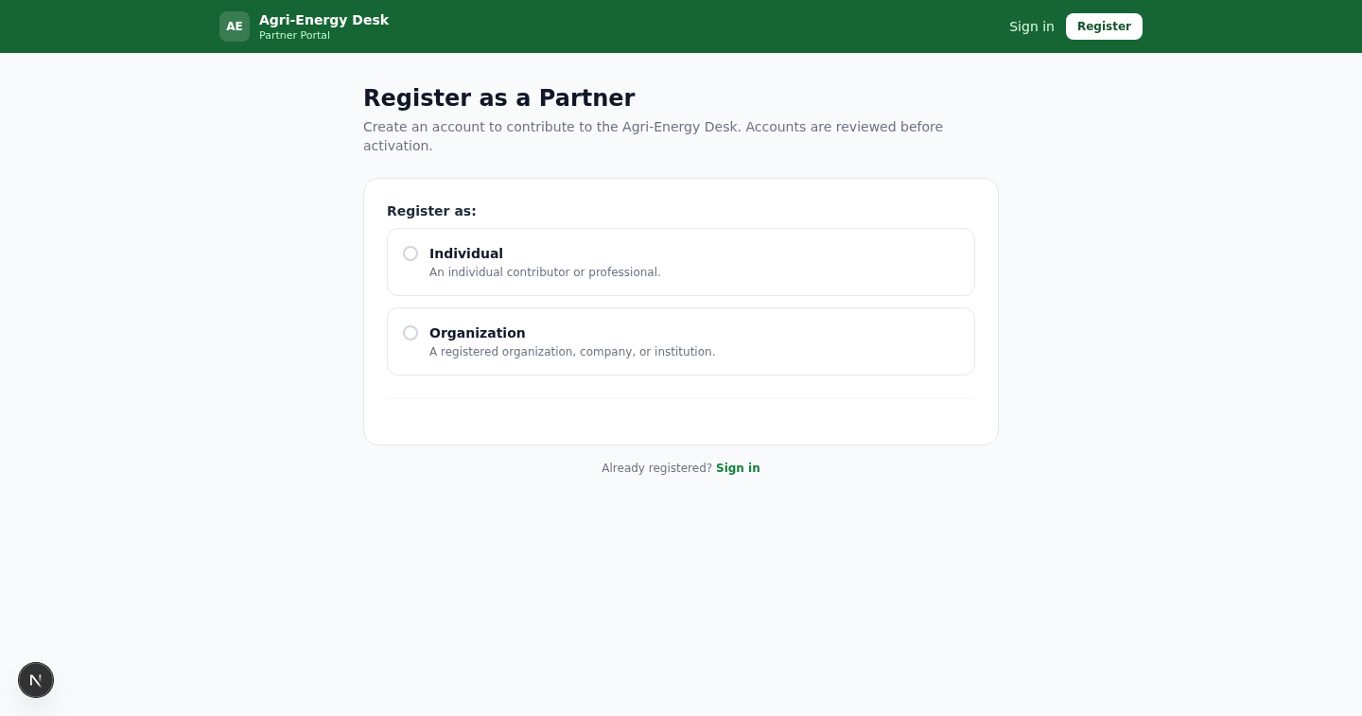
Figure 2: The registration wizard. The route shown depends on whether you register as an individual or as an organisation.

6.2 What an organisation is asked for
Organisation registration is a guided multi-step wizard. Required information includes the organisation name, registration number, tax identification number, organisation email, physical address, sector of operation, mission, a brief description, and areas of expertise.
- Areas of expertise are limited to three selections. The limit is shown on the form.
- Coverage is either National or International, and the two are mutually exclusive. Choosing National presents region and district selection, where choosing a region loads that region's districts. Choosing International presents country selection instead.
- A contact person is required: full name, position, email and telephone. The email is pre-filled from the organisation email and may be changed.
- Optional detail may be added: acronym, year established, postal address, value chains, and bands for employees, branches, beneficiaries and annual budget.
On submission the account is created as pending and a draft organisation profile is created alongside it. Neither is publicly visible until NREP approves them.

6.3 Signing in
- Go to the partner portal and choose Sign in. NREP staff use the administration portal sign-in instead.
- Enter your email address or username, and your password.
- Select Sign in.
If your account is still pending, sign-in is refused. If it has been suspended, access is removed immediately. In either case, contact NREP.
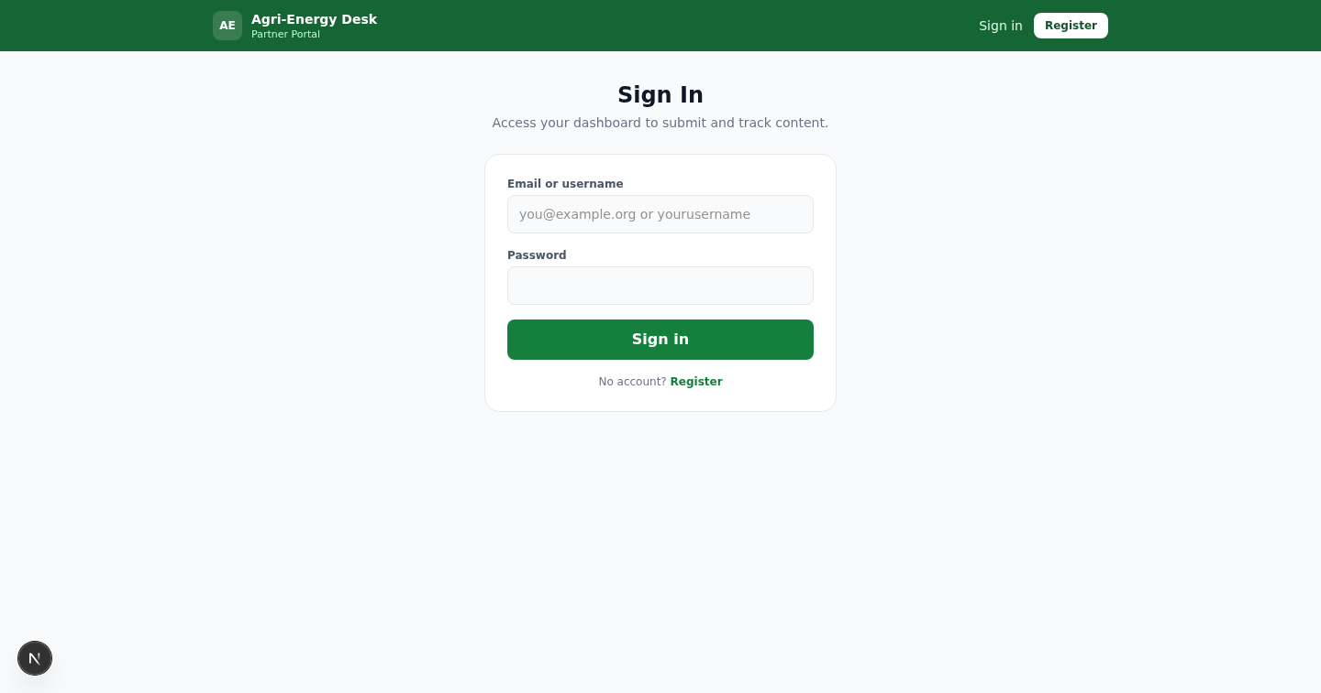
Figure 3: The partner portal sign-in page.
There is no self-service password reset at present. If you forget your password, contact NREP and an administrator will reissue your access.

7. Navigation
The public site carries one navigation bar across every page, holding Projects, Technologies, Thematic Areas, the Ecosystem menu for partners, Resources, an Updates menu for events, opportunities and news, the Map, and About. A search box sits in the header of every page. A language selector and a light or dark theme toggle sit in the strip above it.
The portals use a left-hand sidebar listing only the areas your role may reach. If you cannot see an item, your role does not hold it.

8. The Public Site

8.1 Browsing a directory
Every directory works the same way: a filter bar at the top, a count of matching records, and a grid of cards. Selecting a card opens its detail page.
- Choose the directory you want from the navigation bar.
- Narrow the list using the filters. Projects may be filtered by status, region, district, technology, theme, value chain and implementing partner.
- Select any card to open the full record.
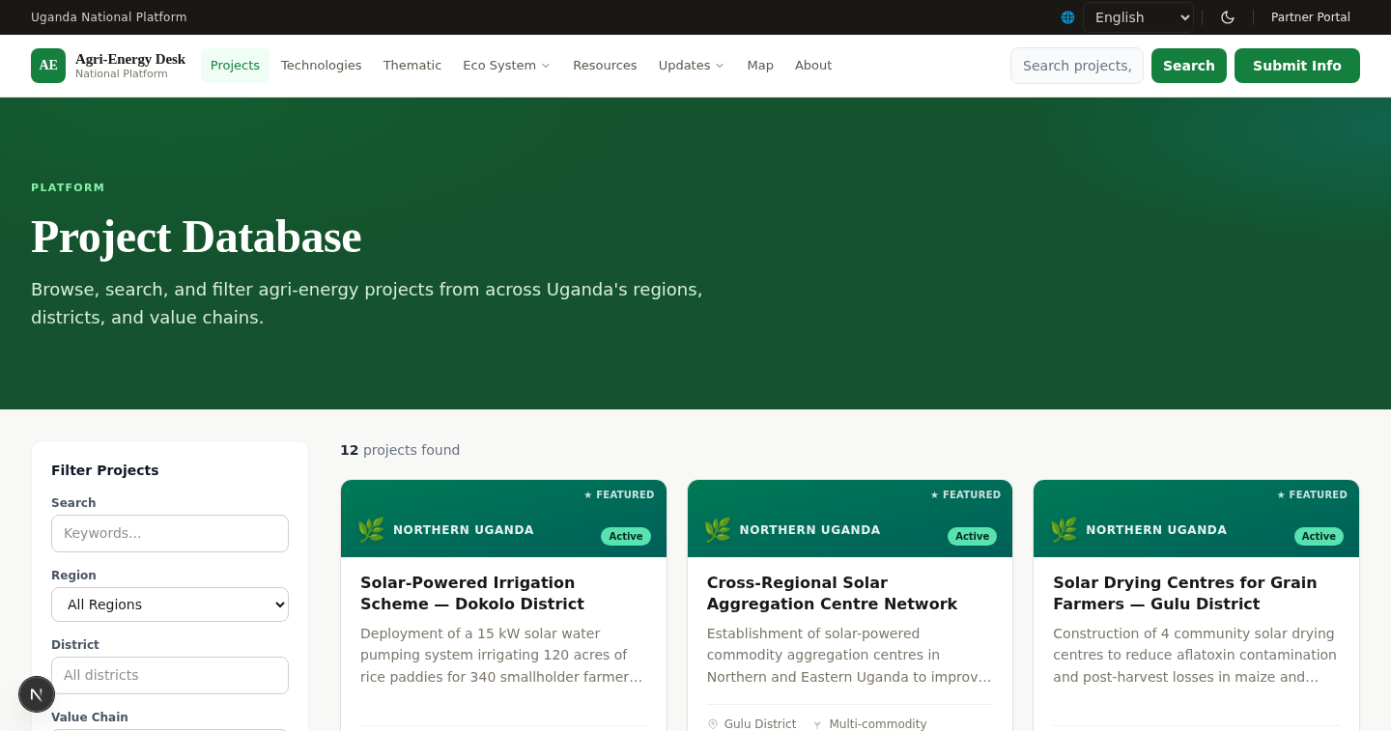
Figure 4: The project directory, with filters and matching record count.
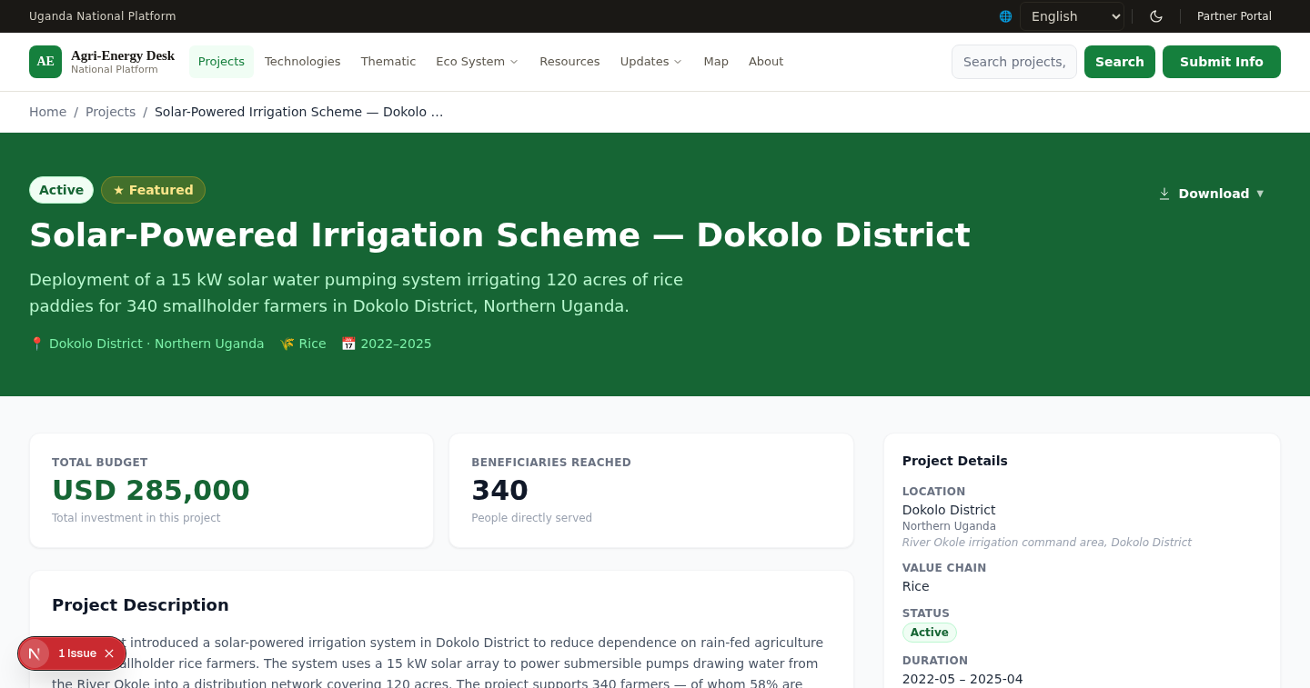
Figure 5: A project detail page, showing summary, location, timeline, budget, beneficiaries, related technologies and themes, and the download menu.

8.2 Searching
- Type into the search box in the header. Suggestions appear as you type.
- Press Enter to see full results, ranked by relevance across projects, technologies, themes, partners, resources, events, opportunities, policies and news.
- Use the counts beside each content type to narrow results to that type.
Search returns published records only. Drafts and records awaiting review never appear.
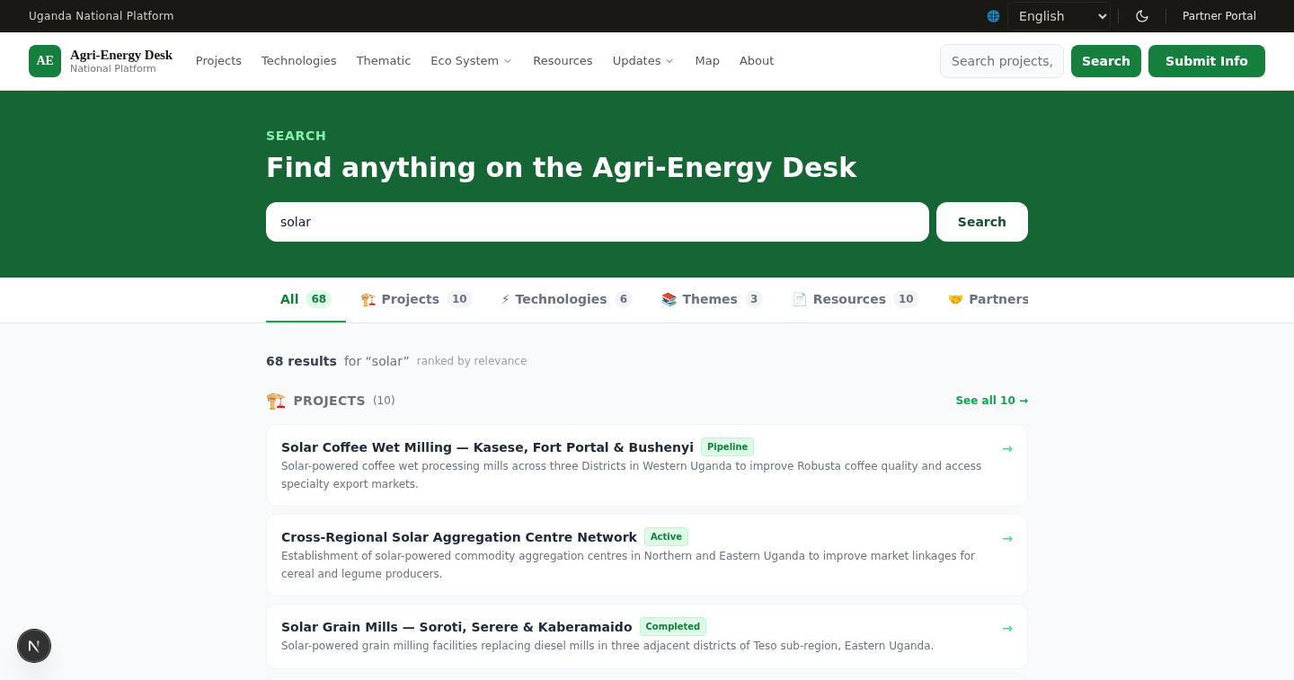
Figure 6: Search results, ranked across all content types with per-type counts.

8.3 Using the map
- Choose Map from the navigation bar.
- Filter by region, district or project status. Use the clear action to reset all filters at once.
- Select a marker to see that project's summary, with a link to its full record.
The charts beside the map respond to the filters you have applied.
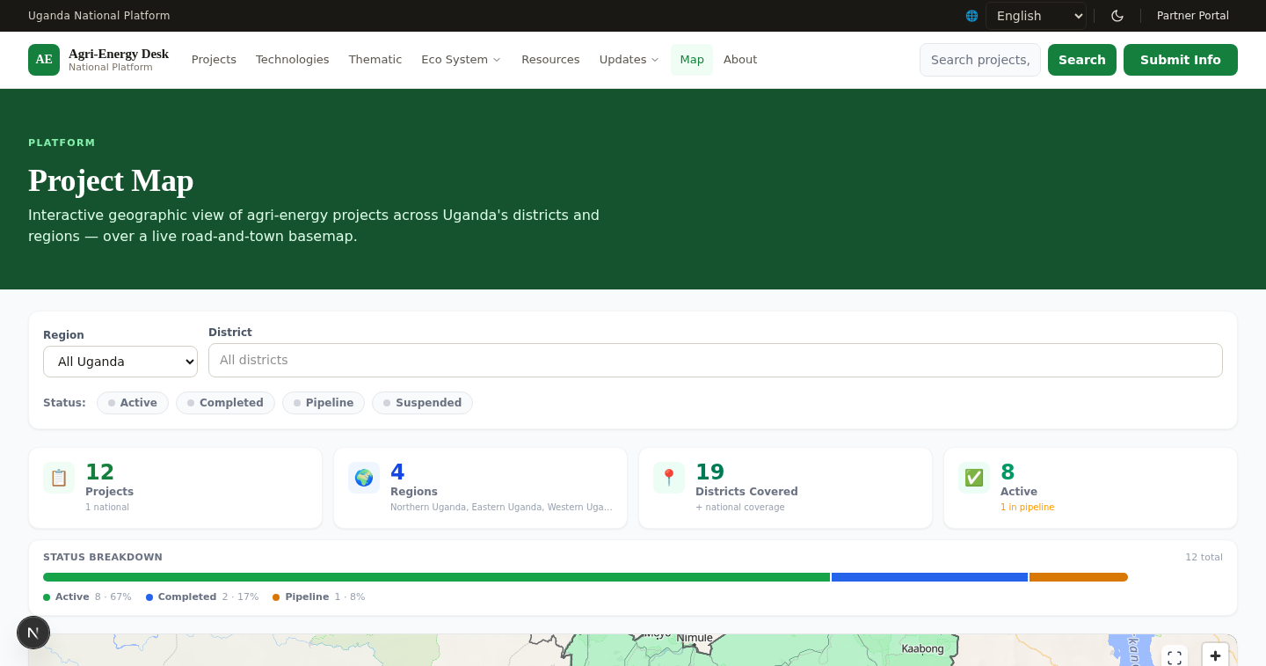
Figure 7: The project map, with regional and district views and filter-responsive charts.

8.4 Opportunities, tenders and vacancies
Opportunities are classified by type: funding or grant, investment, tender, procurement, and job or vacancy. Use the tabs to show one type.
- A vacancy shows the hiring organisation, the job summary, duties and responsibilities, minimum education, experience, competences, the application deadline, and where to send an application.
- A tender shows the issuing organisation, the details, the deadline, where to send bids, and the tender document for download.
- If a listing has a document attached, it can be downloaded from the detail page. A closed listing still shows its document, because a closed tender remains a document people need to read.
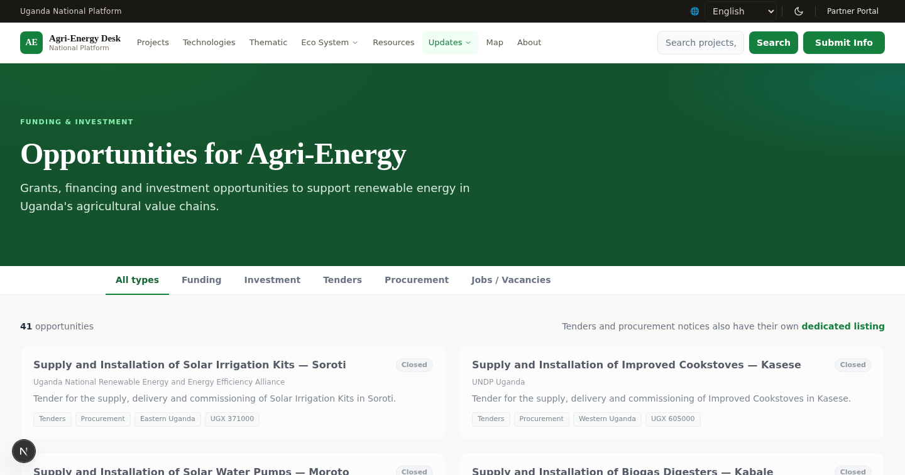
Figure 8: The opportunities listing, filtered by type.
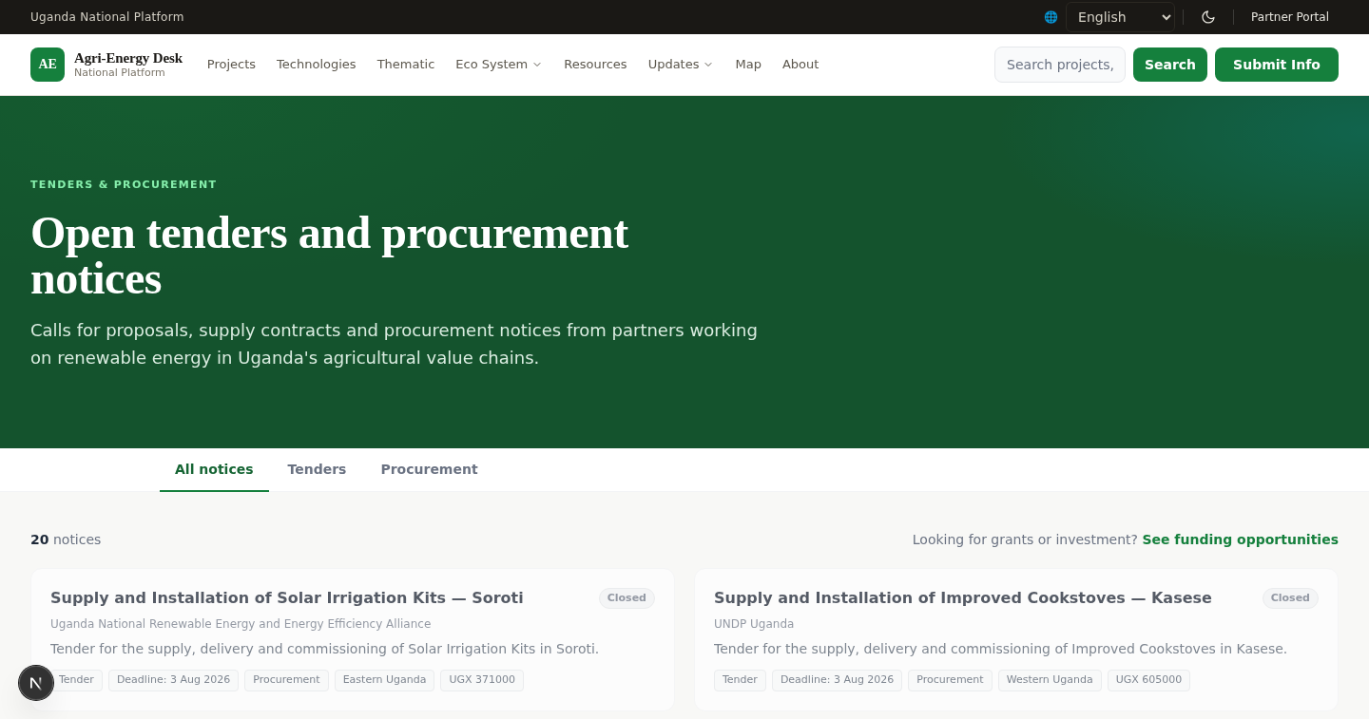
Figure 9: The dedicated tenders and procurement browser.

8.5 Resources and restricted files
Resources may carry a file, an external link, or both. Some files are marked view-only by their author: they can be read in full on the page but are not offered for download. This is enforced by the system, not merely hidden in the interface.
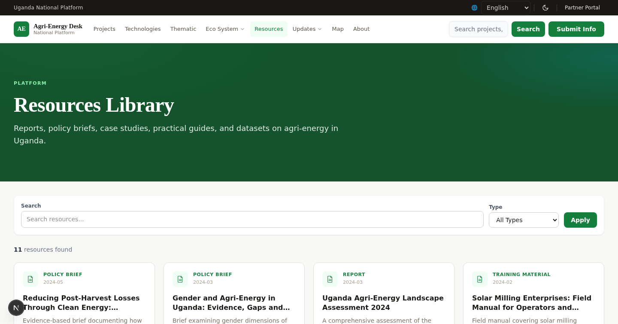
Figure 10: The resource library.

8.6 Open data
The open data area presents regional aggregates as charts and offers the published project dataset for download as CSV and GeoJSON. The public API endpoints the downloads are drawn from are listed on the same page.
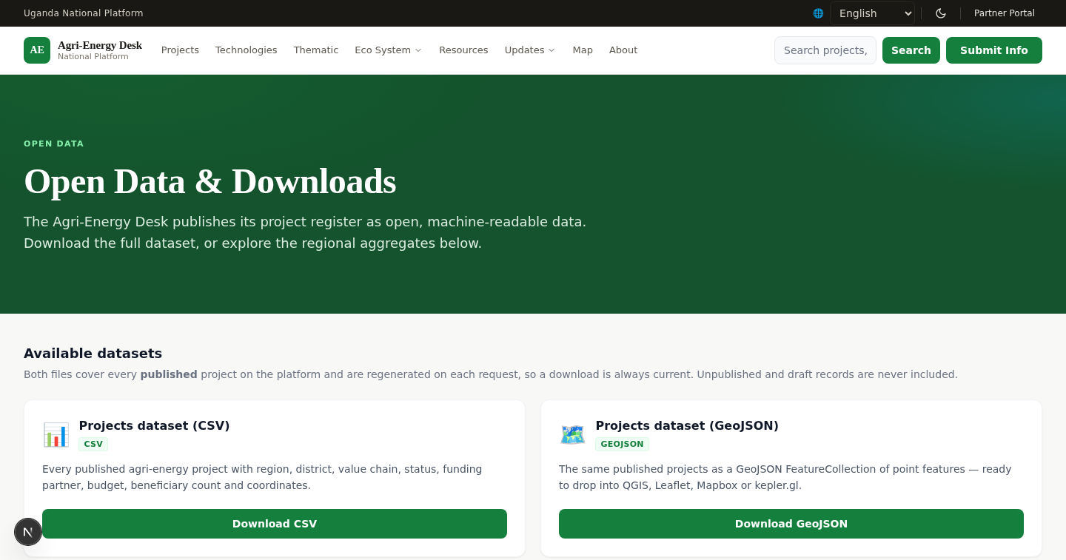
Figure 11: The open data area, with regional aggregates and machine-readable downloads.

8.7 Newsletter and contact
- To subscribe to the newsletter, enter your email on the homepage or the newsletter page. You will receive a confirmation request; the subscription is not active until you confirm it. Every issue carries a one-click unsubscribe link.
- To contact NREP or to suggest content, use the contact form. Choose the type of submission, complete the form and submit. Your message reaches NREP's enquiry inbox.

9. The Partner Portal
This section applies to partner, partner administrator, partner knowledge manager and partner content contributor roles.

9.1 The dashboard
The dashboard lists everything you — or, if you hold an organisation-scoped role, your organisation — have submitted, with its current status in plain words.
Status shown | What it means | What to do
draft | Saved but not submitted | Open it and submit when ready
with your organisation | Awaiting sign-off by your own organisation | Your partner administrator or knowledge manager must endorse it
with NREP | Submitted and awaiting NREP review | Nothing; wait for the outcome
in review | A reviewer is considering it | Nothing
published | Live on the public site | Nothing
needs changes | Returned to you with reviewer notes | Read the notes, revise and resubmit
archived | Withdrawn from public view | Contact NREP if this was unexpected

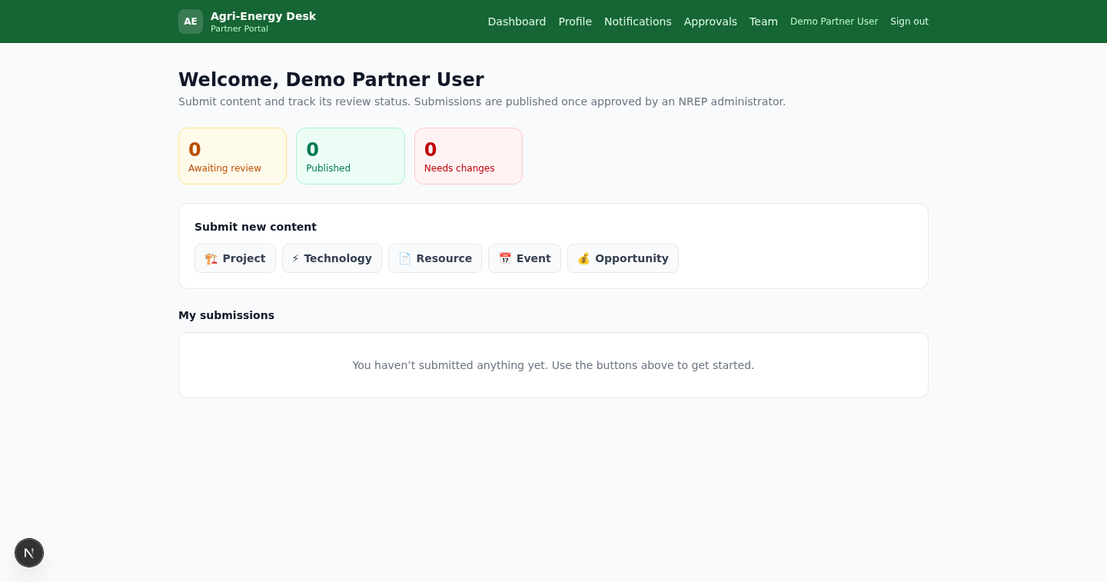
Figure 12: The partner portal dashboard, showing submissions and their workflow status.

9.2 Submitting content
Partners may submit projects, technologies, resources, events and opportunities.
- From the dashboard, choose the type of content you want to submit.
- Complete the form. Required fields are marked with an asterisk.
- For long-form fields the editor provides bold, italic, underline, lists, links and quotes.
- Attach images or documents where the form offers an upload.
- Choose Submit for review.
Your submission is always created as pending and unpublished, whatever the form appears to offer. It cannot publish directly.
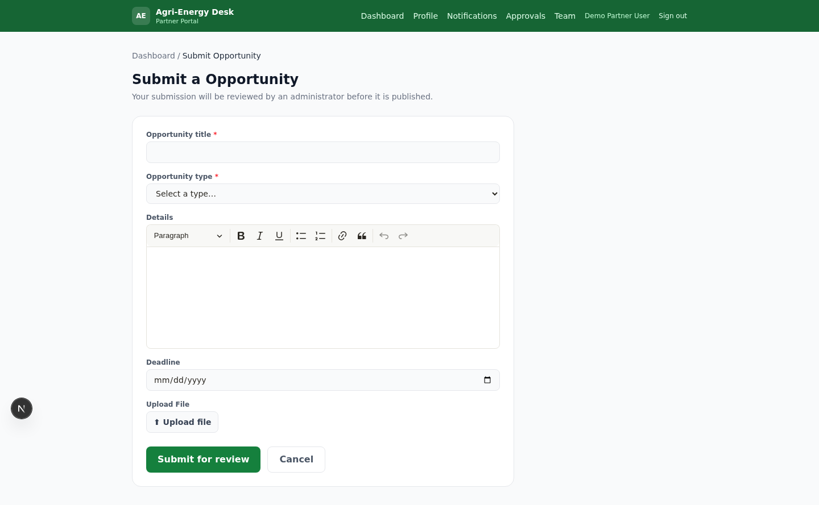
Figure 13: The partner submission form. The fields shown change with the content type — here, an opportunity.
The opportunity form adapts to the type you choose. Selecting Job / Vacancy presents organisation, job title, job summary, duties and responsibilities, minimum education, experience, competences, the application deadline, where to send applications, and a job description upload. Selecting Tender presents the issuing organisation, details, deadline, where to send bids and the tender document.

9.3 Approving your organisation's content
This applies to partner administrators and partner knowledge managers only.
- Choose Approvals from the portal navigation.
- Review each item listed. Expand a row to read the record in full.
- Choose Endorse to send it to NREP, or Return with notes to send it back to its author.
You cannot endorse a record you wrote yourself; those rows are marked as your own. A second person in your organisation must handle them.

9.4 Managing your organisation's team
This applies to partner administrators only.
- Choose Team from the portal navigation.
- To add a colleague, create an account with their name and email and choose their role.
- To remove access, suspend the account. Suspension takes effect immediately and can be reversed.
You may assign only the three organisation-scoped roles. Platform-wide roles are not available to you, and you cannot see or act on accounts belonging to another organisation.

9.5 Your organisation profile
Choose Profile to edit the directory record for your organisation. If the profile is already published, your edit is queued for NREP review and the published version stays live until the change is approved.

9.6 Notifications
The notifications inbox tells you when your submissions are published or returned, and when a record naming your organisation goes live. An unread count appears beside the menu item. Mark items read individually or all at once.
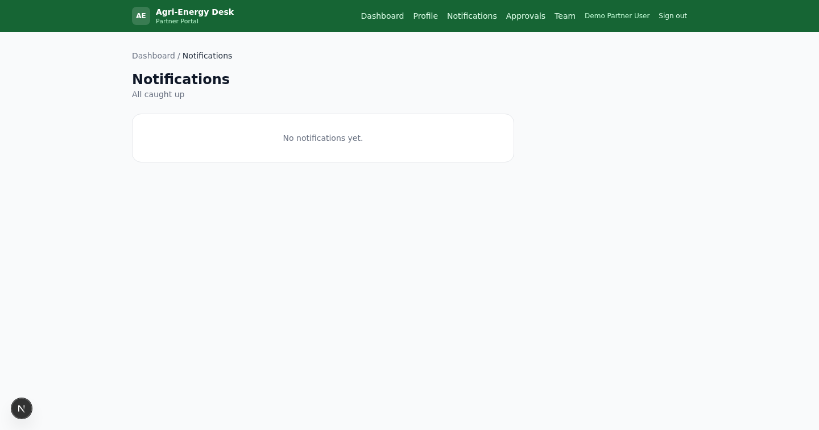
Figure 14: The partner notifications inbox.

10. The Administration Portal
This section applies to NREP staff. Which items you see in the sidebar depends on your role.
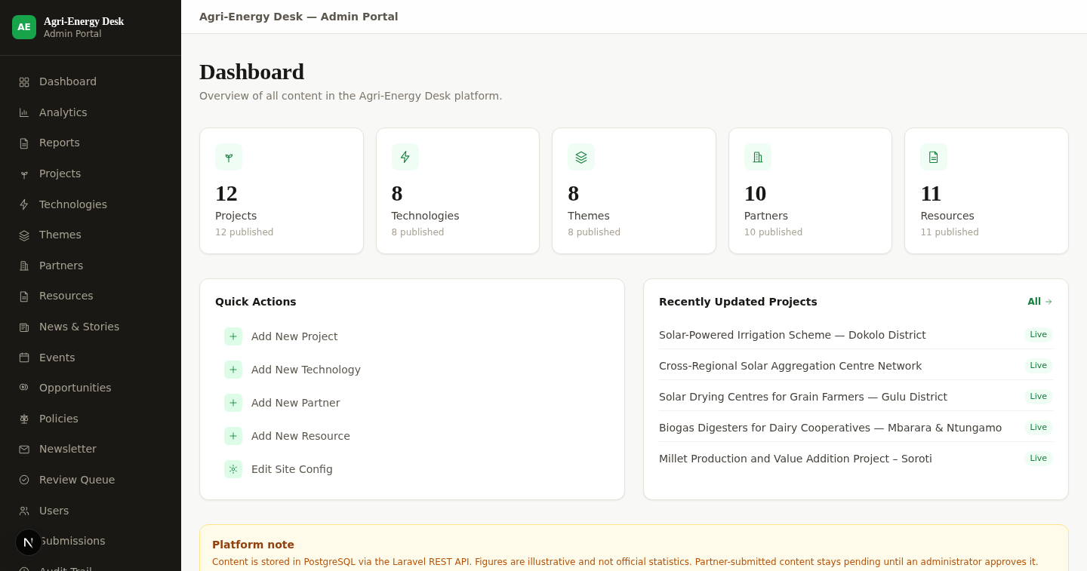
Figure 15: The administration dashboard, showing content counts, recent activity and quick actions.

10.1 Creating and editing records
- Choose the content type from the sidebar.
- Choose New to create a record, or select an existing row to edit it.
- Complete the form. Fields appear and change label according to the record type where that is relevant.
- Use Published and Featured in the sidebar to control visibility and prominence.
- Choose Save.
If you edit a record that is already published, your change is stored as a pending revision and the live record is untouched until the revision is approved. This is deliberate: the public version never disappears while an edit is being considered.
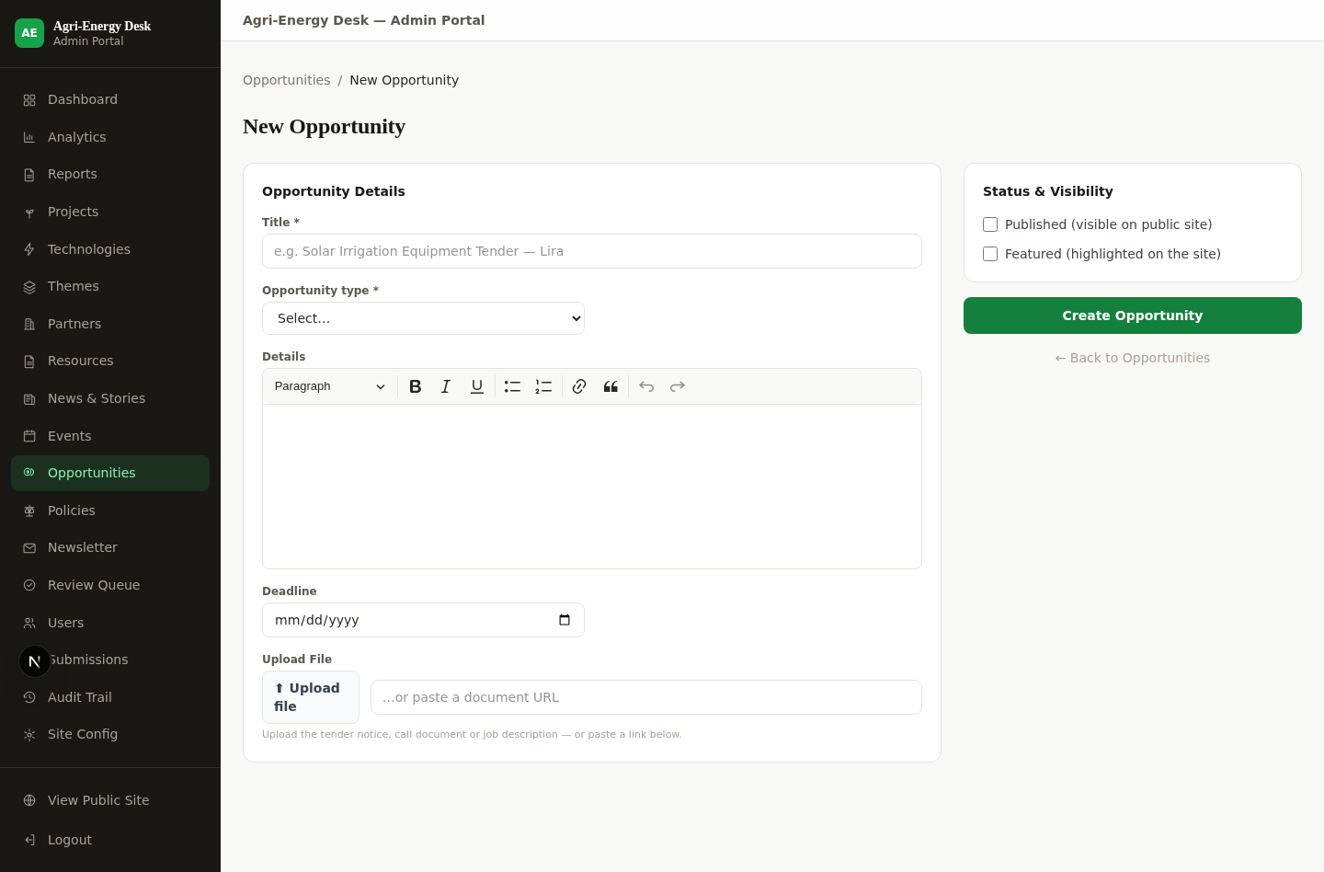
Figure 16: A content editing form. Long-form fields use a rich-text editor; fields shown depend on the record type.
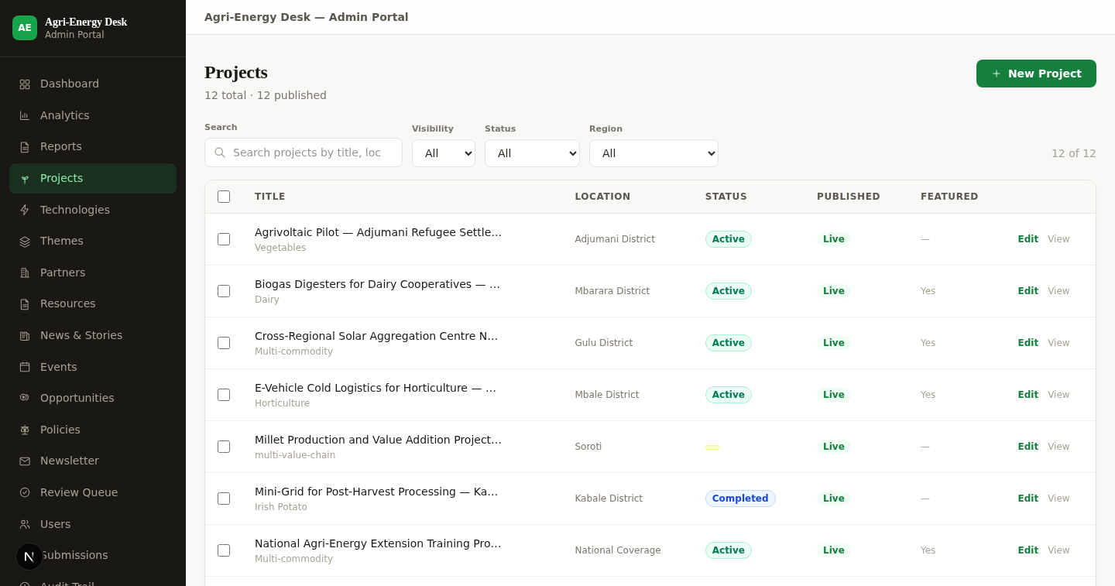
Figure 17: A content list, with filters, record count and bulk actions.

10.2 Searching and filtering lists
Every administration list offers free-text search, filters on the attributes that matter for that type, and a count of matching records. Filters can be cleared in one action.
Bulk actions are available from the list: publish, unpublish and delete. Each record affected is written individually to the audit trail.
Deletion is permanent. The platform does not keep deleted records, so a deletion can only be recovered from a database backup. Take particular care with bulk delete.

10.3 The review queue
This applies to reviewers, knowledge managers and administrators.
- Choose Review Queue from the sidebar.
- The queue lists everything awaiting review across all content types, showing type, author and submission date. Two kinds of row appear: new submissions, and revisions to records that are already live.
- Expand a row to read it. A submission shows the full record; a revision shows a field-by-field comparison of what would change.
- Choose Approve to publish, or Reject and record your reasons. Rejection returns the record to its author with your notes.
You cannot review a record you authored. Approving a revision applies both its fields and its relationships to the live record.
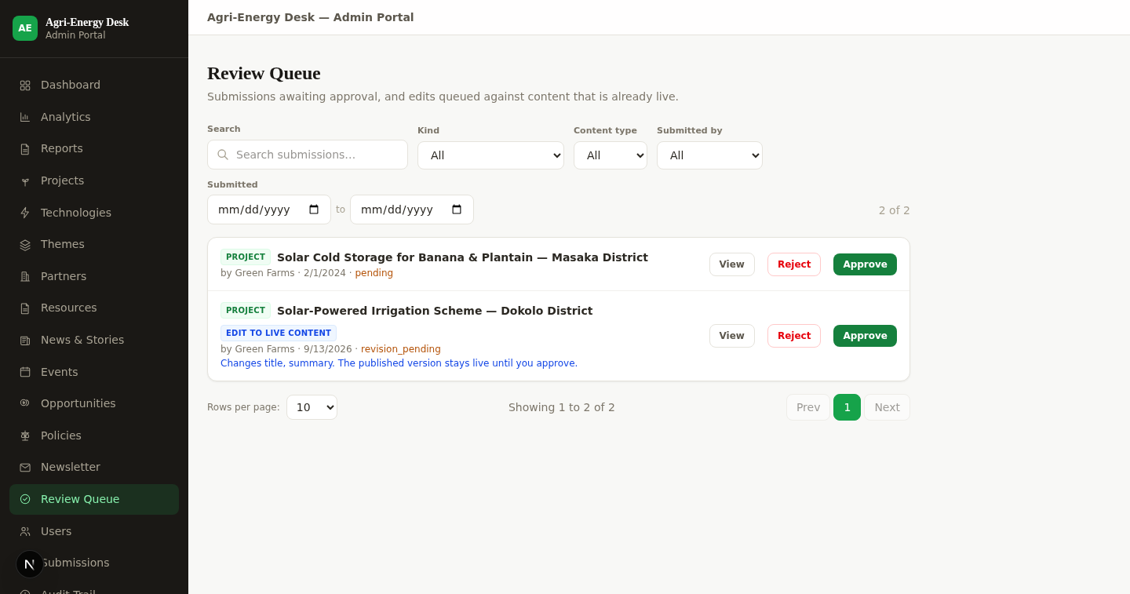
Figure 18: The review queue, listing submissions and revisions awaiting a decision.

10.4 Managing users
This applies to platform administrators and super administrators.
- Choose Users from the sidebar.
- To approve a pending registration, find the account and choose Approve. The applicant can then sign in.
- To create a staff account directly, use the new user form and assign a role.
- To remove access, choose Suspend. This takes effect immediately and can be reversed.
- To change what someone may do, adjust their role assignment.
Only a super administrator may grant the super administrator role, or change the roles of an account that already holds it.
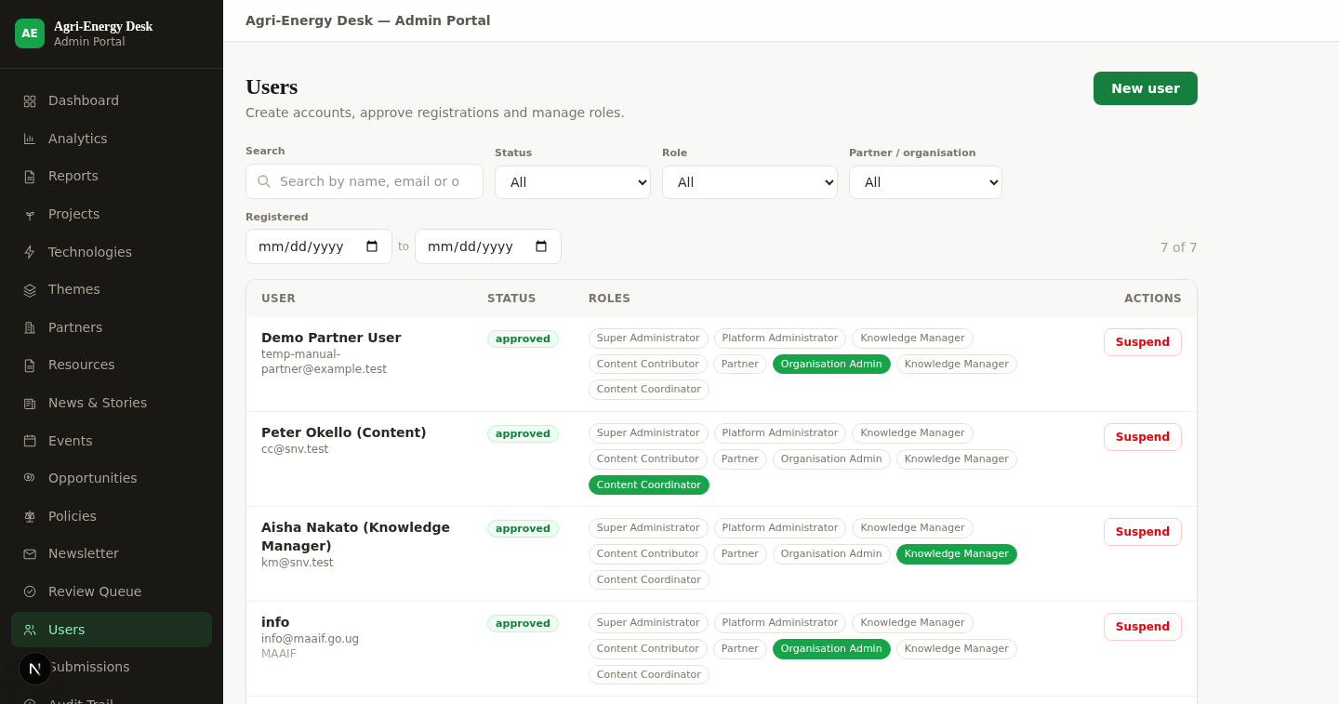
Figure 19: User management, showing account status, roles and pending registrations.

10.5 The enquiry inbox
- Choose Submissions from the sidebar. Unread enquiries are counted beside the menu item.
- Select an enquiry to read it in full.
- Record internal notes and set the status: new, read, responded or archived.
Note that the system does not currently send an automatic acknowledgement to the person who wrote in. Replies must be sent by email in the normal way.
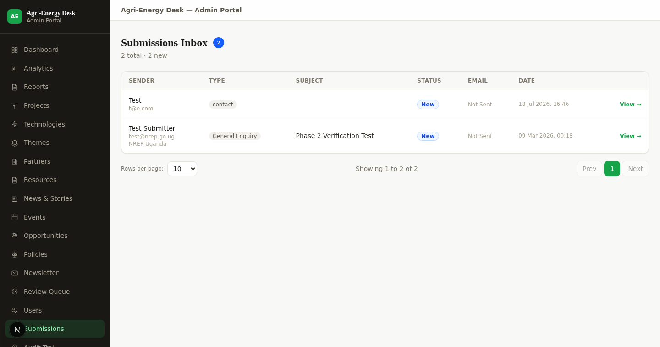
Figure 20: The enquiry inbox.

10.6 Newsletter subscribers
Choose Newsletter to see the subscriber list with confirmed, pending and unsubscribed counts. The Export CSV action downloads the confirmed and active subscribers only.
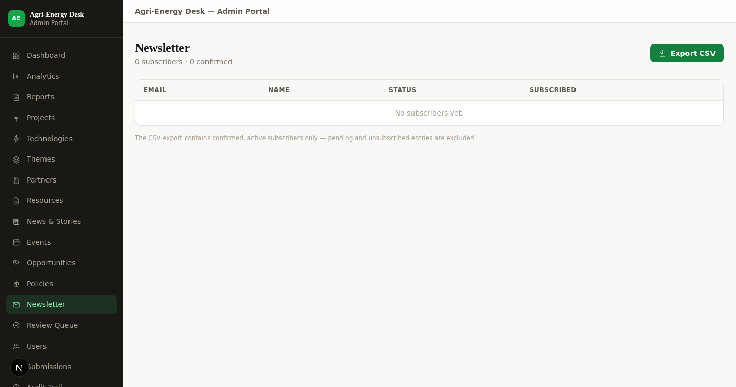
Figure 21: Newsletter subscriber management.

11. Reports and Dashboards

11.1 Analytics
The analytics dashboard summarises content by type and workflow state, projects by region and status, submissions by status, content by theme, and user totals. Each dataset can be downloaded as CSV.
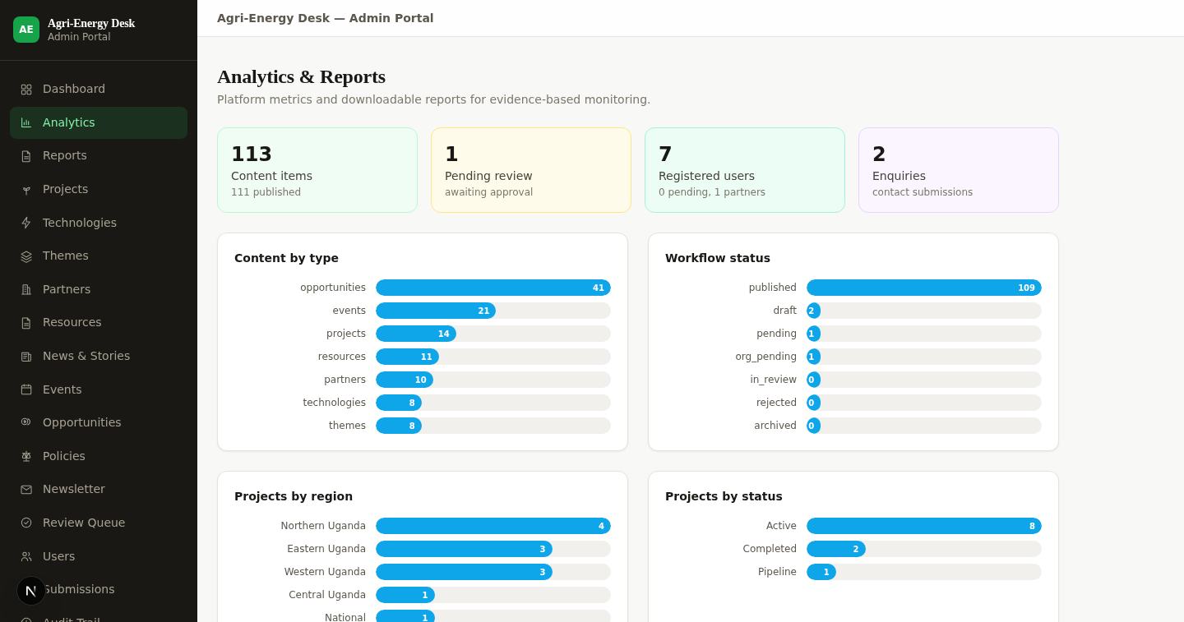
Figure 22: The analytics dashboard.

11.2 Reports
Eight period-scoped reports are available: platform overview, content inventory, content growth and trends, content utilisation, user engagement, project portfolio, stakeholder directory, and opportunities and events.
- Choose Reports from the sidebar.
- Select the report and set the period. The default period is the last twelve months.
- Review the report on screen. The address bar updates, so a report for a given period can be shared as a link.
- Download as PDF for circulation or Excel for analysis.
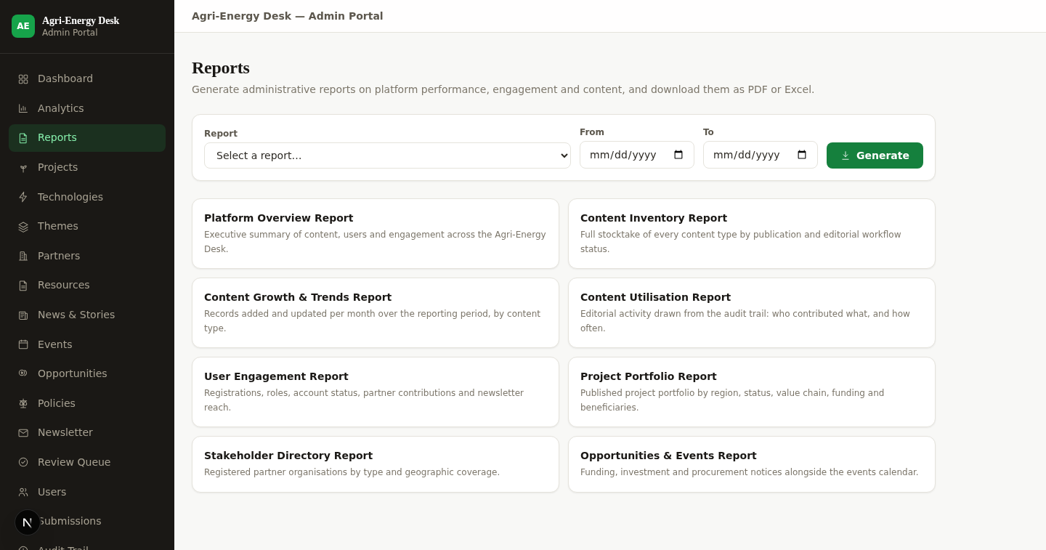
Figure 23: The reporting module, with period selection and PDF and Excel export.
One caution when using these reports externally. The Content Utilisation report measures editorial activity on the platform, not public readership. The platform does not currently record page views, downloads or search terms, so no report can state how many people used the site or what they read.

11.3 Audit trail
The audit trail records every content and user-management action with the actor, the action, the affected record and the time. Expand any entry to see what changed. It is restricted to the super administrator.
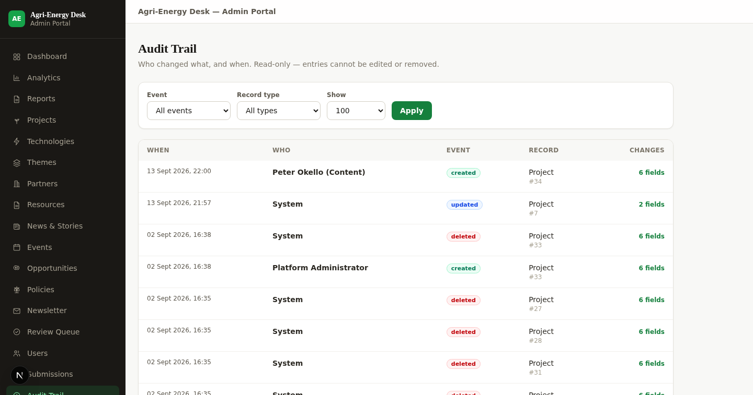
Figure 24: The audit trail, with filters and expandable before-and-after detail.

12. Administration Functions
Function | Where | Who
Content management for all nine types | Sidebar, per content type | Content managers; contributors for their own work
Review queue | Review Queue | Reviewers and above
User management | Users | Platform and super administrators
Enquiry inbox | Submissions | Content managers
Newsletter subscribers | Newsletter | Content managers
Analytics and reports | Analytics, Reports | Knowledge managers and above
Audit trail | Audit Trail | Super administrator only
Site configuration | Site Config | Currently view-only — see Section 15
Taxonomy management | Not available in the interface — see Section 15 | —

13. Data Management Guidance
- Use the controlled lists wherever one is offered. Free text where a list exists is the most common cause of a record not appearing under the filter someone used to look for it.
- Write the summary for a reader scanning a list of cards; it is what appears there and in search results.
- Set a deadline on every opportunity. Listings order by deadline and mark closed items automatically.
- Keep project status current. A knowledge platform loses credibility through stale records faster than through missing ones.
- Attach the source document where one exists, rather than summarising it and discarding it.

14. Error Handling and Common Problems
What you see | What it means | What to do
Sign-in is refused although the password is right | The account is pending approval, or has been suspended | Contact NREP. A pending account cannot sign in until approved
A menu item you expected is missing | Your role does not hold that function | Check Section 5. If you need the function, ask NREP to adjust your role
Your submission does not appear on the public site | It is awaiting organisation sign-off or NREP review | Check its status on your dashboard
A record came back marked "needs changes" | A reviewer returned it | Read the reviewer's notes on the record, revise and resubmit
An edit to a published record has not appeared publicly | Edits to published records queue for review; the live version stays up meanwhile | Wait for the revision to be approved
A page shows no records at all | Either nothing matches your filters, or the connection to the platform failed | Clear the filters. If it is still empty, reload; if it persists, contact NREP
A file will not download | The author marked it view-only | Read it on the page. It is not available as a download by design
You did not receive an expected email | Email delivery is not yet configured on the platform | Check your notifications inbox in the portal, which is not affected
An upload is refused | The file type is not permitted, or it is too large | Use PDF, Office, CSV, text or a standard image format

15. Known Limitations
The following are current limitations of the platform. They are stated here so that users do not spend time looking for functions that are not present.
- There is no self-service password reset. An administrator must reissue access.
- Email is not yet delivered. Address verification, newsletter confirmations, publication notices and rejection notices are all generated but do not reach recipients until NREP configures a mail relay. In-portal notifications are unaffected.
- The site configuration screen is view-only. Hero content, headline statistics and featured selections cannot presently be changed through the interface.
- There is no taxonomy management screen. Controlled lists cannot be edited through the interface.
- Search can be narrowed by content type but not yet by theme, technology, organisation or location.
- Enquiries do not trigger an automatic acknowledgement to the sender.
- The platform does not record page views, downloads or search terms, so reports cannot describe public usage.
- Deleted records cannot be restored from within the platform.
- Policies are managed and held by the platform but are not yet published as a public section.
- All content presently in the system is demonstration data and does not represent real programmes.

16. Security Best Practice
- Use a password you use nowhere else, and do not share it. Accounts are individual; shared accounts destroy the audit trail's usefulness.
- Sign out when you finish, particularly on a shared device. Signing out revokes your access token.
- Ask for the narrowest role that lets you do your work.
- Treat anything you publish as public and permanent — it is a national platform, and published pages are indexed and downloaded.
- Do not put personal data about third parties into content records. Contact details belong in the designated contact fields.
- Tell NREP immediately if you think an account has been compromised, so it can be suspended.

17. Logging Out
Choose Sign out from the portal navigation. This revokes the access token issued when you signed in; simply closing the browser does not. Always sign out on a shared or public computer.

18. Frequently Asked Questions
Question | Answer
Do I need an account to read the site? | No. The whole public site is open, including open data downloads.
How long does account approval take? | NREP approves registrations manually. The service standard is a matter for NREP; contact them if an application is waiting longer than you expect.
Why can I not publish my own submission? | Contributor and partner content always passes through review. Nobody publishes their own work without a second person.
Who reviews my submission? | If you belong to an organisation, your organisation endorses it first, then NREP reviews it. Individual contributors go straight to NREP.
Can I edit something after it is published? | Yes. Your edit is queued as a revision and the published version stays live until the change is approved.
Can I delete my own published record? | No. Authors may delete their own work only while it is unpublished. Ask NREP.
Why can I not find a record I know exists? | Search and directories return published records only. If it is still in review it will not appear.
Can I get the data in bulk? | Yes. The open data area offers the project dataset as CSV and GeoJSON, and the public API is documented.
Is the site available in other languages? | Yes — English, French and Kiswahili. The French and Kiswahili translations are awaiting native-speaker review.
Can I use the site on a phone? | Yes. It is designed for mobile and low-bandwidth connections.

19. Support and Escalation
Issue | Contact | Escalate to
Account approval, suspension or password reset | NREP platform administrator | NREP super administrator
A submission awaiting review longer than expected | Your NREP content contact | NREP knowledge manager
Incorrect or out-of-date published content | NREP knowledge manager | NREP content owner
A suspected security problem | NREP super administrator, immediately | NREP secretariat
A fault or error in the system | NREP technical contact | The platform's technical support provider
An accessibility barrier | As directed on the accessibility statement page | NREP secretariat

Named individuals and contact addresses are not recorded in this manual because they are for NREP to assign. NREP should complete this section with current names before the manual is issued to users.

20. Source Notes
This manual describes the platform as it stood on 29 September 2026. All screenshots were captured from the running system on that date and show demonstration content, not real programme data.
Instructions were verified against the application source, including the role definitions, the content policy and the workflow controller, so that the permissions described match those the system enforces rather than those the interface merely displays.

