# Lab Tasks Time: 2:00 Hrs.

**NOTE:** Only use CMP instruction for making all of the following programs.

1. Translate the following C++ like code into Assembly Language.

int a,b,c,d,eq,ls,gr,count;

a = 16;

b = 32;

c = 64;

d = 64;

e = a + b;

if(e==d && e>0)

eq = 1;

else if(e>d && e!=0)

eq = 0;

else if(e>d || e>10)

gr = 1;

else

gr = 0;

if(e<d)

ls = 1;

else

ls = 0;

while(e!=d)

{

Count++;

}

Cout<<”e is ”<<count<<”times less than d”<<endl;

1. Write an assembly program which will be executed for **(i=2)** two points x1,y1 and x2,y2. You have to compute the following distance formulas in separate procedures.

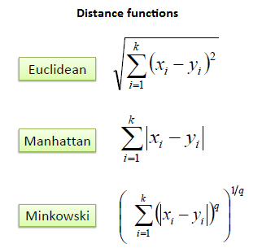

1. Implement a procedure for CGPA GRADE calculator of Fast-Nuces i.e.

A+ is for marks >= 90, A is for marks>=86, A is for marks>= 82 and so on up to 50.

1. Given a string **“fast nuces has changed policy for midterm exams 2018”** your task is to convert this string in to upper case and find the frequency of all VOWELS?
2. Define a procedure **Maximum** having five integer parameters that will return maximum value?