1. INSERT data in each of the tables

a. Add a couple of employees and a couple of departments.

→ INSERT INTO employees(emp_no, birth_date, first_name,last_name, gender,hire_date) VALUES(0001, '1990-01-01', 'jawad', 'ali', 'M', '2018-01-01');

→ INSERT INTO employees(emp_no, birth_date, first_name,last_name, gender,hire_date) VALUES(0002, '1995-01-01', 'qumar', 'husnain', 'M', '2017-01-01');

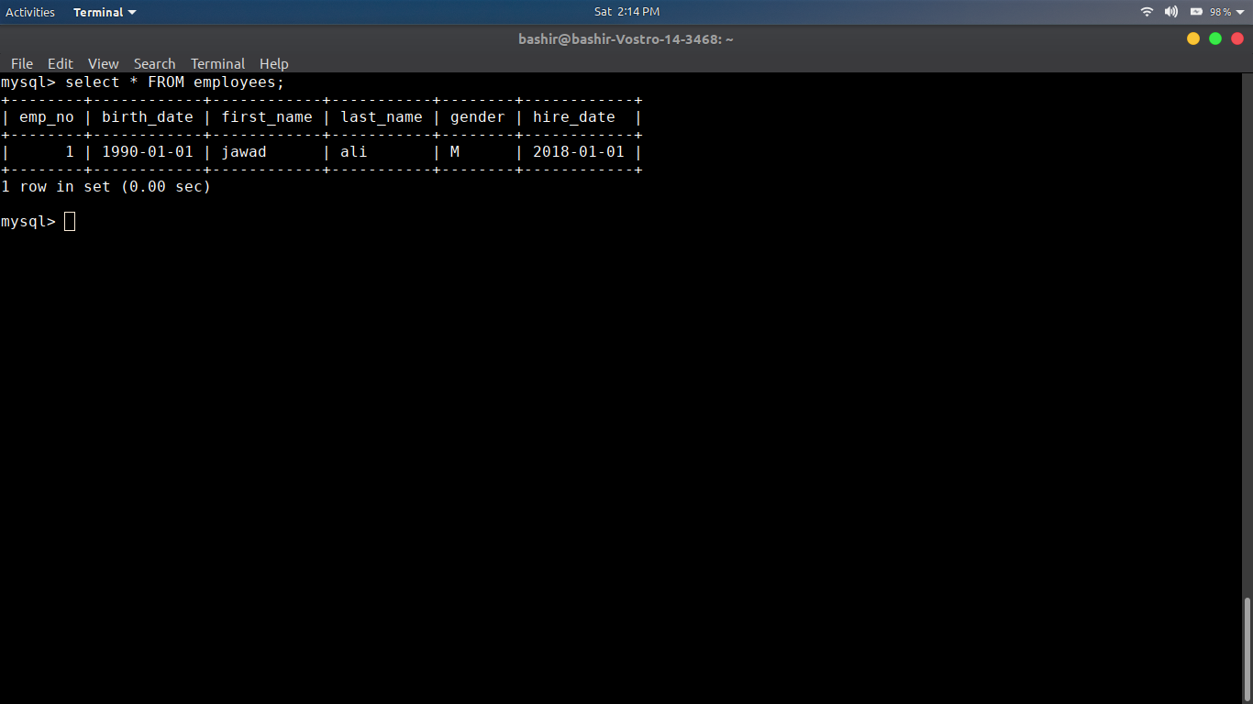

→ INSERT INTO departments(dept_no , dept_name) VALUES('1001','Computer Science');

→ INSERT INTO departments(dept_no , dept_name) VALUES('1002','Electrical Eng');

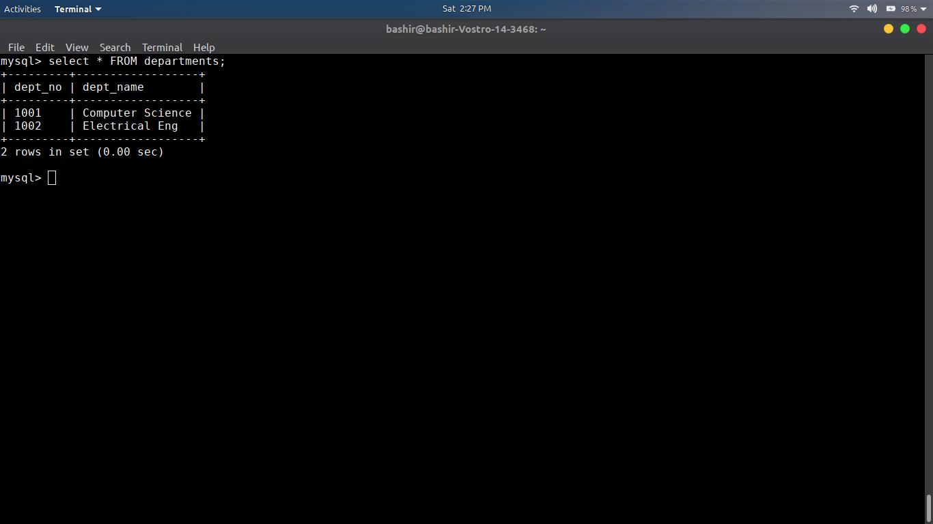

b. Add an existing employee in a department by inserting data into the dept_emp table.

→ INSERT INTO dept_emp(emp_no, dept_no, from_date, to_date) VALUES(1,1001,'2005-01-01', '2010-01-01');

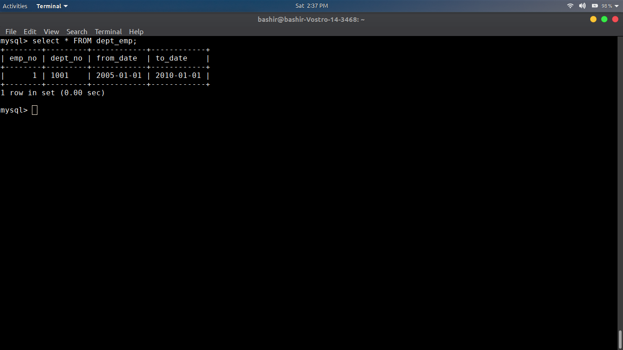

c. Add salaries for the added employees.
→ INSERT INTO salaries(emp_no, salary, from_date, to_date) VALUES(1, 10000, '2005-01-01', '2010-01-01');
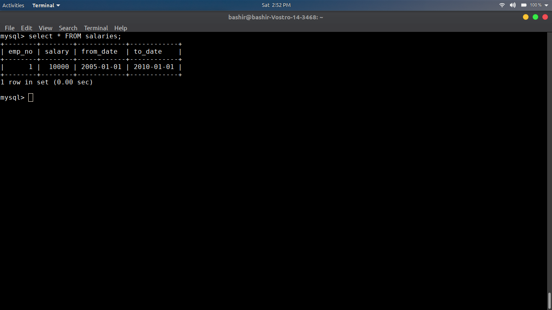
d. Add employee titles and managers of the departments
→ INSERT INTO titles(emp_no, title, from_date, to_date) VALUES(1, 'lab instructor', '2005-01-01', '2010-10-01');
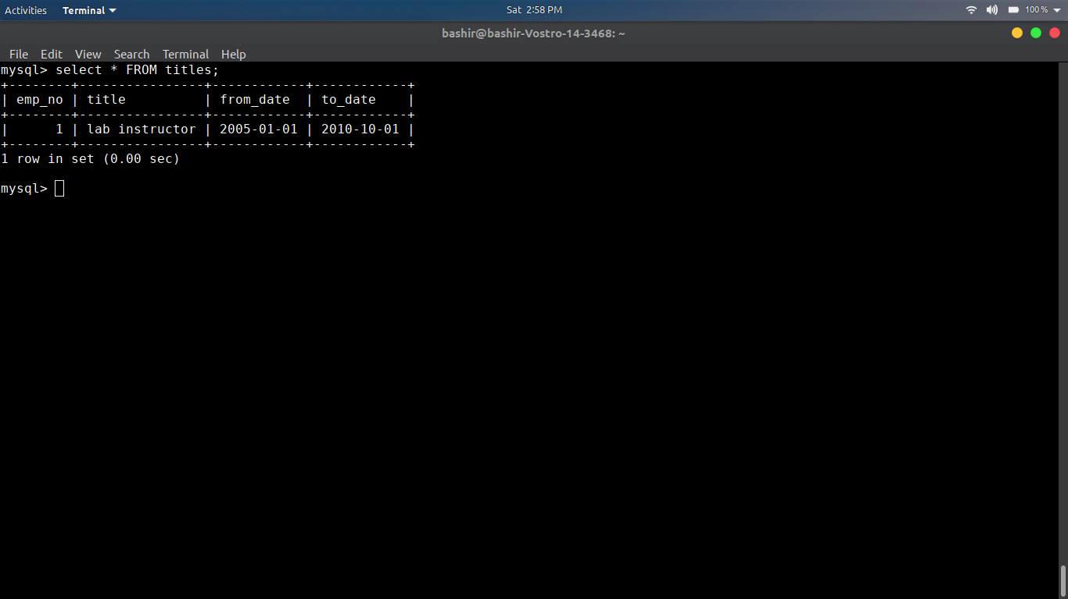

2. UPDATE a number of records. For Example:
a. Change department of an employee.
→ UPDATE dept_emp SET dept_no = '1002' WHERE emp_no = 1;
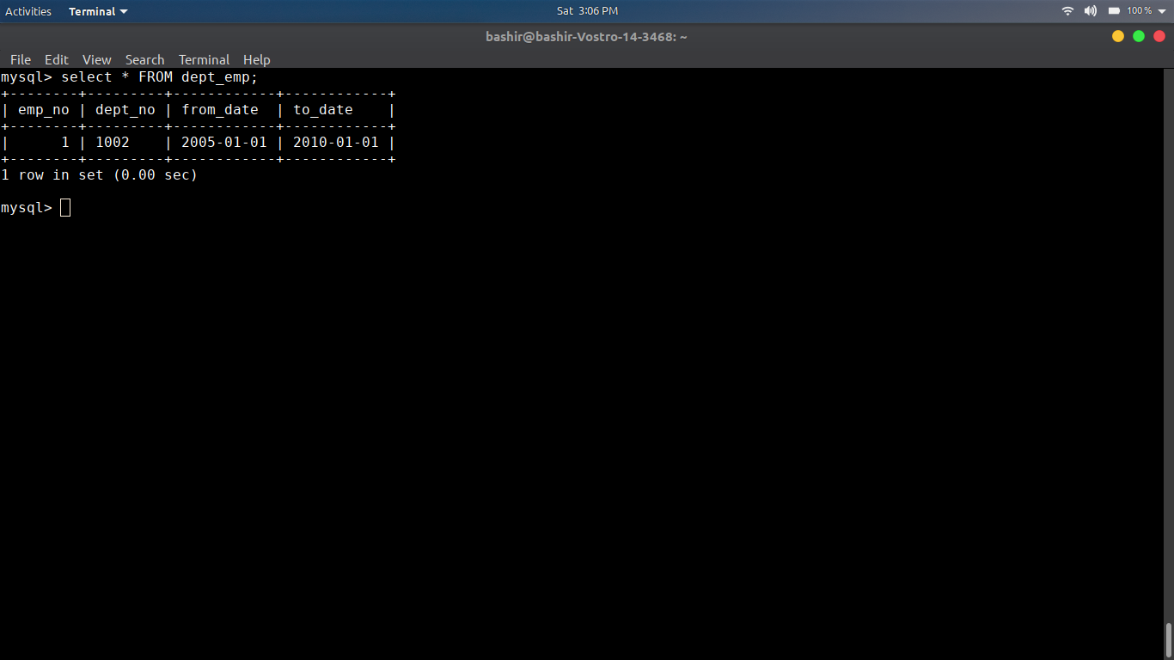

b. Update an employees’ salary.
→ UPDATE salaries SET salary = 20000 WHERE emp_no = 1;
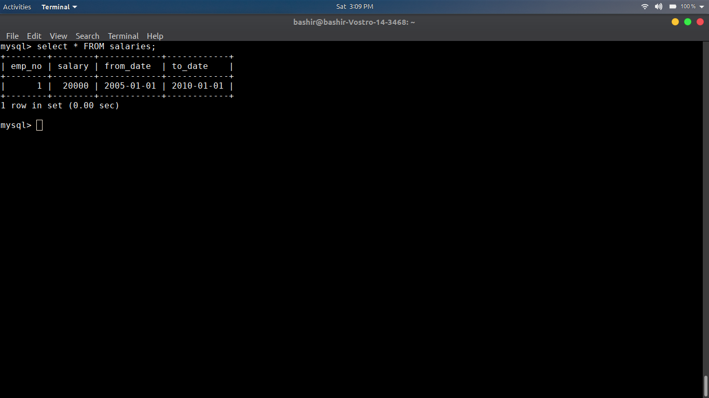

c. Change the name of a department.

→ UPDATE titles SET title = 'class Incharg' WHERE emp_no = 1;
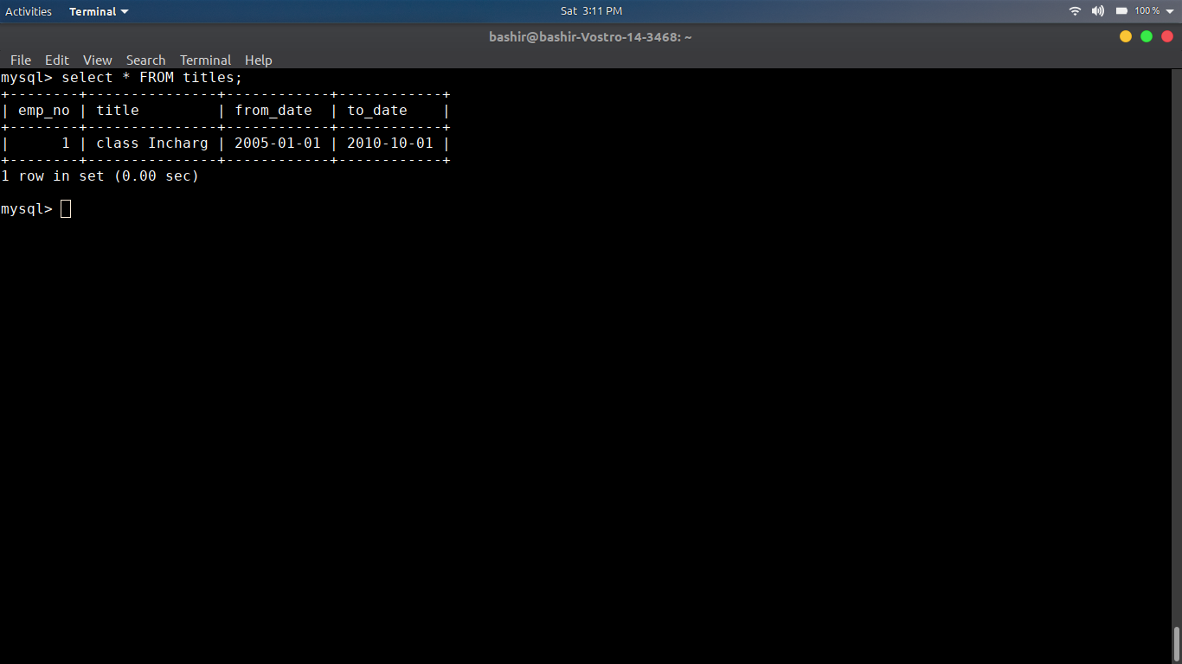
d. Change an employees’ job title. e. Change an employees’ hire date.

→ UPDATE employees SET hire_date = '1998-01-01' WHERE emp_no = 1;
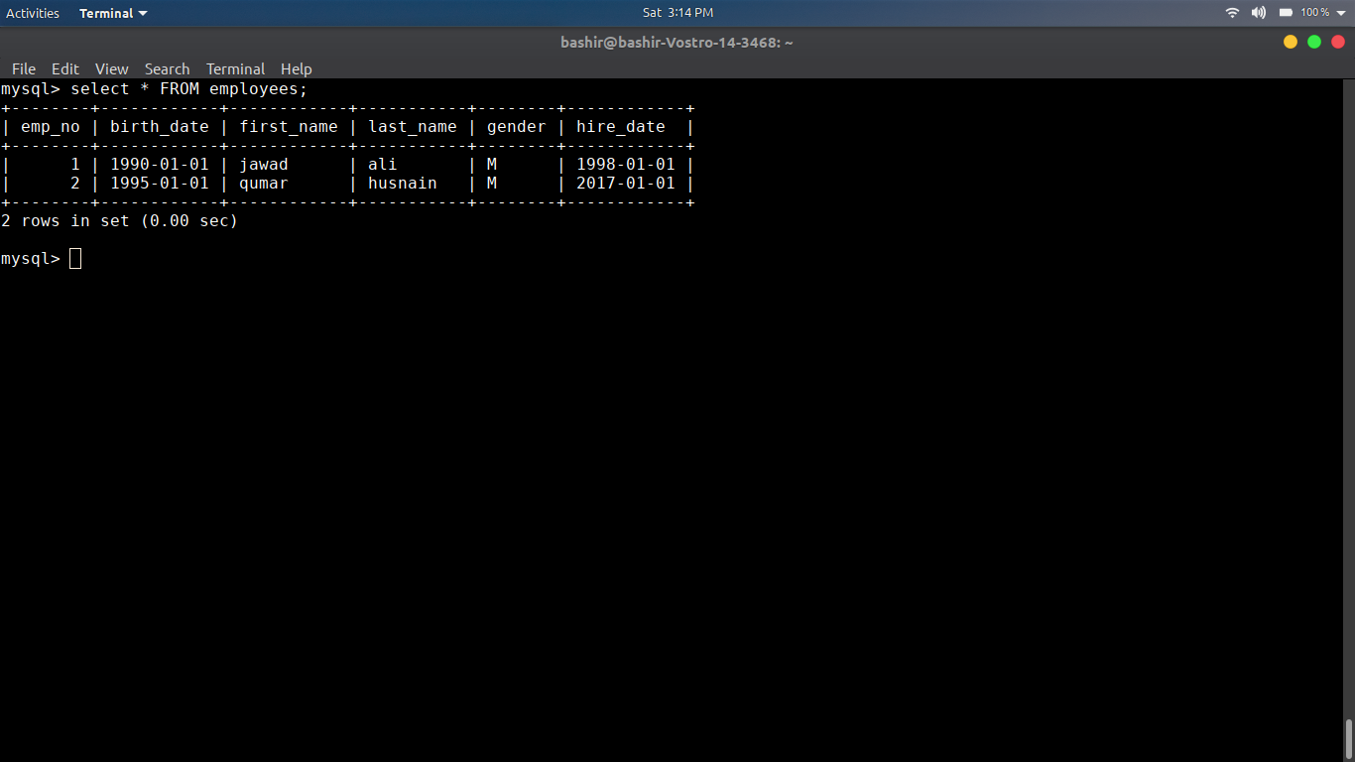

3. DELETE a couple of records. For example:
a. DELETE every employee who was hired before February 2016.
→ DELETE FROM employees WHERE hire_date < '2016-01-01';
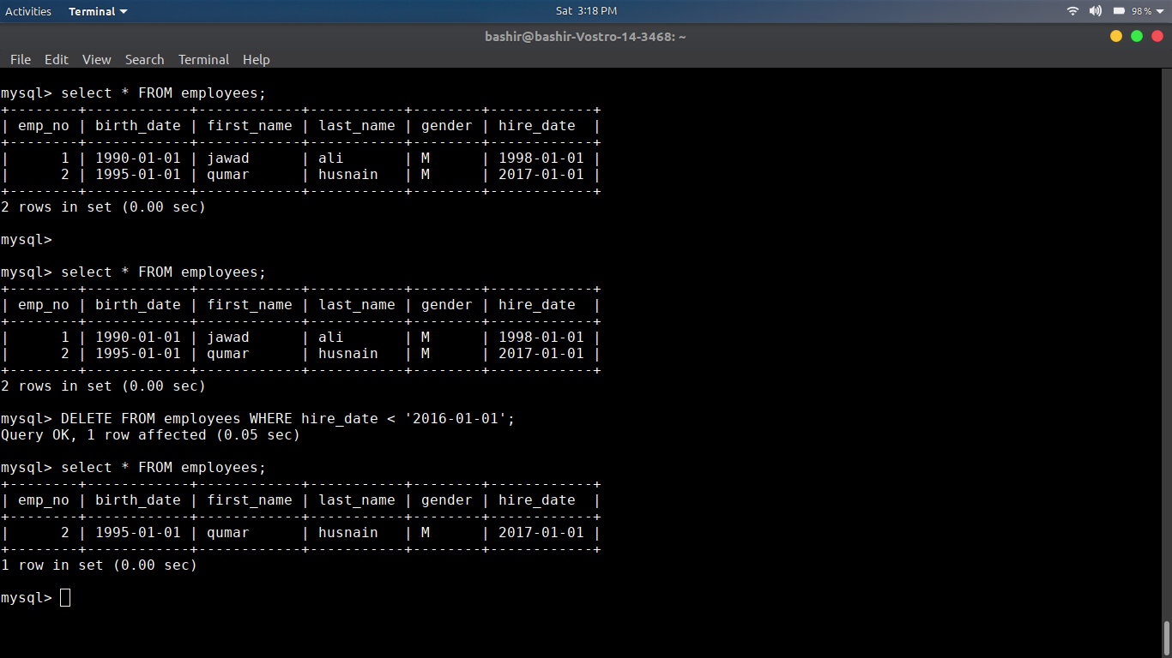
b. DELETE all departments.
→ DELETE FROM departments;
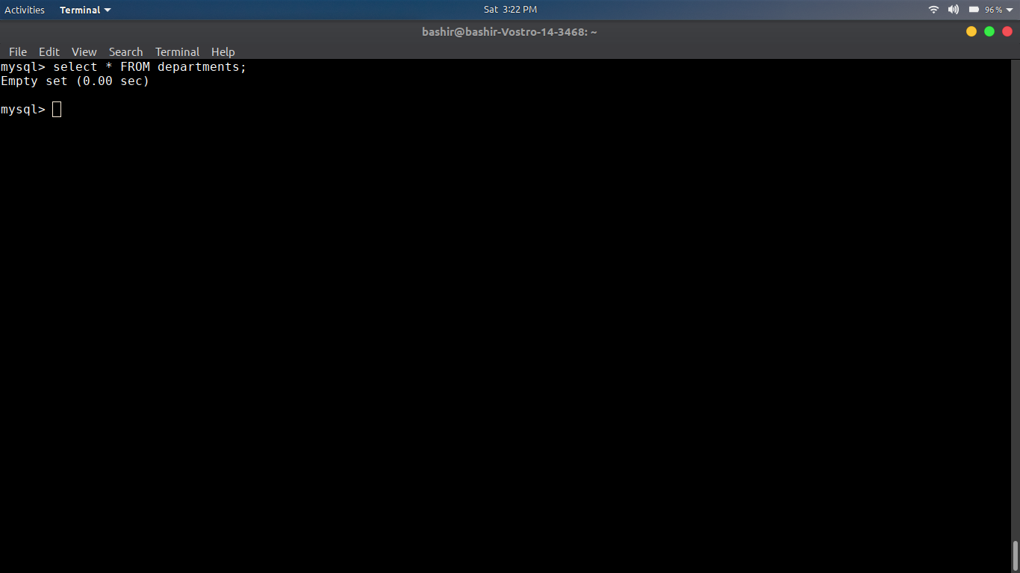

1. Create a database named “pharma”.
→ CREATE database pharama;

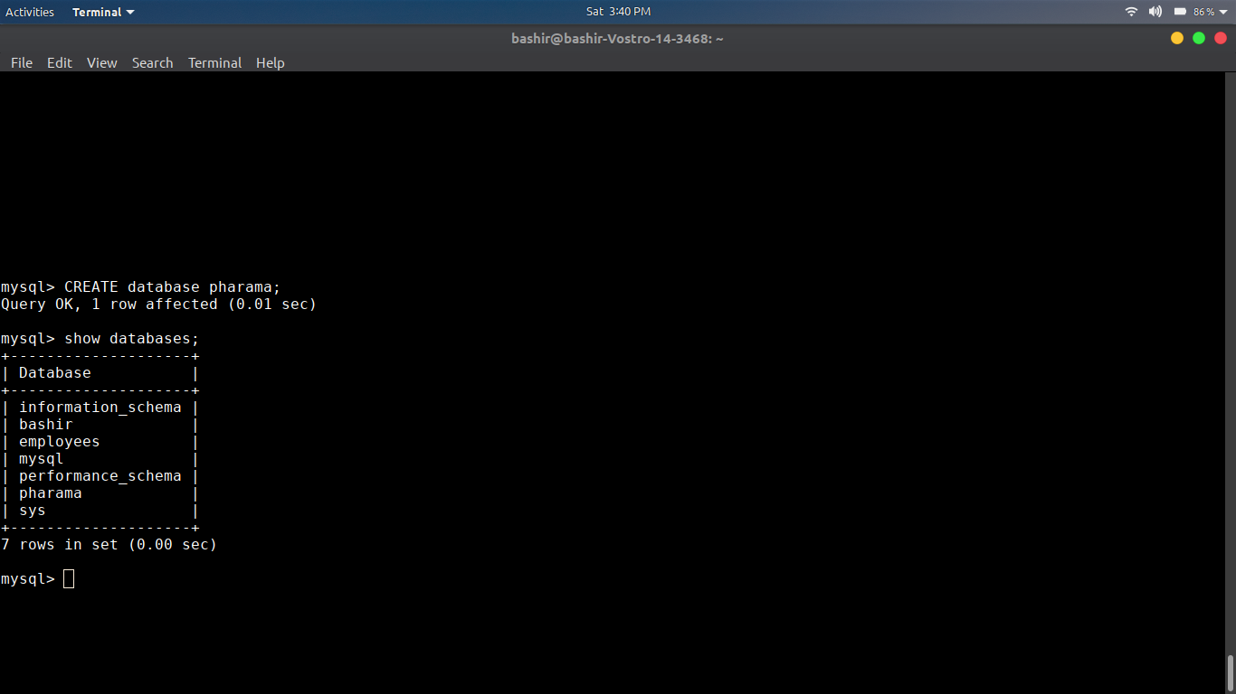

2. Create tables with the primary and foreign key constrains as shown (with on cascade update and
delete).
→

4. Change the name of supplier named Munir Brothers to Muneer Brother.

→ UPDATE suppliers SET s_name = ‘Muneer Brothers’ WHERE
s_id = 320;

5. Delete the Avil syrup product from the product table, does it affect order_detail table? If yes then
how? If no then why?

6. Set unit_price to 40 for all the products whose type is “Tablets”.

→ UPDATE products SET unit_price = 40 WHERE type = ‘Tablets’;
7. Delete the order with the order _id 22 from the orders table, does it affect order_detail table? If yes
then how? If no then why?

→ No, we can bcz order_id is forign key in order_details,

8. Delete all records from all 4 tables.
→ DROP TABLE product;
DROP TABLE supplies;
DROP TABLE orders;
DROP TABLE Order_detail;

9. Delete all 4 tables.

