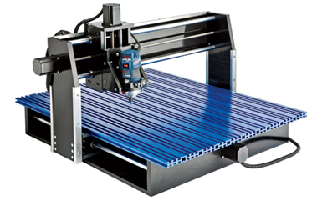

The New Shark Pro Plus!!   
Enhanced controller with more power that allows up to 200 inches per min   
Increased travel on the machine with a max cutting capacity of 25 x 25 x 5 inches   
Automatic on and off software control of Router   
Professional Aluminum case with Push button Estop.   
Pendant control capability included. (Designed for numeric laptop keypad)   
Cut 3D software included ($300 Value!)   
20 3D models, font and graphic package provided   
Extended Aluminum T slot top (28-1/2'' x 36'') for more versatile clamping   
Precision lead Screws with anti backlash on all axis  
Includes V-Carve 5.5 software, Cut3D software, Bosch PR10E router, 1/2'' dia. V-groove Bit and two hold-down clamps!  
  
Bring the speed and precision of computer-controlled machinery to your shop with this top value CNC system! With a table measuring 28-1/2'' x 36'' it's ideally suited for carvings and machining operations on a large variety of signs, doors and other small projects. It boasts impressive power, speed, accuracy, and ease of use. With its robust steel and high-density poly-ethylene construction, it can take accidental impacts that would normally damage or destroy an aluminum or MDF machine.  
It is fully compatible with the Bosch Colt Palm Router and includes a 1/2" diameter V-groove router bit. The CNC Shark also includes the new version 5.5 of the VCarve Pro software interface - a $600 value. You supply a PC computer with USB 2.0 port and a Bosch Colt router (router sold separately). Simply connect the USB cable to the controller box and the other end to your computer (not compatible with Mac computers).

Additional Features:   
Bearings: 12 precision linear bearing guides (4 on each axis) for maximum rigidity.   
Resolution: control to 0.000125 inch.   
High Speed stepper motors rated at 269 oz/in   
USB interface with on controller memory storage.   
Precision modified stainless leadscrews with backlash reducing nuts on all axes.   
24V Supply to provide full power to the steppers and future attachments.   
VCarve Pro 6.5 software program included ($600 value).   
Includes 1/2'' Dia. V-Groove   
Includes two Hold-down Clamps   
Mounts for a Bosch Router included (PR10E Bosch router is Included in our price)   
Free downloadable control program included

**Price $3,995**