**The University of Northampton**

**B.Sc. (Hons) Computing**

**CSY1018 Web Development**

**Term 1 Project**

**Title: Simple CV Portfolio**

**Name: Ayush Bashyal**

**UN Id: 17437370**

**Github URL: https://github.com/bashyalayush/csy1018-assign1**

**Content Page No**

1. Introduction …………………………………………………………………………………… 1

2. Design

2.1 Wireframes ……………………………………………………………………… 1

2.1.1 Wireframe of home page ………………………………….. 1, 2

2.1.2 Wireframe of CV page ………………………………….. 2

2.1.3 Wireframe of BIO page ………………………………….. 3

2.1.4 Wireframe of Contact page ……………………………….... 4

2.2 Sketches

2.2.1 Homepage sketch …………………………………………….. 4

2.2.2 CV page sketch …………………………………………….. 5

2.2.3 Bio page sketch ………………………………………….... 6

2.2.4 Contact page sketch ……………………………………………. 7

3. Favicons ……………………………………………………………………………………………… 7

4. Different Features Using CSS ……………………………………………………………. 8

4.1Logo ……………………………………………………………………………………. 8

4.2Navigation Bar ……………………………………………………………………. 8

4.3Picture ……………………………………………………………………………… 8

4.4Footer Image ……………………………………………………………………. 8

4.5Contact Form …………………………………………………………………… 8

5. Conclusion …………………………………………………………………………………….. 8

6. Reference ………………………………………………………………………………………………….

1. Introduction

We, students of IT have been given some assignments to make a website of my Curriculum Vitae of portfolio, before starting my project I have done many research and investigation of the topic. Where I have found different types and design of portfolio from which I took some information and started my project using HTML and design it with the help of CSS. In the period of 12weeks, I have learned many more things about HTML and CSS which also made me easy to complete my project.

2. Designs:

2.1. Wireframes:

Before starting, to make me easy I have done some wireframes using paint which really help a lot while making my design. The blueprint of my design is listed below:

**2.1.1 Wireframe of Homepage:**

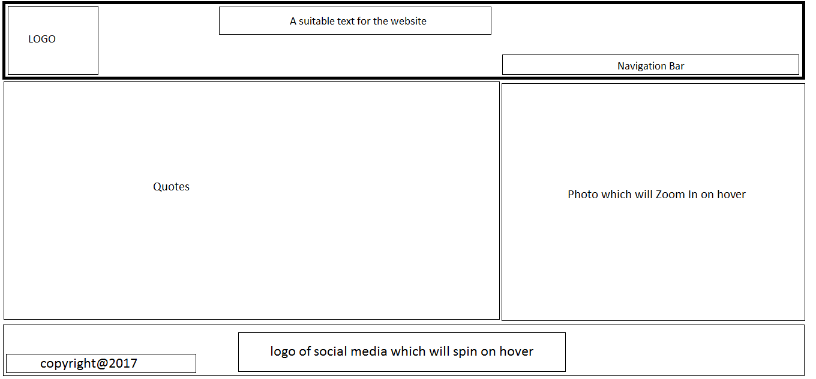

**2.1.2 Wireframe of CV page:**

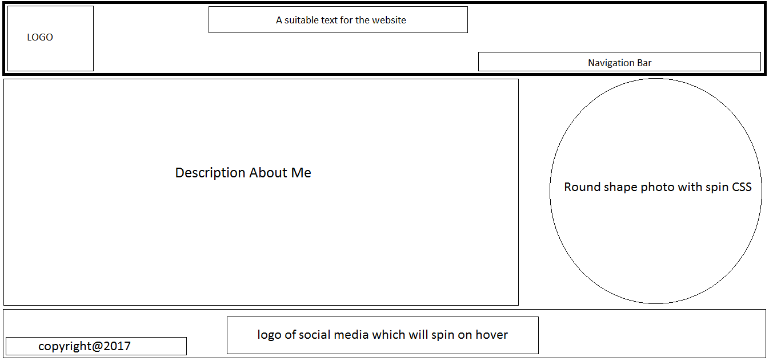

**2.1.3 Wireframe of BIO page:**

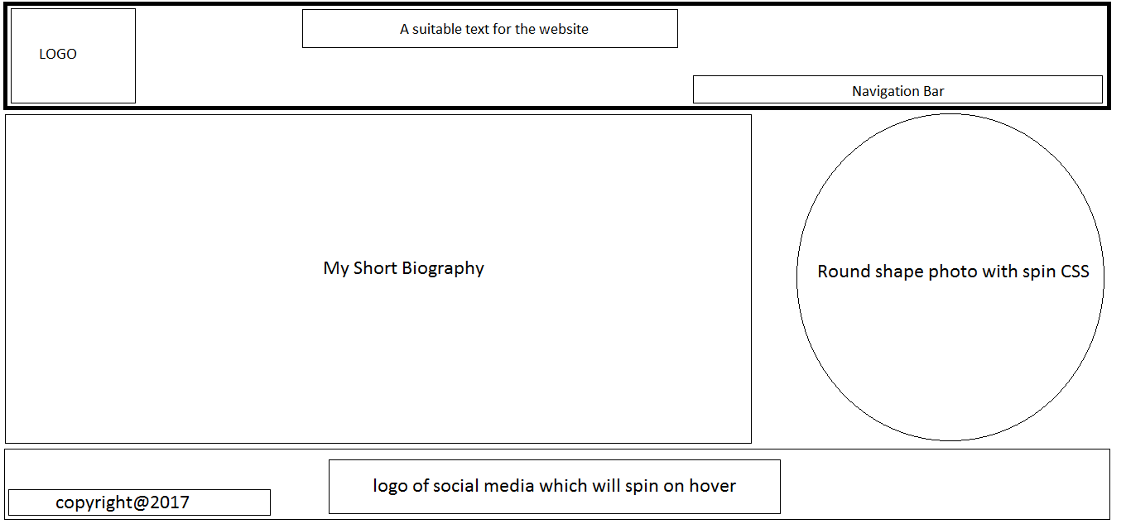

**2.1.4 Wireframe of Contact page:**

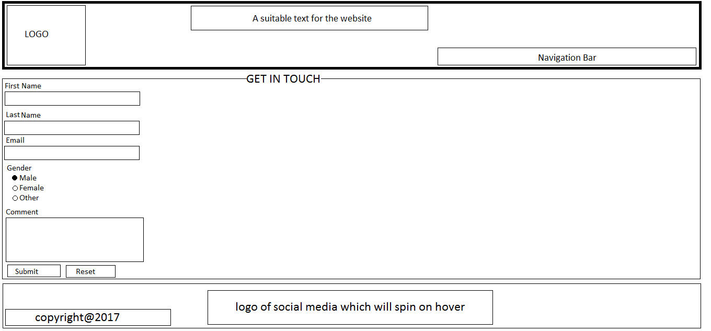

**2.2 Sketches:**

**2.2.1 Homepage sketch**

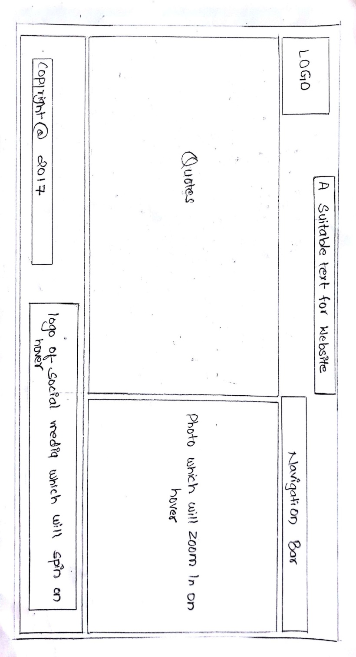 As I want my webpage to be simple and attractive so, also the webpage of my website is simple which contain the logo, navigation bar at the header part and in the Section I will make two division in the right side the sentence quotes is place and in left side of division there will be my photo and also add CSS properties to make it zoom in while hover. Similarly, in footer part some logo of social media will be placed and also want to use CSS property to make it spin while hover.

**2.2.2 CV page sketch:**

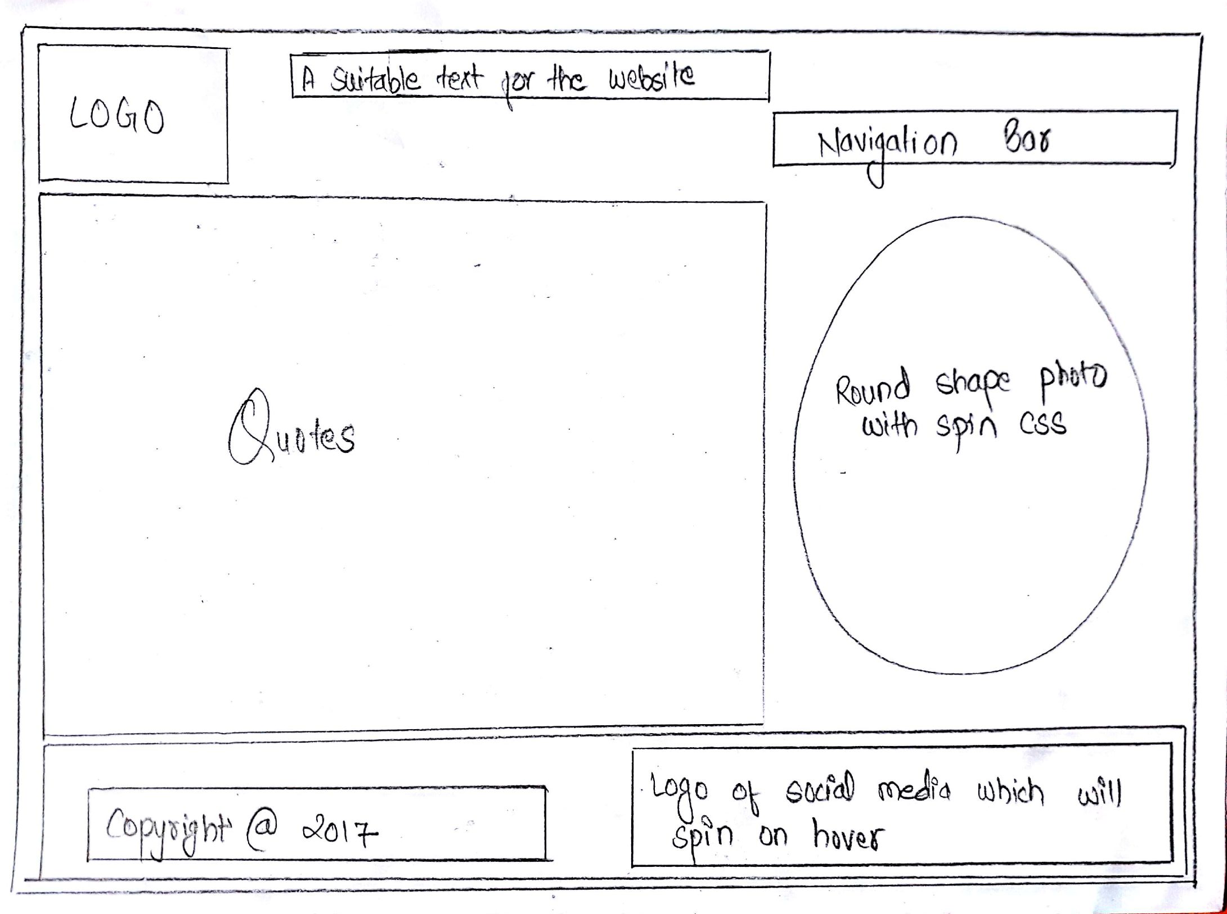

In this CV page there will not be any change in the header and footer but in the main part again the section will be dividing using division in the left side there will be Curriculum vitae of myself and in the right side there will be the oval shape image which has the CSS features of rotating around while hover.

**2.2.3 BIO page sketch:**

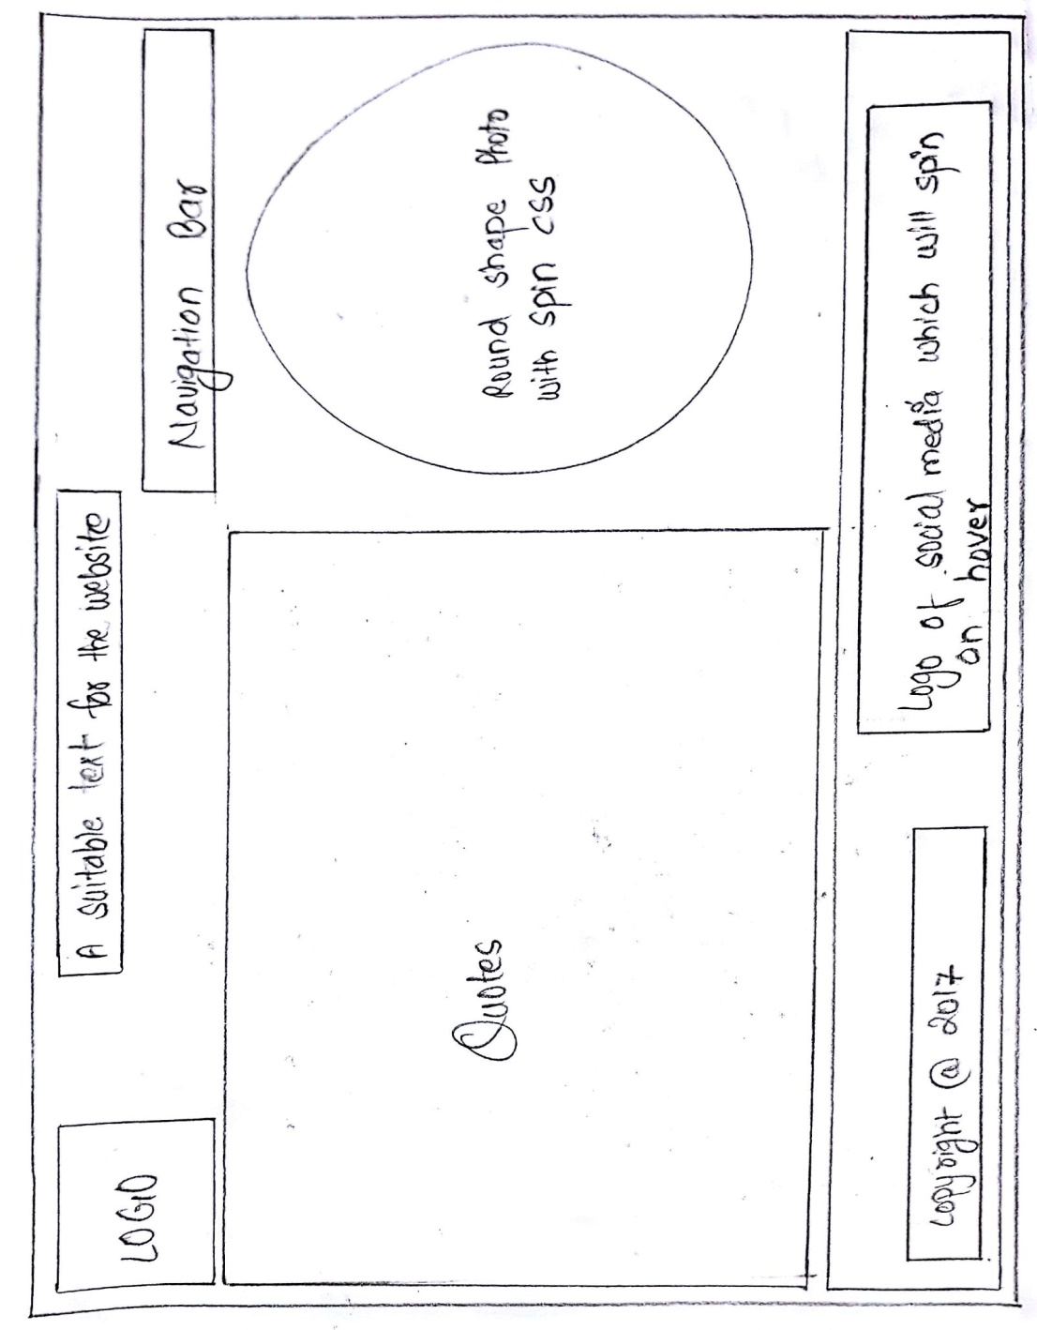

In the main section of the bio part same two divisions and same features using CSS and HTML but in the right side of main part some sorts of my biography will be there and as usual there will not be any changes in header and the footer.

**2.2.4 Contact page sketch:**

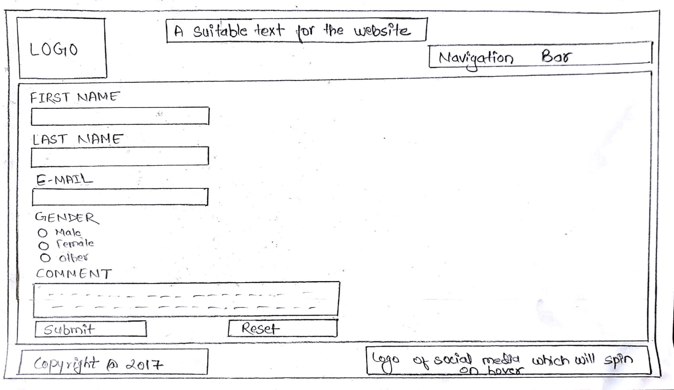

In the main section of the contact page there I will create some forms using division form in which the user has to fill their information and it also allow visitors to comment and give some feedbacks and two buttons submit and reset will be given to submit their comments.

**3. Favicons:**



This is the copyright free logo for my website which is created using paint. After having a look at it a user can easily understand that it indicates the first letter of my name. To make it easy one special feature is added in the logo that if the user is in another page of website then by clicking in the logo they can easily be in homepage.

**4. Different features using CSS:**

4.1 **Logo:** To placed logo in a proper place a suitable CSS is used to look it more attractive.

4.2 **Navigation Bar:** The navigation bar is decorated using CSS in which thehover properties isused in Navigation button to make it more attractive and also change in color and size of the navigation button.

4.3 **Picture:** The simple CSS code is used to decorate thehomepage picture in which the picture will zoom in while hover. In CV page the image will rotate on hover whereas in Bio the photo remain fixed no any changes on the picture.

4.4 **Footer Image:** There is some social media icons in a footer where the properties is the icon will make a spin while hover.

**Contact Form:** The contact form is placed by giving its proper radius and border to the form and the clickable submit and reset button is placed with colorful CSS.

**5. Conclusion:**

To Sum up, I would like to give a conclude that during my project the during 12 weeks I have learned many more things about HTML and CSS where HTML help me to complete my project and CSS to design my project to make it more attractive through this I can able to make a simple and user friendly website to complete my report.

**6.** **Reference:**

* W3schools.com.(1999)THEWORLD’SLARGESTWEBDEVELOPERSITE.(ONLINE)**.**Aval able from: **https://www.w3schools.com/** [accessed 24 March 2017]