RAKESH JADHAV

Sr. TIM Engineer

Email: rakeshjadhav83@gmail.com
Contact Number: 7558531580
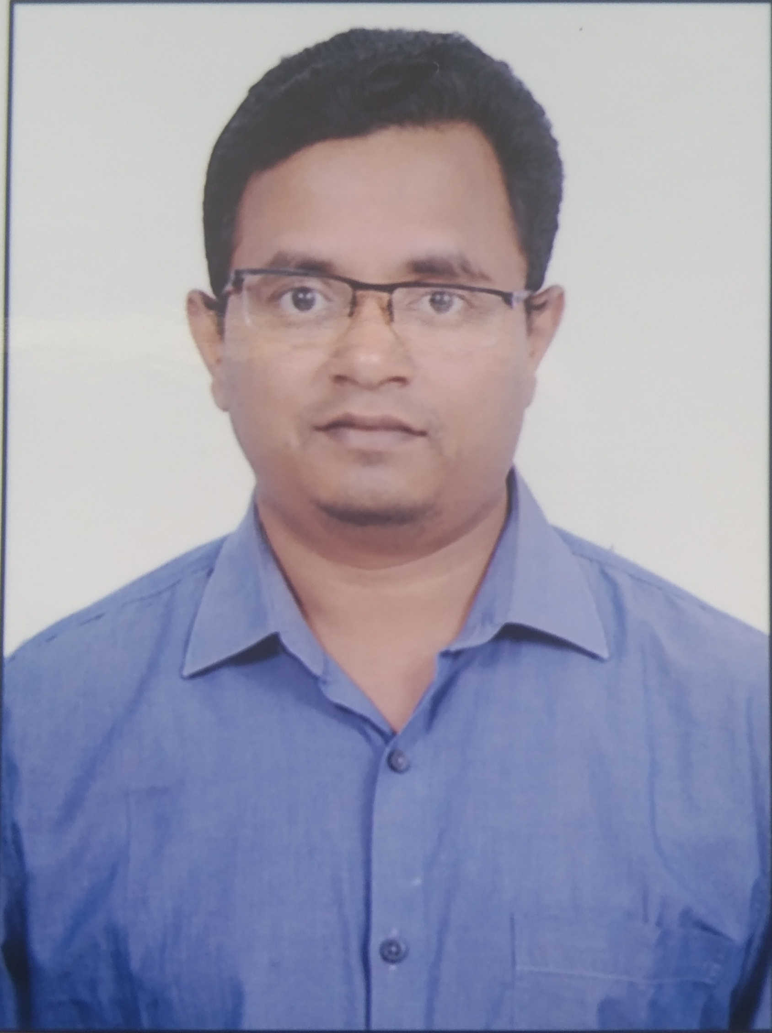

Professional Abstract
- Passionate and focused Engineer with 8+ Years of experience as Technical Support Engineer & System Administrator
- Technical knowledge & proficiency in System administration, hardware maintenance, operating systems, Windows (All versions) and the willingness to learn and efficiency apply new technologies.
- Analytical thinker, consistently resolving ongoing issues, Extensive exposure to a comprehensive range of team activities, thrive on working in challenging environment.
- Demonstrated problem analysis/ resolution skills, ability to troubleshoot, solve problem quickly and completely.
- Excellent Client/user management skills, ability to build strong and mutually beneficial relationships.
- Aware of ITIL concept, Ticket life cycle, Service Level documentation like SLA, Escalation matrix etc.
Experience Chronology

Company: Tech Mahindra Ltd, Pune
Designation: Senior Technical Infrastructure Management Engineer
Duration: April 2014 to till date (8+ Years) (Permanent Role)
Job Responsibilities:

- Provided 24*7 First and second level Support to diagnosing & resolution service request raised by Customers using BMC Remedy tool & ServiceNow.
- Provides support of 24*7 Global Support (US & UK client) process by serving as tier 1 & tier 2 first point of contact and owner of problem/incident.
- Good troubleshooting skills for group policy, AD replication, DNS and DHCP and Azure AD.
- Experienced in PowerShell scripting to manage M365 and accounting.
- Perform AD related activities Unlock/Password reset, System/User OU movement, Use Security Groups to apply Permissions to Resources, Group Membership Management.
- Manage & Maintain Microsoft Exchange as well as Microsoft O365 Administrator.
- Managing Outlook webmail access and ActiveSync of Email accounts for Employees located worldwide.
- Mailbox creation, modification, Database Movement and Mailbox Quota size change and delegate rights.
- ID Migration from one Domain to another using ADMT (Active Directory Migration Tool) Tool, NAS Quota Change.
- Checking, filtering, tracking, and releasing quarantined emails using Cisco Iron Port Email Gateway and EOP Gateway.
- Distribution List & Query based DL creation, modification moderation and delegation access.

- Checking daily report for spammer domains & blacklisted domains as well as monitoring/managing queues on Exchange 2013.
- Handling Escalated service request/issues by Team.
- Ability to solve complex hardware and software issues, proficiency in Windows 10 OS.
- Done Installation of Freeware, Licensed software installation for various applications and programs.
- Done McAfee Antivirus installation & Configuration & data encryption.

Company: Tata Consultancy Services (Contract on PCS Technology, Pune)
Designation: Remote Support Engineer
Duration: December 2012 to April 2014

Job Responsibilities:
- Worked as Remote Support Engineer to provide solution for windows platform through remote access tool & telephone calls for multiple countries.
- Performed responsibility for technical operation effectiveness in line with contracted SLA to avoid contractual penalties.
- Experienced in Installing, Upgrading & Administrating Windows operating systems.
- Done Configuration for: User profiles, outlook, SAP, Remedy software and VPN.
- Worked on remote connectivity tools like Net meeting, IBM remote Ayudame, Tivoli and Dame Ware utility.
- Used BMC Remedy tool for Incident Management.
- Updated Anti-Virus software, Applied Latest Updates, and patches to all Windows Computers.
- Used Fog server for the desktop, laptop OS image deployment on the site.

Company: Wipro Technology (Contract on Impact Info Tech Pvt. Ltd., Pune)
Designation: Technical Support Engineer
Duration: February 2011 to September 2012

Job Responsibilities:
- As a system Support Engineer, provided solution for windows platform remotely through net meeting and juniper meeting in all over countries.
- Assisted in troubleshooting user problems relating to Operating System issues (Windows XP and Windows 7), upgrades, MS Office products and Internet connectivity.
- Performed upgrades, installation of various software, printer drivers and essential desktop troubleshooting.
- Documented various technical activities, which involves procedure for installation of new software or existing software.
- Deployed service packs, windows update, automatic updates, and software installation through DDM (Distributed Device Management) tool.
- Done L1 activities for Messaging team (Lotus Notes configuration and related other issues)

Academia

- B.E.(Computer) from Pune University in 2007. Secured 57.8% Marks
- 12th (H.S.C) from Nasik Board secured 51.50%
- 10th (S.S.C) from Nasik Board secured 72.93%

Strengths

- Believer in Trust and Honesty in my work.
- Flexible ability to suit to any environment.
- Ready to accept all kinds of challenges.
- Ready to work 24/7 with rotational shift or any shift.

PERSONAL DETAILS

Date of Birth : 11th September 1983
Languages : English, Hindi, and Marathi.
Marital Status : Married
Address : Flat No: 706, Suvira Nest, Aamare Colony, Dighi-411015

Rakesh Sharad Jadhav

