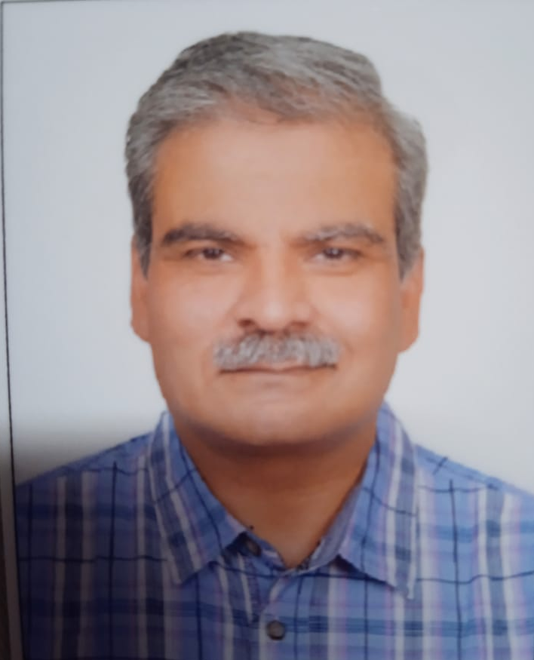
RESUME

ASHUTOSH SETH
SENIOR MANAGER—TOOLROOM
Experience-32yrs
Email ID: ashutoshseth11@yahoo.in
Mobile: +91- 9015266133

Objective: -

Confident to accept challenges and to produce results. Hardworking, honest and sincere towards work, responsible enough to deliver the goods. Having leadership qualities and very comfortable with working in a team or a group Environment.

Over all summary:-

- Graduation in “Tools and Die making” from Tool Room & Training Centre, Delhi (TRTC, Delhi).
- Industrial Exposure : 32years experience of Tool room and product development and customer liaisoning in the Automobile sector
- Experience & Knowledge of development and handling the product development operations entailing manufacturing, planning, coordinating, process developments and modifications. Thorough understanding of manufacturing of Press Tools, Gauges & Fixtures, Sheet Metal Parts, Tool Maintenance and Moulds. Instrumental in costing of components & tools. Effective communicator with excellent planning, organizational and problem solving skills
- Pursuing ‘Auto CAD and CREO’ from a PTC-authorized training centre.

Current Company:
- Working with M/s SKH METALS LTD (KRISHNA GROUP) Maruti JV since SEP 2017 as Senior Manager TOOL ROOM
In Maruti J.V Complex Gurgaon.
SKH Metals are Mfrs of Fuel tank and Critical body parts

Roles & Responsibilities:-

- Co-ordinating the entire product development including requirement analysis, finalizing specifications, prototype development and testing activities.
- Study tool designs and die layout for an easy and suitable production run.
- Conducting project feasibility and APQP activity with CFT team.
- Coordination with the customers and vendor from spec. meeting to final tool trial & PPAP.
- Verifying and approval Panel checker and gauge validation report as per design data from the customer.
- Vendor selection & analyzing the process capabilities for new product development.
- Price Negotiations and finalization for the tools & components.
- Responsible for VA-VE & alternate source.
- Planning, Coordination & follow up the vender activities like tool manufacturing & ensuring timely completion, tool trials, tool rectification & production.
- Providing direction & guidance to tool designer & die fitters.
- Managing tool tryouts, maintenance & modifications.
- Participating during T-0 and T-1 (Tooled-up) sample approval and submission from customers.
- Participating in weld assembly trials from DP Trial, PP Trial, MP Trial, Pilot lot and S.O.P.
- ECN control and implementation as per customer requirement.
- Managing review meetings for continual improving Quality.
- Verifying Part as per part inspection check sheet.
- Managing customer queries & ensuring customer satisfaction by achieving delivery & service quality norms.

Previous Company:-
- Worked with M/s Munjal Auto Ltd since DEC 2014 as Senior Manager(Tool Room & Press Shop)
Munjal Auto Industries Ltd., (MAIL) is a TS 16949 and ISO 14001 accredited, leading auto component manufacturing company in India producing Exhaust systems complete for two wheelers and four wheelers, Spoke rims for two wheelers, Steel Wheel Rims for Two Wheelers and Four Wheelers, Fuel Tanks for Four wheelers, Seat Frames for four wheelers and other automotive assemblies. The company has a technical collaboration with Samsung Industries Ltd. of Korea for the manufacture of Fuel Tanks for Four Wheelers. The company holds the pride of being among the largest manufacturer of the exhaust systems in the world, manufacturing close to 22,000 systems per day. Besides, the company produces more than 10,000 spoke rims for motorcycles and steel wheel rims every day.

- Manager in Tool Room from Jan 1997 to Nov 2014 from M/s Insulation & Electrical Products Pvt. Ltd., Gurgaon. A TS-16949 – 2002 certified company is a leading manufacturer of Sheet Metal components. It is the manufacturer of Seat Tracks, Seat Adjusters, and Cushion Height Adjusters & Rear Seat Locks. Main customers are M/s. Tata Jonson Controls Ltd., (Ford India Ltd, & Tata Motors Ltd.), M/s. Krishna Maruti Ltd. & M/s. Bharat Seats Ltd., (Maruti Suzuki Ltd.), M/s. Lear Seating Corp. Ltd. (Mahindra And Mahindra, & General Motors) .
Insulation has a good stamping machine from 20 Tons to 315 Tons (72 machines) and 32 Welding stations.
- December 1989 to January 1991 as Tool room engineer in M/s Jayna Times Industries Sahibabad, manufacturer of Jayco watches and clocks
- January 1991 to December 1996 as Technical Head M/s. Bentex Control & Switch Gear Company, Delhi manufacturer of Motor starter, MCB, ELCB and various Electrical products. The company has got press shop (5 Tons & 150 Tons) mechanical and double action Press and Moulding shop which includes Injection moulding of Windsor make and hydraulic compression moulding.

Roles & Responsibilities:-

- Schedule of tools.
- Responsible to maintain spare parts for die maintenance and Designing as per requirements & Manufacturing as per design.
- Member of CFT for NPD and conduct trial for new tools and moulds.
- Providing guidance & direction to tool designer & Die Fitters.
- Responsible to make preventive maintenance and maintain the tools for production.
- To arrange men, materials & m/c to make work effective.
- Development of new products with standardization of existing models (Prototype Sample).

Personal Details;-

Father’s Name : Late Sh. S.P Seth
Date of Birth : 27/11/1966
Marital Status : Married

Address : A-77,1st Floor, Lok Vihar,
Pitampura
New Delhi-110034
Language : English & Hindi

Salary Drawn 20.75 Lac/ annum

Place : Delhi

Date : 02/02/2023

(ASHUTOSH SETH)

