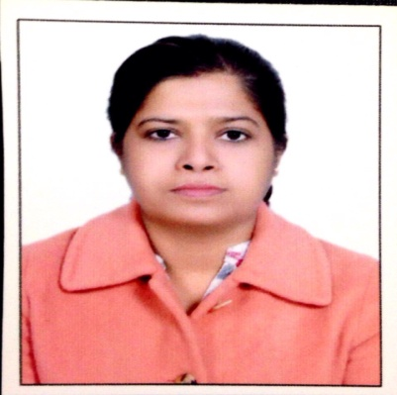

**Key Points**- PRT/ Computer Teacher / Subject Teacher/Art & Craft Teacher/Mother Teacher/**Exp**-6yrs

**SHASHI SINGH**

**Email: shashi.singh28**[**@gmail.com**](mailto:pratima.garg@gmail.com)**.   Phone: 91- 7834982416**

**Objective-**

Obtain a position as a School Teacher that will utilize my strong dedication to children’s development and to their educational needs and to encourage creativity and higher-order thinking to increase children performance. A goal-oriented individual with the ability to multitask efficiently and pay close attention to detail. I have managed a number of responsibilities at once.

**Experience Summery-**

|  |  |  |
| --- | --- | --- |
| **Dates** | **Schools** | **Classes** |
| April 2018 – Nov 2022 | FLORENCE INTERNATIONAL SCHOOL,Noida Ext (Greater Noida) | 2,3 ,Computers (1 to 5) |
| Jul 2016 - April 2018 | “Hello kids cuddle”,Ghaziabad | 4,5, Art and craft |

**Skills and Abilities-**

* Ability to work with children of different attitudes and skills .
* Excellent communication and ability to mix with children effortlessly .
* Ability to create an effective teaching method for the children.
* Ability to interact with the children effectively so they can learn quickly.
* Ability to motivate the children, so that they will consider themselves a special personality.
* Maintaining discipline in classroom
* Energetic, Active, Sharp, Committed and Problem-solving.
* Preparing resources for lessons.
* Developing lesson plans with curriculum objectives.
* Capable of multitasking work efficiently.

**Technical Skills-**

* Extensive knowledge of Internet and Computer Software’s
* Knowledge of windows 98/xp./windows 10
* Internet Surfing.
* MS-Office Suite (Excel Word)
* Paint and Tux Paint
* Forms, Padlet, Kahoot etc

**Strengths and Achievements-**

* Enthusiastic and hardworking.
* Possess Positive attitude.
* Responsible towards work.
* Self-motivated and directed.
* Won 2nd prize in fashion designing in college
* Won 1st Prize in the dance competition

**Academic Qualification-**

* B Ed from CCS University Meerut .
* MCA from UPTECH Lucknow.
* B SC from Dr B R A University, Agra .
* Intermediate from T R G College, Aligarh .
* High School from T R G College ,Aligarh .

**Areas of Interests-**

* Drawing, Crafting and Painting
* Dancing.
* Playing badminton
* Watching movies
* Singing

**Personal Details-**  
  
 Date of Birth: Jun 5th 1978 Nationality: Indian

         Husband’s Name: Jeetesh Bhoria Language: Hindi, English,

      Address:Flat 2106,TowerE,Ajnara Le Garden, Greater Noida West