BIO-DATA

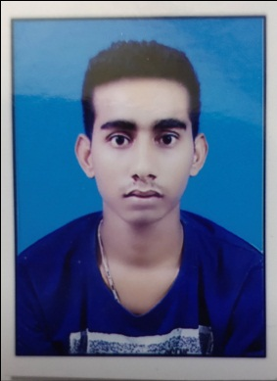NAME: SANTANU HALDER FATHER’S NAME: KARTICK HALDER

# PRESENT ADDRESS:

VILL-BHAJANGHAT POST-BHAJANGHAT PS-KRISHNAGANJ DIST-NADIA

PIN-741507

STATE-WEST BENGALE

**MOB- 7001482685/9831484875 E- MAIL –**[santanuhalder205@gmail.com](mailto:santanuhalder205@gmail.com)

# PERSONAL DETAILS:

DOB- 04/07/1994 COMMUNITY- SC RELIGIOUN-HINDU SEX-MALE

MARITIAL STATUS- UNMARRIED

# EDUCATION QUALIFICATION:

|  |  |  |  |
| --- | --- | --- | --- |
| NAME OF THE EXAM | NAME OF THE BOARD/UNIVERSITY | PASSING YEAR | REMARKS |
| MADHYAMIK | W.B.B.S.E | 2010 | PASS |
| HIGHER SECONDARY | W.B.C.H.S.E | 2012 | PASS |

**TECHNICAL QUALIFICATION:** ITI ELECTRICIAN TRADE FROM NCVT.

|  |  |  |  |
| --- | --- | --- | --- |
| NAME OF THE TRADE | NAME OF THE BOARD/UNIVERSITY | PASSING YEAR | REMARKS |
| ELECTRICIAN | NCVT | 2021 | PASS |

**OTHER QUALIFICATION:** DIPLOMA IN COMPUTER APPLICATION.

**EXPERIENCE:** ONE YEAR AT WELKIN AND 2 YEARS AT MAXEED (JIO MICROWAVE PROJECT CERAGON AND ERICSSON).

**DECLEARATION:** I HERE BY INFORMED THAT ALL OF THE ABOVE INFORMATIO ARE TRUE AND GENIUNE.

PLACE:

……………………………………………

DATE: SIGNATURE