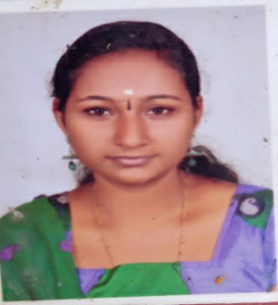RESUME

# POOJA SREEKUMAR

# Puthen Veedu, Kizhakkumkara

# Nettayam , Trivandrum-695013

# Phone No - 9072469052

# Email-[poojasreekumar94@gmail.com](mailto:poojasreekumar94@gmail.com)

# CARRIER OBJECTIVE

To make life challenging through a creative and Competitive environment where I have the opportunity to assert strong since of responsibility to know about the real world laid ahead of me

# EDUCATIONAL QUALIFICATION

|  |  |  |  |  |  |
| --- | --- | --- | --- | --- | --- |
| Examination  passed | Subject | Institution | Board Of  University | Year of passing | Percentage % |
| SSLC | SSLC | Viswa prakash Central  School Thirumala | CBSE | 2010 | 50% |
| HSE | Science (Bio Computer) | A R R Public School  Nettyam | CBSE | 2012 | 59% |
| Diploma | Computer Science Engineering | The Indian polytechnic College, Thirunelveli | AnnaUniversity | 2014-17 | 90% |

**PERSONAL PROFILE**

Name

Name of Father Name Of Mother

: POOJA SREEKUMAR

: V. SREEKUMARAN NAIR

: PRABHA S KUMAR

Date Of Birth : 25/10/1994

Gender : FEMALE

Nationality :

Marital Status :

Language Known as :

# DECLARATION

INDIAN

MARRIED

MALAYALAM , ENGLISH ,TAMIL

I do hereby declare that all the above information given by me are true to the

best of my knowledge and belief

Place : NETTAYAM POOJA SREEKUMAR

