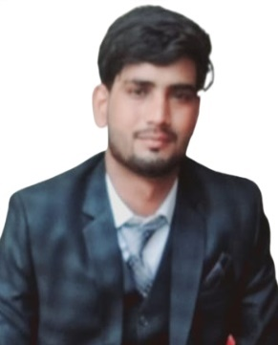CURRICULUM VITAE

**JUBER**

Mobile: 6397115133

Email: jubertyagi6397@gmail.com

H. NO. 16 Masjid Colony

Aliyarpur Deh (251318

Distt. Muzaffarnagar (U.P.)

**CAREER OBJECTIVE:**

Seeking a position to utilize my skills and abilities in an industry that offers professional growth while being resourceful in the respective organization, to be a part of world- class team that explores new horizons which enhance my abilities and learning.

**EDUCATIONAL QUALIFICATION:**

|  |  |  |  |  |
| --- | --- | --- | --- | --- |
| **QUALIFICATION** | **COLLEGE /SCHOOL** | **UNIVERSITY /BOARD** | **YEAR** | **PERCENTAGE** |
| B. PHARMA | Translam Institute Pharmaceautical Education & Research Meerut | Dr. A.P.J. Abdul Kalam Technical University Lucknow U.P. | 2018 - 2022 | 70% |
| INTERMEDIATE | Shree Arvind Inter College Pura Muzaffarnagar | UP BOARD | 2018 | 58% |
| High School | Shree Arvind Inter College Pura Muzaffarnagar | UP BOARD | 2015 | 65% |

**SKILLS &ABILITY:**

* Good Communication…
* Team Work…
* Good Listening…
* Discipline …

**ACHIEVEMENTS:**

* I have completed to my Hospital Training Dev Anant Hospital Ganga Nagar Meerut.
* I have completed to my Industrial Training **SYNOKEM PHARMACEUTICALS** **L.T.D.** from Ranipur Haridwar.

**HOBBIES:**

* Reading Books…
* Playing Cricket…
* Traveling…
* Listing Music…

**EXPERIENCE:**

* Accrecia HQ at Hpaur in join date 15 July and leave date 15 October.
* Shreya life science HQ at Meerut in join date 16 October and leave date 10 January.

**INTEREST AREA:**

* Marketting.

**PERSONAL DETAILS:**

* Father’s Name : Late Mohd. Tahir
* Date of Birth : 10 July 2001
* Gender : Male
* Language Know : Hindi & English

**DECALARATION:**

I hereby declare that the above written particulars are true to the best of my knowledge.

Date………….

Place…………… (Juber)