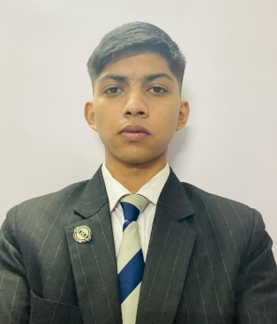**Zeeshan Hussain**

**Address:** T.B. hospital road near electric crematorium,shillong

**Mobile Number:** 813286066

**Date of birth- 12/04/2003**

**Father’s Contact Number-** 9612079886

**E-mai**: iihm21kol406_zeeshan@iihm.ac.in

**Field of Training Desired: All the core departments**

**Length of Program desired: 6 Months**

**Date available to start training: June 2022**

**EDUCATION**

**Institute name:** International Institute of Hotel Management

**Location:** Kolkata **Institution start date**: 2th October 2021

**Graduation/Expected graduation date:** July 2023

**Field of study:** B.Sc in International Hotel and Tourism Administration from

International Institute of Hotel Management, Salt Lake Sector V Kolkata

**School name: St. Peter School**(2019)

BSF Senior Secondary School (2021)

**Classes taken at institute relevant to training:**

|  |
| --- |
| **Basic Training in Kitchen :** Basic kitchen is fully equipped with modern catering equipments and appliances. This kitchen is used primarily to introduce the basic art of cookery to the students and it is the launching pad for the new learners.  **Basic Training in Front Office :**  Familiarity with the art of guest interaction and communicating with them is indeed an essential part of good hospitality operation.  **Basic Training in the F&B Outlet:** Restaurant is fully equipped with the tables and chairs properly set up with numerous covers, crockeries and cutleries are set up in the tables with proper demonstration module.  **Basic training in the Housekeeping outlet:** The housekeeping lab is primarily used to introduce the art of service which is provided by housekeeping department in the hospitality industry. |
|  |

**EXPERIENCE:**

* Casual Training(CT) at The Park Hotel Kolkata,Park Street,Taltala,

Kolkata,West Bengal

Working as a member for SKAL

Worked for Digital marketing team in IIHM.

Worked in FOOD Fest 2022

Worked in YCO 2022 as a digi buddy for team Hong kong.

**Skills/qualification:-**

* Languages & Level: English, Hindi & Bengali (Fluent in all)
* Computer Skills: Good(MS Word, Excel & Powerpoint)