**CURRICULUM-VITAE**

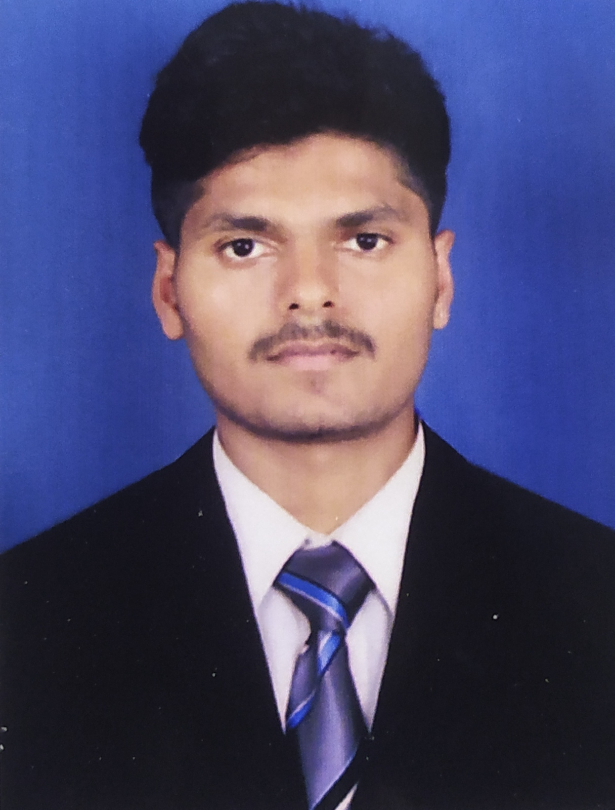

**BHARATH D NAIK**

Murudeshwara

Uttar kannada-581350

Karnataka, India

Phone no: +917019979636

**yuvabharat998@gmail.com**

**Career Objective**:

Aspiring to get a challenging position in an organization like yours, where I could

demonstrate my skills and abilities for betterment of the organization professional growth.

**Professional Attributes:**

Friendly, Hardworking, Sincere, Polite, Management skills and Positive attitude with Fairly

Good

communication skills.

Ability to work under pressure.

Effective team player with high motivation.

Insists on punctuality and committed for achieving set target.

Capable of multi-tasking and taking on additional responsibilities.

**Academic Credentials:**

Class 12th The New English college Bhatkal (Pre University Education Board) 2016

Class 10th Janata vidhyalaya Murudeshwara (Karnataka Secondary Education Examination

Board) 2014

**Professional Qualification:**

Completed 2 Years Diploma in Hotel Management and Catering Technology from

**KALPATARU**

**COLLEGE OF MANAGEMENT STUDIES, HONNAVAR, KARNATAKA**, affiliated to Bharat Sevak

Samaj Vocational Education, Tamilnadu and approved by National Development Agency,

Established in

1952 by Planning Commission, Govt, of India.

|  |  |  |
| --- | --- | --- |
| **UNIVERSITY** | **COURSE** | **PERCENTAGE** |
| Kalpataru College of  Management  Studies | Diploma in Hotel  Management and Catering  science | Distinction |

**Interests & Hobbies:**

Dancing

Reading Books related to food and beverage.

Playing Games

**Industrial Exposure:**

IET Training in CGH Earth,Casino Hotel (kochi) (14th November 2017 to 16th April 2018).**Work**

**Experience:**

➢ Worked as a Trainee GSA in F&B Service,Suraj Grand Kurnool,A.P. (from 6thNovember

2018 to 3rd May 2019).

➢ Worked as a GSA in F&B Service,Kalpana Residency,Andra Pradesh(from 1stAugust 2019

to May 2022).

➢ Worked as a senior GSA in F&B Service,R.N.S. Residency,Murudeshwara(from 2nd

February 2021 to 3rd March 2022).

➢ Working as as A1 operational department (Banquets & Resturant),Vivanta By Taj Hotel, Trivandrum Kerala.(from 7th March to till date)

**Area of Interest:**

Food and Beverage Service, Restaurant

**Personal Details:**

Date of Birth : 27 October 1999

Father’s Name : Durgayya Naik

Mother’s Name : Kasturi Naik

Languages Known : English, Hindi, Kannada,Telugu.

Nationality : Indian

MaritalStatus : Unmarried

**Declaration:**

I hereby declare that the information furnished by me is factually correct and to the best of

my knowledge.

DATE:

Place : Murudeshwara (**BHARATH)**