Sudeep Banerjee 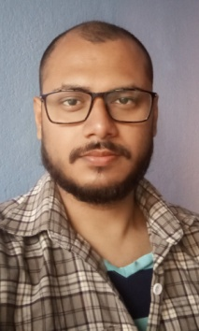

Address: Kurmun, Nutan Pally,

P.O- Kurmun

P.S- Dewan Dighi

Dist- Purba Burdwan,

Pin- 713102

West Bengal.

Email: [Sankusudeep@gmail.com](mailto:Sankusudeep@gmail.com)

Mobile: 8777745734

--------------------------------------------------------------------------------------------------------------------

**CAREER OBJECTIVE:**

* To start a career in a challenging and growth oriented organization to effectively use skills and excel as a professional to achieve greater heights and recognition in career.

**SUMMARY:**

* An enthusiastic, punctual and steady minded individual with interpersonal skills.

**EDUCATIONAL QUALIFICATION:**

* Diploma in Information Technology Application from Computer Training Institute under State Youth Centre, Kolkata.
* 12th from Ashokgarh higher secondary school for boys, Kolkata.
* 10th from Ariadaha Kalachand High School for boys, Kolkata.

**PROFESSIONAL SKILLS:**

* An International Published Author (Writer) in the field of English Literature.
* Basic knowledge of Computer.
* Diploma in Information Technology Application.
* Obtained Certificate from IBM.
* Very good at Computer Typing.

**EXPERIENCE:**

* Fresher.

**STRENGTH:**

* Punctuality.
* Hard Working.
* Ability to learn new things.
* Willing to do anything.

**ACHIEVEMENTS:**

* Won several awards in Sports and Running.
* Won awards in several Cricket Matches.

**HOBBIES:**

* Book Reading.
* Book Writing.
* Listening Music.
* Playing Card and Chess Games.

**PERSONAL DETAILS:**

Father’s Name : Bimal Behari Banerjee.

Date of Birth : 08 November 1993

Gender : Male.

Nationality : Indian.

Religion : Hindu.

Marital Status : Unmarried.

Language known : Bengali, Hindi, English.

**DECLARATION:**

I hereby declare that all the above mentioned information is true to the best of my knowledge and belief.

Place: Burdwan, Kurmun, Nutan Pally. 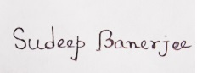

Date: 06/02/2023