SHIVANAND ARUMUGASWAMY 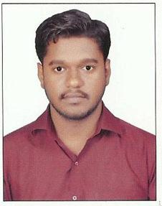



# ***Mobile –*** +91 9820980856

# ***E-mail* -** asydej@gmail.com

# **Summary**

* **An organized and creative professional with proven skills and desire to learn more. Looking to utilize my existing skill set to increase company profitability.**

# **Languages Known**

* **English, Tamil, Hindi and Marathi**

# **Experience**

* Mixed and Mastered Tumba (Punjabi Song) for DJ Rinks featuring Suresh Yamla
* Mixed and Mastered Yasithen (Tamil HipHop song) for artist Arish
* Worked as a recording engineer for various artists on Tamil songs in Chennai

# **Skills**

* Good knowledge about post production
* Quickest DAW operation
* Handling tight schedules
* Delivered projects on time

# **Industry Expertise**

* Pro Tools
* Logic
* Adobe Audition
* FL Studio

# **Educational Details**

* Bachelor of Business Administration in Marketing from Bharati Vidyapeeth Deemed University, Pune.
* HSC 12th from Venutai College of Commerce, Karad.
* SSC 10th from SMS English Medium School, Karad.