**CURRICULUM VITAE**

**HEMANT KUMAR**

Mobile no: 9534836589 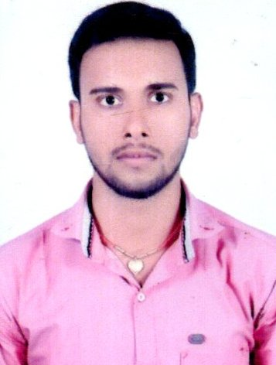

Email ID: - hemantkumar9531@gmail.com

**CAREER OBJECTIVE:**

To secure a challenging position in an esteemed organisation by becoming the part of the team that dynamically works towards the growth of the organisation.

**PROFESSIONAL EXPERIENCE:**

**Profile:** Commercial

**Organisation:** JK tyres and industries LTD

**Department:** Commercial

**From:** 21st Sep 2019

**Location:** Patna

**ROLE &RESPONSIBILITIES:**

* Connect with Dealers Regarding Billing
* Taking Order From Dealers Over Call In absence of Sales Officer
* Making Permit for tyre Delivery
* Claim Acknowledge
* Maintaining Claim Level by calling Dealers to send claim Processed tyre to Depot
* Billing Tyre to Dealers

**ACADEMIC QUALIFICATIONS:**

**2019:** BA In history, Darbhanga 53%

**2016:** 12th from K S COLLEGE Dharbhanga, 52%

**2014:** 10th from LM HIGH SCHOOL , 55%

**Hobby: Cricket**

**SKILLS:**

* Effective communication skill.
* MS EXCEL BASIC Knowledge
* Basic computer Knowledge

**PERSONAL & CONTACT DETAILS:**

Name: Hemant kumar

Date of Birth: 08 – FEB -1998

Languages Known: English, Hindi,

Marital Status: married

Gender: Male

Mobile no: 9534836589

Email ID: hemantkumar9531@gmail.com

Aadhaar card no :4786 5482 3155

**DECLARATION:**

I here by declare that, all the details furnished above are true and correct to the best of my knowledge.

**PLACE: Patna Signature**

**DATE:28.09.2022 Hemant kumar**