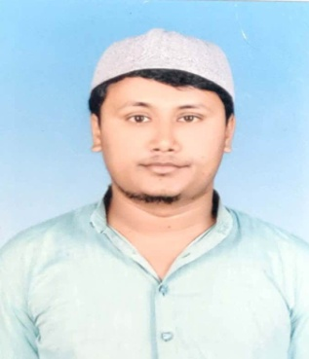***Resume***

**KHALID SAIFULLAH**

**Mobile No-8789939161**

**At-Azad Nagar Ward No-19**

**Po – Araria , Ps – Araria**

**Dist.– Araria, (Bihar)**

**Pin-854311**

***email Id :-khalidsaifullah425@gmail.com***

Educational qualification

|  |  |  |  |  |
| --- | --- | --- | --- | --- |
| **Exam Passed** | **Board University** | **Year** | **Per (%)** | **Div** |
| **Matriculation** | **CBSE DELHI** | **2011** | **76** | **1st** |
| **Intermediate** | **BSEB PATNA** | **2014** | **62.8** | **1ST** |
| **B.TECH(CIVIL)** | **BNMU MADHEPURA** | **2019** | **65** | **1ST** |

Extra Qualification

**ADCA,**

**VOCATIONAL TRANING 1 MONTH (CIVIL TRANING)**

Work Experience

**Fresher**

Personal Details

***Father’s Name : Md Rizwan Alam***

***Date of Birth : 15-12-1995***

***Gender : Male***

***Religion : Muslim***

***Languages Known : Hindi, English & Urdu***

**Marital Status : Unmarried**

**Nationality : Indian**

Declaration

**I hereby declared that above information is true & correct to the best of my knowledge.**

**Thanking you,**

**Place:- Purnea**

**Date- Signature**