Introduction
Welcome
This course is designed for the person that wants to learn what it means to become or be a follower of Jesus. Many people that seek this knowledge realize that the Bible is where they must look, but have been hampered in their quest for one reason or another (e.g. intimidated by the size of the Bible, don’t know where to begin, tried to read the Bible but couldn’t make sense of it, got discouraged, etc.).
This is a self-directed study to assist you in your quest for answers. It is intended to take you rapidly through select books of the Bible to give you a “big picture” overview of what it means to be or become a follower of Jesus, and to become familiarized with the Bible——which is the definitive handbook for those who want to follow Jesus. For maximum benefit, plan on spending about 30 minutes every day for the next few weeks.
The course consists of two parts: the first covers the basics and can be completed in two weeks. The second part “digs deeper” into the Bible and takes an additional five weeks of daily reading. This study lays the basic foundation for understanding the Bible and what it means to be a follower of Jesus.
After completing this course, you will be equipped, empowered and excited to continue your study of the Bible.
The Non-Sequential Reading Approach
Most people that are new to the Bible approach it like any other book that they read——they start at the beginning and read linearly through to the end.
However, this often leads to frustration because a linear reading approach does not readily facilitate an understanding of the Bible as you are reading it. This course takes a different approach by taking you through books of the Bible in a non-sequential order. As such, this facilitates a greater understanding of the big picture of the Bible as you are reading it——that is, as you progress through the daily reading schedule, you will understand more and more what the Bible is saying.
Getting Started
You will need a Bible and a pencil or highlighter.
It is not necessary to buy a study version of the Bible for this course, but you may find it beneficial in the long term to start this course using a study Bible. If English is your native language, choose a modern Bible translation——NIV, NRSV, NASB, ESV and NKJV are all excellent choices——but avoid paraphrase versions for this study. (Paraphrase versions are excellent for getting a different perspective on a word in the original Greek or Hebrew text, but this type of study should be saved for later in your journey.)
The Importance of Daily Reading
Carve out time each day to complete the readings.
This course requires about 20-40 minutes of focused, uninterrupted daily reading. Every day before you begin reading, pray to God asking that the Holy Spirit would give you insight and understanding into what you are about to read.
Read the Bible selection as quickly as you can without skimming or speed reading (if you have a study Bible, do not stop to read the commentary notes, or do so only sparingly). If you notice a verse of interest, highlight it or underline it with a pencil, but do not stop to contemplate at this point in time yet (instructions will be given at the end of the course on how to read the Bible contemplatively and how to effectively use study Bibles and other commentaries).
It is important to read every day——missing a day or two will make it more difficult to remember where you left off and will also make it harder for you to develop a “big picture” view of the Bible.
The Bible at a Glance
The Bible consists of the Hebrew and Greek Scriptures.
The Hebrew Scriptures contain 39 books written by many different authors over a one thousand year period, between approximately 1400-400 BC. Except for a few sections, it is written entirely in Hebrew. A more detailed description of the Hebrew Scriptures is included later in this study, but for the purposes of this introduction, it is sufficient to summarize that the Hebrew Scriptures as a whole tell of a special and unique task that the Creator God gave to the descendants of a man named Abraham——the Israelites. The purpose of this task was that the Israelites were “commissioned” to tell all the other people of the world about the Creator God. The Hebrew Scriptures contain many references of the coming of a Messiah (which is the Hebrew word for savior or rescuer).
Image: Old Testament Structure and Timeline
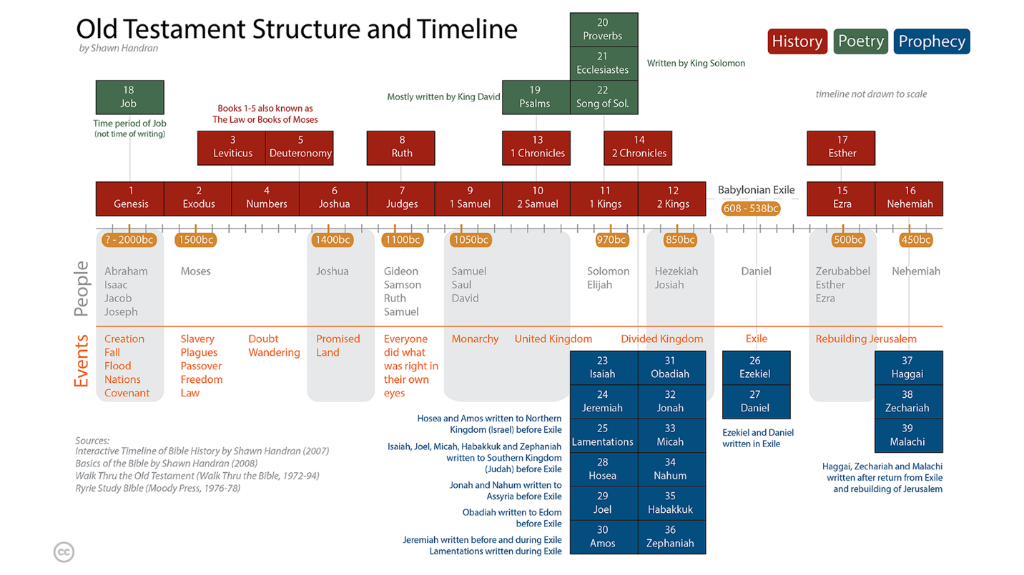
The Greek Scriptures contain 27 books, also written by several different authors over a period of approximately 50 years, around 40-90 AD. The Greek Scriptures show how the Creator God entered into history by becoming a human, fulfilling what was written in the Hebrew Scriptures about the coming Messiah (Savior). The Messiah is a descendant of Abraham named Yeshua (Joshua), or as translated in English: Jesus. The Greek word for Messiah is Christos, from which the title Christ is derived. Today, we put the name and title together: Jesus (the) Christ.
Image: New Testament Structure and Timeline
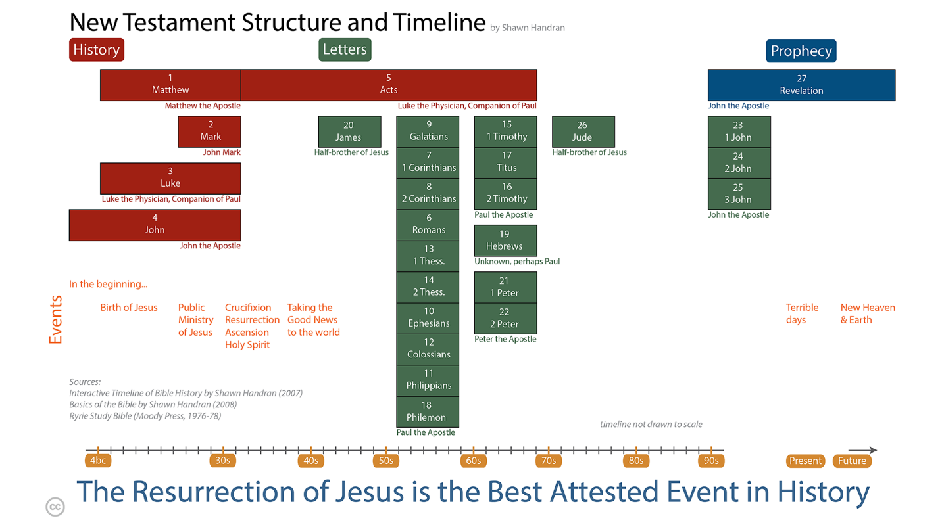
Navigating the Bible: Chapters and Verses
The Bible is numbered so that it is easy to navigate and find a particular passage.
Most of the books are divided into chapters (a few of the smallest books have a single un-numbered chapter), and each chapter in turn is divided into verses. A verse is typically one or two sentences. Even those that are unfamiliar with the Bible have probably heard someone quote or refer to John 3:16. This means the book of John, chapter 3, verse 16. When looking up books in the Bible, refer to the table of contents. In this example, the book of John, or the Gospel of John as it is known by its longer title, is located toward the back of the Bible. Once you locate John, flip through a couple of pages until you reach chapter 3. In most Bibles, the font size of the chapter number is much larger than the rest of the text whereas the verse number is a small superscript number embedded within the text itself. See examples:
Genesis 1:1 1¹In the beginning God created the heavens and the earth.
John 3:16 ¹⁶For God so loved the world that he gave his one and only Son, that whoever believes in him shall not perish but have eternal life.

簡介
歡迎
本課程專為想要了解成為或作為耶穌跟隨者有何意義的人而設計。許多尋求這方面知識的人明白，他們必須從聖經中尋找答案，但在尋求的過程中卻因各種原因受阻（例如：被聖經的篇幅嚇退、不知從何讀起、試著讀聖經卻看不懂、感到氣餒等）。
這是一份自主學習材料，旨在協助你尋找答案。它的目的是帶領你快速瀏覽精選的聖經書卷，為你提供一個「全局」概覽，讓你了解成為或作為一名耶穌跟隨者的意義，並讓你熟悉聖經——對於那些想要跟隨耶穌的人來說，這是一本權威的手冊。為了獲得最大的益處，請計畫在接下來的幾週內，每天花費大約30分鐘。
本課程包含兩個部分：第一部分涵蓋基礎知識，可在兩週內完成。第二部分「深入探討」聖經，需要額外五週的時間每天閱讀。這項學習為理解聖經以及成為耶穌跟隨者的意義奠定了基礎。
完成本課程後，你將得到裝備、獲得能力並充滿熱忱地繼續學習聖經。
非順序讀經法
大多數剛接觸聖經的人，會像閱讀其他書籍一樣來讀聖經——他們從頭開始，按順序一直讀到最後。
然而，這往往會帶來挫折感，因為線性的閱讀方式無法幫助你輕易地*在閱讀的當下明白聖經。本課程採取不同的方法，帶領你以非順序的方式來閱讀聖經各卷書。因此，這能幫助你在閱讀的同時對聖經的全貌有更深入的了解*——也就是說，隨著你按著每日的閱讀進度前進，你會越來越明白聖經在說什麼。
準備開始
你需要一本聖經和一支鉛筆或螢光筆。
本課程不一定要購買研讀版聖經，但從長遠來看，使用研讀本聖經來開始本課程對你可能會大有裨益。如果英文是你的母語，請選擇現代的聖經譯本——NIV、NRSV、NASB、ESV和NKJV都是極佳的選擇——但在本課程的研讀中，請避免使用意譯本。（意譯本對於從不同角度理解希臘文或希伯來文原文中的詞彙極為有用，但這類型的研讀應該留待你未來進深時再進行。）
每日閱讀的重要性
請撥出時間，每天完成閱讀進度。
本課程需要大約 20-40 分鐘專注、不受打擾的每日閱讀。每天在開始閱讀前，請向上帝禱告，求聖靈賜你洞察力與悟性，以明白你即將閱讀的內容。
請在不略讀或速讀的情況下，盡可能快地閱讀所選的聖經經文（如果你使用的是研讀本聖經，請勿停下來閱讀註釋，或者盡量少讀）。如果你注意到感興趣的經文，可以使用螢光筆標記或用鉛筆畫線，但此時還不要停下來默想（課程結束時將會提供指引，教導如何默想式地閱讀聖經，以及如何有效地使用研讀本聖經與其他註釋書）。
重要的是要每天閱讀——漏掉一兩天會讓你更難記住上次讀到哪裡，也會讓你更難建立對聖經的「全貌」觀。
聖經概覽
聖經由希伯來經典和希臘經典所組成。
希伯來聖經包含39卷書，由許多不同的作者在約公元前1400至400年間，歷經一千年的時間寫成。除了少數段落外，它完全是用希伯來文寫成的。本研究稍後將對希伯來聖經作更詳細的說明，但就本簡介的目的而言，只需總結：希伯來聖經整體講述了創造主上帝交託給一個名叫亞伯拉罕的後裔——以色列人——一項特別且獨特的任務。這項任務的目的是以色列人受「委託」，要向世界上所有其他人傳揚這位創造主上帝。希伯來聖經包含許多關於彌賽亞（希伯來文的意思是救主或拯救者）降臨的記載。
圖片：舊約結構與時間線
希臘文聖經包含27卷書，同樣由幾位不同的作者在約50年的期間內寫成，大約在公元40-90年。希臘文聖經展示了造物主上帝如何藉著成為人類進入歷史，成就了希伯來文聖經中關於那位將要來的彌賽亞（救主）的記載。彌賽亞是亞伯拉罕的後裔，名叫耶書亞（約書亞），或按英文翻譯為：耶穌。彌賽亞的希臘文是 Christos，基督這個稱呼即源自於此。今天，我們將名字和稱呼放在一起：耶穌基督。
圖片：新約結構與時間線
聖經導覽：章與節
聖經有編號，以便於查閱並找到特定的經文。
大多數的書卷被劃分為多個章（少數篇幅最短的書卷只有一章且不標示章號），而每一章又被劃分為多個節。一節通常包含一兩個句子。即使是不熟悉聖經的人，可能也聽過有人引用或提及約翰福音3:16。這指的是約翰福音，第3章，第16節。在聖經中查找書卷時，請參考目錄。在這個例子中，約翰這卷書（或者按其較長的書名被稱為《約翰福音》），位於聖經較後面的部分。找到《約翰福音》後，往後翻幾頁，直到翻到第3章。在大多數的聖經中，章號的字體會比其他內文大得多，而節號則是嵌入在內文中的小型上標數字。請看範例：
創世記 1:1 11起初，神創造天地。
約翰福音 3:16 16神愛世人，甚至將他的獨生子賜給他們，叫一切信他的，不致滅亡，反得永生。
一般來說，使用您的第一語言能讓您最透徹地理解聖經，因此如果您的母語有相應的譯本，請隨意使用。如果您精通雙語，請使用您最習慣的語言。

Generally, you’ll understand the Bible best in your first language, so feel free to use that translation if it is available in your native tongue. If you are bilingual, use the language with which you are most comfortable

