TubeFlow Local Renderer - Daily Workflow
Use this every day after Windows setup is already completed
Use this document for daily work. Do not repeat the install steps unless admin asks you to reinstall.

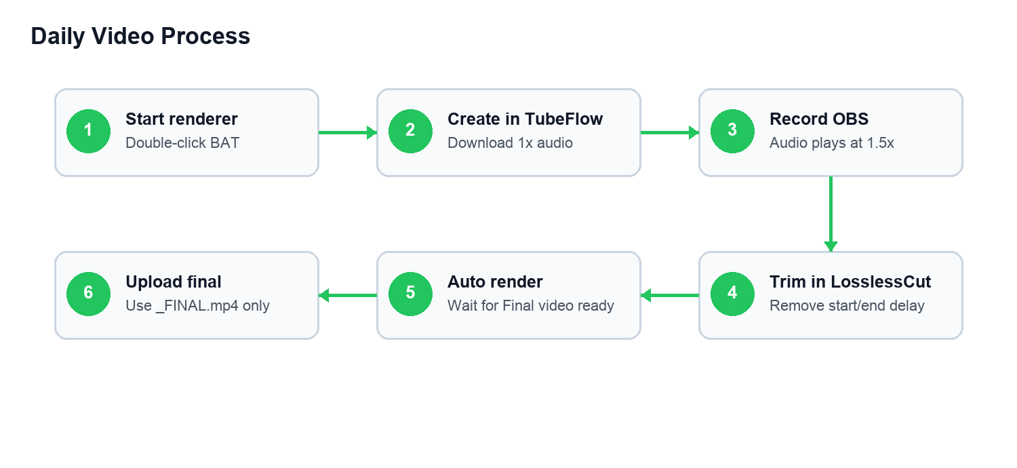

Before Starting Videos
- Open C:\TubeFlow_Local_Renderer.
- Double-click Start_TubeFlow_Renderer.bat.
- Keep the black renderer window open while working.
- Confirm it says Waiting for LosslessCut exports.

For Each Video

1. Create Audio In TubeFlow
- Open TubeFlow Production Tool.
- Create the topic.
- Generate script and audio.
- Click Download 1x Audio.
- Leave the audio in Downloads.
Do not use random names like audio.mp3 or download (4).mp3. The audio name should match the topic.

2. Record Screen In OBS
- Start OBS recording.
- In TubeFlow, click Start Recording.
- The audio plays at 1.5x.
- Record the browser steps.
- Stop OBS when finished.

3. Trim In LosslessCut
- In OBS, click File > Show Recordings.
- Double-click the latest OBS recording to open it in LosslessCut.
- Trim the delay at the beginning.
- Trim the delay at the end.
- Export the trimmed file to C:\Users\<your-name>\Videos\LosslessCut.
- Name the exported video similar to the audio/topic.
Only the trimmed LosslessCut export should go into Videos\LosslessCut. Raw OBS recordings should stay in Videos\OBS_Recordings.

4. Wait For Final Render
The renderer window should show:
Found video
Matched audio
Starting FFmpeg render
Final video ready
Do not close the renderer while it says Starting FFmpeg render.

5. Upload Final Video
- Open C:\Users\<your-name>\Desktop\Ready_For_Google_Drive.
- Play the final video once.
- Upload only the file ending with _FINAL.mp4 to Google Drive.

Quality Check Before Upload
- Screen text is sharp.
- Audio is clean.
- Audio timing matches the screen action.
- Start delay is removed.
- End delay is removed.
- Filename ends with _FINAL.mp4.

Do Not Do These
- Do not close the renderer while it is rendering.
- Do not upload raw OBS recordings.
- Do not upload files from Processed_By_TubeFlow.
- Do not continue many videos if audio is wrong.
- Do not export LosslessCut files to Downloads.

If Something Goes Wrong
Problem | Likely Reason | What To Do
Audio not found | Audio name does not match video topic. | Check Downloads and contact admin.
Final video not created | Renderer moved the file for checking. | Check Videos\LosslessCut\Needs_Admin_Help.
Wrong audio | Wrong audio was downloaded or matched. | Stop and contact admin immediately.
Renderer closed | Black window was closed. | Open Start_TubeFlow_Renderer.bat again.
FFmpeg not found | Install was not completed correctly. | Contact admin.

