TubeFlow Local Renderer - Windows Install Only
One-time setup guide for freelancer PC
Use this document only once during setup. After setup is complete, use the separate Daily Workflow document for normal work.

What This Installs
This installs the local renderer on the freelancer's Windows computer. The renderer automatically creates the final TubeFlow video after the freelancer places the 1x audio in folder 01 and the OBS or LosslessCut video in folder 02.
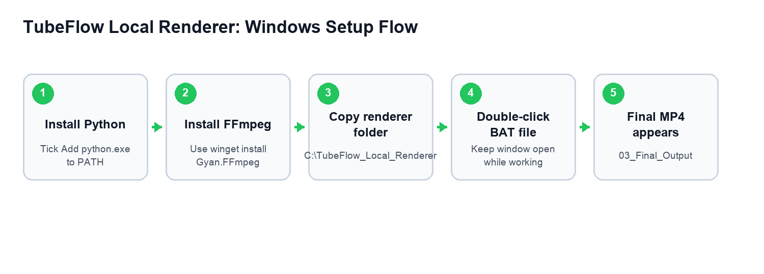

What You Will Receive From Admin
Admin will provide one ZIP file named TubeFlow_Local_Render_Freelancer_Package.zip. Download this ZIP file first, then extract it on the Windows PC.
After extracting, the folder should contain these important files:
- 01_Audio_1x - put the downloaded TubeFlow 1x audio here.
- 02_OBS_or_LosslessCut_Video - put the final screen recording here after trimming if needed.
- 03_Final_Output - collect the final _FINAL.mp4 video from here.
- 04_Processed_Raw_Video - old raw video is moved here after successful render.
- 05_Needs_Checking - failed videos are moved here for admin checking.
- Start_TubeFlow_Renderer.bat - double-click this to start the local renderer.
- renderer.py - main renderer program.
- config.json - renderer settings.
- TubeFlow_Local_Renderer_Windows_INSTALL_ONLY.docx - this setup document.
- TubeFlow_Local_Renderer_DAILY_WORKFLOW.docx - daily work process document.
Do not create your own renderer folder. Use the ZIP file provided by admin, then copy the extracted TubeFlow_Local_Render folder to C:\TubeFlow_Local_Render.

Required Links
Tool | Link | Purpose
Python for Windows | https://www.python.org/downloads/windows/ | Required to run the renderer.
FFmpeg official page | https://ffmpeg.org/download.html | Required for video merging.
FFmpeg Windows builds | https://www.gyan.dev/ffmpeg/builds/ | Recommended Windows build.
FFmpeg install video search | https://www.youtube.com/results?search_query=install+ffmpeg+windows+11+add+to+path | Use if extra visual help is needed.
OBS Studio | https://obsproject.com/download | Screen recording software.
LosslessCut | https://github.com/mifi/lossless-cut/releases | Used to trim start/end delay.

Step 1: Install Python
- Open the Python link above.
- Download Python for Windows.
- On the first installer screen, tick Add python.exe to PATH.
- Click Install Now and finish setup.
Important: If Add python.exe to PATH is missed, the renderer may not start.

Step 2: Install FFmpeg
- Press the Windows key.
- Search Command Prompt.
- Right-click Command Prompt and choose Run as administrator.
- Paste this command and press Enter:
winget install Gyan.FFmpeg
- When Windows asks for permission, accept it.
- After install finishes, close Command Prompt.
- Open Command Prompt again and run:
ffmpeg -version
If version details appear, FFmpeg is working. If not, contact admin.

Step 3: Copy The Renderer Folder
After extracting the ZIP file from admin, copy the full folder named TubeFlow_Local_Render to the C drive. Do not copy only one file.
C:\TubeFlow_Local_Render
The folder must contain these files:
- 01_Audio_1x
- 02_OBS_or_LosslessCut_Video
- 03_Final_Output
- 04_Processed_Raw_Video
- 05_Needs_Checking
- renderer.py
- config.json
- Start_TubeFlow_Renderer.bat
- TubeFlow_Local_Renderer_Windows_INSTALL_ONLY.docx
- TubeFlow_Local_Renderer_DAILY_WORKFLOW.docx
Correct final example:
C:\TubeFlow_Local_Render\Start_TubeFlow_Renderer.bat
C:\TubeFlow_Local_Render\renderer.py
C:\TubeFlow_Local_Render\config.json

Step 4: Check The Five Work Folders
These folders are already included in the ZIP. Open the renderer folder and confirm they are visible:
C:\TubeFlow_Local_Render\01_Audio_1x
C:\TubeFlow_Local_Render\02_OBS_or_LosslessCut_Video
C:\TubeFlow_Local_Render\03_Final_Output
C:\TubeFlow_Local_Render\04_Processed_Raw_Video
C:\TubeFlow_Local_Render\05_Needs_Checking
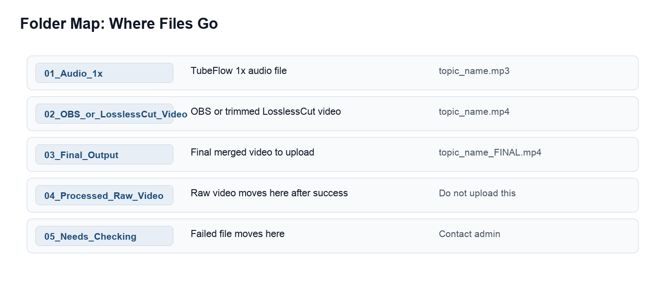

Step 5: Test Renderer Opens
- Open C:\TubeFlow_Local_Render.
- Double-click Start_TubeFlow_Renderer.bat.
- A black window should open.
- It should say:
Waiting for video files...
Setup is complete when the black renderer window opens successfully.

OBS Settings To Confirm
Setting | Value
Base Canvas Resolution | 1920x1080
Output Scaled Resolution | 1920x1080
Downscale Filter | Lanczos
FPS | 30
Recording Format | MKV preferred, MP4 allowed
Video Encoder | Hardware H.264 if available
Bitrate | 15000 Kbps
Audio Sample Rate | 44.1 kHz
Recording Path | C:\Users\<your-name>\Videos\OBS_Recordings

Opening OBS Recording In LosslessCut
OBS does not reliably auto-open every finished recording in LosslessCut. Use this simple process instead:
- In OBS, keep Recording Path as C:\Users\<your-name>\Videos\OBS_Recordings.
- After stopping OBS, click File > Show Recordings.
- Double-click the latest recording to open it in LosslessCut.
- If trimming is needed, export the trimmed file back to C:\TubeFlow_Local_Render\02_OBS_or_LosslessCut_Video.
Important: do not use 02_OBS_or_LosslessCut_Video as the raw OBS recording folder if you need to trim. Put only the ready video there.

