TubeFlow Local Renderer
Windows install guide and daily merging process for freelancers
Purpose: Install the local renderer one time on Windows, then use it daily to merge TubeFlow 1x audio with OBS recordings made while listening at 1.5x.

Required Download Links
Tool | Link | Why Needed
Python for Windows | https://www.python.org/downloads/windows/ | Install Python and tick Add python.exe to PATH.
FFmpeg official download page | https://ffmpeg.org/download.html | Official FFmpeg download information.
Recommended FFmpeg Windows builds | https://www.gyan.dev/ffmpeg/builds/ | Used by winget package Gyan.FFmpeg.
LosslessCut | https://github.com/mifi/lossless-cut/releases | Used to trim the start/end delay before final render.
OBS Studio | https://obsproject.com/download | Used for screen recording.
FFmpeg install video search | https://www.youtube.com/results?search_query=install+ffmpeg+windows+11+add+to+path | Use a recent tutorial if manual help is needed.

One-Time Windows Setup
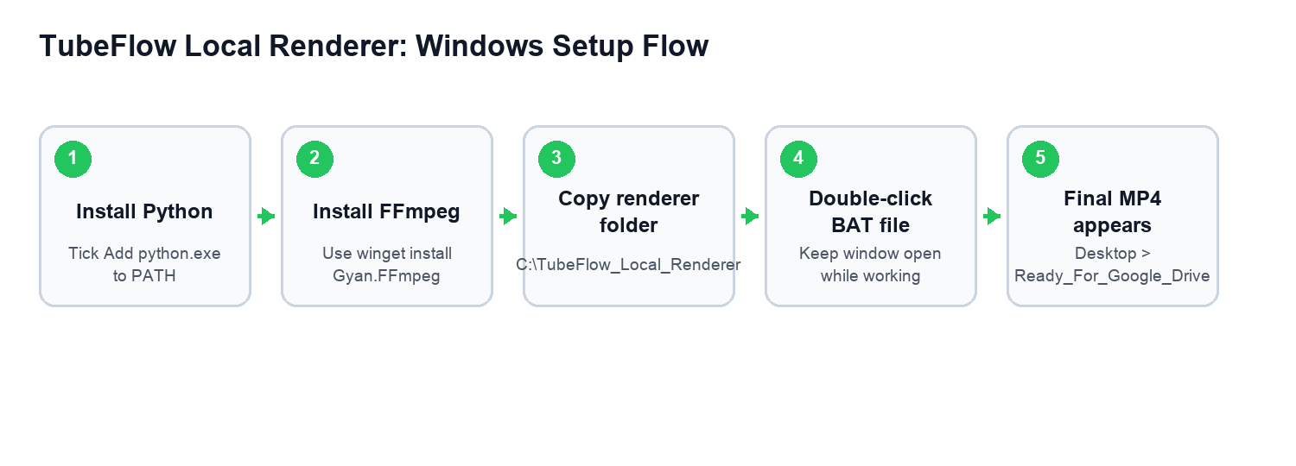

Step 1: Install Python
- Open the Python link from the Required Download Links table.
- Download the latest Python for Windows.
- On the first installer screen, tick Add python.exe to PATH.
- Click Install Now and wait until setup is complete.
Do not skip Add python.exe to PATH. The renderer may not start if this is missed.

Step 2: Install FFmpeg
- Press the Windows key and search Command Prompt.
- Right-click Command Prompt and choose Run as administrator.
- Paste the command below and press Enter.
winget install Gyan.FFmpeg
- When Windows asks for permission, accept it.
- After install finishes, close Command Prompt and open it again.
- Run the check command below.
ffmpeg -version
If version details appear, FFmpeg is installed correctly. If Windows says ffmpeg is not recognized, contact admin.

Step 3: Copy The Renderer Folder
- Admin will share a folder named TubeFlow_Local_Renderer.
- Copy that full folder directly to C drive.
- The final location must be exactly:
C:\TubeFlow_Local_Renderer
- renderer.py
- config.json
- Start_TubeFlow_Renderer.bat

Step 4: Create These Windows Folders
C:\Users\<your-name>\Videos\LosslessCut
C:\Users\<your-name>\Desktop\Ready_For_Google_Drive
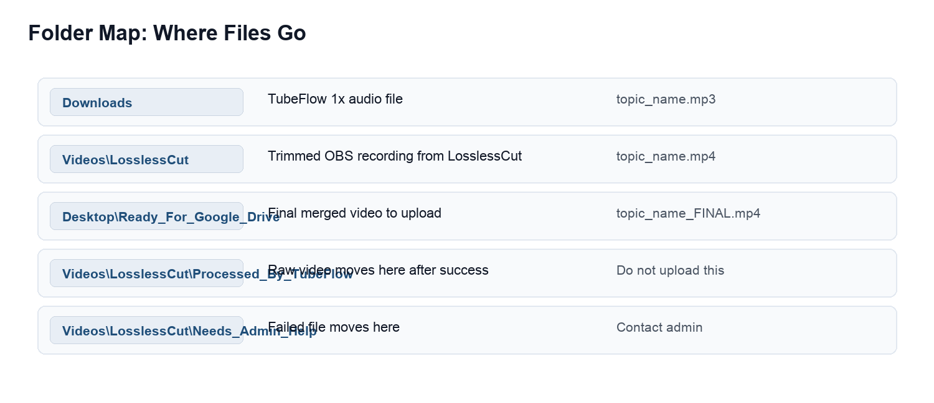

Step 5: Start The Renderer
- Open C:\TubeFlow_Local_Renderer.
- Double-click Start_TubeFlow_Renderer.bat.
- A black window opens.
- Keep this window open while working.
Waiting for LosslessCut exports...

OBS Recording Settings
Setting | Value
Base Canvas Resolution | 1920x1080
Output Scaled Resolution | 1920x1080
Downscale Filter | Lanczos
FPS | 30
Recording Format | MKV preferred, MP4 allowed if needed
Video Encoder | Hardware H.264 if available
Rate Control | CBR
Bitrate | 15000 Kbps
Keyframe Interval | 2 seconds
Profile | High
Audio Sample Rate | 44.1 kHz
OBS audio is only a rough reference. The renderer removes OBS audio and adds the clean TubeFlow 1x audio.

Daily Process For Every Video
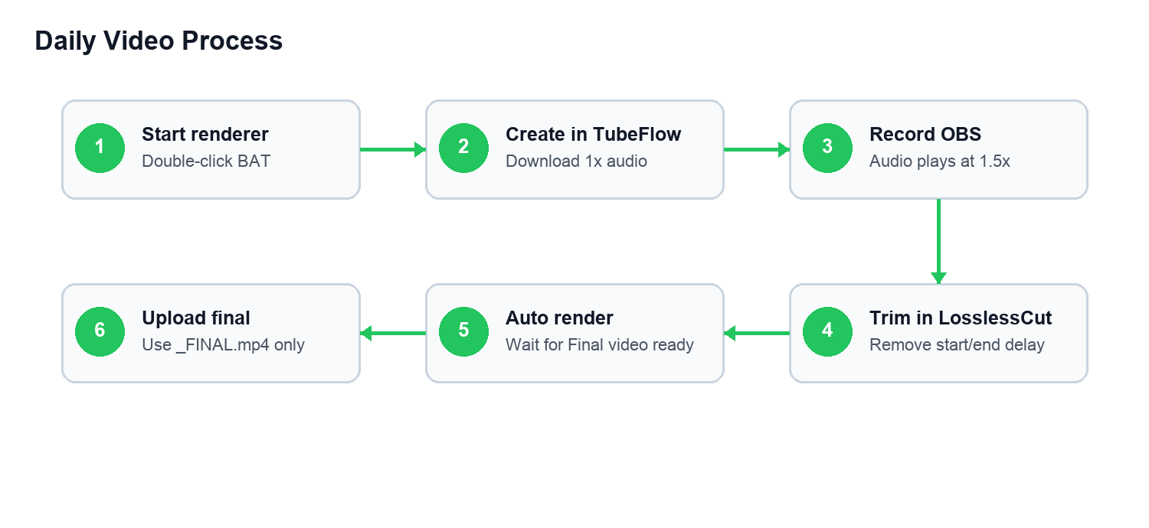

1. Start Renderer Before Work
- Open C:\TubeFlow_Local_Renderer.
- Double-click Start_TubeFlow_Renderer.bat.
- Keep the black window open.

2. Create Audio In TubeFlow
- Open TubeFlow Production Tool.
- Create the video topic.
- Generate script and audio.
- Click Download 1x Audio.
- Keep the downloaded audio in Downloads.
Audio filename should clearly match the topic. Avoid generic names like audio.mp3 or download (4).mp3.

3. Record Screen In OBS
- Start OBS recording.
- In TubeFlow, click Start Recording.
- Listen to TubeFlow audio at 1.5x while recording the browser steps.
- Stop OBS when the task is complete.

4. Trim In LosslessCut
- Open the OBS recording in LosslessCut.
- Trim the beginning delay.
- Trim the ending delay.
- Export to C:\Users\<your-name>\Videos\LosslessCut.
- Name the video similar to the downloaded audio.

5. Wait For Auto Merge
Found video
Matched audio
Starting FFmpeg render
Final video ready
Do not close the black renderer window while it says Starting FFmpeg render.

6. Upload Final File
- Open C:\Users\<your-name>\Desktop\Ready_For_Google_Drive.
- Play the final video once.
- Upload only the file ending with _FINAL.mp4 to Google Drive.

Important Rules
- Audio and video names must match the same topic.
- Always trim in LosslessCut before final render.
- Upload only the _FINAL.mp4 file.
- Do not upload raw OBS recordings.
- Do not upload files from Processed_By_TubeFlow.
- If anything looks wrong, stop and ask admin before creating more videos.

Common Problems
Problem | Likely Reason | What To Do
FFmpeg not found | FFmpeg was not installed or PATH did not update. | Run ffmpeg -version. If it fails, contact admin.
Audio not found | Audio filename does not match video topic. | Check Downloads and rename carefully.
Final video not created | Video moved to Needs_Admin_Help. | Check Videos\LosslessCut\Needs_Admin_Help and contact admin.
Wrong audio | Wrong audio was downloaded or matched. | Stop work and contact admin immediately.
Renderer closed | Black window was closed. | Open Start_TubeFlow_Renderer.bat again.

Final Quality Check
- Screen text is sharp.
- Audio is clean.
- Audio timing matches the screen action.
- Start delay is removed.
- End delay is removed.
- Filename ends with _FINAL.mp4.

Admin Reference
Renderer output profile:
Resolution: 1920x1080
FPS: 30
Video codec: H.264
Speed correction: setpts=1.5*PTS
Audio: AAC, 44.1 kHz, mono
Final upload file: *_FINAL.mp4

