MySQL and Database Design:

ERD: Entity Relationship Design

* ERD’s are visual blueprints for how your database looks and behaves. ERD’s and SQL work together very intimately.
* ERD is map of structure of how we want to store our data. SQL is the language we use to manipulate the data as per the relationships we defined in our ERD.

**Don’t Repeat Data!**

Database Relationships (remember to check both directions):

* One to One:
  + Customers and Credit Cards: Every Customer has one Credit Card, every Credit Card belongs to one Customer.
  + User and Email: Every User has one Email Address, every Email Address has one User.
  + Product and Image: Every Product has an Image, every Image is of a Product.

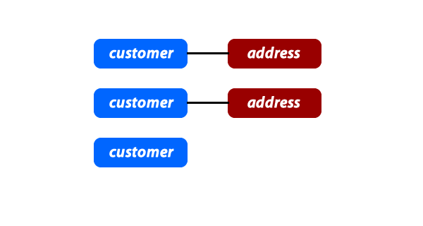

* One to Many
  + Messages and Comments - One Comment belongs to one Message, but one Message can have many Comments.
  + States and Cities - One City is only in one State, but one State can have many Cities.
  + Customers and Orders - One Order only has one Customer, but one Customer can have many Orders.

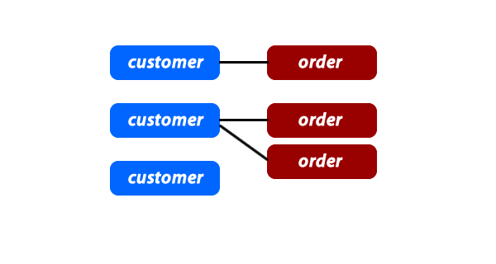

* Many to Many: **anytime you have a Many-to-Many, it will require some sort of joining table!**
  + Users and Interests - One User can have many Interests, one Interest can be applied to many Users.
  + Actresses and Movies - One Movie can have many Actresses, one Actress can be in many Movies.
  + Businesses and Cities - One Business can be spread across many Cities, one City can be home to many Businesses.

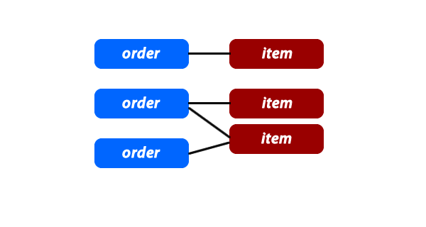

**Normalization:**

Database normalization is simply a convention for splitting large tables of data into smaller separate tables with the primary goal being to not repeat data. *It is possible to take normalization to an extreme.*

Some rules (in order of priority):

1. Each column in your table can only have 1 value.
2. Each column in your table that is not a key (primary or foreign) must have unique values.
3. You cannot have a non-key column that is dependent on another non-key column.

**Conventions:**

Reasons:

1. Developers can have a better understanding of your database if you are using a set of industry standards.
2. Developers can create software to automate a lot of the queries if some assumptions can be made.

**Guidelines:**

1. **Make the table name plural and ALL lowercase**
2. **Use “id” as the primary key**
3. **Name foreign keys with singular_table_name_id**
4. **Use *created_at* and *updated_at* as columns for the timestamp in EVERY table you create**

DATA TYPES:

Simple Data Types:

* **VARCHAR(*number of characters*)**
  + Used to store non-numeric values that can be up to 255 characters. It is called a VARCHAR because it can store a variable number of characters and will only use the space required for each record that is stored in the database. VARCHAR should be used for values with different character lengths like an email, first_name, or last_name.
* **CHAR(*number of characters*)**
  + Also used to store non-numeric values, however, it will use up all space for the set number of characters regardless of what value is added. For instance, if I set CHAR(15), and I try to store the value "Coding", it will use up the equivalent of 15 characters even though "Coding" is only 6 characters long. Char is good to use for things that will always be a given number of characters. Char would work well for something like a state_abreviation.
* **INT**
  + Used to store integers.
  + The columns that you will find mostly using the INT are things like a unique identifier for each table. The majority of rows in a table will not exceed 2.1 billion records. INT is good to use for most normal number values like a phone_number or a zip_code.
  + **unsigned** (positive numbers only) - can store numerical values from 0 up to 4294967295
  + **signed** (positive and negative numbers) - can store numerical values from -2147483648 up to 2147483647
* **BIGINT**
  + BIGINT would be used for columns that would need to store huge numbers. In most cases you wouldn't need BIGINT, but if you wanted to store something like a Facebook id when using Facebook's API, since they have over a billion users the id will need to be a data type of BIGINT.
  + **unsigned**(again positive numbers only) -can store numerical values from 0 up to 18446744073709551615
  + **signed**(positive and negative numbers) - can store numerical values from 9223372036854775807 to -9223372036854775808.
* **TINYINT**
  + TINYINT would be good to use for numbers that will be relatively small. A good example of something that would use a TINYINT is user level identifier (0 - inactive user, 1 - active user, 9 - admin).
  + **unsigned -**can store numerical values from 0 up to 255
  + **signed -**can store numerical values from -128 up to 127
* **FLOAT**
  + Used to store floating point numbers (numbers that need to have decimal places). An example column for this would be like an item_cost.
* **TEXT**
  + Used to store a large amount of text, like a description, message, or comment. Use this for any text that VARCHAR() is too small to handle.
* **DATETIME**
  + used to store a date and time in the format *YYYY-MM-DD hh:mm:ss*