Detailed time series 2001 to 2014

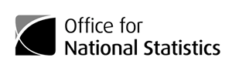

Correction

MYEB3 detailed population estimates series UK, 2002 to 2015

A small error occurred in Mid-2015 Table MYEB3_summary_components_of_change_series_UK_(0215) due to a processing error for Northern Ireland subnational internal migration data. We have corrected this error. You can see all [previous versions](https://www.ons.gov.uk/peoplepopulationandcommunity/populationandmigration/populationestimates/datasets/populationestimatesforukenglandandwalesscotlandandnorthernireland/mid2015) of this data. We apologise for any inconvenience.

Corrected: 23 March 2017

Source: Office for National Statistics © Crown Copyright 2017

2017 Data supplier: Population Estimates Unit Population Statistics Division Office for National Statistics Segensworth Road FAREHAM

PO15 5RR