Temperature Prediction Using Machine Learning

Course: Neural Networks & Deep Learning
Project Type: Regression with Auxiliary Classification Analysis
Dataset: Weather History, Szeged, Hungary (2006–2016)
Group Members: Wisam Alam (F2023-751), Basil Haq (F2023-625)

1. Introduction
Weather forecasting plays an important role in agriculture, transportation, energy management and daily human planning. Temperature in particular is influenced by a combination of atmospheric, seasonal and environmental factors. Accurately predicting temperature is therefore a challenging but valuable machine learning problem.
The objective of this project is to predict hourly temperature (°C) using historical weather data. This is formulated primarily as a regression problem, where the goal is to estimate a continuous numerical value. In addition, a secondary classification based analysis is performed to qualitatively assess how well the model captures real world weather conditions (e.g., Cold, Warm, Hot).
Rather than focusing only on achieving high accuracy, this project emphasizes understanding and applying the machine learning pipeline, including data preprocessing, feature engineering, baseline modelling, training optimization, evaluation and error analysis.

2. Dataset Description & Data Understanding
The dataset used in this project is the Weather History Dataset (Szeged, Hungary), covering the years 2006 to 2016 with hourly observations. Each record contains meteorological measurements collected from weather sensors.
Key Features Used
- Humidity
- Pressure (millibars)
- Wind Speed (km/h)
- Visibility (km)
- Formatted Date
Target Variable
- Temperature (°C)
Initial inspection revealed missing values, redundant features and sensor related anomalies making preprocessing a necessary step before model training.

3. Data Preprocessing & Cleaning
To ensure data quality and prevent the model from learning noise, the following preprocessing steps were applied:
- Handling Missing Values
Rows containing null values were removed using dropna() to maintain data consistency.
- Outlier Removal
The Pressure (millibars) feature contained values equal to zero, which are physically unrealistic and likely caused by sensor errors. These rows were filtered out.
- Removing Redundant Features
The Loud Cover column was dropped as it contained only zero values and provided no predictive information.
After cleaning, the dataset was well structured and suitable for feature engineering and modelling.

4. Feature Engineering
4.1 Motivation
Initial experiments using only raw physical features resulted in limited performance. This indicated that temperature is not solely dependent on instantaneous weather measurements but is also strongly influenced by seasonality.
4.2 Cyclical Feature Encoding (Seasonal Features)
Calendar based features such as month or day number are not inherently meaningful to machine learning models. For example, December (12) and January (1) appear far apart numerically despite being seasonally adjacent.
To address this, the day of the year was encoded using sine and cosine transformations:
- day sin = sin(2π × day of year / 365.25)
- day cos = cos(2π × day of year / 365.25)
This transformation allows the model to capture the cyclical nature of seasons smoothly and continuously.
4.3 Final Feature Set
The final features used for training were:
- Humidity
- Pressure (millibars)
- Wind Speed (km/h)
- Visibility (km)
- day sin
- day cos
This step proved to be the most impactful improvement in the project.
5. Establishing a Baseline Model
A baseline Linear Regression model was first trained using raw physical features without seasonal encoding.
Baseline Performance
- R² Score: ~0.44 (44%)
- Mean Absolute Error (MAE): ~5.8 °C
The poor baseline performance confirmed that raw sensor readings alone are insufficient to explain temperature variations, especially across different seasons.

6. Training Optimization
To improve performance and model stability, several training optimization techniques were applied.
6.1 Train-Test Split
The dataset was split into:
- 80% Training Data
- 20% Testing Data
This ensured that the model’s performance was evaluated on unseen data reducing the risk of overfitting.
6.2 Feature Scaling
All features were standardized using StandardScaler to ensure that variables with larger numerical ranges did not dominate the learning process.
6.3 Polynomial Feature Expansion
Second degree polynomial features were generated to capture non linear relationships between weather variables (e.g., interactions between humidity and seasonal effects).
6.4 Ridge Regression (Regularization)
Polynomial expansion increases model complexity and the risk of overfitting. To counter this, Ridge Regression (L2 regularization) was applied. This penalizes large coefficients and improves generalization.
These optimization steps significantly enhanced model robustness without sacrificing interpretability.

7. Model Evaluation & Validation
7.1 Regression Performance (Primary Evaluation)
The optimized model achieved:
- R² Score: ~0.84 (84%)
- Mean Absolute Error (MAE): ~3.0 °C
- Root Mean Squared Error (RMSE): ~3.9 °C
Interpretation:
The model explains approximately 84% of the variance in temperature and predicts values within ±3°C on average, which is strong performance for real world weather data.
A scatter plot of Actual vs. Predicted Temperature showed a tight clustering around the ideal 45° line, further validating the model’s effectiveness.

8. Auxiliary Classification Analysis
To interpret regression results qualitatively, predicted temperatures were grouped into five weather categories:
- Freezing (< 0°C)
- Cold (0–10°C)
- Mild (10–20°C)
- Warm (20–30°C)
- Hot (> 30°C)
Classification Results
- Overall Accuracy: 72%
Interpretation
Classification accuracy is inherently limited because continuous temperature values are mapped to discrete categories. Most misclassifications occurred near category boundaries (e.g., Mild vs. Warm), rather than due to large prediction errors.
A confusion matrix confirmed that the model performs well for extreme categories while showing expected overlap in transitional ranges.

9. Error Analysis
Key observations from error analysis:
- Errors are concentrated near category boundaries
- Extreme misclassifications are rare
- Seasonal trends are captured effectively
This indicates that the model understands overall weather patterns but is sensitive to small numerical deviations which is expected in real world regression tasks.

10. Conclusion & Future Work
This project successfully demonstrates a complete machine learning workflow, progressing from a weak baseline to a well optimized model through thoughtful feature engineering and training optimization.
Key Achievements
- Improved R² score from 44% to 85%
- Demonstrated the importance of cyclical feature encoding
- Applied regularization to control overfitting
- Conducted both quantitative and qualitative evaluation
Future Improvements
- Use ensemble models (Random Forest, Gradient Boosting)
- Apply time-series specific models
- Explore deep learning approaches for long term forecasting

Overall, this project highlights that understanding the data and problem structure is often more important than using complex models and that careful feature engineering can significantly improve model performance.

Screenshots
Confusion Matrix:
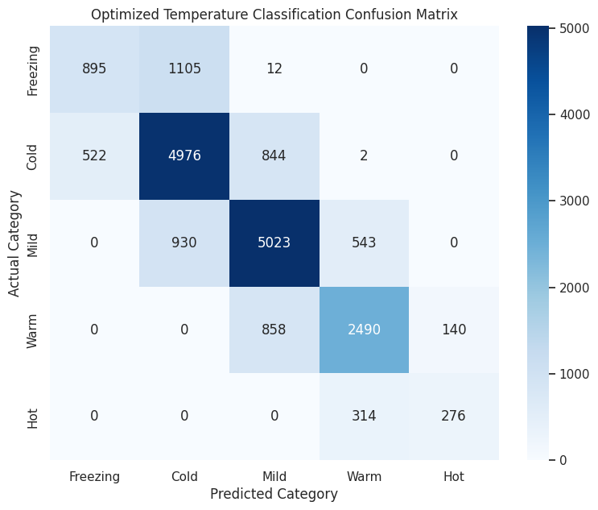

Visualization – Actual vs Predicted:
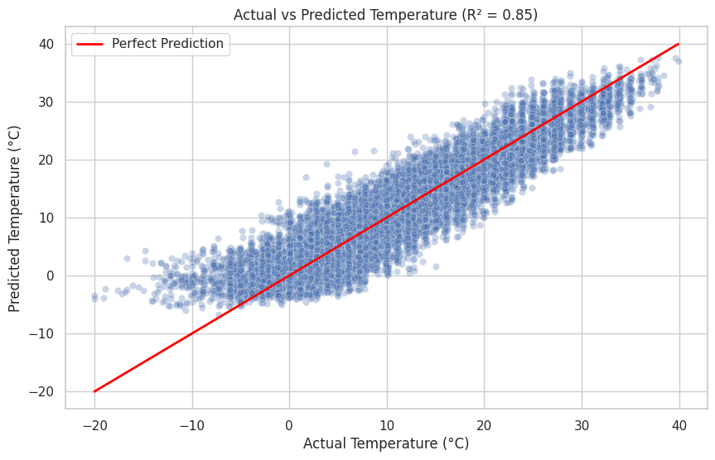

Classification Report:
