ADVERTISING BANNERS
Types, descriptions and examples
Activity in English
Type of advertising banner | Example / visual | Example
Rectangular Banner |  | A banner promoting a pair of Nike shoes.
Leaderboard |  | A Coca-Cola promotion at the top of a website.
Robapáginas (Medium Rectangle) |  | An Amazon advertisement between news articles.
Skyscraper |  | A vertical advertisement for a new movie.
Interstitial |  | A full-screen advertisement for a new smartphone.
Reminder | 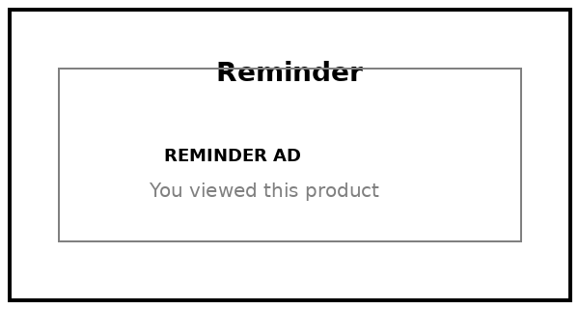 | An online store reminding a user about shoes they viewed.
Layer | 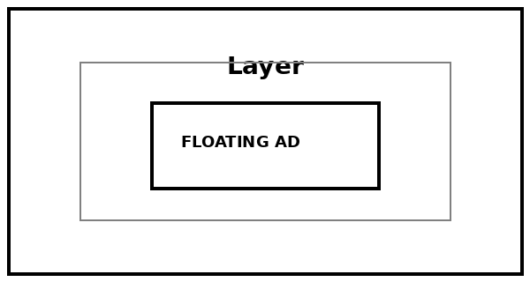 | A floating discount banner offering 20% off.
Skin | 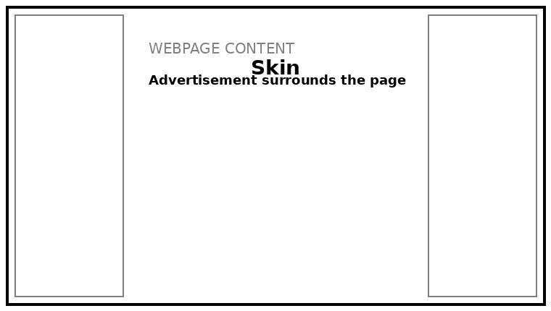 | A movie advertisement covering the sides and background of a website.
Rich Media | 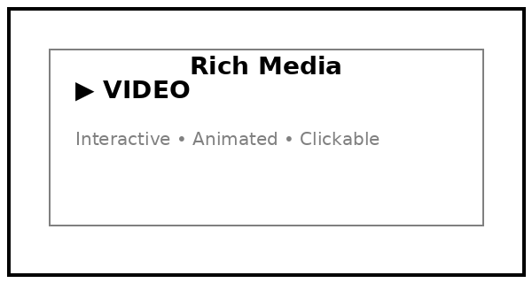 | An interactive car advertisement with a video and buttons.
Advertorial |  | A sponsored article about the benefits of a skincare product.

Note: The banner types and descriptions follow the attached reference document. The images are simple illustrative examples created for the activity.

