Sequence-diagrams-v0.1

|  |  |  |
| --- | --- | --- |
| Νικόλαος Χαλκιόπουλος* | Κωσταντίνος Γιακαλλής* | Βασίλειος Τσούλος* |
| up1072572 | UP1072533 | UP1072605 |
|  | Ιωάννης Παναρίτης† |  |
|  | UP1072632 |  |

Table of Contents

Robustness Diagrams 2

1. Vehicle Upgrades 2

2. Maintenance And Problem History 3

3. Garage 4

4. Μap 5

5. Membership 6

6. Forum 7

7. News Feed 8

8. Expenses Tracking 9

9. Failure History 10

# Sequence Diagrams

## Vehicle Upgrades

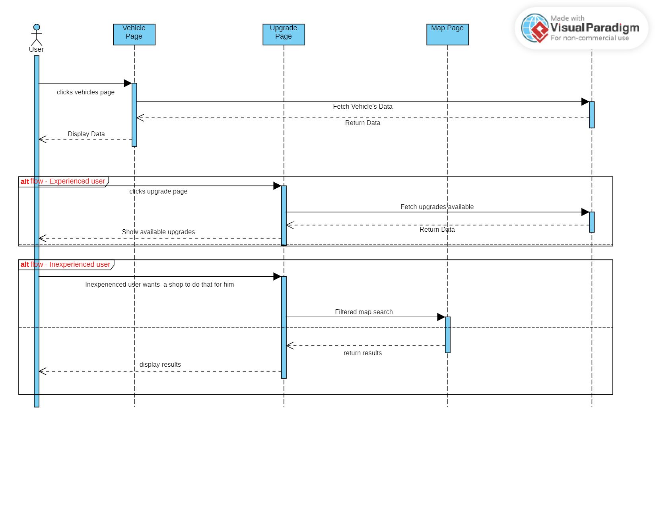

## Maintenance And Problem History

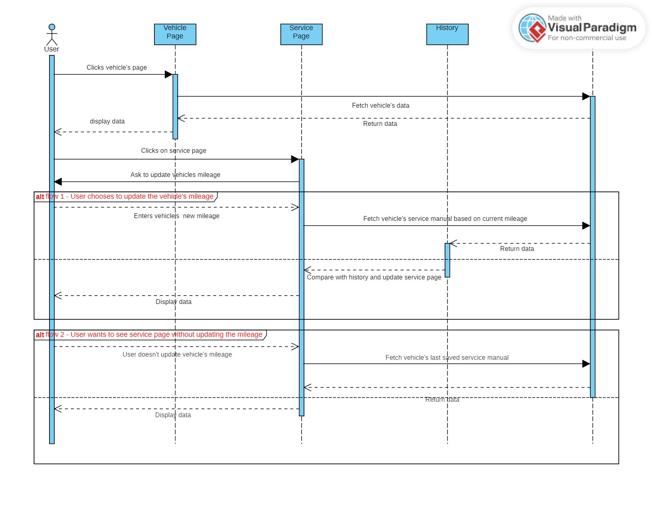

## Garage

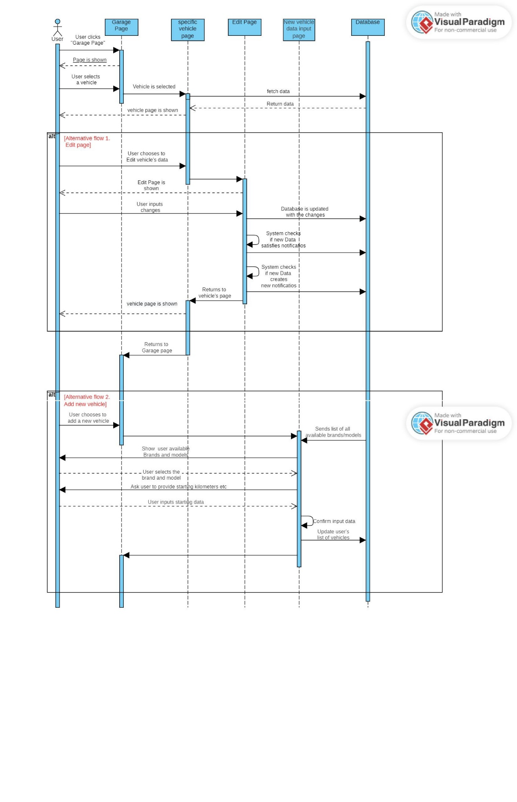

## Μap

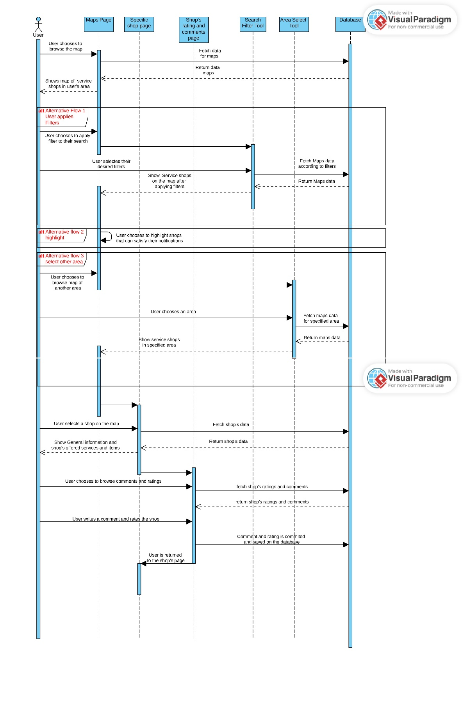

## Membership

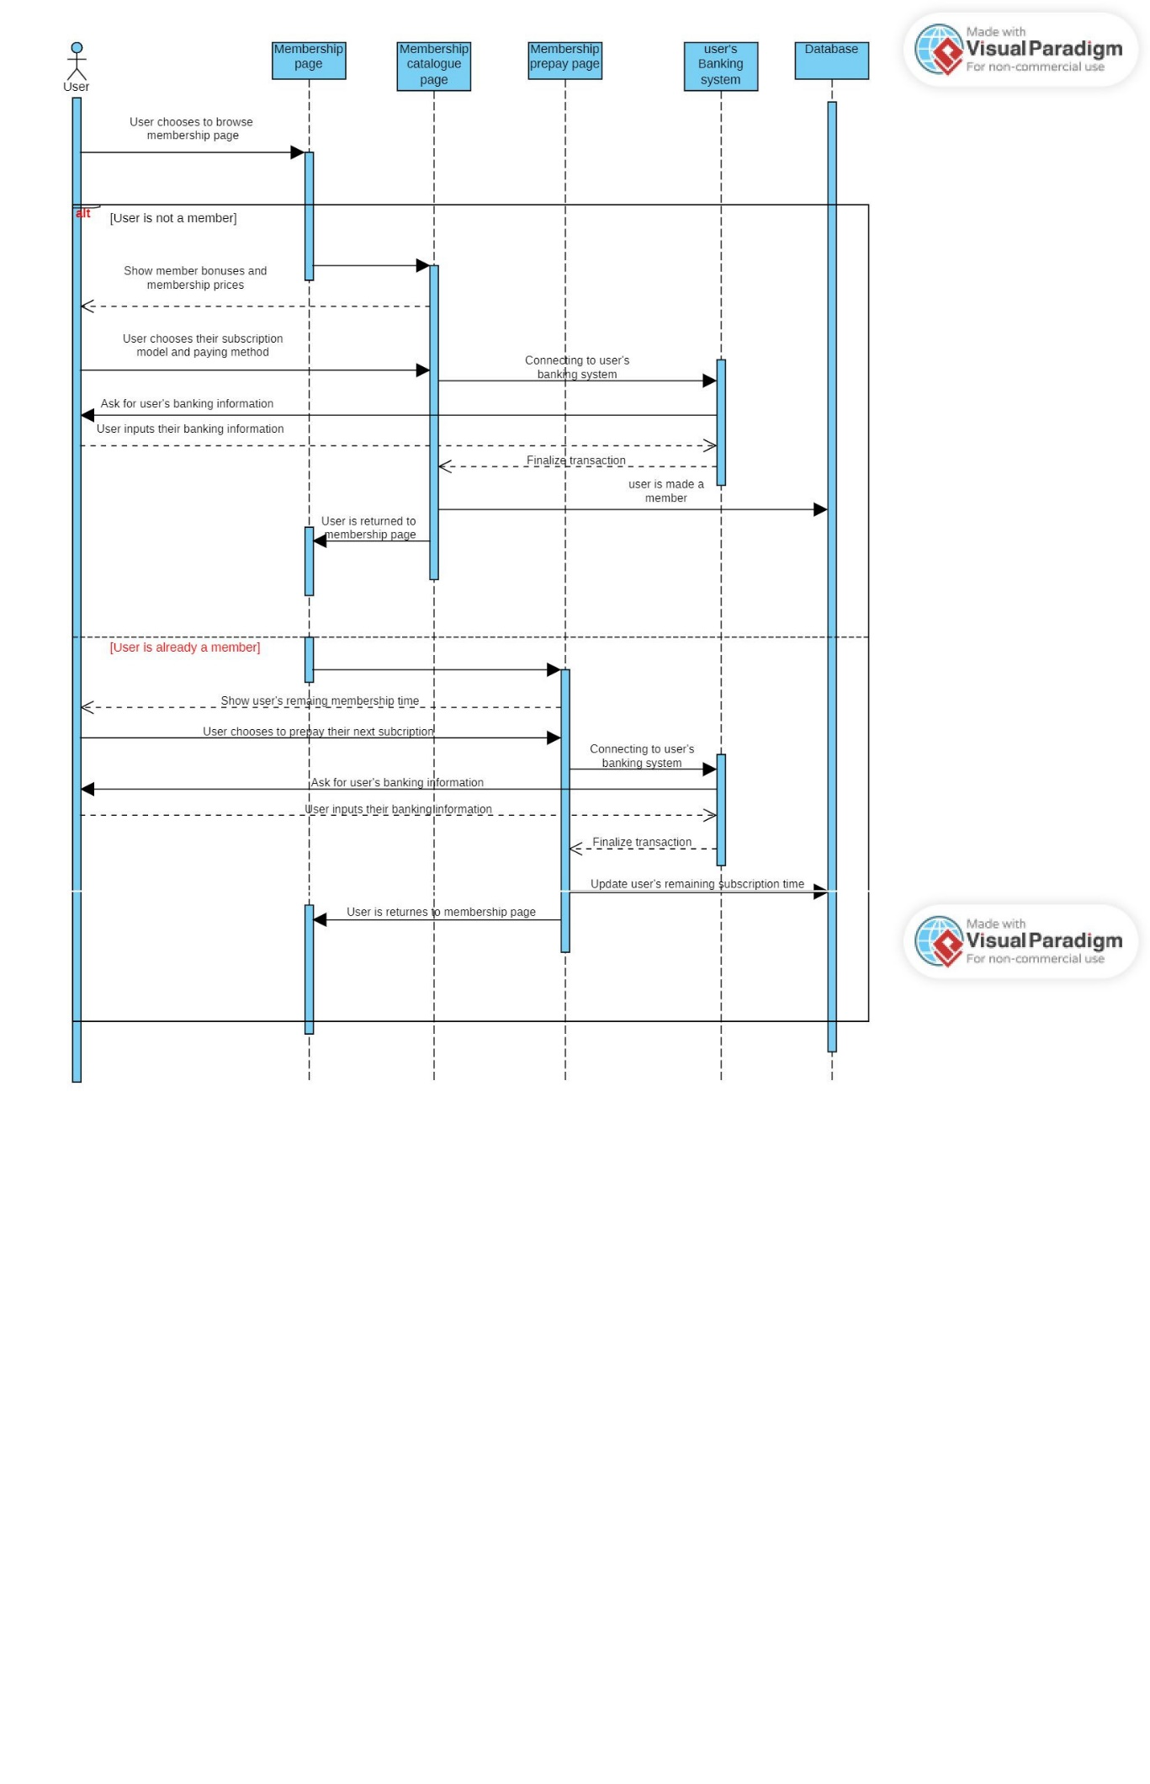

## Forum

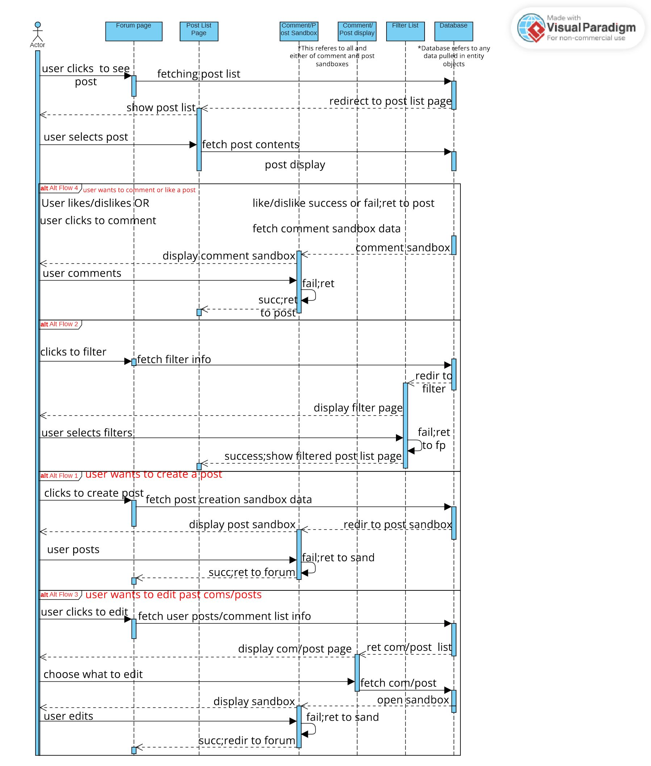

## News Feed

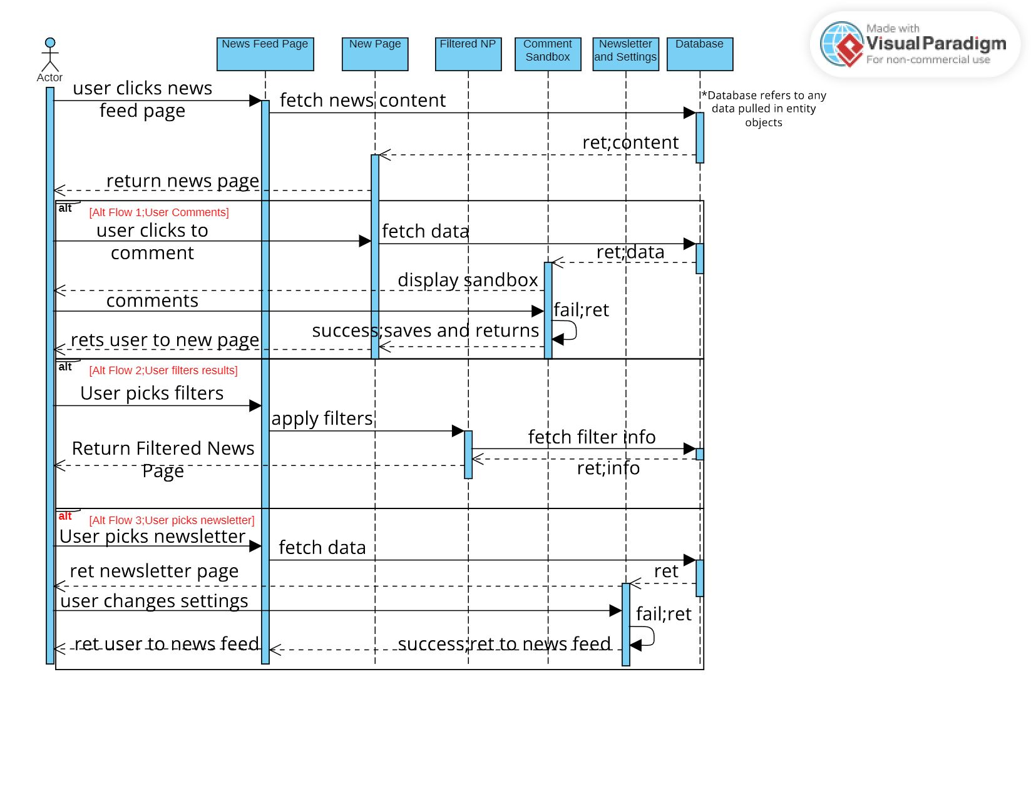

## Expenses Tracking

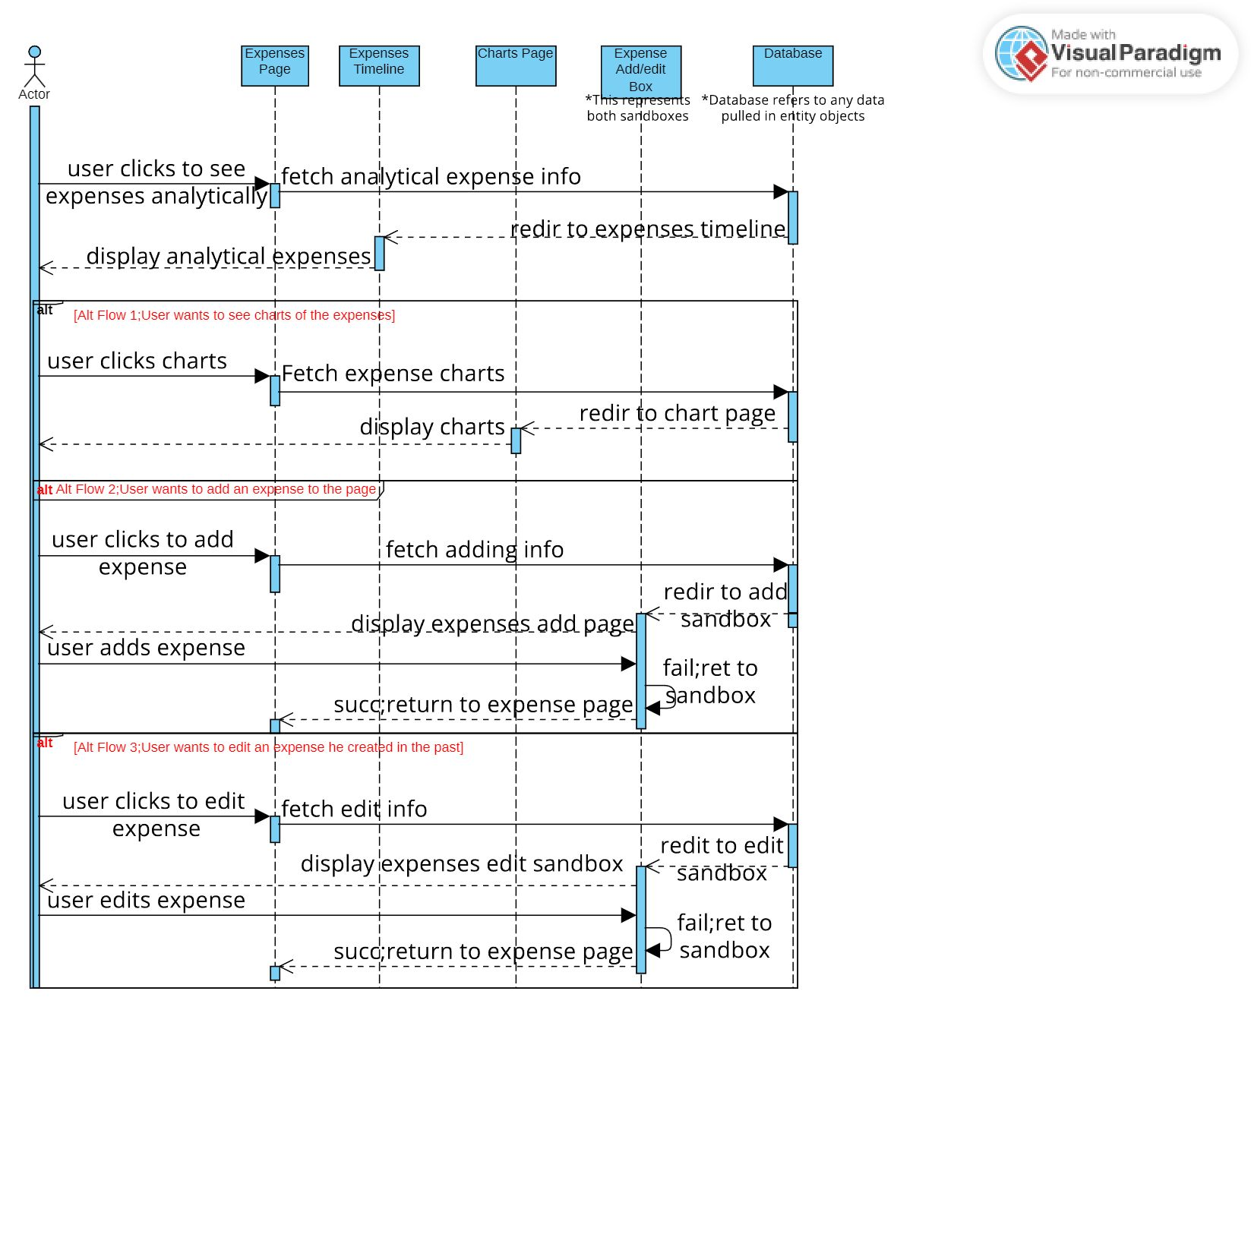

## Failure History

