**DCN HW-01-Fall-2024**

Name: Basil khowaja

Id: bk08432

Q1) **most data communication in a computer network uses serial transfer as compared  
to parallel transfer of data which is used in computer peripherals. Can you find out and explain the reason why serial communication is the preferred mode of data transfer in networking devices?**

Ans: A [serial transmission](https://www.tutorialspoint.com/what-is-serial-transmission) transfers data one bit at a time through a communication channel or computer bus in telecommunication and data transmission. On other side, **Parallel transmission** is a method of data transfer where multiple bits are sent simultaneously across multiple communication channels or wires. Below are the reasons why series is preferred over parallel:

Signal integrity:

* In Serial communication sends data one bit at a time which reduces the chances of signal degradation. Since only one bit is traveling at a time, there is no need to synchronize multiple bits, and there is less risk of **timing mismatches** or interference between signals.
* While, in Parallel communication all bits are being transferred at one time simultaneously hence it is more prone to signal degradation and also synchronization of bits is needed to be performed which is a complex task to do.

Reduced Complexity and Cost:

* Serial transmission uses fewer wires as compared to parallel transfer of data because it uses multiple wires for simultaneous transfer of data.

Type of transmission model:

* I found that both half and full duplex can be implemented in series transfer of data while parallel transfer of data typically is used in half duplex configuration, although it can be implemented in full duplex too but It is hard and highly costly too. Hence series allows full duplex easily and is preferred.

**Higher Frequency and Reduced Crosstalk in Serial Transmission:**

* Parallel transmission can transfer more data per cycle, it is limited by the requirement for all signals to arrive at the receiver simultaneously. At high frequencies, even small differences can cause delays, which reduces the effective transfer rate. While, parallel transmission is more prone to crosstalk which happens because of electromagnetic fields generated by cables nearby which happens in the case of parallel transfer, where interference between signal lines increases the chance of errors. But serial transmission, although it transfers fewer bits per cycle, it can still operate at much higher frequencies with fewer synchronization issues and less crosstalk which results in a higher overall net speed.

**Q2)** **in our class, we’ve focused on layered network models specifically within computer networks. However, layered models are also utilized in various other applications. Your task is to investigate another communication system that employs a layer architecture. Discuss the reasoning behind the number of layers in the system you choose. Additionally, provide a brief overview of the functionality of each layer and compare it to the functionalities of the TCP/IP layers.**

**Ans:** I have investigated the ZigBee protocol, which is commonly used in Internet of Things (IoT) devices, smart homes, andindustry. ZigBee follows a layered architecture similar to the OSI and TCP/IP models but is optimized for low-power, low data rate, and short range communication.

**ZigBee Protocol layers:**

1. **Physical Layer**:
   * This layer handles the transmission of raw bits wirelessly between devices. It is responsible for frequency selection, signal modulation, transmission, and reception. It also manages synchronization, power control, and error correction.
   * **Comparison with TCP/IP:** This layer of ZigBee is similar to the Physical Layer in the OSI and Network Interface Layer in TCP/IP. Both handle the physical transmission of data over the medium (wireless in ZigBee's case).
2. **Medium Access Control layer**:
   * This MAC layer controls how devices access the shared wireless channel, like dealing with addressing, error detection, and protecting from collision of data packets being sent and received. It ensures that data packets are successfully sent and received across the network.
   * **Comparison with TCP/IP:** This is similar to the Data Link Layer in the OSI model and part of the Network Interface Layer in TCP/IP. It manages access to the communication medium and ensures reliable delivery of packets between nodes in the network.
3. **Network Layer**:
   * ZigBee's Network Layer provides network formation, routing, and addressing services. It supports both star and mesh topologies, allowing devices to communicate directly with each other or through intermediate nodes, which is essential for large-scale networks.
   * **Comparison with TCP/IP**: This layer is equivalent to the Network Layer in the OSI model or the Internet Layer in TCP/IP. It is responsible for routing data between devices, assigning addresses, and managing network topology.
4. **Application Layer**:
   * This layer defines how applications interact with the ZigBee protocol. It includes the Application Support Sublayer (APS) and the ZigBee Device Objects (ZDOs), which facilitate communication between devices and enable specific tasks, such as device control, data exchange, and service discovery.
   * **Comparison with TCP/IP:** The ZigBee Application Layer is similar to the Application Layer in TCP/IP. Both layers handle application-specific functions, where the data is interpreted and used by end-user applications (e.g., lighting control in ZigBee or web browsing in TCP/IP).

Reasoning Behind the Number of Layers:

The ZigBee protocol stack employs these four layers to provide a streamlined and efficient communication system, which is made to match the needs of low-power devices like sensors, smart lights, and thermostats. The goal is to reduce complexity while ensuring reliability, scalability, and low energy consumption. The four layers are sufficient for ZigBee’s intended use cases, which actually helps it to support mesh networking, handling real-time communication, and maintain battery life for long periods.

Comparison with TCP/IP:

* While TCP/IP is designed for high-bandwidth**,** long-range communication (such as the internet), on other hand ZigBee is optimized for short-range, low-data-rate, and low-power communication.
* TCP/IP has more layers (5 or 7,) and is more complex because it needs to support a broad range of applications and hardware, whereas ZigBee simplifies its stack to meet the specific requirements of IoT and automation systems.
* The Physical and MAC layers in ZigBee are similar to the Physical and Data Link layers in TCP/IP, but ZigBee’s network layer offers a more specialized role in supporting mesh topologies, making it more energy-efficient for local, small-scale networks.

Reference link: [The ZigBee Protocol (netguru.com)](https://www.netguru.com/blog/the-zigbee-protocol)

**Q3) the presentation of data is becoming more and more important in today’s Internet. Some people argue that the TCP/IP protocol suite needs to add a new layer to take care of the presentation of data. If this new layer is added in the future, where should its position be in the suite? Redraw Figure 1.17 to include this layer. Also, describe duties and responsibilities of the newly designed presentation layer. How will the new presentation layer communicate with lower and upper layers?**

The Presentation Layer should be inserted between the Application Layer (Layer 5) and the Transport Layer (Layer 4), making it a new layer (Layer 4.5) specifically for handling the presentation of data. The Presentation Layer will be between the Application and Transport Layers to act as a path that handles tasks like data translation, encryption, compression, and formatting. This will make ensure that data is properly prepared before being sent over the network. Since the Application Layer focuses on the user side and the Transport Layer ensures reliable delivery, the Presentation Layer will make sure the data is in the right format for both ends to understand and process.

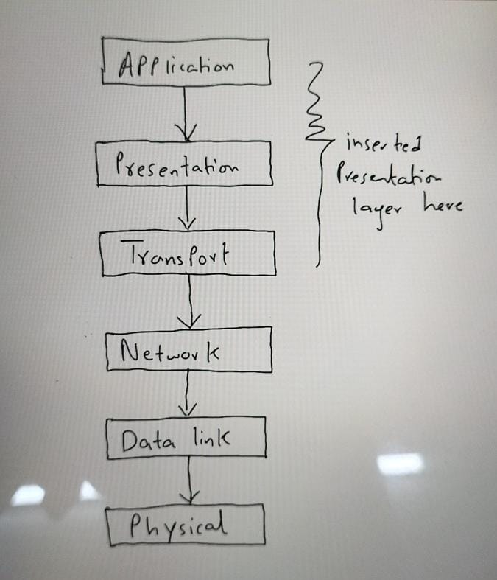

Duties and responsibilities of this new layer:

1. **Data Translation**: Converts data from specific formats into a standard format suitable for network transmission, ensuring the compatibility between different systems.
2. **Data Encryption**: Secures user data by encrypting it before transmission and decrypting it when it is received, ensuring that data remains secure and protected.
3. **Data Compression**: it has to reduce the size of the data to be transmitted, optimizing bandwidth usage and increasing the speed of data transfer.
4. **Data Formatting**: it has to ensure that the data is presented in a structured and consistent way making sure it is readable and understandable by the receiving system.

The new Presentation Layer will communicate with the Application Layer above by receiving raw data from applications and handling tasks like translation, encryption, or compression, depending on the requirements. Once the data is formatted and ready, the Presentation Layer will pass it down to the Transport Layer, which will take care of delivering the data across the network. On the receiving end, the Presentation Layer will take the incoming data from the Transport Layer, handle any necessary decryption or decompression as such if needed, and then pass the properly formatted data up to the Application Layer so the application can use it. This ensures a smooth flow of data between layers, with each layer focusing on its own responsibilities, helping to maintain security, and efficiency.

**Q4) In addition to the basic topologies discussed in class, there is a concept of the use of a hybrid topology in practical computer networks, both campus as well as enterprise networks. • Search one practical example of a hybrid topology.**

**Draw its diagram and discuss its advantages and disadvantages in detail:**

A **star-wired ring hybrid topology** is a practical example used in many enterprise and campus networks because it combines the strengths of two different network setups. In this type of network, several smaller **star topologies** are grouped together and connected by a **ring topology.**

In a **star topology,** each device or computer connects to a central switch. This is great for performance because each device has a direct link to the network, which reduces the chances of data collisions. However, if the central switch fails, the entire network can go down, which is a major weakness.

On the other hand, a **ring topology** connects all devices in a loop, making it more reliable in terms of network failures. If one connection breaks, the data can still travel in the other direction, keeping the network functional. However, it can be slower since data has to travel through multiple devices to reach its destination.

By combining these two topologies, the star-wired ring hybrid network takes advantage of the star's efficiency and simplicity while benefiting from the ring's reliability and fault tolerance. Each **star network** serves a specific department or section, and these stars are then connected to a **ring,** which acts as the backbone of the entire network. This setup ensures that even if one star network has an issue, the rest of the system remains unaffected. Plus, the ring backbone provides an additional layer of security and data flow management.

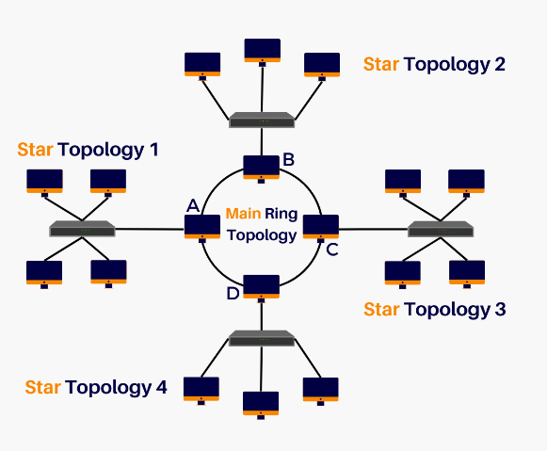

Reference for pic: [A Guide to Hybrid Topology. Definition, Practices, and Importance - zenarmor.com](https://www.zenarmor.com/docs/network-basics/what-is-hybrid-topology)

### Advantages:

1. **Reliability**: If one star network fails, the others remain unaffected because of the separation by the ring topology. The ensures that data can flow even if there is a failure in one segment of the ring.
2. **Fault Tolerance**: The system can quickly detect faults and remove them hence the system doesn’t crashes.
3. **Scalability**: New star networks can easily be added to the central ring without disturbing the existing structure.
4. **High Performance**: Combining the star’s simplicity and the ring’s reliability provides high throughput and efficient network performance.
5. **Flexibility**: This topology allows easy customization and adaptation to the specific needs of the organization.

### Disadvantages:

1. **Complex Design**: Setting up a hybrid topology is more complex due to the combination of multiple topologies. It requires careful planning and skilled labor to implement.
2. **Higher Costs**: The installation and maintenance of hybrid networks are more expensive due to the additional hardware and cables required.
3. **Cable Failures**: A failure in the main ring can affect multiple star networks, although this can be mitigated by repetitive paths.
4. **More Hardware**: Hybrid topologies require more network devices like switches and routers which makes the system more complex and hardware intensive

The **star-wired ring hybrid topology** can be used to connect **five different departments** in an organization, like this:

### 1. ****HR (Human Resources) Department:****

* HR can have its own **star network** where all HR computers are connected to a central switch. This switch can be connected to the **ring** (which connects all departments), allowing HR to work independently but still share important data with other departments, such as employee information for payments.

### 2. ****Finance Department:****

* Finance can also have a **star network** that connects its computers, accounting software, and data securely. Through the central ring, finance department can share data with other departments, like HR for salaries or with Sales for invoicing, while ensuring financial records stay protected.

### 3. ****IT Department:****

* IT can manage the overall network and its security using its own star network connected to the central ring. IT can quickly detect and fix issues without disrupting the rest of the departments. Through this they can ensure everything runs smoothly.

### 4. ****Sales and Marketing Department:****

* Sales and Marketing can have their own star network for tools like customer databases and marketing campaigns. By being connected to the ring, they can share customer data with Finance for billing or with Operations to check inventory, while maintaining their own high-speed tools.

### 5. ****Operations Department:****

* Operations, which manages production or logistics, can have a star network for managing inventory, production tools, and logistics. Their star network connects to the ring, allowing them to share real-time data with other departments like Sales and Finance for stock management and budgeting.

### Q5)

### 1. Application Layer: HTTP (Hypertext Transfer Protocol)

HTTP is what allows you to view websites. When you type a website's URL in your browser, HTTP sends a request to the server where the website is hosted. The server then sends the website’s data back to your browser, allowing you to view the page. HTTP uses port 80 and works on a client-server model where the browser is the client and the web server is the server.

**2. Transport Layer: TCP (Transmission Control Protocol)**

TCP ensures that data sent over the internet arrives at its destination accurately. It breaks data into smaller pieces (called segments), sends them, and checks if all pieces have arrived safely. If any data is lost, TCP will resend it. This is why it's called a reliable protocol.

**3. Internet Layer: IP (Internet Protocol)**

IP is responsible for directing data to its destination by assigning unique addresses (called IP addresses) to each device on a network. It helps move data from one computer to another, ensuring it goes to the right address, similar to how a postal service delivers mail.

**4. Network Access Layer: Ethernet**

Ethernet is used to connect computers within a local area network (LAN), like in offices or homes. It provides a wired connection, sending data through cables to ensure fast and stable communication between devices.

### Q6)

1. **International ISP: Verizon**

Verizon is one of the top global ISPs, particularly known for its extensive fiber optic backbone across the United States. Its flagship service, **Verizon Fios**, offers lightning-fast fiber-optic internet speeds, with plans providing up to 940 Mbps for both downloads and uploads, ideal for businesses and home users alike. Verizon focuses heavily on reliability and security in its services​([Macronet Services](https://macronetservices.com/who-are-the-leading-global-tier-1-isps/) [Network Interview](https://networkinterview.com/top-10-isps-worldwide/)).

**2. National ISP: PTCL (Pakistan Telecommunication Company Limited)**

PTCL is the largest ISP in Pakistan, providing internet services across the country. Its flagship product is PTCL Broadband, which offers speeds ranging from 8 Mbps to 100 Mbps depending on the package. PTCL also provides Fiber-to-the-Home (FTTH) services in major cities, allowing users to access ultra-fast internet with speeds up to 1 Gbps.

**3. Regional ISP: StormFiber**

StormFiber is a popular regional ISP that focuses on fiber-optic broadband in major cities such as Lahore, Karachi, Islamabad, and Peshawar. StormFiber's flagship product is its fiber broadband service, offering speeds from 10 Mbps up to 100 Mbps, with a strong reputation for reliability and customer service. It operates primarily in urban areas and is known for its high-speed internet and quality support.