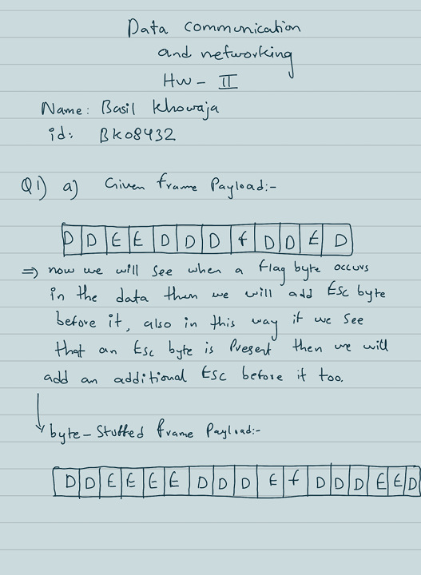

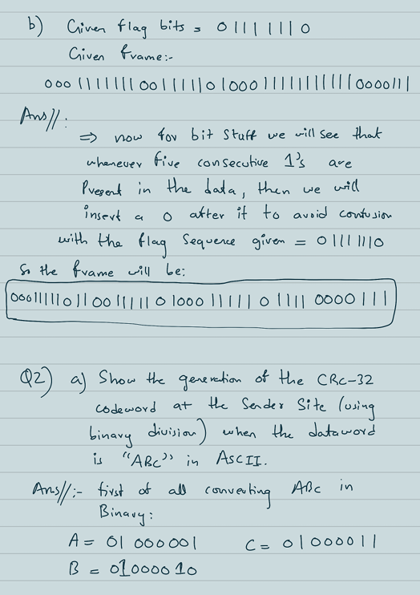

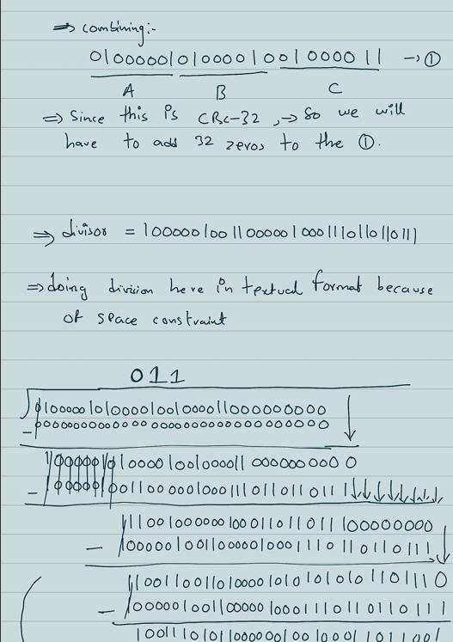

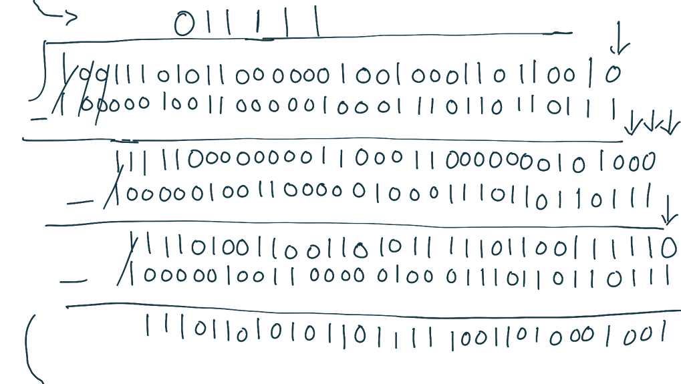

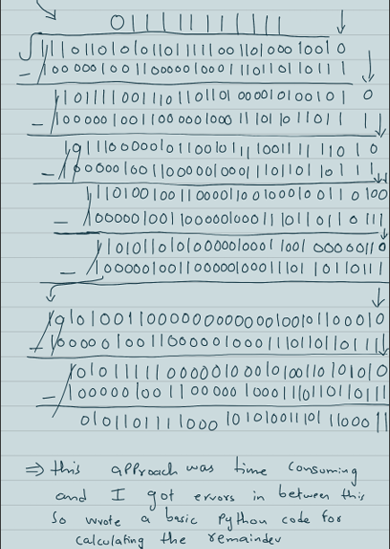

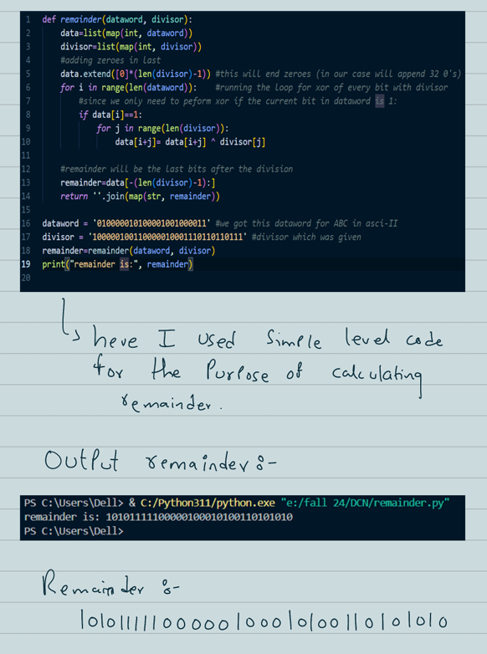

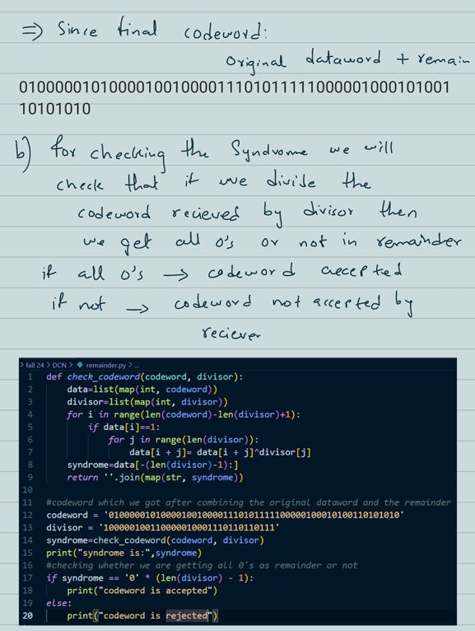

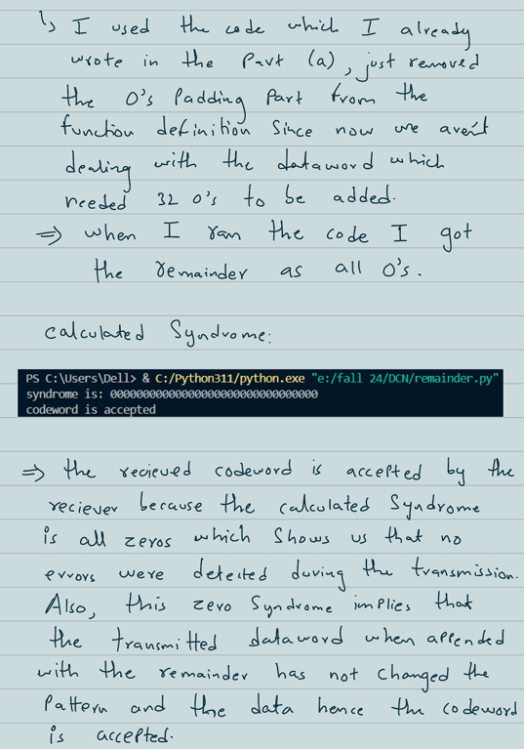

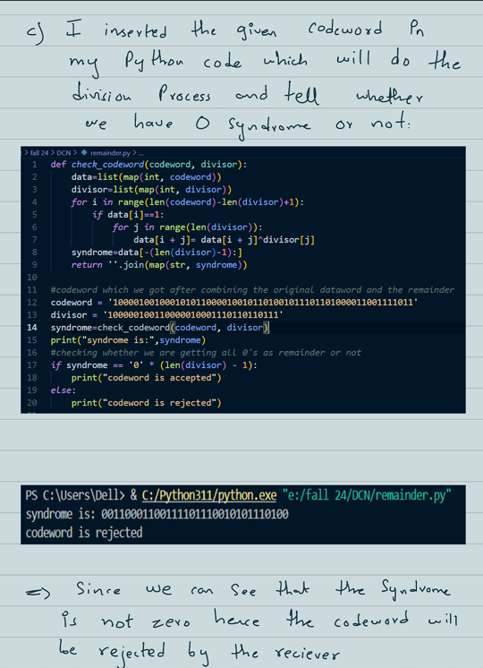

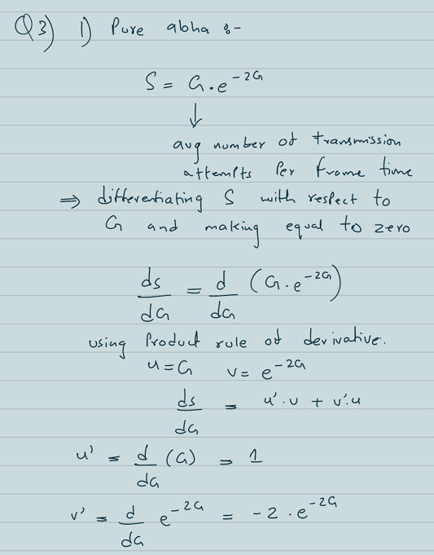

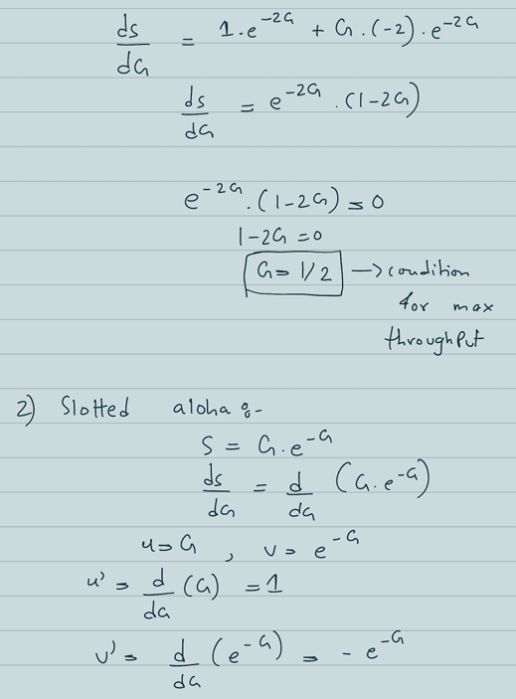

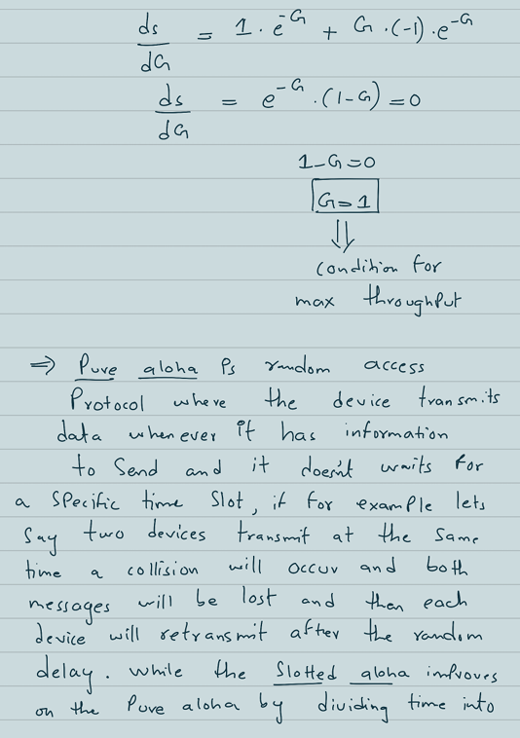

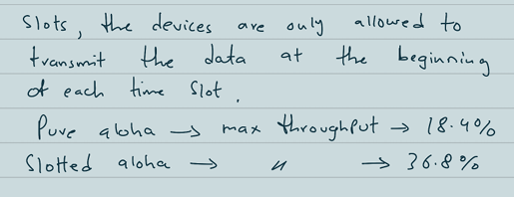

**Q4)**

In a CSMA/CD network, devices begin transmitting as soon as they sense that the channel is clear. However, if two devices start transmitting nearly simultaneously, a collision can occur. For effective collision detection, the transmitting device must remain active on the network long enough to detect any collisions that might occur as the signal propagates to the farthest point on the network and back, known as the round-trip time requirement. If the frame is too short, a device could finish transmitting before the collision signal has time to return, resulting in undetected collisions and errors on the network. Ensuring a sufficient frame length allows each station to detect collisions before completing its transmission, thereby maintaining network reliability.

• **Propagation Delay**: In a CSMA/CD network, it takes time Tp​ for the signal to propagate from one end of the network to the other. If a collision occurs at the far end, it will take another Tp​ for the collision signal to propagate back to the transmitting station.

• **Frame Transmission Time**: If Tfr​ is shorter than 2⋅TP a station could finish sending its frame before it even realizes that a collision occurred. This would defeat the purpose of collision detection.

• **Ensuring Collision Detection**: By ensuring Tfr≥2⋅TP

the rule guarantees that:

* The transmitting station will still be actively sending data when the collision signal reaches it.
* This enables the station to detect the collision and retransmit the frame later, following the CSMA/CD protocol.

Given:

Tfr=40us

Tp=25us

• Station A starts sending a frame at t=0 μs

• Station B starts sending a frame at t=20 μs

**Does Station A Detect Collision?**

Station A starts transmitting a frame at t=0 μs and will complete its transmission by t=40 μs. If a collision occurs, the collision signal takes Tp=25 μs to reach Station A. By the time this signal arrives at t=25 μs, Station A is still transmitting. Since A continues to transmit until t=40 μs it will ultimately detect the collision. Therefore, Station A will detect the collision.

**Does station B detect collision?**

Station B starts sending its frame at t=20 μs. If a collision happens, it means both Station A and Station B are trying to send data at the same time. Since Station B has already begun sending its data when the collision occurs, it will be able to notice that something went wrong. When a collision happens, the signals from both stations interfere with each other. This interference creates a collision signal that travels back through the network. Because Station B started sending its frame at t=20 μs and the collision occurs shortly after that, the collision signal will reach Station B while it is still transmitting. As a result, Station B can detect the collision during its transmission. It will recognize that its data did not go through correctly, prompting it to stop transmitting and try again later. Therefore, Station B will detect the collision.

**c) For the given network Tp = 25 μs and data rate of 10Mbps, suggest the appropriate value of Tfr and minimum frame size so that both station can detect collision.**

Using the rule;

Tfr>=2.Tp

Tfr>=2x25us (given Tp=25us)

**Tfr>=50us**

Minimum frame size=Tfr x Data rate

Data rate=10mbps (given);

Minimum frame size= 50us (found earlier) x 10mbps

Minimum frame size=50x10^(-6)s x 10 x 10^(6)

**Minimum frame size= 500bits**

**Q5) Contrast different types of MAC addresses and state one use case for each type of MAC address in different LAN settings.**

**1. Unicast MAC Address**

* A unicast MAC address is a unique identifier assigned to a network interface card (NIC) that allows for one-to-one communication. This address is used to send data to a specific device on a network.
* uses:
  + **File Sharing**: Transmitting files directly between two computers in a local network.
  + **VoIP Calls**: Establishing a one-on-one voice call between two IP phones, ensuring that audio packets are sent to the intended recipient.
  + **Secure Connections**: Creating a direct encrypted connection between a user’s device and a secure server for data transfer, such as in VPN connections.

**2. Broadcast MAC Address**

* A broadcast MAC address allows data packets to be sent to all devices on a network segment. The standard broadcast address in Ethernet networks is FF:FF:FF:FF:FF:FF.
* **Uses**:
  + **ARP Requests**: Address Resolution Protocol (ARP) requests use the broadcast MAC address to map IP addresses to MAC addresses within a local network, allowing devices to discover each other's addresses.
  + **Network Time Protocol (NTP)**: NTP servers may use broadcast messages to synchronize time across all devices in a network simultaneously.
  + **Software Updates**: Sending broadcast messages to notify all devices on a network about available software updates or maintenance tasks.

**3. Multicast MAC Address**

* A multicast MAC address is used to send data packets to a specific group of devices rather than all devices (as with broadcast) or a single device (as with unicast). Multicast addresses are typically in the range of 01:00:5E:00:00:00 to 01:00:5E:7F:FF:FF.
* **Uses**:
  + **Video Conferencing**: Sending video and audio streams to multiple participants in a video conference using multicast addresses to optimize bandwidth.
  + **Online Gaming**: Multiplayer online games often use multicast to send game state updates to multiple players connected in the same local network.
  + **Sensor Networks**: In IoT applications, multicast can be used to send sensor data to multiple applications or devices that need to receive updates simultaneously.

**Difference between the Different Types of MAC Addresses**

* + **Unicast**: One-to-one communication, where data is sent to a specific device only.
  + **Broadcast**: One-to-all communication, where data is sent to every device on the network.
  + **Multicast**: One-to-many communication, where data is sent to a specific group of devices that have joined a multicast group.
* **In terms of efficiency;**
  + **Unicast**: Efficient for direct communication but can lead to high traffic if many devices are sending data to a single device simultaneously.
  + **Broadcast**: Efficient for sending the same message to multiple devices, but can lead to network congestion if overused, as all devices must process the broadcast frame.
  + **Multicast**: More efficient than broadcast when sending data to multiple specific devices, as only those devices in the multicast group process the data, reducing overall network load.

**Q6)**

**A)**

The IEEE 802.3 standard for 40Gbps and 100Gbps Ethernet introduces several advancements that differentiate these high-speed Ethernet technologies from earlier standards, such as 10Gbps Ethernet.

1. **Physical Layer Specifications**

* **Cabling: 40GbE and 100GbE support similar cabling options, including multimode fiber (MMF) using QSFP+ SR4 optics. 100GBASE-SR10 uses 10 lanes over multimode fiber, and, in contrast, the single-mode version of this module achieves a distance of up to two miles while employing four wavelengths.**
* **Transceivers & Connectors: Your information will allow any connection, the standards defines different types of transceiver mostly CFP (C Form-factor Pluggable) for 100Gbps connections that operates at various implementations such as​ 100GBASE-SR10 and ​100GBASE-LR4.**

2. **Modulation Techniques and Encoding Schemes**

* **Encoding Schemes: Different encoding schemes are crucial to an effective apllication of data over communication steams. This includes, for instance, the definition of a 40GbE that can take advantage of a 64b/66b encoding scheme instead of the 8b/10 used in legacy Ethernet implementations to provide lower overhead and increased efficiency than its older sibling at >100 Gbps data rates​.**
* **Baseband Modulation Techniques: Progress in modulation techniques allows for faster data rates on the same cabling. Wavelength division multiplexing (WDM) is used in 100GBASE-LR4 for example to have signals on different wavelengths over the same fiber​.**

3. **Maximum Transmission Distances**

* **Transmission Distances**: 40GbE can achieve a maximum distance of 150 meters over OM3 multimode fiber and up to 400 meters over OM4 fiber. In contrast, 100GbE can reach up to 100 meters on OM3 and 150 meters on OM4 fiber​. For single-mode fiber, both standards support longer distances, with 100GBASE-LR4 achieving distances of up to 10 kilometers.

4. **Data Rate**

* **Data Rates**: The main distinguishing feature is the significant increase in data rates. While 10Gbps Ethernet allows for speeds of up to 10 Gbps, 40GbE operates at 40 Gbps, and 100GbE operates at 100 Gbps. This increase allows for faster data transmission and the ability to handle larger amounts of network traffic​

5**. Signal Types**

* **Signal Types**: 40GbE and 100GbE utilize multiple signal types, including:
  + **10GBASE-R** for 10 Gbps links,
  + **40GBASE-SR4** for short-range multimode applications,
  + **100GBASE-SR10** for short-range multimode applications,
  + **100GBASE-LR4** for long-range single-mode applications​

These signal types allow for flexibility in deployment and compatibility with existing infrastructure while providing options for both short-range and long-range connectivity. The IEEE 802.3 standard for 40Gbps and 100Gbps Ethernet introduces critical advancements in physical layer specifications, modulation techniques, maximum transmission distances, data rates, and signal types, significantly enhancing network performance compared to earlier standards like 10Gbps Ethernet. These improvements cater to the growing demand for higher bandwidth and faster data transmission in modern network environments.

**Q7)**

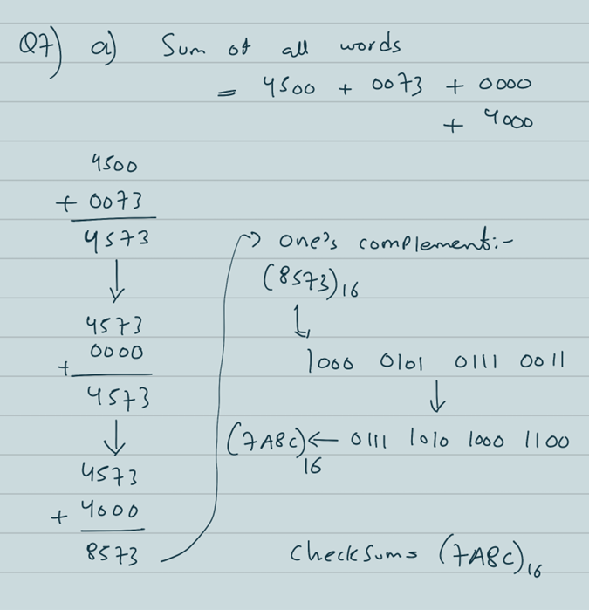

**b)**

