ASSIGNMENT 8

1. When to use (Rapid Application Development) RAD model. When not to use (Rapid
Application Development) RAD model

RAD model is Rapid Application Development model.It is based on Model Phases. It is a type of incremental model. In RAD model the components or functions are developed in parallel. This can quickly give the customer something to see and use it to provide feedback regarding the delivery and their requirements.
The various phases in this are:

- Business modelling
- Data modelling
- Process modelling
- Application generation
- Testing and turnover

RAD models are commonly used in:

- A Rapid Application development model is used when a product is to be delivered in a short span of time.
- RAD model is used where the customers need a prototype of the actual product and the customers want to accomodate changes in the project when and where required.
- RAD should be used only if there is high availability of resources be it be human or tools requirements.RAD requires high experts .

- RAD SDLC model should be chosen only if domain experts are available with relevant business knowledge.

- It should be used only if the budget permits use of automated code generating tools.

- RAD should be used when there is a need to create a system that can be modularized in 2-3 months of time.

RAD models are not used in:

- RAD cannot be used if the system cannot be modularised.

- Inapplicable to cheaper projects as cost of modelling and automated code generation is very high.

- RAD cannot be used if the customer is not ready to get involved and makes a statement that he just needs the end product and not any prototype.

- Not used where management complexity is high.

- Not used where modelling skills have higher dependancy.

2. Define an ER diagram of a software Organization with all the relationship model that was
discussed in the classroom

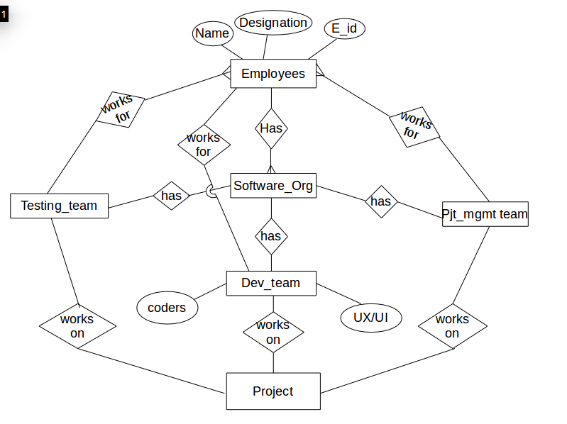

3. Describe the Entity Relationships for the following diagram
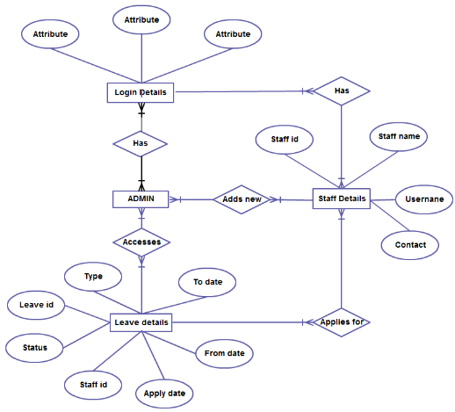

The Entity Relationship for the diagram are:

- Admin has login details of all users (attributes)
- Admin can access leave details
- Admin can add new Staff and their details
- All staff have their own login details
- All staff can apply for leave

Each staff has

- Staff id
- Staff name
- Username
- Contact
- Login details

Leave details consists of

- Type
- leave id
- Status
- From date
- To date
- Staff id
- Apply date

- Entity Admin has a many to many relationship with Login Details.
- Entity Admin has a many to many relationship with Leave details
- Entity Admin has an adds new relation with staff details.Its a many to many relationship.
- Entity staff details has applies new relationship with Leave Details.

