DAY9-SESSION ASSIGNMENTS

1. Draw a Use Case Diagram for an online Library Management System

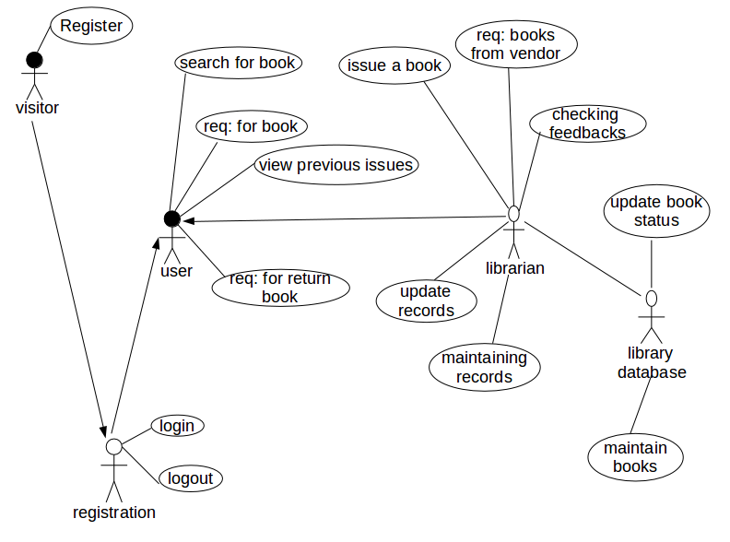

2. List down the best practices from Agile/Scrum methodology

The best practices in Agile/ Scrum methodology are:

- Customer Collaboration

There is a constant communication with the team about the work to be done in the sprint, also with the customer about the progress being made.

- Burndown chart

They show the work schedule and time.Work to be completed can be understood from this chart and it helps to check if the project is moving as per schedule

- Retrospective Meeting

It is a compulsorily meeting attended by all of the team, to discuss about the lessons learned,problems faced,quality of work, progress of the project etc

- Release Planning

It is used to give a clear message about the releases of new software functionality.

- Planning poker

It is a useful way to estimate the durations required for each sprint to finish work

- Daily standup meetings

They are short meetings usually of 10-15 minutes. The problems faced,work that was completed previously and the work that is to be done next is discussed here.

- Product Backlog

All the user requirements are listed and prioritised by the product owner into a list known as the Product backlog.

- User stories

User stories are used to describe the user requirements

- Sprint review

Meeting to present the completed work.

- ROI(Return On Investment)

ROI values are useful to determine item priorities in a sprint. Planning poker can be used to determine ROI values.

3. Collaboration

a. How does collaboration help agile development?

Collaboration is a team work process, consisting of seceral individuals who use their own strengths all together and produce the most efficient outcome.Collaboration is important in agile.There is a lot of negotiating,learning and challenges in this process. Collaboration helps in the following ways
- Helps use each individual strength all together to create a better and well efficient output.
- It helps to build the right features in the right priority order
- Engage directly with the customers and increase their involvement
- Faster and more efficient production.
- Designers with different strengths can learn from each other.
- It creates the framework for faster time-to-market.
- Working with cross functional teams enhance the communication in agile among everyone.

b. What if the team is distributed and can you achieve the same productivity?

No, the same productivity cannot be achieved if the team is distributed. Agile is a mindset in which collabration should be there. Communication is a significiant part in delivery of softwares. Issues can be discussed and resolved more quickly. If an issue came up that is to be discussed, in the case of a distributed team, it would waste a lot of time to resolve it. So if the team is distributed there is no face to face communication between within the development team and may be also bussiness people. Co-location is a better way to collabration and it is recommended as the optimal approach in agile. When the team is distributed the communication tools should be there for collbrative development.The development team should be always available for any queries among developers.

c. What would you do to achieve the productivity for a distributed team?

To make a distributed team more productive,the team must be trained to be collaborative. They should discuss their issues and resolve them. They should be colocated and work together in a common place. Also

- They should hold up short meetings inorder to discuss their issues,work completed and work that is to be done.

- There should be some medium like a group chat so that they can catch up together in the progress

- Encourage collaboration

- There should be proper planning in the responsibilities and roles to be performed throughout the project development.
- Communication which is the essential part should be considered and tools should be there for support.

- The developers should emphasized that they should be always open and available.

- At every location the right mix of talent should be identified and alloted.

- make sure every team member understand their role and workload.

- The teams should share issues whenever something arises.

- Provide right tools for training

4. What is Sprint Zero in Agile? Describe the activities that are done in Sprint Zero.

Sprint Zero is also called as Iteration Zero. It is a commonly used practice, to build a team,train them, and let them get to know each other. Its usually held for 2-3 days. The main idea of sprint zero is to have a starting for the remaining upcoming sprints. It is just a conversation held to identify the user goals and discuss the product backlog. There is an active participation of the customer with the members, so that they form and act like a team. So the user goals can be further more better understood and better ideas could be given. Thus a team building starts and initial requirements are determined. It is the first initial step before the first sprint which is very critical in the development and completion of the project.Before the actual steps, sprint zero collects quality items product backlog. A list of all prioritized features or stories with estimates will be there. A release plan that assigns each feature or story to an iteration or sprint. A high-level application architecture, i.e. how the features will likely be implemented.

Some common activities in sprint zero are
- Training
The team is made ready for development and testing process.These play an essential role in the sucess of a project

- Developing a team
A team is formed, and made ready to be trained based on their skills and qualities

- Product backlog examination
The product backlog is made by the product owner which is examined by the team based on their conversation and participation with the customer. These requirements in the product backlog form the foundation for the project development and success.

