Battery Energy Management (BEM) System
Group 4 - Communication & System Integration
Week 3 Deliverable rectification + week4 modelling explication
Table of Contents
- Introduction
- BMSModes Enumeration Class
- A4.1 CAN Communication Subsystem
- A4.2 Operating Mode Management
- A4.3 Diagnostic Communication Subsystem
- A4.1.1 Receive & Validate CAN Messages (Detailed)
- BMS_Profile Architecture
- Team Integration Architecture
- Group 4 - Manage BMS Integration
- Implementation Guidelines
- Conclusion

1. Introduction
This document provides the files add such as the BMS modes and a retification to the SADT model and comprehensive explanation of each module implemented in MATLAB System Composer for the Battery Energy Management (BEM) system. The architecture follows a hierarchical, modular design pattern that ensures separation of concerns, safety compliance, and seamless integration with vehicle systems. Each module has been designed with specific responsibilities and well-defined interfaces to enable efficient battery management, fault detection, and communication with external systems.

2. BMSModes Enumeration Class file
2.1 Overview
The BMSModes class is a custom enumeration that defines the discrete operational states of the Battery Management System. This class inherits from Simulink.IntEnumType, making it compatible with Simulink and Stateflow models for state machine implementation. The enumeration provides a type-safe mechanism for representing BMS states, eliminating the use of magic numbers and reducing the likelihood of errors in state-dependent logic. This foundational component is essential for the entire operating mode management subsystem.
2.2 Defined States
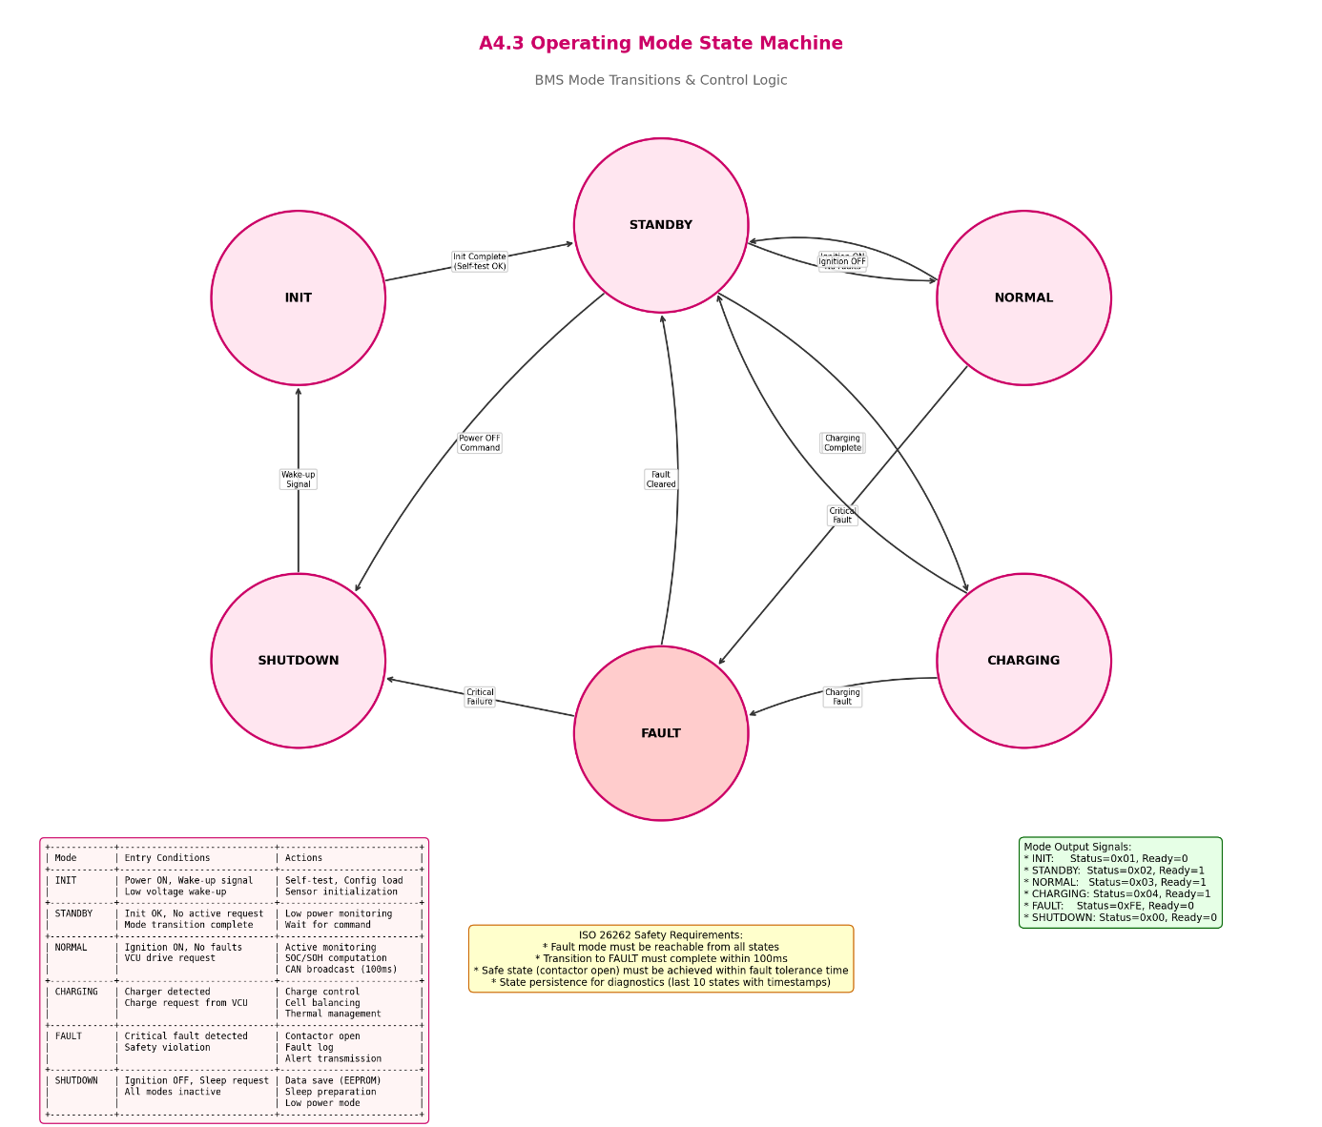

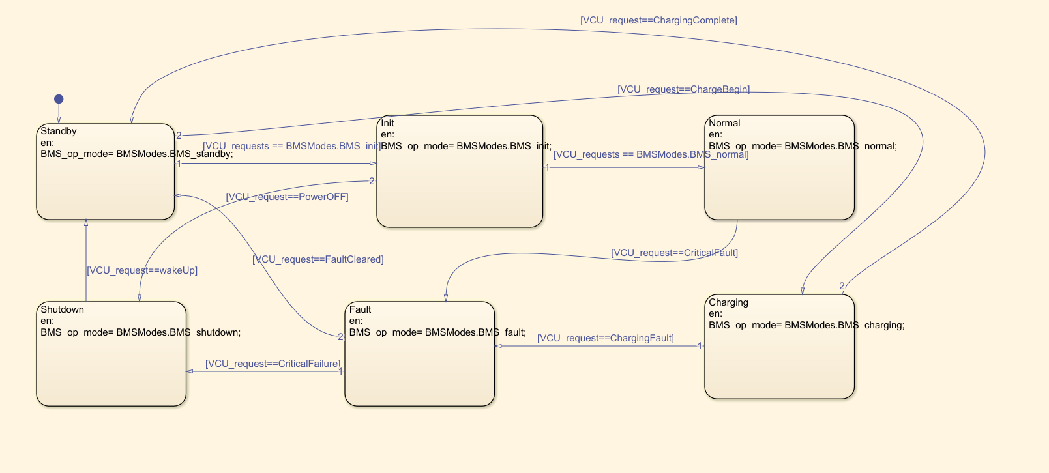

State Name | Value | Description
BMS_shutdown | 0 | System is powered off; safe state with all contactors open
BMS_standby | 1 | System is idle, waiting for activation; low power mode
BMS_init | 2 | System initialization; self-checks and sensor calibration
BMS_normal | 3 | Normal operation; active monitoring and control
BMS_fault | 4 | Fault condition detected; protective actions engaged
BMS_charging | 5 | Charging mode; charge control and monitoring active
2.3 Role in System Architecture
This enumeration serves as the foundation for the state machine implementation in the Operating Mode Management module (A4.2). It enables consistent state representation across all BMS components and facilitates clear communication of system status to external controllers via CAN messages. The enumeration is referenced throughout the Simulink model to implement state transition logic, safety interlocks, and diagnostic reporting. Each state has associated entry and exit actions that define the system behavior during transitions.

SADT full system model(General module for our team 4 :communication & interfacing)
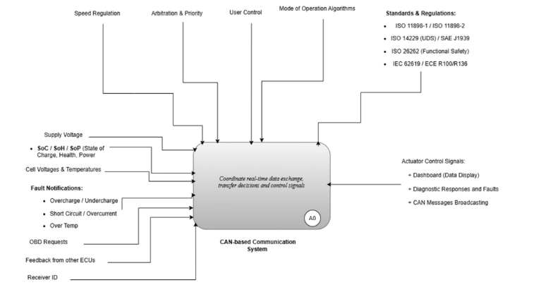
3. A4.1 CAN Communication Subsystem (SADT rectification)
3.1 Overview
The CAN Communication Subsystem (A4.1) is responsible for all external communication between the BMS and other vehicle controllers. This subsystem implements bidirectional message handling through two primary modules: Receive & Validate CAN Messages (RX) and Assemble & Transmit CAN Messages (TX). The architecture ensures reliable data exchange while adhering to timing constraints and safety requirements specified in ISO 11898 for CAN bus communication.
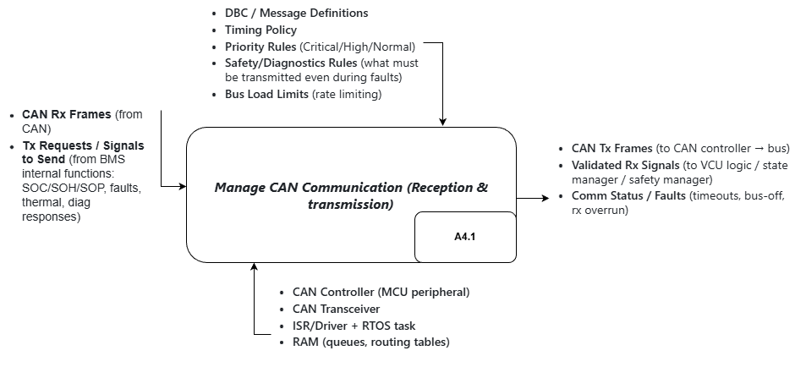

3.2 Architecture Components
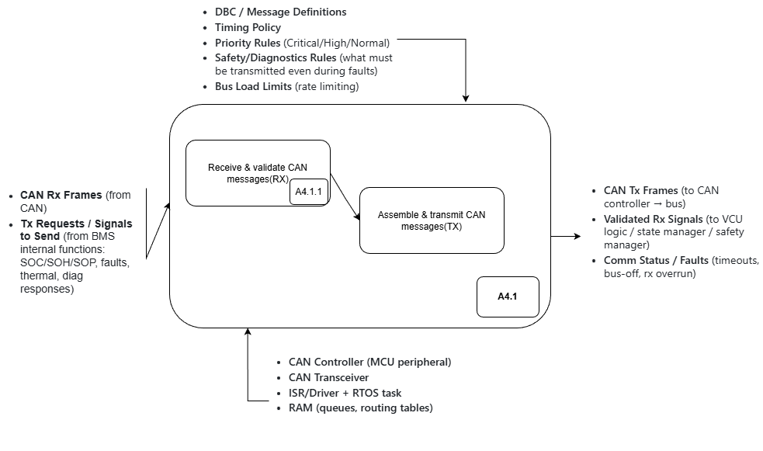
3.2.1 Receive & Validate CAN Messages (RX)
The RX module handles incoming CAN frames from the vehicle bus. It performs acceptance filtering based on configured CAN IDs, validates message integrity through DLC (Data Length Code) checking, verifies data plausibility against expected ranges, and monitors message freshness through timeout detection. Validated signals are then forwarded to the appropriate internal consumers including the State Estimator, Safety Logic, and Operating Mode Manager.
- CAN Rx Frames: Raw CAN messages from the vehicle bus
- Acceptance Filter Configuration: Defines which CAN IDs to accept
- Routing Table: Maps CAN IDs to message handlers
- Validation Rules: DLC, plausibility, and freshness checks
- Timeout Thresholds: Maximum wait time for expected messages
3.2.2 Assemble & Transmit CAN Messages (TX)
The TX module packages internal BMS data into CAN frames for transmission on the vehicle bus. It receives transmission requests from various internal functions including SOC/SOH/SOP estimations, fault status, thermal data, and diagnostic responses. The module assembles messages according to DBC (Database Container) definitions, applies priority-based arbitration, and manages transmission timing to comply with bus load limits.
- Tx Requests/Signals: Data from BMS internal functions (SOC, faults, thermal, diagnostics)
- CAN Tx Frames: Formatted messages ready for bus transmission
- Comm Status/Faults: Communication health indicators (bus-off, rx overrun, timeouts)
3.3 Configuration Rules
The CAN Communication Subsystem operates under strict configuration rules that govern message handling. These rules ensure compliance with automotive standards and maintain system reliability under all operating conditions. The configuration includes DBC/Message Definitions that specify CAN message formats, Timing Policy for transmission scheduling, Priority Rules for message arbitration, Safety/Diagnostics Rules for critical message handling, and Bus Load Limits for rate limiting.

- A4.2 Operating Mode Management
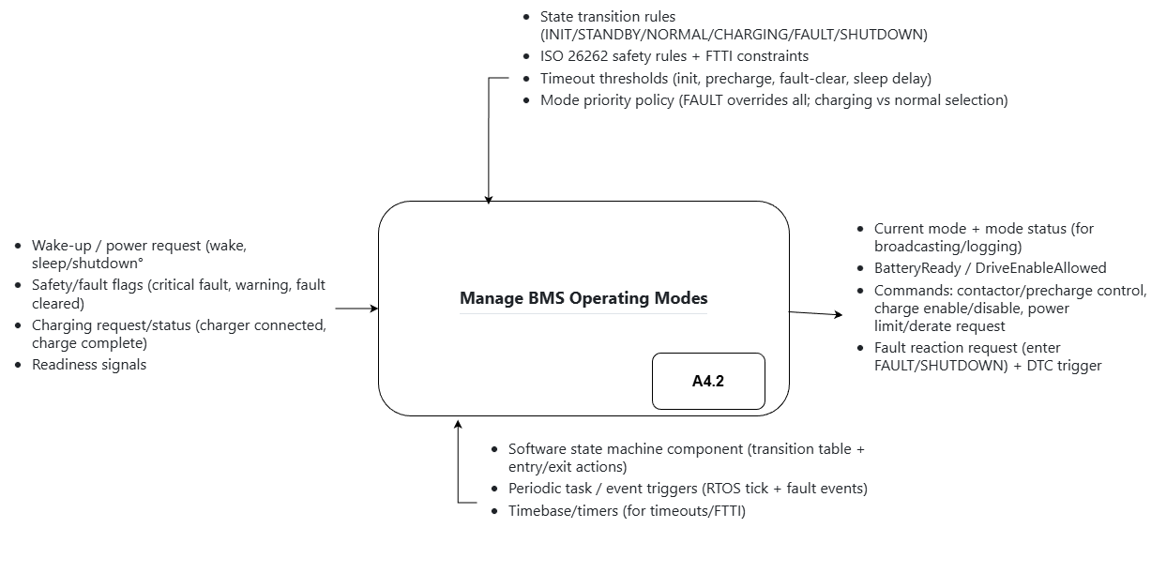
4.1 Overview

The Operating Mode Management module (A4.2) serves as the central state machine controller for the entire BMS. It determines the current operational state based on system inputs, manages transitions between states according to predefined rules, and generates control commands for system actuators. This module implements ISO 26262 functional safety requirements including FTTI (Fault Tolerant Time Interval) constraints and ensures safe system behavior under all conditions.
4.2 Input Signals(will be concatenated in VCU CAN messages)
Category | Signal | Description
Wake-up / Power | wake | Triggers system activation from vehicle ignition or external power
Wake-up / Power | sleep/shutdown | Triggers system deactivation for low-power states
Safety / Fault | critical fault | High-priority fault requiring immediate action (overvoltage, short circuit)
Safety / Fault | warning | Low-priority fault not halting operation (temperature out of range)
Safety / Fault | fault cleared | Signal that previously detected fault has been resolved
Charging | charger connected | Indicates external charger is plugged in
Charging | charge complete | Signal that charging has finished
Readiness | readiness signals | Status from BMS components indicating operational readiness
4.3 Output Signals(also to be concatenated in CAN messages)
Category | Signal | Description
Mode Status | Current mode + mode status | Broadcasts current operating mode and status for logging
Battery Control | BatteryReady | Indicates battery is safe and ready for use
Battery Control | DriveEnableAllowed | Allows vehicle to start only in safe mode
Control Commands | contactor/precharge control | Controls main battery contactor and precharge circuit
Control Commands | charge enable/disable | Enables or disables charging based on status
Control Commands | power limit request | Requests power limit to protect battery
Fault Reaction | Fault reaction request | Triggers transition to FAULT or SHUTDOWN mode
Fault Reaction | DTC trigger | Generates Diagnostic Trouble Code for fault logging
4.4 Internal Rules and Constraints
The module implements several critical internal rules that govern state transitions and system behavior. State Transition Rules define the logic for switching between operating modes, including guard conditions and transition priorities. ISO 26262 Safety Rules enforce functional safety requirements and define safe states for each fault condition. Timeout Thresholds specify maximum times for completing state transitions and initializing subsystems. Mode Priority Policy establishes the hierarchy where FAULT mode overrides all other modes, followed by CHARGING mode over NORMAL mode.
4.5 State Transition Logic
The state machine follows deterministic transition paths based on input conditions. From the SHUTDOWN state, a wake signal triggers transition to INIT state. After successful initialization (readiness signals confirmed), the system transitions to STANDBY. From STANDBY, the system can enter NORMAL mode (for driving) or CHARGING mode (when charger connected). A critical fault at any state triggers immediate transition to FAULT mode. From FAULT, the system can return to STANDBY if the fault is cleared, or transition to SHUTDOWN if recovery is not possible.

- A4.3 Diagnostic Communication Subsystem
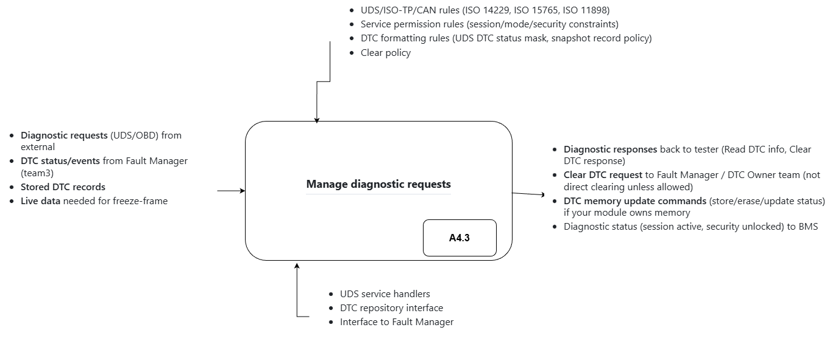
5.1 Overview
The Diagnostic Communication Subsystem (A4.3) implements the UDS (Unified Diagnostic Services) protocol stack according to ISO 14229 and ISO 15765 standards. This subsystem enables external diagnostic tools to query BMS status, read diagnostic trouble codes (DTCs), clear fault codes, and perform advanced diagnostic operations. The architecture follows a layered approach with specialized modules for each diagnostic function.
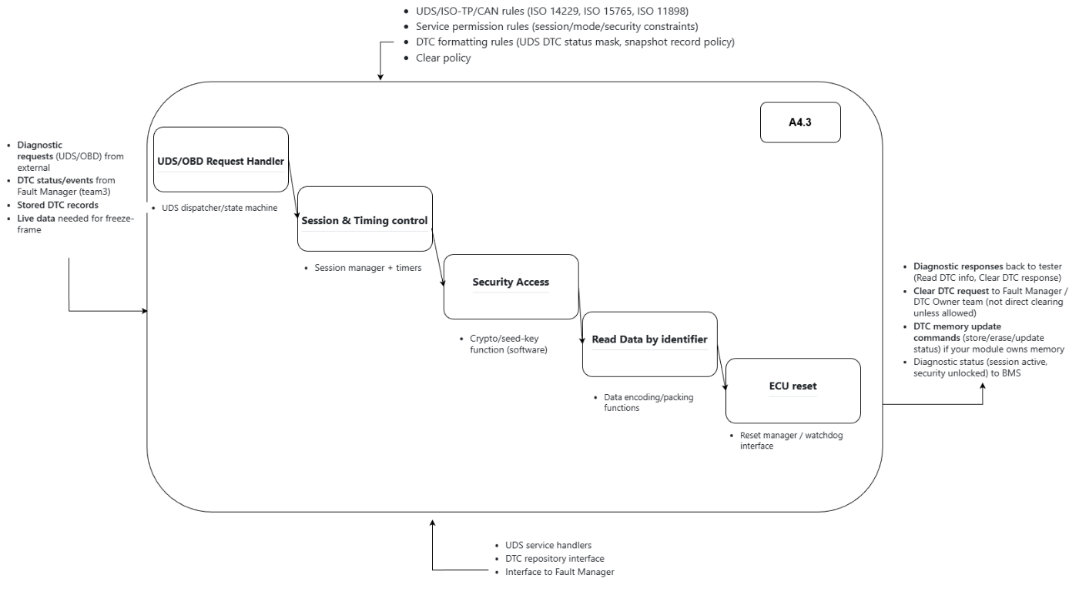
5.2 Protocol Stack Modules
5.2.1 UDS/OBD Request Handler
This module serves as the entry point for all diagnostic requests. It receives incoming UDS/OBD requests from external testers, performs initial request parsing and validation, and routes requests to the appropriate service handlers. The module also interfaces with the Fault Manager to receive DTC status updates and stored DTC records, as well as live data for freeze-frame functionality. Valid requests are forwarded to the Session & Timing Control module for further processing.
5.2.2 Session & Timing Control
This module manages diagnostic sessions and enforces timing constraints according to UDS specifications. It implements three session types: default session (normal operation), extended diagnostic session (enables additional services), and programming session (for firmware updates). The module monitors session timeouts (S3 Server timer) and automatically returns to default session when the timeout expires. Response timing constraints (P2 and P2* timers) are enforced to ensure timely responses to diagnostic requests.
5.2.3 Security Access
The Security Access module implements authentication procedures for protected diagnostic services. It manages seed-key exchanges according to ISO 14229 Service 0x27, validates security permissions before allowing access to restricted functions, and implements cryptographic operations for secure communication. The module maintains security levels and tracks the current security state, allowing or denying access to specific services based on the authenticated level.
5.2.4 Read Data by Identifier
This module processes UDS Service 0x22 requests for reading data by identifier. It maintains a mapping of Data Identifiers (DIDs) to internal data sources, retrieves requested data from appropriate subsystems, and formats responses according to UDS specifications. The module supports reading static data (calibration parameters), dynamic data (sensor readings), and DTC-related data (fault information). Each DID is associated with access permissions and security requirements.
5.2.5 ECU Reset
The ECU Reset module handles system reset operations through UDS Service 0x11. It supports multiple reset types including hard reset (power cycle), key reset (restart without power cycle), and soft reset (restart application only). The module manages watchdog timer interactions and coordinates with the Operating Mode Manager to ensure safe shutdown before reset. Reset operations are subject to security access restrictions to prevent unauthorized system restarts.
5.3 Standards Compliance
The diagnostic subsystem is designed to comply with multiple automotive standards. ISO 14229 defines the UDS protocol services and session management. ISO 15765 specifies the ISO-TP transport layer for message segmentation and reassembly. ISO 11898 governs the underlying CAN physical and data link layers. Compliance with these standards ensures interoperability with standard diagnostic tools and enables third-party service equipment to communicate with the BMS effectively.

6. A4.1.1 Receive & Validate CAN Messages (Detailed)
6.1 Functional Requirements
The A4.1.1 module implements detailed processing logic for incoming CAN messages. This submodule of A4.1 is responsible for the complete receive path from hardware interface to validated signal output. The module operates in real-time context and must meet strict timing requirements to ensure timely processing of safety-critical messages. The processing chain includes reception, queuing, parsing, routing, validation, and signal extraction stages.
6.2 Input Processing Chain
- Reception: Raw CAN Rx Frames are received by the CAN controller and stored in Rx FIFO/Mailboxes
- Queuing: Frames are moved to the Rx Queue by the Rx Task (RTOS task)
- Parsing: Parser/Unpack Functions convert raw binary data to structured signal values
- Routing: Routing Table directs frames to correct signal handlers based on CAN ID
- Validation: Validation Rules check DLC, plausibility, and freshness of data
- Output: Valid signals are output; invalid/missing frames generate Rx Status errors
6.3 Validation Rules Implementation
The validation subsystem implements multiple layers of data integrity checking. DLC (Data Length Code) validation ensures received messages have the expected number of bytes according to the DBC definition. Plausibility checking verifies that signal values fall within acceptable ranges defined for each signal type (e.g., SOC between 0-100%, temperature within -40 to 85 degrees Celsius). Freshness monitoring tracks message timestamps and sequence counters to detect stale or missing data. When validation fails, appropriate error counters are incremented and Rx Status flags are set for diagnostic purposes.

- 7. BMS_Profile Architecture
7.1 Overview
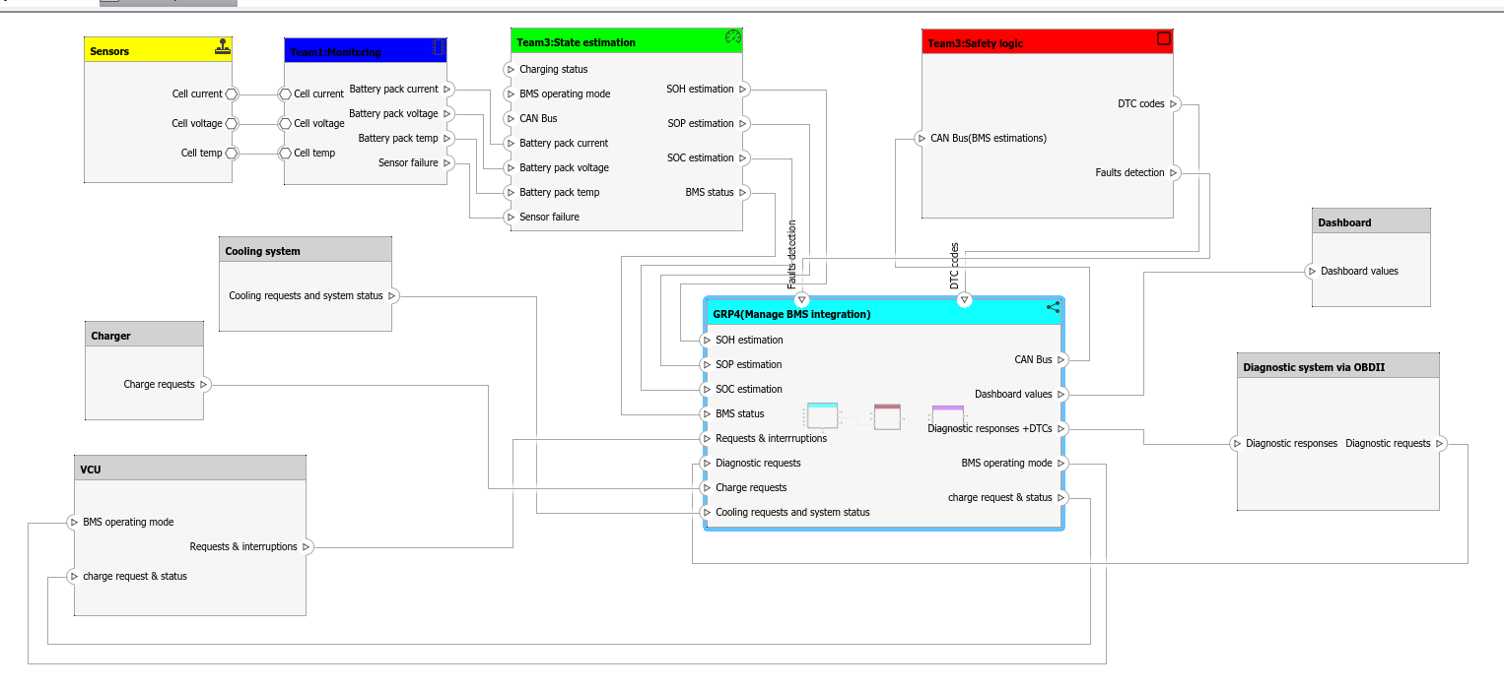
The BMS_Profile is the top-level architectural container that encapsulates all BMS components. It provides a modular, hierarchical structure that supports independent development and testing of individual components. Each sub-component has well-defined parameters that configure its behavior, enabling customization for different battery configurations and vehicle platforms. The architecture emphasizes separation of concerns and clear interface definitions between components.
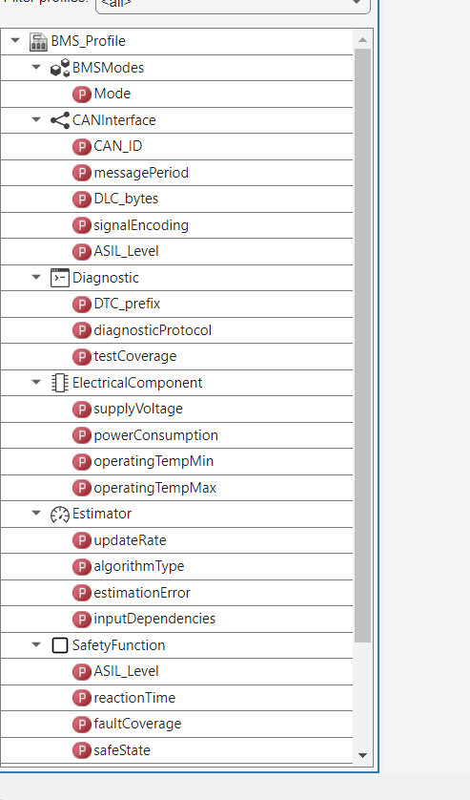
7.2 Component Parameters
Component | Key Parameters | Purpose
CANInterface | CAN_ID, messagePeriod, DLC_bytes, signalEncoding, ASIL_Level | Manages CAN bus communication
Diagnostic | DTC_prefix, diagnosticProtocol, testCoverage | Monitors system health and logs faults
ElectricalComponent | supplyVoltage, powerConsumption, operatingTempMin/Max | Models battery electrical behavior
Estimator | updateRate, algorithmType, estimationError, inputDependencies | Estimates SOC, SOH, SOP states
SafetyFunction | ASIL_Level, reactionTime, faultCoverage, safeState | Enforces safety-critical rules
Sensor | samplingFrequency | Manages sensor data acquisition

7.3 Data Flow Between Components
The data flow follows a logical path from sensors through processing to communication. Sensor components collect raw battery data including cell voltages, currents, and temperatures. This data flows to the Estimator component, which calculates battery states (SOC, SOH, SOP) using algorithms such as Kalman Filters or Coulomb Counting. The SafetyFunction component monitors these states and enforces safety limits, triggering protective actions when thresholds are exceeded. The ElectricalComponent provides electrical model parameters for accurate state estimation. All processed data is communicated externally through the CANInterface, while the Diagnostic component maintains fault records and supports diagnostic queries.

8. Team Integration Architecture
8.1 Overview
The Team Integration Architecture shows how multiple teams work together to form the complete BMS system. This architecture demonstrates the collaboration between Team 1 (Monitoring), Team 3 (State Estimation and Safety Logic), and Group 4 (Communication & System Integration). Each team's component has specific responsibilities and well-defined interfaces, enabling parallel development and integration. The architecture follows a layered approach with data flowing from sensors through processing layers to external interfaces.
8.2 Team Responsibilities
8.2.1 Sensors Module
The Sensors module is responsible for acquiring raw data from battery cells. It outputs cell-level current, voltage, and temperature measurements at a configured sampling frequency. This module interfaces directly with the battery management ICs and provides the fundamental data required for all subsequent processing. The raw sensor data is the foundation for all higher-level calculations and safety monitoring functions.
8.2.2 Team 1: Monitoring
Team 1's Monitoring module processes raw sensor data to generate aggregated system-level metrics. It receives cell-level data and computes battery pack-level values including total pack current, pack voltage, and pack temperature (minimum, maximum, average). Additionally, the module performs sensor health monitoring and outputs a Sensor Failure flag when anomalies are detected. This processed data provides the foundation for state estimation and safety monitoring.
8.2.3 Team 3: State Estimation
Team 3's State Estimation module calculates critical battery parameters using monitored data and charging status. It employs algorithms to estimate State of Charge (SOC), State of Health (SOH), and State of Power (SOP). The module considers operating mode and environmental conditions in its calculations. Outputs include SOC/SOH/SOP estimations and overall BMS status, which are essential for vehicle control and driver information display.
8.2.4 Team 3: Safety Logic
Team 3's Safety Logic module monitors battery parameters and detects fault conditions. It receives BMS estimations via CAN bus and implements protective logic for overvoltage, undervoltage, overcurrent, and overtemperature conditions. When faults are detected, the module generates DTC codes for diagnostic purposes and controls contactor operations to isolate the battery when necessary. This module is critical for ISO 26262 compliance and functional safety implementation.
8.3 Defined Interfaces
The architecture defines several standard interface buses that enable communication between components. These interfaces ensure consistent data exchange and reduce coupling between modules. The DataAcqBus carries raw sensor data from acquisition modules. The DataCalcBus contains calculated values such as SOC and power limits. The CANBusInterface handles external vehicle communication. The SafetyInterface carries safety-critical signals and fault information. The UDSInterface provides diagnostic communication capability. The ChargerInterface and ThermalInterface manage charging and thermal control respectively.
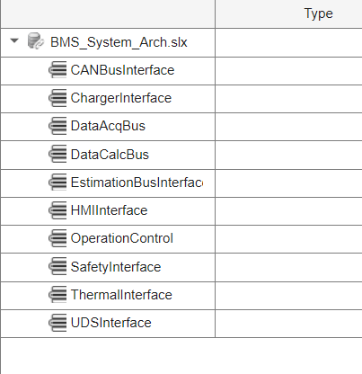

9. Group 4 - Manage BMS Integration
9.1 Overview
Our group(GRP4) Manage BMS Integration module is the central coordination hub for Group 4's responsibilities. It serves as the integration point between internal BMS functions and external vehicle systems, managing CAN communication, operating mode control, and diagnostic services. This module receives data from multiple sources, processes it according to system requirements, and distributes information to appropriate destinations. The architecture ensures coherent system behavior while maintaining compliance with automotive standards.
9.2 Internal Architecture
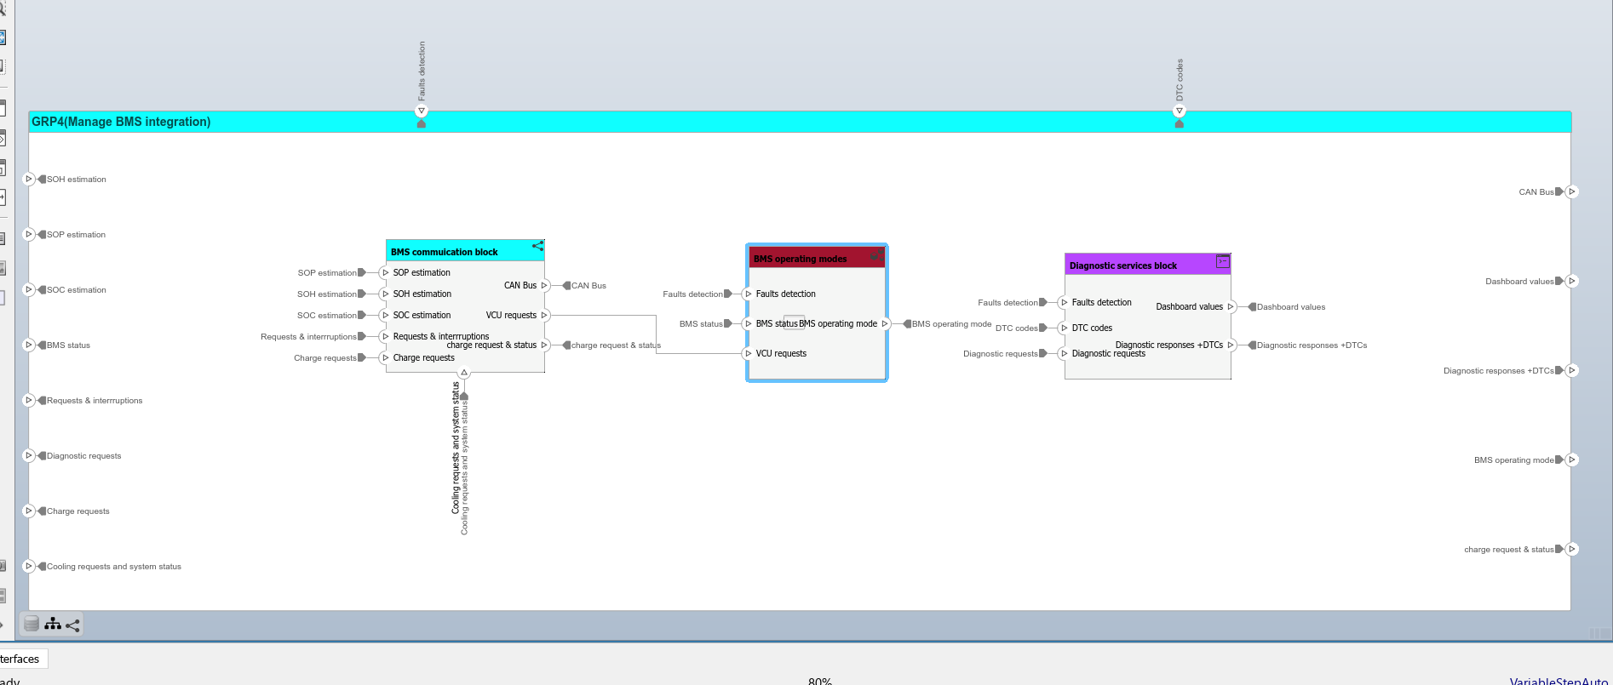
9.2.1 BMS Communication Block
The BMS Communication Block serves as the gateway for all external BMS communication. It receives battery state data (SOH, SOP, SOC estimations) from Team 3's State Estimation module, processes external requests and interruptions from the VCU, and handles charge requests from the charging system. The module formats data for CAN transmission and generates appropriate responses to external queries. It maintains communication state and handles protocol-specific requirements for CAN message assembly and transmission timing.(we will use CAN config,CAN pack,CAN unpack ,CAN transmit and receive,and we will define different CAN channels in this moduls)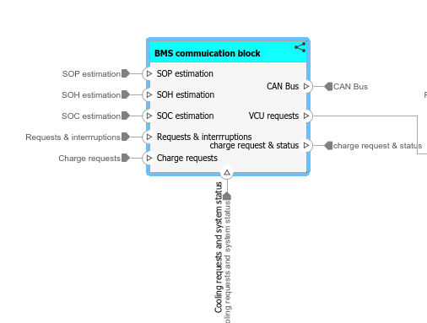

9.2.2 BMS Operating Mode Block
The BMS Operating Mode block determines and maintains the current operational state of the BMS. It receives fault detection signals from the Safety Logic module and BMS status from the State Estimator, then determines the appropriate operating mode based on system conditions. The module generates mode-specific control commands and DTC codes when fault conditions are detected. It implements the state machine defined by the BMSModes enumeration and enforces mode transition rules including safety interlocks and timeout constraints.
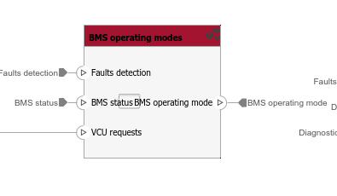
9.2.3 Diagnostic Services Block
The Diagnostic Services block handles all diagnostic requests and generates diagnostic responses. It processes diagnostic queries from external tools (via OBDII port), retrieves DTC codes from the operating mode and safety logic modules, and generates dashboard values for driver information display. The block implements UDS services for reading data, clearing DTCs, and performing diagnostic control functions. It maintains session state and enforces security access requirements for protected diagnostic operations.
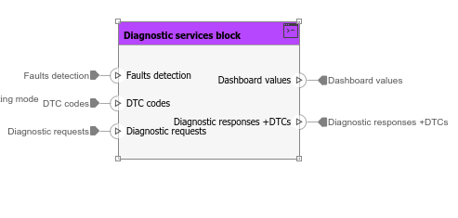
9.3 External Interfaces
Direction | Interface | Data Content
Input | SOH/SOP/SOC estimation | Battery state values from Team 3 State Estimation
Input | BMS status | Overall BMS operational status
Input | Requests & interruptions | VCU commands and system interrupts
Input | Diagnostic requests | External diagnostic tool queries
Input | Charge requests | Charging system commands
Input | Cooling requests | Thermal management commands
Output | CAN Bus | BMS data for vehicle network
Output | Dashboard values | Driver information display data
Output | Diagnostic responses + DTCs | Diagnostic tool responses
Output | BMS operating mode | Current mode status to VCU
Output | Charge request & status | Charging status feedback
Output | Cooling request & status | Thermal system feedback

10. Implementation Guidelines
10.1 Simulink Implementation
Each module described in this document can be implemented in Simulink using standard blocks and Model-Based Design principles. State machines should be implemented using Stateflow charts with explicit state definitions matching the BMSModes enumeration. CAN communication blocks should use the Vehicle Network Toolbox for CAN Pack and Unpack operations. Rate Transition blocks should be used where data is exchanged between tasks running at different rates. The implementation should follow automotive coding guidelines (MISRA C) when generating production code.
10.2 Testing Recommendations
Each module should be tested at multiple levels including unit testing, integration testing, and system-level testing. Unit tests should verify individual function behavior with boundary value analysis and equivalence partitioning. Integration tests should verify data flow between connected modules and timing behavior. System tests should validate end-to-end functionality including fault injection scenarios. All tests should be automated using Simulink Test and results should be documented for ISO 26262 qualification evidence.
10.3 Safety Considerations
The implementation must address ISO 26262 functional safety requirements throughout the development lifecycle. Safety-critical functions should be implemented with appropriate ASIL levels and include defensive programming techniques such as range checking, plausibility verification, and watchdog monitoring. Fail-safe behaviors should be defined for all identified fault conditions. Traceability between requirements, design, implementation, and tests must be maintained. All safety-related design decisions should be documented in the safety case.

11. Conclusion
This document has provided a comprehensive explanation of each module implemented in MATLAB System Composer for the Battery Energy Management system. The architecture follows industry best practices for automotive systems including modular design, clear interface definitions, and compliance with relevant standards (ISO 26262, ISO 14229, ISO 11898). Communication & System Integration components serve as the critical bridge between internal BMS functions and external vehicle systems, enabling reliable data exchange, proper operating mode control, and comprehensive diagnostic capabilities. The modular architecture supports independent development, testing, and maintenance while ensuring coherent system behavior through well-defined interfaces and data flows.

