Regenerative Braking System
Week4 : REPORT
The National Engineering School Of Sousse (ENISo)
Department : Industrial Electronics

Maissa Lajmi-Ghaith Abid  Field: Automotive Software Engineering | 



Overview
The modeling of a Regenerative Braking System (RBS) in electric vehicles (EVs) involves a systematic, physics-based representation of interconnected subsystems to capture energy during deceleration while ensuring vehicle stability, battery safety, and driver comfort. In one-pedal driving mode the accelerator pedal controls both propulsion and normal deceleration through regen (strong regenerative braking on lift-off), while the brake pedal provides hydraulic friction braking when regen is insufficient (low speed, cold battery, low grip) and is used also for emergency or panic stops. This architecture maximizes energy recovery (typically 60–85 % of kinetic energy in urban cycles) and simplifies driver interaction.

Model Design
In MATLAB/Simulink environments (using Simscape Electrical, Powertrain Blockset, Motor Control Blockset, and Vehicle Dynamics Blockset), the RBS is typically decomposed into modular subsystem.
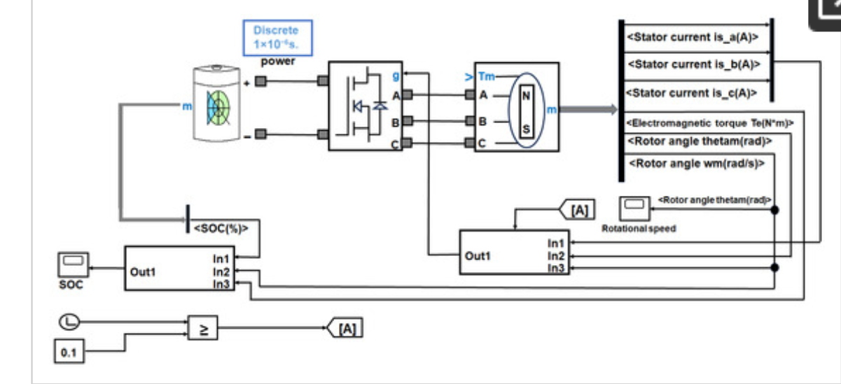
The subsystems that we will be working on:
- Drive cycle or variable vehicle speed input:
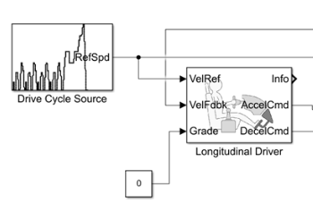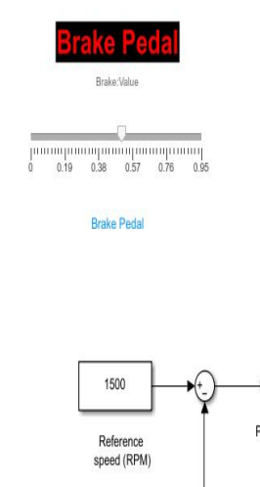
These will serve as the vehicle speed input before applying braking and so RB (to be discussed further) we used first the brake pedal as a constant block with the slider model for easier manipulation. Then we will switch to the drive cycle source for more advanced and realistic case simulation.
- Motor PMSM:
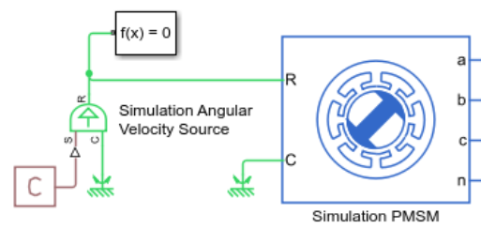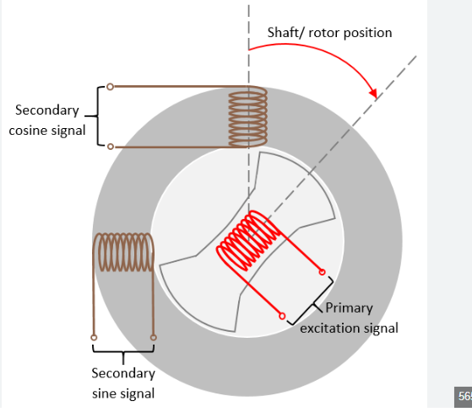

The PMSM receives its mechanical rotational speed directly from the wheels through the fixed-ratio transmission (two-speed gearbox in the Mercedes CLA 250+ platform). When the driver releases the accelerator pedal in one-pedal mode, vehicle inertia keeps the wheels turning; this rotation is transmitted via the gearbox (gear ratio 11:1 or 5:1) to the motor rotor shaft, mechanically driving the PMSM above its synchronous speed and forcing it to operate as a generator.

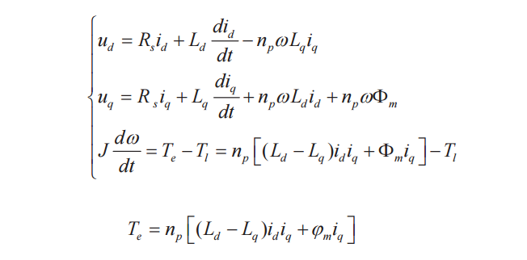
The Permanent Magnet Synchronous Motor (PMSM) was selected because it offers the highest efficiency (95–97 %), excellent power density, very low torque ripple, and wide constant-power speed range through field weakening.
Dynamic d–q Model of the Permanent Magnet Synchronous Motor (PMSM)

- Motor Control Unit (Inverter and FOC in regenerative mode)
The Motor Control Unit is the heart of the RBS. It receives three-phase AC power generated by the PMSM (now acting as a generator) and converts it back into DC power to charge the battery while simultaneously producing precise braking torque. The same hardware and control algorithms used for propulsion are reused in regeneration and only the torque command changes sign.
- FOC: Field Oriented Control Mechanism
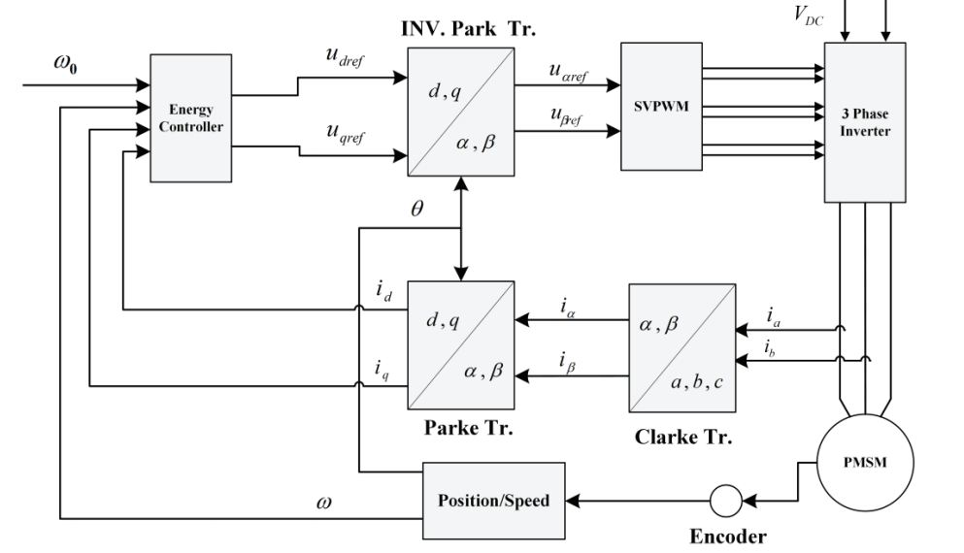
When the PMSM is rotating, the permanent magnets on the rotor sweep past the stator windings and induce a back-EMF (Faraday’s law).
According to Lenz’s law “any induced current will create a magnetic field that opposes the change that produced it” and in this case ; opposes the rotor motion. The FOC controller deliberately sets a negative quadrature current (i_q < 0) so the stator produces a magnetic field that fights the rotor’s rotation. This opposing torque extracts kinetic energy from the vehicle, converting it into electrical energy.
The generated AC voltage and current are higher (in power terms) than what the battery supplies, so power flows reversely through the inverter into the DC bus and then into the battery. The inverter no longer “creates” 3-phase current from the battery, instead it acts as a controlled active rectifier, pushing current back while keeping the torque exactly at the demanded braking level. This process is seamless and instantaneous (<5 ms response) thanks to FOC.

The FOC includes Park and Clarke Transformations PI regulation and space vector PWM
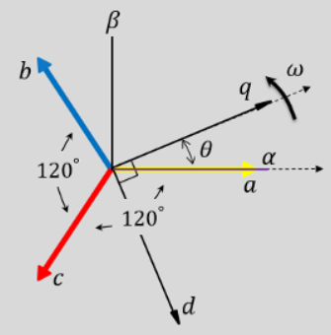
1. Clarke Transformation (abc → αβ stationary frame)
$$i_{α}=\frac{2}{3}i_{a}-\frac{1}{3}i_{b}-\frac{1}{3}i_{c}$$
$$i_{β}=\frac{1}{\sqrt{3}}(i_{b}-i_{c})$$
2. Park Transformation (αβ → dq rotating frame, aligned with rotor)
$$i_{d}=i_{α}cos⁡θ+i_{β}sin⁡θ$$
$$i_{q}=-i_{α}sin⁡θ+i_{β}cos⁡θ$$
3. Current Control (PI regulators) The controller forces id to its reference (usually 0 or negative for field weakening) and iq to the negative torque command coming from the VCU (for example 150 A for strong regen).
Decoupled voltage commands (with feed-forward):
$$v_{d}^{*}=K_{p}(i_{d}^{*}-i_{d})+K_{i}∫(i_{d}^{*}-i_{d}) dt-ω_{e}L_{q}i_{q}$$
$$v_{q}^{*}=K_{p}(i_{q}^{*}-i_{q})+K_{i}∫(i_{q}^{*}-i_{q}) dt+ω_{e}(L_{d}i_{d}+ψ_{pm})$$
4. Inverse Park (dq → αβ)
$$v_{α}^{*}=v_{d}^{*}cos⁡θ-v_{q}^{*}sin⁡θ$$
$$v_{β}^{*}=v_{d}^{*}sin⁡θ+v_{q}^{*}cos⁡θ$$
5. Space Vector PWM (SVPWM) Converts (vα*, vβ*) into switching times for the 6 IGBTs (Insulated-Gate Bipolar Transistors) , producing the exact stator voltage vector needed to achieve the desired iq (negative) and id.
The entire loop runs identically in regen only iqref < 0 changes. The same 6 IGBTs now route the generated current back to the DC bus, charging the battery while the opposing torque (from Lenz) slows the vehicle.
- The Inverter:
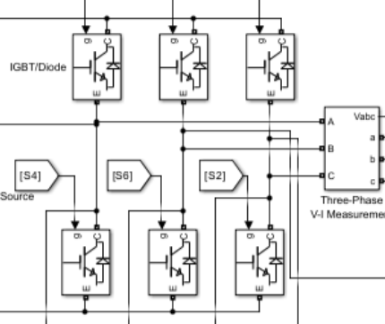

The inverter (six IGBTs with anti-parallel diodes) is fully bidirectional:
In motoring: DC → AC (inverter mode)
In regeneration: AC → DC (active rectifier mode)
During regen the IGBTs are PWM-modulated (SVPWM) so the anti-parallel diodes conduct in a controlled way, or the switches actively short phases to shape the current. This gives unity power factor rectification, minimal harmonics, and maximum energy recovery (typically 92–96 % efficient at 100 km/h).
Power balance in regen (ideal case):
$$P_{\text{mech}}=T_{e}⋅ω_{m}=-P_{\text{elec}}=-\frac{3}{2}(v_{d}i_{d}+v_{q}i_{q})$$
(The negative sign shows power flowing from motor → inverter → battery.)

- The battery :
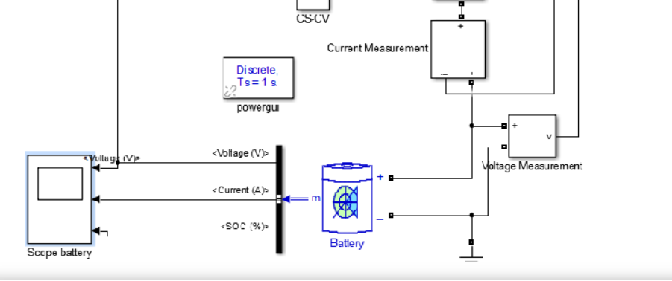
In the one-pedal driving architecture, the high-voltage battery serves three critical roles:
- Energy supplier during propulsion (positive current from battery to inverter/motor).
- Energy storage during regenerative braking (negative current into the battery from the inverter).
- Safety gatekeeper that actively intervenes to protect the cells by limiting or completely disabling regenerative braking when operating conditions exceed safe limits. (interconnected with the BMS)
The battery that we have chosen is based on the Mercedes-Benz CLA 250 with +800 V platform: 85 kWh usable capacity, NMC chemistry with silicon-oxide/graphite anodes, 192s1p configuration, nominal voltage ≈ 800 V.
BMS Intervention Logic (Regen Limitation):
The BMS continuously monitors cell voltages, temperatures, and SoC, then broadcasts the maximum allowable regen current/power to the VCU via CAN bus. Regen is throttled or stopped according to the following typical rules (implemented as lookup tables or state machine in Simulink):
Regenerative current limit (Iregen_max):
$$I_{\text{regen_max}}=min⁡\left(I_{\text{motor_max}}, I_{\text{BMS}}(SOC,T)\right)$$
where the BMS limit function is typically:
$$I_{\text{BMS}}(SOC,T)=\left\{\begin{matrix}0 & \text{if }SoC≥SoC_{\text{max}} (95\%\text{–}98\%) \\ \text{or }T≤T_{\text{min}} (0^{∘}\text{C}) & \\ \text{or }T≥T_{\text{max}} ({45}^{∘}\text{C–}{50}^{∘}\text{C}) & \\ k⋅(SOC_{\text{max}}-SOC)⋅f(T) & \text{linear fade between limits} \\ I_{\text{full_regen}} & \text{otherwise}\end{matrix}\right.$$

Power limit (more commonly used in modern systems):
$$P_{\text{regen_max}}=V_{\text{terminal}}⋅I_{\text{regen_max}}$$
SoC dynamics (Coulomb counting – implemented in every battery model):
$$\frac{dSOC}{dt}=-\frac{I_{\text{batt}}}{3600⋅Q_{\text{nom}}}(\%)$$
(positive I_batt = discharge, negative I_batt = charging during regen)
We will be using a Full Lithium-Ion Battery Model
What we’ll be using exactly in modeling :
- Library: Simscape Battery .
- Parameters (CLA 250+ scale): – Nominal voltage: 800 V – Rated capacity: 106 Ah (85 kWh usable) – Initial SOC: 70 % – Temperature port enabled (0–50 °C range)
- We will add Temperature Sensor and Voltage Sensor blocks.
- Iregen_max calculation and feedback to the VCU.
- BMS-CAN Emulation (most realistic for full RBS)
- And we will communicate information to the VCU using CAN Pack / CAN Unpack block (from Vehicle Network Toolbox) to simulate real CAN messages:
– Message: “Battery Regen Power Limit” (e.g. 0–150 kW)
– Message: “Battery Max Charge Current”
– Message: “Battery Temperature Status”

- Conventional Braking: (case of Low vehicle speed)
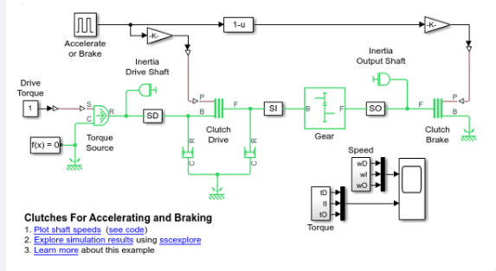
In one-pedal driving mode, regenerative braking provides the primary deceleration when the accelerator pedal is released. However, below a certain vehicle speed (typically 8–15 km/h, depending on the vehicle), regenerative braking becomes ineffective and is gradually or fully replaced by conventional hydraulic friction braking. This is called brake blending.

Why Regenerative Braking Fails at Low Speed :
The back-EMF voltage generated by the PMSM (acting as generator) is directly proportional to rotor speed:
$$E=k_{e}⋅ω_{m}(k_{e}=p⋅ψ_{pm})$$
At low ω_m (low vehicle speed), E becomes smaller than the battery voltage (≈ 800 V). The power that can be regenerated is:
$$P_{\text{regen}}=T_{e}⋅ω_{m}$$
Even if the motor could produce maximum torque, the available braking power drops dramatically as speed approaches zero. To maintain meaningful braking torque at very low speed would require extremely high phase currents → excessive power losses, overheating of the inverter and motor windings, and poor efficiency. Therefore, the BMS and VCU automatically limit T_regen_max → 0 as v → 0.

The Brake Blending Principle:
The system always ensures the total braking torque matches the driver’s demand (or the VCU’s one-pedal command), regardless of speed:
$$T_{\text{total_req}}=T_{\text{regen}}+T_{\text{friction}}$$
- T_regen = actual regenerative torque delivered by the PMSM/FOC (limited by speed, battery, temperature).
- T_friction = shortfall supplied by hydraulic brakes.

At high speed: T_regen ≈ T_total_req (strong regen, almost no friction brakes). At low speed (< 10 km/h): T_regen → 0 → T_friction ≈ T_total_req (full hydraulic braking).
The transition is seamless and usually imperceptible to the driver.

Role of the Brake Control Unit (BCU)
The BCU (also called Electronic Brake Control Module or iBooster) is responsible for real-time brake blending. It receives:
- Total braking demand from VCU (from accelerator lift-off or brake pedal ).
- Actual T_regen from Motor Control Unit (via CAN).
- Wheel speeds, vehicle speed, and stability data (ESC).
It then calculates the torque deficiency and commands the exact hydraulic pressure.
Equations used by the BCU:
-Torque deficiency per axle (rear-wheel-drive example):
$$T_{\text{friction_req}}=T_{\text{total_req}}-T_{\text{regen_actual}}$$

-Hydraulic pressure required (per caliper):
$$P_{\text{hyd}}=\frac{T_{\text{friction_req}}}{2⋅μ⋅A_{\text{piston}}⋅r_{\text{eff}}⋅η_{\text{brake}}}$$
where:
- μ = friction coefficient pad/disc (≈ 0.35–0.45)
- A_piston = total piston area of the caliper (m²)
- r_eff = effective disc radius (≈ 0.12–0.15 m for CLA)
- η_brake = mechanical efficiency (≈ 0.95)
- Brake force at the tyre:
$$F_{\text{brake}}=\frac{T_{\text{friction}}}{R_{\text{eff}}}$$
The BCU sends the pressure command to the electro-hydraulic actuator (iBooster or ESP pump), which builds pressure in the brake lines (typically 0–120 bar) within 20–50 ms.

