Regenerative Braking System
Algorithm Development — Progress Report
Ghaith Abid | Maissa Lajmi

1. Project Overview
This project implements a complete Field-Oriented Control (FOC) pipeline for a regenerative braking system on the Mercedes-Benz CLA 250+ electric vehicle (estimation) . The motor is an Interior Permanent Magnet Synchronous Motor (IPMSM) rated at 200 kW and 335 Nm, powered by a 706 V DC bus.

The control strategy is developed entirely from first principles , each algorithm is derived mathematically before being implemented in Python for validation, then used in MATLAB/Simulink for the final simulation model. The Python validation layer uses numerical solvers and plot validation suites to confirm each module before it is used by the next.

The FOC pipeline covers three distinct operating regions, each governed by a different optimisation problem (for current and voltage constraints):
- MTPA (Maximum Torque Per Ampere) : low speed region where current is the main constraint. The controller finds the minimum-current operating point for a given torque request.
- Field Weakening (FW) : intermediate speed region where both the current constraint and the voltage constraint are simultaneously active. The operating point sits at the intersection of the current circle and the voltage ellipse in the dq plane.
- MTPV (Maximum Torque Per Volt) : high speed region where current is the main constraint. Here, the voltage ellipse has shrunk inside the current circle. The current constraint becomes inactive and the controller maximises torque on the voltage ellipse boundary.

(these details are well developed in the validation section in the project repository)

2. Algorithm Status
The following table summarises the current state of all Python modules. The three core reference generation algorithms ( MTPA, FW, MTPV) are complete and validated as well as the different control models .

Algorithm | File | Status | Validation
Clarke + Park Transforms (math helpers) | clarke_park.py | ✅ Done | /
MTPA Solver | mtpa.py | ✅ Done | ✅ Validated
Field Weakening | field_weakening.py | ✅ Done | ✅ Validated
MTPV Solver | mtpv.py | ✅ Done | ✅ Validated
FOC Reference Switcher | foc_references.py | 🔄 In Progress | 🔄 In Progress
PI Controller + Decoupling | pi_controller.py | ⏳ Pending | ⏳ Pending
Space Vector PWM | svpwm.py | ⏳ Pending | ⏳ Pending

3. Motor Parameters
Since the CLA 250+ electrical parameters are proprietary to Mercedes-Benz, all values not available from official specifications are estimated using physical constraints. The d-axis and q-axis inductances are not hardcoded as they are computed by an embedded solver function (solve_consistent_params) in motor_params.py that finds the Ld value guaranteeing a physically valid field-weakening arc. The key constraint enforced is:

id_mtpa(I_max) > I_ch (center of voltage ellipse)= -lambda_m / Ld

This ensures the MTPA operating point at full current is less demagnetised than the characteristic current, which is the necessary condition for the FW region to exist.

Parameter | Symbol | Value | Source
Peak Power | P_max | 200 kW | Official Spec
Peak Torque | T_max | 335 Nm | Official Spec
DC Bus Voltage | V_dc | 706 V | Official Spec
Max Phase Voltage | V_max | 407.6 V | Derived (V_dc / sqrt(3))
Pole Pairs | p | 4 | Estimated
Stator Resistance | R_s | 0.012 Ohm | Estimated
d-axis Inductance | L_d | 250 uH | Solver-derived
q-axis Inductance | L_q | 600 uH | Solver-derived
PM Flux Linkage | lambda_m | 0.095 Wb | Estimated
Max Phase Current | I_max | 580 A | Estimated
Characteristic Current | I_ch | -380 A | Derived (-lambda_m/Ld)
Saliency Ratio | xi | 2.4 | Derived (Lq/Ld)
Base Speed | w_base | 576 rad/s (5500 RPM) | Derived (P/T)
Max Speed | w_max | 1466 rad/s (14000 RPM) | Estimated

4. Control Architecture
The complete FOC pipeline takes a torque request (T_request) and electrical speed (We) as inputs and produces three-phase duty cycles (Da, Db, Dc) as outputs. The reference generation layer (MTPA / FW / MTPV) operates in steady-state and feeds the inner current control loop which handles all transient dynamics.
The steady state: the condition where all electrical quantities (currents, voltages, and flux linkages ) are no longer changing with time, meaning the motor is spinning at a constant speed with a constant torque and the dq-frame derivatives d(id)/dt and d(iq)/dt are both zero. (this approach is quite impractical in real-time but we would apply it in short time intervals to reduce complexity deducted from derivates)
Pipeline :
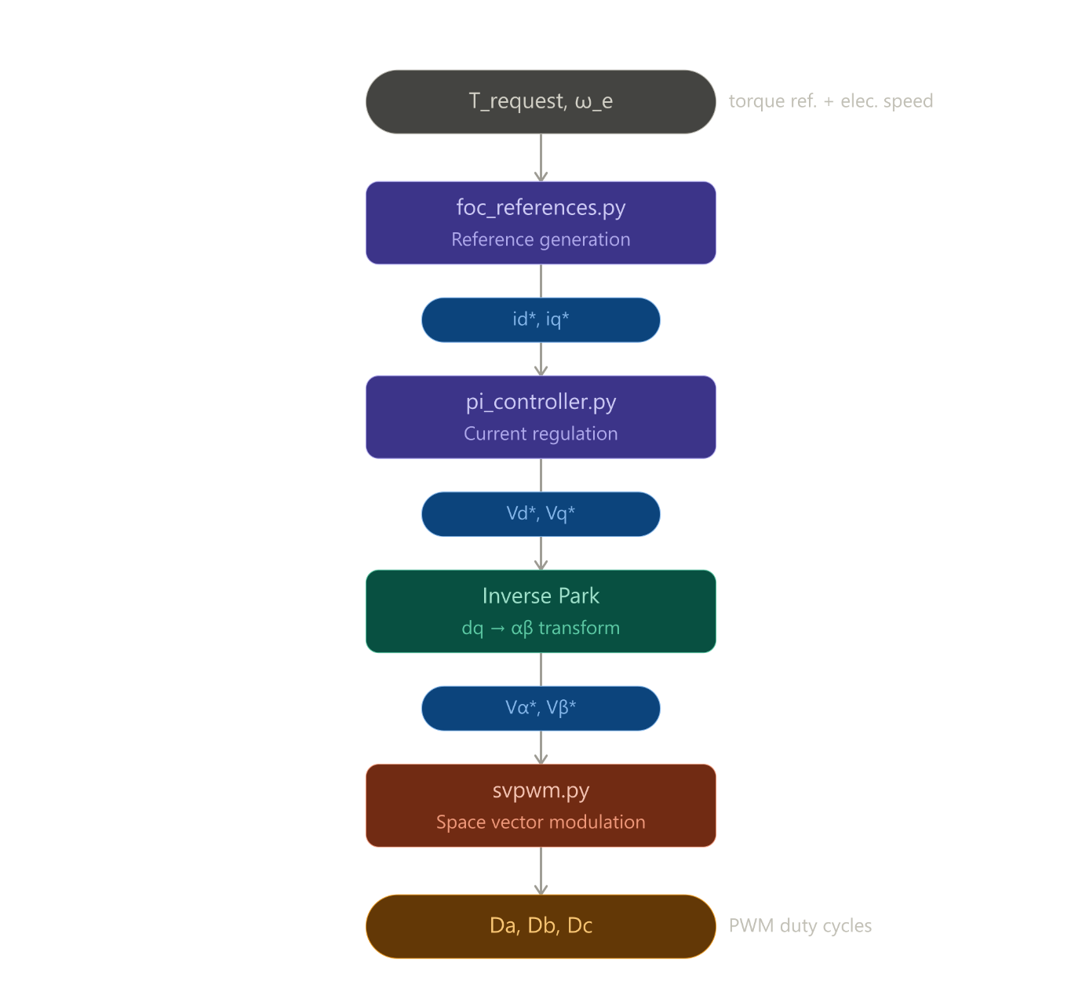

The master switcher (foc_references.py) is the only file that imports from all three solvers. It computes the MTPA transition speed per torque request and the MTPV transition speed once at startup, then routes every control cycle to the correct solver based on the current electrical speed.

5. File Architecture
The repository is split into three top-level directories. Python contains all algorithm development and validation. MATLAB contains the translated function blocks and Simulink model. Docs contains weekly progress reports.

File | Role & Responsibility
python/motor_params.py | Single source of truth for ALL parameters. Contains two solver functions: solve_consistent_params() finds Ld ensuring a valid FW arc; verify_params() prints a full consistency report. Every other file imports from here as parameters are never hardcoded elsewhere.
python/clarke_park.py | Three pure mathematical transforms with no motor parameters: amplitude-invariant Clarke (Ia, Ib → Ialpha, Ibeta), Park (stationary → rotor dq frame), and Inverse Park (dq voltages → stationary frame for SVPWM).
python/mtpa.py | Reference generator for the low-speed region.  Newton-Raphson solver on a degree-4 polynomial finds (id*, iq*) minimising stator current magnitude for a given torque request. Also builds offline lookup tables for Simulink.
python/field_weakening.py | Reference generator for the intermediate-speed region. Closed-form quadratic finds (id*, iq*) at the intersection of the current circle and voltage ellipse. Includes transition speed computation and voltage feasibility check.
python/mtpv.py | Reference generator for the high-speed region.  Lagrange multiplier derivation with produces a quadratic finds (id*, iq*) Includes FW->MTPV transition speed solver.
python/foc_references.py | Master switcher , the only file that imports from all three solvers. Decides MTPA / FW / MTPV each control cycle based on electrical speed. Exposes initialise() called once at startup and compute_references() called every cycle.
python/pi_controller.py | Inner current control loop with full dq decoupling feedforward, anti-windup integrator, and voltage saturation on the (vd*, vq*) circle. All transient handling lives here. PI gains tuned via pole-zero cancellation.
python/svpwm.py | Space Vector PWM: converts (valpha*, vbeta*) voltage commands to three-phase duty cycles (Da, Db, Dc) via sector identification (1-6), dwell time calculation (T1, T2, T0), and duty cycle mapping.
python/validation/ | One validation script per solver. Each script runs numerical sanity checks (assertions) followed by multi-plot visual verification in the dq plane. No module is considered done until all checks pass.
matlab/functions/ | Direct MATLAB translations of each Python solver. Written after Python validation is complete. Used as MATLAB Function blocks inside Simulink (same equations, same logic, MATLAB syntax).
matlab/params/motor_params.m | MATLAB equivalent of motor_params.py. Loaded at the start of every Simulink simulation. Must always be kept in sync with the Python version.
matlab/models/RBS_main.slx | The main Simulink model and the final deliverable. Connects all MATLAB Function blocks into the full FOC pipeline from current sensors through to inverter duty cycles.

GitHub Repository Link :
https://github.com/BlascoW001/Regenerative-Braking-system-Simulink-Model

6. FOC Pipeline — Detailed Signal Flow

The following describes every stage of the FOC pipeline in signal-flow order, from the torque request at the top level down to the three-phase duty cycles sent to the inverter. Each stage is implemented as a separate Python file that will become a MATLAB Function block in Simulink.

Stage 1 — Torque Request & Speed Measurement
Inputs to the system: T_request [Nm] from the vehicle controller (positive = motoring, negative = regeneration) and omega_e [rad/s] electrical angular speed from the rotor position sensor. The sign convention is critical .

Stage 2 — Reference Generation (foc_references.py)
The master switcher receives T_request and omega_e and decides which of the three solvers to call:
- If omega_e <= omega_base(T): calls solve_mtpa() , the transition speed omega_base is torque-dependent because a smaller torque request has a lower current operating point that the ellipse takes longer to shrink to.
- If omega_base(T) < omega_e <= omega_MTPV: calls solve_fw() , the MTPV transition speed omega_MTPV is computed once at startup and is
torque-independent (depends only on motor parameters and I_max).
- If omega_e > omega_MTPV: calls solve_mtpv() , if solve_fw() returns None (numerical edge case at the boundary) the switcher falls through to MTPV automatically.

The output is always (id*, iq*, T_achieved, active_region). The active_region integer (1=MTPA, 2=FW, 3=MTPV) is useful for Simulink signal routing and debugging.
T_achieved may be less than |T_request| in the FW and MTPV regions , the caller (vehicle controller) must handle this later.

Sign rule enforced here:
id* is always negative regardless of region or torque sign.
iq* sign follows T_request sign only:
* Positive for motoring
* Negative for regeneration.
This rule is checked by assertion in every sanity check.

Stage 3 — Inner Current Control (pi_controller.py)
The PI controller drives the measured dq currents (id_measured, iq_measured) toward the references (id*, iq*) from Stage 2. The full steady-state dq voltage equations include
cross-coupling terms that must be cancelled by feedforward:
vd* = Kp*ed + Ki*integral(ed) - omega_e * Lq * iq_measured
vq* = Kp*eq + Ki*integral(eq) + omega_e * Ld * id_measured + omega_e * lambda_m
The last two terms on each line are the cross-coupling decoupling terms. Without them, the d and q axes interact, and the controller cannot be tuned independently. The feedforward terms are computed from the measured currents (not references) to cancel the actual disturbance.

PI gains are tuned via pole-zero cancellation targeting a closed-loop bandwidth of omega_c rad/s:
Kp = L * omega_c, Ki = Rs * omega_c
Anti-windup prevents the integrator from growing unboundedly when the voltage output is saturated. Voltage saturation clips (vd*, vq*) to the V_max circle, not independently on each axis, which would distort the voltage vector direction.

Stage 4 — Inverse Park Transform (clarke_park.py)
Rotates the dq voltage commands back to the stationary alpha-beta frame using the electrical rotor angle:
valpha* = vd* * cos(theta_e) - vq* * sin(theta_e)
vbeta* = vd* * sin(theta_e) + vq* * cos(theta_e)
This is the only place theta_e appears in the voltage path , other than this everything is in the stationary frame. The angle must be the same theta_e used in the Park transform (feedback path) to ensure consistency.

Stage 5 — Space Vector PWM (svpwm.py)
Converts the stationary-frame voltage commands (valpha*, vbeta*) to three-phase duty cycles (Da, Db, Dc) for the inverter legs. The algorithm proceeds in three steps:
- Sector identification: the voltage vector angle determines which of the six 60-degree sectors it falls in (1 through 6). This governs which two adjacent active vectors are used.
- Dwell time calculation: T1 and T2 are the times spent at each active vector, computed from the projection of the reference vector onto the sector boundaries.
T0 is the remaining zero-vector time.
- Duty cycle mapping: T1, T2, T0 are mapped to Da, Db, Dc based on the sector. The result is three signals in [0, 1] that drive the high-side switches of the three inverter legs.

7. Completed Modules — Equations & Validation

7.1 clarke_park.py — Coordinate Transforms
Implements the three transforms needed to move between the three-phase stationary frame and the rotating dq reference frame. Only ia and ib are measured from the motor while ic is always reconstructed via Kirchhoff's current law (ic = -ia - ib).

The amplitude-invariant Clarke transform converts three-phase currents to a two-axis stationary frame:
i_alpha = ia, i_beta = (ia + 2*ib) / sqrt(3)
The Park transform rotates into the rotor-aligned dq frame using the electrical rotor angle:
id = i_alpha * cos(theta_e) + i_beta * sin(theta_e)
iq = -i_alpha * sin(theta_e) + i_beta * cos(theta_e)
The Inverse Park transform rotates voltage commands back to the stationary frame before SVPWM:
v_alpha = vd * cos(theta_e) - vq * sin(theta_e)
v_beta = vd * sin(theta_e) + vq * cos(theta_e)

7.2 mtpa.py — Maximum Torque Per Ampere
Finds the (id*, iq*) pair that minimises the stator current magnitude for a given torque request. This is a constrained optimisation problem solved analytically via the Lagrangian:
Minimise |i|^2 = id^2 + iq^2
Subject to: T = K_T * [lambda_m * iq + (Ld - Lq) * id * iq]

The optimality condition produces a degree-4 polynomial in iq which is solved using Newton-Raphson. The MTPA locus traces a cubic curve in the dq plane. The id* value is always negative for an IPMSM because the reluctance term (Ld - Lq) is negative and demagnetising the d-axis reduces the required iq for a given torque, reducing overall current magnitude.

Validation confirms convergence in 5-6 Newton-Raphson iterations, operating points on the MTPA cubic curve, and all points inside the current circle boundary.

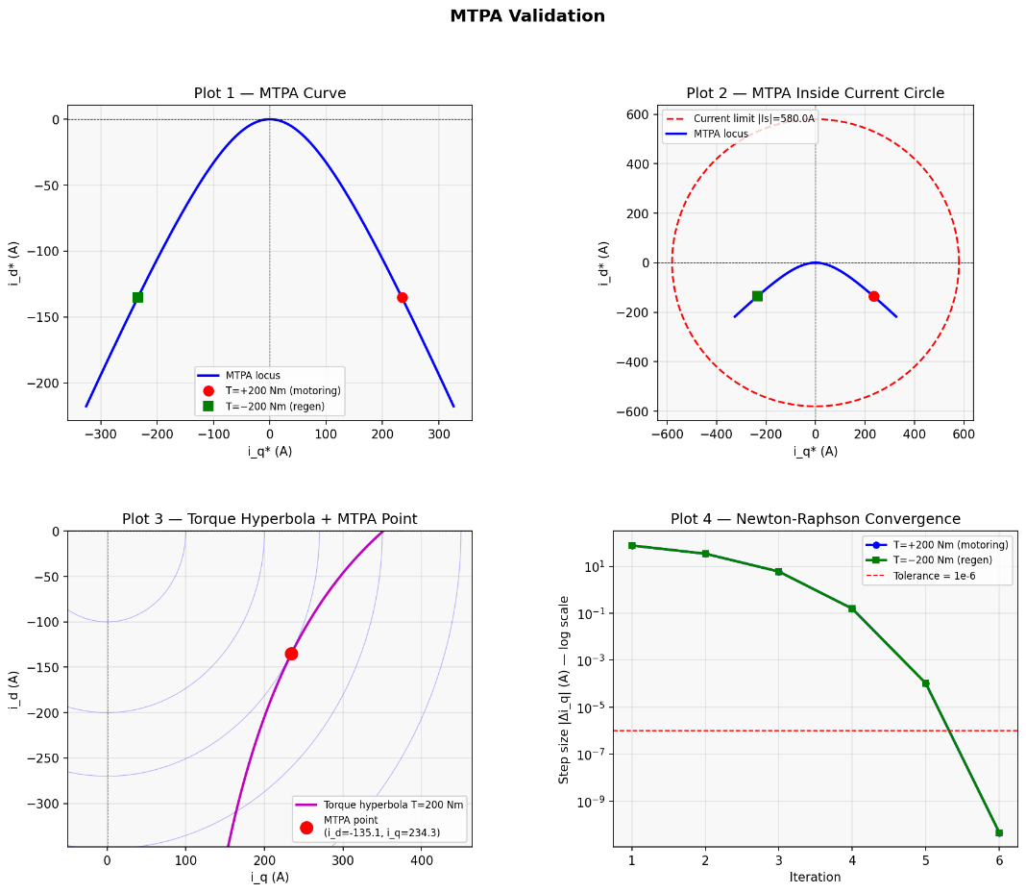

MTPA validation: operating points trace the minimum-current locus for each torque level

7.3 field_weakening.py — Field Weakening
Above the base speed, the back-EMF occupies an increasing portion of the available voltage headroom. The voltage constraint becomes active and the MTPA operating point is no longer reachable. The steady-state voltage equations (dropping Rs at high speed) define a voltage ellipse in the dq plane:
((id + lambda_m/Ld)^2 / (Vmax/w*Ld)^2 ) + ( iq^2 / (Vmax/w*Lq)^2 ) = 1

The ellipse centre is fixed at the characteristic current I_ch = -lambda_m/Ld regardless of speed.
Only its semi-axes shrink proportionally to 1/omega. The FW operating point is the intersection of the current circle and the voltage ellipse , solved by substituting the current circle constraint into the ellipse equation, yielding a closed-form quadratic in id*:
(Ld^2 - Lq^2)*id^2 + 2*Ld*lambda_m*id + (lambda_m^2 + Lq^2*Imax^2 - (Vmax/w)^2) = 0
For this motor, |I_ch| = 380 A < I_max = 580 A. This means the ellipse centre lies inside the current circle, guaranteeing a feasible operating point at all speeds up to the MTPV transition.

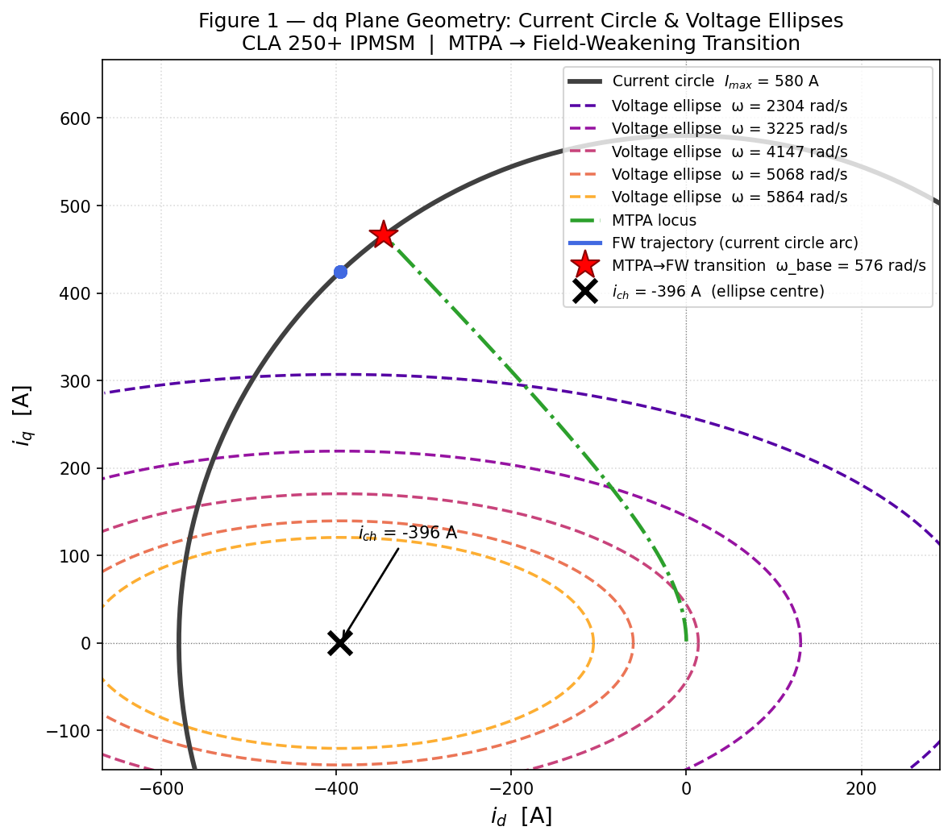

FW validation: voltage ellipses shrink with speed while the operating point slides along the current circle toward I_ch

7.4 mtpv.py — Maximum Torque Per Volt
Above the MTPV transition speed, the voltage ellipse has shrunk so that its boundary lies entirely inside the current circle. The current limit is no longer binding. The new problem is to find the point on the voltage ellipse that maximises torque:
Maximise T = K_T * [lambda_m * iq + (Ld - Lq) * id * iq]
Subject to : w^2 * Lq^2 * iq^2 + w^2 * (Ld*id + lambda_m)^2 = Vmax^2
Lagrange multipliers produce two optimality conditions. Eliminating the multiplier µ and substituting the change of variable w = Ld*id + lambda_m reduces the problem to a clean quadratic whose discriminant is always positive:
2*deltaL * w^2 - lambda_m*Lq * w - deltaL * Vr^2 = 0
Discriminant = (lambda_m * Lq)^2 + 8 * deltaL^2 * Vr^2 > 0 always
The physically correct root is the smaller one (w2), which places the operating point on the voltage ellipse boundary. As speed increases toward infinity, the MTPV operating point asymptotically approaches the characteristic current I_ch = (-lambda_m/Ld, 0).

The FW to MTPV transition speed (omega_MTPV = 1047 rad/s mechanical for this motor) is found numerically by solving for the speed at which the MTPV operating point crosses inside the current circle.

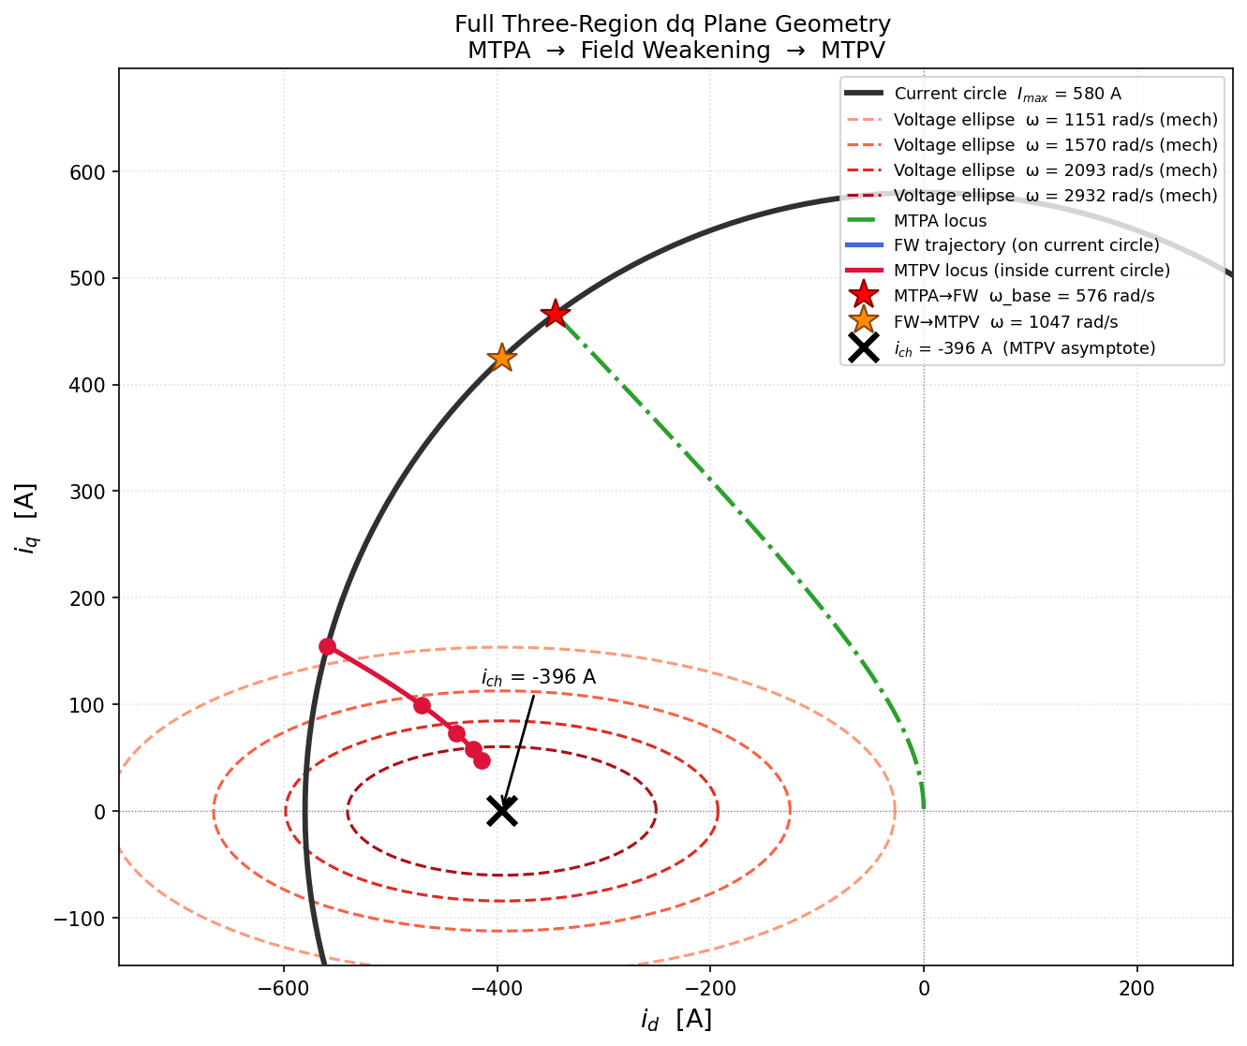

MTPV validation: operating points detach from the current circle and move inward along the MTPV hyperbola toward I_ch

8. Key Physics Rules
The following constraints are enforced across all modules and never violated regardless of operating region or torque direction:

- id* is always negative in MTPA, FW, MTPV, motoring and regeneration
- iq* sign follows T_request sign only:
* Positive for motoring
* Negative for regeneration
- Lq > Ld always: the saliency condition that defines an IPMSM and enables reluctance torque.
- |I_ch| < I_max always : guarantees the ellipse centre lies inside the current circle, enabling high-speed operation
- Clarke transform uses amplitude-invariant form ,only ia and ib measured, ic reconstructed via KCL
- Rs dropped in steady-state voltage equations for FW and MTPV , valid when omega >> Rs/Ld

9. Immediate Next Steps
The Python implementation is approximately 70% complete. The remaining steps to close out the Python layer are:

- foc_references.py — master switcher that routes each control cycle to MTPA, FW or MTPV based on electrical speed. Currently being written and validated.
- pi_controller.py — inner current control loop with full dq decoupling feedforward, anti-windup integrator, and voltage saturation. PI gains tuned via pole-zero cancellation: Kp = L*wc, Ki = Rs*wc.
- svpwm.py — Space Vector PWM converting (valpha*, vbeta*) to three-phase duty cycles (Da, Db, Dc) via sector identification and dwell time calculation.
- MATLAB translation — direct translation of all validated Python files to MATLAB Function blocks for integration into RBS_main.slx.
- RBS_main.slx — full Simulink model connecting all MATLAB Function blocks into the complete FOC pipeline from current sensors to inverter duty cycles.

