  - Project Scope and Requirements

In this section, We’ll be discussing what will our regenerative braking model present and simulate pinning out the limitations and what tools we’ll be using to clearly model the functioning process our the Regenerative Braking System .

Project Objective
The model will actually simulate:
- Simulate energy recovered during braking in an EV under an urban driving cycle (normal stop-and-go of a vehicle in different traffic states) for different regenerative braking modes (work on the RB system on MERECEDES CLA EQ 2026 model) and estimate how regen braking affects the battery SoC (state of charge).
- Model a PMSM (Permanent Magnet Synchronous Motors) motor when acting as a generator during the braking process and how the energy is delivered to the battery packs
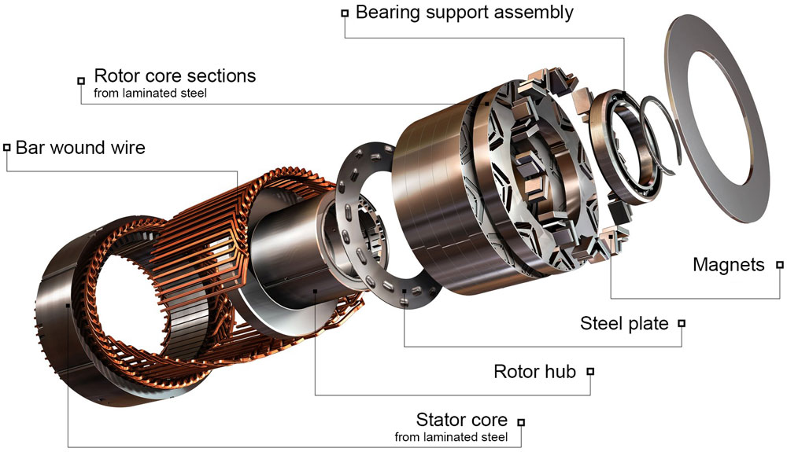
Figure 1 : Permanent Magnet Synchronous Motor architecture

Scope and Boundaries
- What will be included:
- Motor/generator energy conversion principe
- Battery Charging behavior during the braking process and how that affects the State of Charge (SoC)
- A simple drive cycle (stop-and-go) ( Vehicle Speed -> Braking Torque -> energy recovered )
- What will not be included :
- Battery Charging behavior during plug-in charging
- Braking mechanical losses and detailed powertrain simulation
- Thermal modeling
Assets and modeling approach

- MATLAB/SIMULINK
We’ll be using the block diagrams provided by its wide libraries to model subsystems and provide a real-time look-alike simulation.

Figure 2: Matlab & Simulink

- Python (NumPy + SciPy + Matplotlib)

For performance measurement and behavior observations, we’ll be providing graphs and implement safety efficiency algorithms.

Figure 3: Python Logo

Flow of I/O variables
- Inputs
- High-level vehicle parameters
• Vehicle mass (kg)
• Wheel radius (m)
• Aerodynamic drag coefficient (Cd)
• Frontal area (m²)
• Rolling resistance coefficient (Crr)
- Motor/generator parameters
• Motor type (PMSM) and its descriptive parameters
• Motor efficiency (%)
• Maximum regenerative braking torque (Nm)
• Torque–speed curve data
• Motor inertia (optional)

- Battery parameters
• Battery voltage (V)
• Battery capacity (kWh)
• Maximum charging current (A)
• State of Charge (SOC) at start (%)
• Battery temperature (to reduce complexity we’ll assume it constant)
- Motion inputs and controller/braking inputs
• Speed vs. time data (Urban cycle)
• Initial vehicle speed (m/s)
• Final speed (m/s)
• Driver braking demand (light/medium/hard braking)

- Outputs
- Energy and Power results
• Instantaneous regenerative braking power (W)
• Total recovered energy (Wh or Joules)
• Energy lost as heat in friction brakes
• Percentage of energy recovered (%)
- SoC & Battery results
• SOC change during braking (%)
• Charging current vs. time (A)
• Battery voltage response (optional)

- Vehicle Dynamic Results
• Braking torque vs. time (Nm)
• Total braking force (regen + friction)
• Deceleration profile (m/s²)
• Stopping distance (m)

