

Tunisian Republic
Ministry of Higher Education and Scientific Research University of Sousse
National Engineering School of Sousse
Industrial Electronics Department

Project Report

Submitted as part of the modular project for
the Automotive Overview subject

Presented By

Ghaith Abid – Maissa Lajmi

Project: Regenerative Braking System Modulation for The Mercedes CLA 250+ model

Presented on the 21/04/26 before the jury:
Mr. Nour Eddaher Zaidi
Automotive Software Engineering 1

Academic Year: 2025-2026

Abstract

This report presents a comprehensive modelling and general control design of a Regenerative Braking System (RBS) for an electric vehicle (Mercedes CLA 250+ 2025). The project develops the complete energy and control pipeline starting from the driver input and wheel movement to torque generation and motor behavior, also we discuss the inverter operation in respect to that behavior and DC bus dynamics and how battery could actually be charged through braking, within a MATLAB/Simulink environment. The implemented architecture combines high-level supervisory braking logic and low-level current and voltage control, where the RBS computes total deceleration demand and allocates the corresponding torque under battery, speed, and system constraints and that torque decides the IPMS motor behavior. Key components include IPMSM modeling, reference generation across the Field-Oriented Control (FOC) regions, PI control modulation and inverter response.
The implementation demonstrates flawless transition between motoring and regenerative braking operation and SoC evolution during braking events without violating its constraints. Results confirm correct and physically coherent bidirectional power flow across both modes.

Table of Contents

1. General Introduction 6
1.1. Project Context 6
1.2. Project Objectives 7
1.3. System Requirements 7
1.3.1. RBS01 - Low Speed Cutoff threshold (Functional) 7
1.3.2. RBS02 - Architecture-level standards alignment (Functional) 7
The system shall be separated into different subsystems for better testing and validation. 7
1.3.3. RBS03 - Battery-Constrained regeneration (Functional) 8
1.3.4. RBS04 - Multi-region reference generation (Functional) 8
1.3.5. RBS05 - Response time for Torque Application (non-functional) 8
2. The Regenerative Braking System Architecture and Physical Pipeline 8
2.1. Electric Vehicle braking system overview 8
2.2. Energy Flow Overview in Regenerative Braking 10
2.3. Driver Inputs and Torque Generation 11
2.4. Motor as Generator in Regenerative Braking 12
2.5. Inverter Behavior in Regenerative Braking 13
2.6. DC Bus and Battery charging Dynamics 13
3. Motor Modeling 14
3.1. Motor Choice : The IPMSM 14
3.1.1. Definition 14
3.1.2. IPMSM in EVs 15
3.1.3. Measurement Basis for Control in Both Operating Modes 15
3.2. dq reference frame 16
3.3. IPMSM in Steady-state 17
3.4. Motor Parameters 19
4. FOC Architecture Overview 20
4.1. FOC Principle 20
4.2. FOC operating regions and transition logic 20
4.3. FOC signal pipeline 21
5. Reference Generation 22
5.1. MTPA (Maximum Torque Per Ampere) 22
5.2. Field-Weakening (FW) 23
5.2.1. MTPA – FW transition 23
23
5.2.2. Field – Weakening optimization statement 24
5.3. MTPV (Maximum Torque Per Voltage) 25
5.3.1. Optimization statement 25
5.3.2. MTPV – FW transition speed 26
6. Current Control – Pi controller 26
6.1. Control Pipeline 26
7. The Inverter Modulation (SVPWM) 27
7.1. Why using SVPWM ? 27
7.2. Space Vector Sectors 27
7.3. Dwell-time Computation 28
7.4. Duty-cycle generation 29
8. Simulink Modulation 29
8.1. Model Architecture and Top – level Overview 29
8.1.1. Functional Layers 30
8.1.2. General Control Loop 31
8.2. System Parameters and operating point initialization 31
8.2.1. Vehicle Parameters 31
32
8.2.2. Motor Parameters 32
8.2.3. Battery Parameters 32
8.2.4. Inverter and Controller Parameters 32
8.2.5. Base speed 33
8.2.6. Characteristic Current 33
8.2.7. Maximum MTPA torque 33
8.3. Braking profile and torque reference generation 34
8.3.1. Braking profile 34
8.4. Regenerative Braking Control Logic 35
8.4.1. Regen Availability Check 35
8.4.2. Reference Torque Limitation 36
8.5. Mode Selection and Current Reference Generation 37
8.5.1. Mode Decision Logic 37
37
8.5.2. Mode 1 : MTPA 38
8.5.3. Mode 2 : Field Weakening (FW) 38
8.5.4. Mode 3 : MTPV 38
8.6. FOC Current Control and inverter gate signals 39
8.6.1. PI Current Control and Anti-windup implementation 39
39
8.6.2. Space Vector PWM Implementation 40
8.7. Motor Electrical Dynamics Sybsystem (IPMSM) 40
8.8. Battery and Energy Management 41
41
9. Problems encountered and potential solutions 41
9.1. MATLAB Simulation too slow 41
9.2. Python implementation vs MATLAB implementation 42
9.3. Estimated Values lead to immense errors 42
10. Model limitations and Future improvements 42
11. Conclusion 43

- General Introduction
  - Project Context
Modern electric vehicles are increasingly expected to deliver high energy efficiency while maintaining an extended driving range without compromising safety. Electric vehicles have come at first to change pure-mechanical approaches in combustion vehicles with electronic approaches, yet among the most notorious mechanics that remained in both models is friction braking that emits a lot of wasted kinetic energy, transformed into heat, which is something absurd and non-practical. And so, the core solution for this problem is the regenerative braking which eventually have become a fundamental function in contemporary EV powertrains. By converting vehicle kinetic energy into electrical energy during deceleration, it reduces dependence on friction brakes and improves overall energy utilization through feeding the regenerated electric energy to the battery.
In a modern traction system, the same electric system must operate in both motoring and regen modes, while the inverter and the Field-oriented control (FOC) allow bidirectional power flow between the motor and the battery. This duality introduces important control challenges, especially during transitions between coasting, acceleration to braking. Unlike conventional friction braking systems, deceleration in EVs can be requested not only by brake pedal input but also by accelerator release in one-pedal driving strategies. As a result, braking demand must be interpreted as an interpolated torque request rather than a mere hydraulic action from pressing a pedal.
The integration of regenerative yet friction braking therefore requires a supervisory strategy to control and to be capable of blending torque under multiple battery, motor, inverter and vehicle constraints. At lower control levels, Field-Oriented Control (FOC) is responsible for regulating machine electric behaviour and ensure accurate torque tracking across different operating regions depending on which speed our vehicle needs to be.
This project models a complete regenerative braking control pipeline for an IPMSM-based EV platform in MATLAB/Simulink, with the Mercedes CLA 250+ 2026 used as a reference case.
  - Project Objectives
The primary objectives are :
- Model the complete regenerative braking energy path in an EV from wheels and driver pedal request to battery.
- Implement an IPMSM-based Field-Oriented Control (FOC) framework enabling consistent electronic and torque behavior control in both motoring and regenerative operation.
- Implement the corresponding PI controller with decoupling feedforward and anti-windup suitable for operating in different behaviors.
- Implement an inverter voltage synthesis framework in accordance to each operation under bidirectional power flow.
- Evaluate the model’s physical and control-level consistency through torque tracking, FOC regions activation, battery state constraints and overall RBS performance.

  - System Requirements

    - RBS01 - Low Speed Cutoff threshold (Functional)
The system shall disable regenerative braking below 3-12 km/h to prevent negative torque issues.
    - RBS02 - Architecture-level standards alignment (Functional)
The system shall be separated into different subsystems for better testing and validation.
    - RBS03 - Battery-Constrained regeneration (Functional)
The system shall limit regenerative braking torque according to battery acceptance constraints (SoC and charge power/current limits) to prevent unsafe charging scenarios (OC, OV…).
    - RBS04 - Multi-region reference generation (Functional)
The control layer shall generate valid current references across different FOC regions with consistent transition logic depending on speed change and voltage/current constraints change.
    - RBS05 - Response time for Torque Application (non-functional)
The system shall achieve 10-90% regenerative torque in 0.11-0.83 seconds

- The Regenerative Braking System Architecture and Physical Pipeline

  - Electric Vehicle braking system overview
To begin with, Braking is the process of controlling the velocity of an object by inhibiting its motion. An object in motion possesses kinetic energy that is in direct increase with the speed in which the object moves , and to bring this object to stop we should remove its kinetic energy.
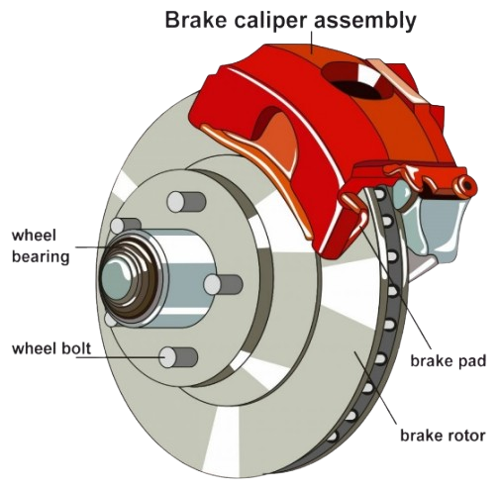
Traditionally, in normal combustion cars, removing the kinetic energy can be accomplished by dissipating the energy to the atmosphere through friction as heat through a hydraulic brake system that consists of braking pads that when subdue pressure from the Caliper, they will apply a force to the wheel disk (rotor) through contact.
Figure 1: friction brakes diagram

This contact would slow the movement of the wheels through Newton’s Second Law of motion
Where acceleration a<0 (deceleration)

Figure 2: Newton's Second Law of Motion

And since this applied force is applied from a fixed object to another moving one, we can discuss a Friction Force (F_friction) that would be transformed into heat dissipating to the environment.

Meanwhile, in electric vehicles, braking is not produced by a single subsystem. Instead, total deceleration is generated through the combined action of regenerative braking and friction braking.
Regenerative braking for instance is another way to remove the kinetic energy but not through wasting it in the air but instead use it to generate electrical energy from the braking mechanism of electric vehicles. Unlike mechanical braking (friction), it allows an electric motor to operate as a generator capable of absorbing vehicle motion energy into electrical energy returned then to the battery, creating a negative electromagnetic torque that opposes wheel rotation when the vehicle is slowing down. Regenerative braking can be designed for all-electric vehicles as it does not require adding any components to the vehicle.
Friction braking, in contrast, dissipates kinetic energy as heat and remains essential for high deceleration demand and safety-critical situations (sudden brakes or traffic jam braking).

  - Energy Flow Overview in Regenerative Braking

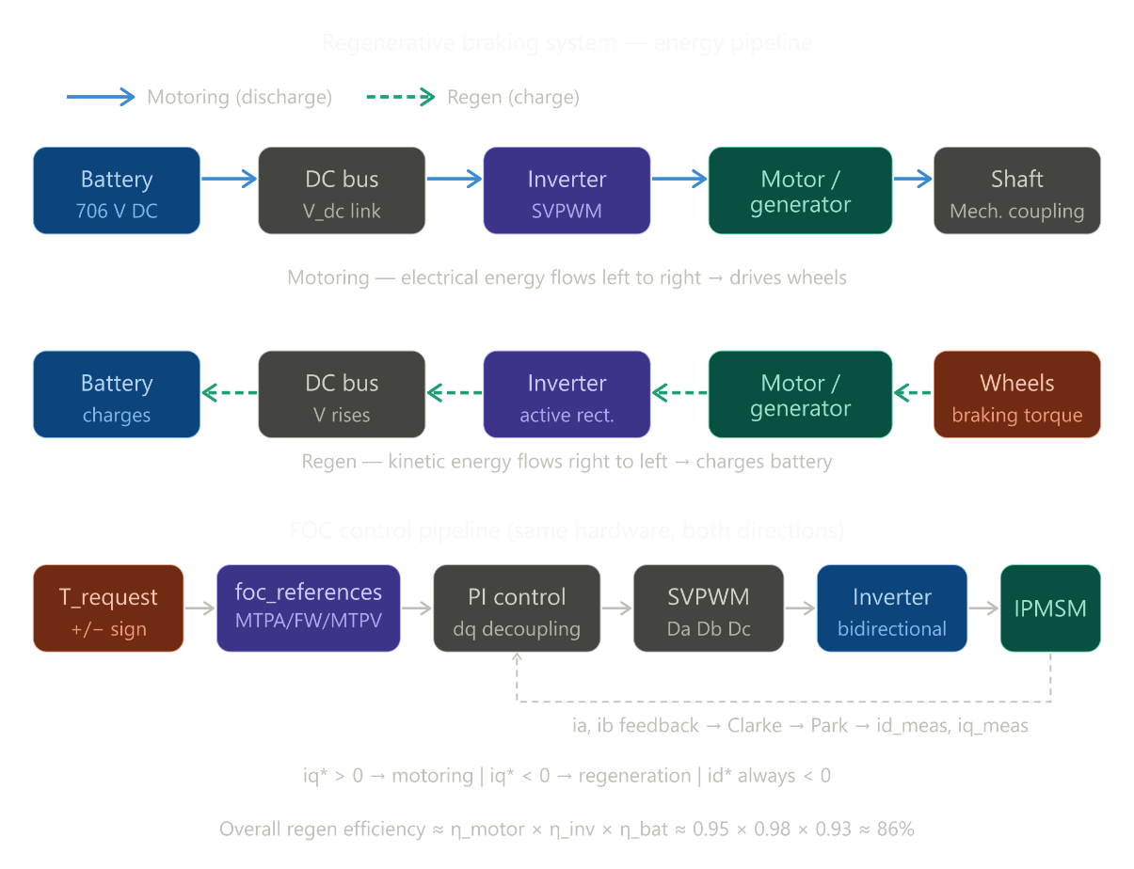
During regenerative braking, the vehicle’s kinetic energy is converted into electrical energy and returned to the battery through a traction powertrain. The physical energy path is represented by:
Figure 3: recovered energy in regenerative braking
When the driver requests deceleration (accelerator pedal release or braking pedal push), the requested wheel torque becomes negative at the machine shaft and changes direction. The motor now operates in generator mode, producing electrical power from the mechanical input.
The inverter then, using the same switching hardware as in traction mode, yet with different algorithmic approach, routes this power to the DC bus, from which the battery absorbs charging current subject to its constraints (related to the Battery Management System (BMS) such as SOC, and charge limits).
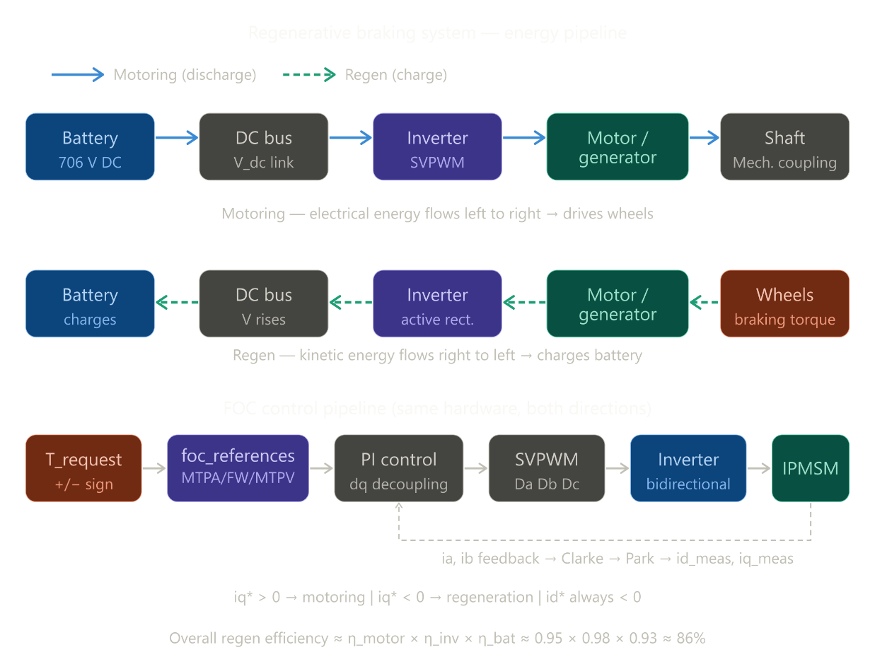
In motoring operation (no braking pedal and pressing of the accelerator pedal), the exact same chain is used but in the opposite direction:
Figure 4:energy flow in motoring mode
Therefore, regenerative braking does not require separate propulsion hardware, as it shares the same components used in EV traction (motoring) through a bidirectional operation of the same motor–inverter system. This behavior is controlled by a four-quadrant operation in the torque–speed plane, where torque and speed signs define whether the machine is delivering power to the wheels or recovering energy from them.
This bidirectional behavior is the basis for braking control, but it also introduces many constraints among them the regen capability depending mainly on machine current limits, inverter voltage limits, and of course whether the battery could accept the coming energy or not. Consequently, energy flow management must be coordinated and supervised by a torque blending algorithm, detailed later in the following subsections.

  - Driver Inputs and Torque Generation

First, the work starts with an input or a request from the driver. This input refers to “in which state he wants his vehicle to be?” and “Through what interface can he possibly send this order (or input) to his vehicle?”
The answer to these questions is simply entitled to the accelerator and brake pedals positions demanding whether an acceleration or a deceleration as:
- Acceleration: accelerator press and brake total release
- Deceleration: accelerator release and brake pedal actuation. (main focus)
In particular, when demanding a deceleration, the accelerator pedal would be partially or fully released, the system therefore interprets this action as a potential request for coast regeneration (or one-pedal deceleration), depending on calibration and vehicle speed. In parallel, brake pedal input expresses an explicit braking demand and generally maps to a stronger deceleration request and so certain braking torque.
For further explanation, we can normalize the two pedal inputs as :
- Let a∈ [0,1]: accelerator position (0 = released, 1 = full throttle)
- Let b∈ [0,1]: brake pedal position (0 = released, 1 = full brake)

Also let’s consider these sign conventions:
- positive torque (T_request>0): motoring/traction,
- negative torque (T_request<0): braking/regen request.
With the requested torque can be combined as:

Where coast (accelerator release action) and brake contributions are modeled through calibration maps:

Where (f_coast) and (f_brake) are two functions that depend on the corresponding pedal position and the vehicle speed where they both represent calibrated maps matching vehicle’s behavior targets (comfort, pedal feel, and control authority.
So that increasing brake demand (T_brake) or accelerator release (T_coast) makes (T_request) more negative and so the braking is more important.

  - Motor as Generator in Regenerative Braking

In normal speeding driving (accelerator press), the traction inverter controller sends current to the motor in a certain direction that creates an electromagnetic torque that aligns with wheel rotation, so the motor pushes the vehicle forward (motoring mode).
But when a deceleration request occurs, the same controller changes the commanded current direction and magnitude, so the electromagnetic torque is no longer aligning with wheels helping rotation, instead it starts acting against it. At that point, the wheels (through vehicle inertia) keep turning the rotor, but the machine behaves now like a generator.

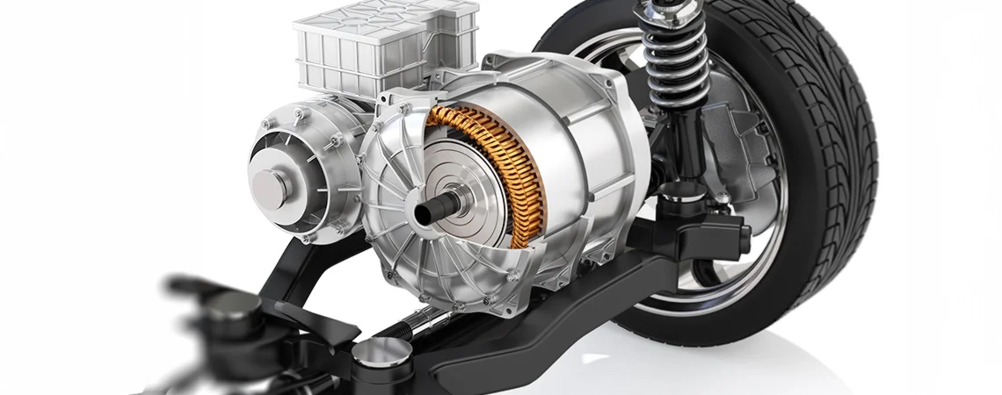
Figure 5: EV motor

In simple terms, the same motor functionality is “reoriented” by current control so braking torque is produced while energy is recovered.This transition between motoring and generating is therefore not a hardware switch but an algorithmic operating-mode switch of the same machine–inverter set that takes into consideration the different operating conditions such as the vehicle speed, electrical limits and constraints and charge acceptance. This algorithmic approach is the Field-Oriented Control (FOC).

  - Inverter Behaviour in Regenerative Braking

In motoring operation, the inverter’s main role is to convert the battery’s DC voltage into controlled three-phase AC voltages and currents for the traction motor to work. And that’s by switching its semiconductor legs at high frequency (through a modulation strategy such as SVPWM), it imposes then the voltage vector requested (deducted from the requested torque) by the motor controller, which allows precise torque production.
And during regenerative braking, the same inverter hardware performs the same controlled switching function (AC and DC), but the energy direction changes or more precisely the current changes sign. The motor, functioning as a generator, is now driven by the wheels, so electrical power is produced on the AC side and transferred through the inverter back to the DC bus then the battery. In other words, the inverter no longer only feeds the motor but also manages the return of generated power toward the battery.
This is why this regenerative operation is often described as “active rectification” as the inverter actively shape machine currents and convert AC-side generated power from the generator into usable DC-link power to charge the battery, rather than relying on passive diode behavior, so less hardware. As a result, both traction and energy regen are achieved with the same bidirectional converter, ensuring continuity of torque control while enabling battery recharge when operating conditions allow it.
  - DC Bus and Battery charging Dynamics

The DC link is the electrical connection between the inverter and battery, so its behavior directly affects whether regenerative braking is effective and performant. During energy regen, generated power is directly injected into the DC bus after being treated by the inverter, which can easily cause DC voltage rise (Over Voltage). Also, if battery charging is limited (generated power more than what battery can accept), excess power cannot be absorbed , and so DC-link control constraints become more restrictive and less tolerant.
State of charge (SoC) here plays a pivotal role in regen management. As SoC increases, the battery’s ability to accept high charging current generally decreases, especially near upper SoC range. In addition, temperature strongly affects charge acceptance as low temperatures typically require tighter current limits to protect cell health, while high temperatures may also impose protective derating and other safety measures.
For this reason, regenerative braking must respect battery limits in real-time, including:
- Maximum charging current then power
- voltage ceiling constraints
- SoC dependent charge derating,
- Temperature dependent charge derating.
When any of these limits is reached and could be violated, regenerative torque must be reduced, and in some cases totally stopped, and the remaining braking request would be supplied by mechanical friction brakes to reach deceleration goal and preserve its continuity and safety.
- Motor Modeling
  - Motor Choice : The IPMSM
    - Definition
An Interior Permanent Magnet Synchronous Motor (IPMSM) is a type of AC synchronous motors in which permanent magnets are inside the rotor core rather than mounted on its surface.
Since the permanent magnets are inside the rotor core, the motor can develop torque from two mechanisms:
- A magnetic Torque (T_pm): permanent magnets create a constant magnetic field B that when applying current that is perpendicular to it, lead to a rotation force or simply a torque.
- A reluctance Torque (T_rel) : the IPMSM has a magnetic saliency which means that its rotor’s physical shape creates different inductances paths (L_d and L_q) and due to that, when applying a misaligned current to the rotor , it tries to rotate to align itself. This rotation creates what we called the reluctance torque.
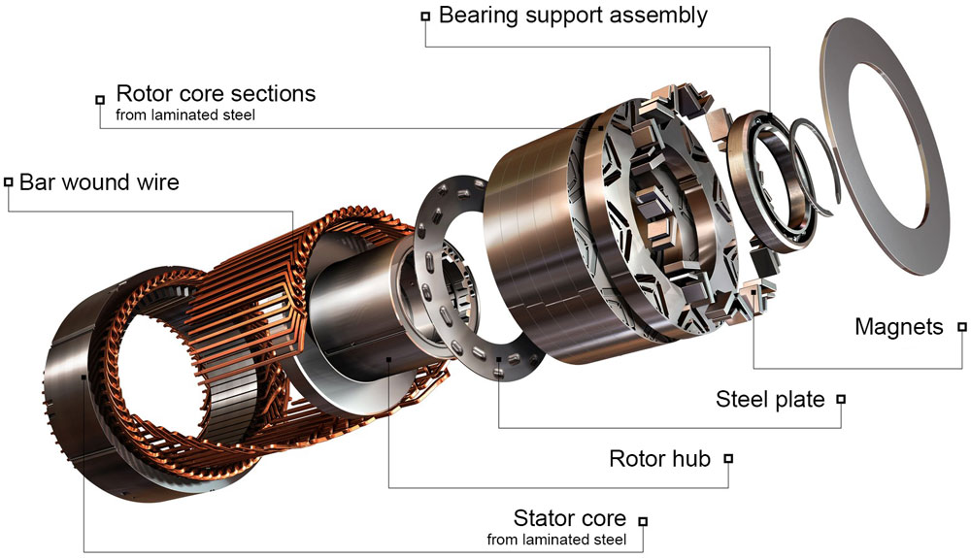
Figure 6: Diagram of an Interior Permanent Magnet Synchronous Motor

This structure gives IPMSMs high torque density, strong efficiency, and strong high-speed capability, and since EV operation requires both dynamic low-speed torque response (in cases of low-speed operations) and efficient performance over a broad speed range which makes it a suitable choice for traction applications such as Electric vehicles .
    - IPMSM in EVs
The same IPMSM in the electric vehicle can operate in both motoring and generating modes without changing hardware but it would be controlled through current :
- In motoring mode, the inverter injects three-phase stator currents with a controlled amplitude and phase relative to rotor position. This creates an electromagnetic field interaction that generates positive torque since T_request >0 in motoring. Therefore, this torque would be in the same direction as wheel rotation, so electrical energy drawn from the battery is converted into mechanical power for propulsion.

- In regenerative mode, the inverter control system (FOC) progressively modifies the current vector so that the commanded electromagnetic torque changes sign since in deceleration the T_request <0. The machine torque then acts against rotation instead of assisting it. At that moment, the rotor is not “stopped” by the motor itself, but it continues to be driven by vehicle kinetic energy through the wheels and transmission. And with that mechanical input, power at the shaft is converted into electrical power at the stator terminals which then will be transferred by the inverter to the DC link.

    - Measurement Basis for Control in Both Operating Modes
From an implementation perspective (low-level view), the real control of the IPMSM behavior starts from directly measurable electrical variables that are merely the same for both traction and regen operation.
The inverter-side sensors continuously measure the motor stator phase currents (i_a, i_b, i_c). These same raw signals are used regardless of power-flow direction: In motoring, they correspond to a propulsive operating point, and in regenerative braking, to a generating operating point with reversed torque sign.
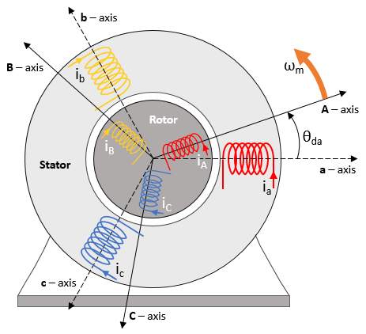
Figure 7: motor stator phase currents

To make control design tractable, the measured phase quantities are then transformed into control-oriented coordinates in the FOC for torque and flux regulation.

  - dq reference frame
In the three-phase form, stator currents (i_a, i_b, i_c) are sinusoidal and coupled, which makes direct control less intuitive and more complex. For this reason, EV control-oriented module commonly transforms measured phase quantities into a rotating reference frame using Clarke and Park transformations.
First, assuming a balanced three-phase system ((i_a+i_b+i_c=0)) , the Clarke transform maps phase currents variables into the stationary orthogonal (α,β) frame.
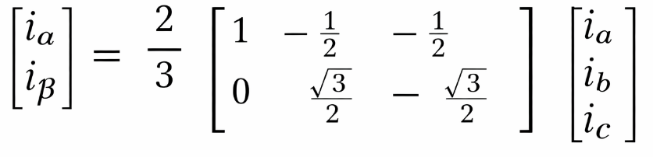

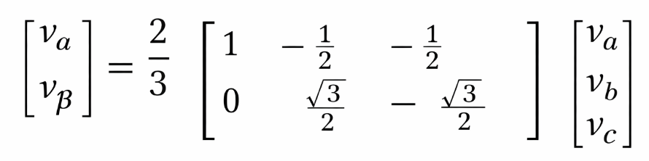
The same transformation is applied to voltages:

Then, the Park transforms rotates (α,β) by the rotor electrical angle (θe​) (obtained from rotor position information that we can get from an implemented resolver or an encoder) , yielding the synchronous (d,q) frame making sinusoidal machine quantities appear nearly constant in steady state:
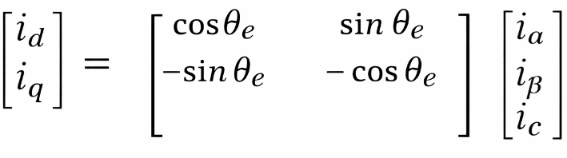

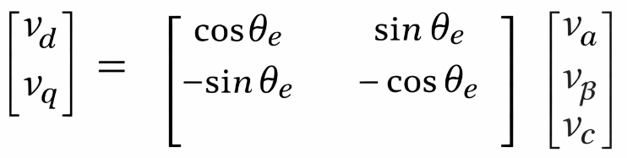
And for voltages:

In this frame ( and aligned with rotor flux), sinusoidal phase quantities become quasi-DC or simply appear nearly constant in steady state , this state implies that the motor has reached a stable operating point where currents no longer vary within time .
This approach is quite impractical at first but within functioning the neglected varying currents would be corrected through filter, and using this approach greatly simplifies controller design and interpretation.

The current components have direct physical meaning:
- (i_q): component responsible for producing torque (dominant in electromagnetic torque generation) with the convention of :
- In Motoring (T>0) , i_q>0
- In Regen (T<0) , i_q<0

- (i_d): flux-shaping component, and it’s used to validate current and voltage constraints in different speeds later in Field-Oriented Control .
Since the sign of i_q depends deeply from the sign of torque, transition between propulsion and regeneration is mainly achieved by reversing (i_q) sign.
  - IPMSM in Steady-state
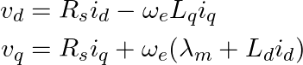
For a clear and less complicated reference generation later , the IPMSM is commonly described in the synchronous dq frame under steady-state assumptions ( neglecting current-derivative transients). The stator voltage equations (measured voltages) then become:

Where:
- (R_s) is stator resistance
- (L_d,L_q) are dq reluctance inductances
- λₘ is Permanent Magnet Flux Linkage (how strongly the rotor magnets are "holding onto" the stator coils magnetically)
- ωₑ is the electrical speed

The electromagnetic torque is given by :
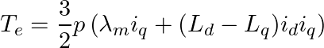
(p is the number of pole pairs (pairs of N-S magnet poles in the rotor) )

And we mentioned before that torque can be produced by two means:
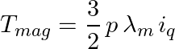
- Magnetic torque:
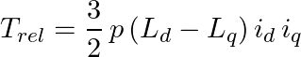
- Reluctance torque:

Hence, IPMSM depends primarly from both (i_q) and (i_d) with (i_q) the main torque channel and (i_d) shaping it , which is central to efficiency optimization and high-speed operation by validating two main constraints that the admissible operating point (i_q, i_d) should respect :
- Current magnitude constraint:
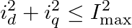

- Voltage magnitude constraint:
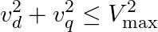

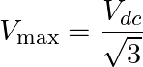
where (I_max) is the maximum allowable current magnitude (motor parameter) and (V_max) is the maximum stator-voltage magnitude achievable from the DC bus with

These constraints define, at each speed, the feasible current region in the dq plane in an efficient way by assuring the produce of the requested torque with the smallest yet sufficient magnitudes. As speed increases, the voltage constraint becomes more restrictive, pushing operation toward field-weakening regions. In regenerative braking, the same limits determine the maximum achievable negative torque and therefore directly bound energy recovery capability under given DC-link and battery conditions.

  - Motor Parameters
Symbol | Description | Value | Unit | Type | Source / Method | Consistency Check
Input / Design Parameters
Rs | Stator phase resistance | 0.012 | Ω | Input | Datasheet / DC measurement | 3Rs·Imax² << Pmax
λm | PM flux linkage | 0.095 | Wb | Input | Back-EMF no-load test | λm > 0 required
p | Number of pole pairs | 4 | — | Input | Motor design / datasheet | Even integer; rotor symmetry
Imax | Peak phase current (amplitude) | 580 | A | Input | Inverter peak rating | Imax ≤ Iinv,rated
ξ=Lq/Ld | Saliency ratio | 2.4 | — | Input | FEA / inductance measurement | ξ > 1 required for IPMSM
Tmax | Peak electromagnetic torque | 335 | Nm | Input | Drive-cycle requirement | Verified via Te equation
Pmax | Peak mechanical power | 200 | kW | Input | System specification | Pmax ≈ Tmax · ωbase
ωbase | Base (corner-point) speed | 5 500 | rpm | Input | Control design spec | ωbase ≈ Vmax / λm
ωmax | Maximum operating speed | 14 000 | rpm | Input | Mechanical / bearing limit | FW range = ωmax/ωbase ≈ 2.55
VDC | DC-link voltage | 706 | V | Input | Battery pack (nominal) | Derates with SoC & temperature
Derived Parameters
Vmax | Max. stator voltage (SVPWM) | VDC/√3 = 407.6 | V | Derived | Vmax = VDC/√3 | SVPWM inscribed-circle radius
Lq | q-axis inductance | ξ·Ld = 576.44 | μH | Derived | Lq = ξ·Ld | Lq > Ld confirmed (ξ = 2.4 > 1)
Ich | Characteristic (short-circuit) current | -λm/Ld = -395.5 | A | Derived | Ich = -λm / Ld | |Ich| < Imax: deep FW feasible ✓
Numerically Solved Parameter
Ld | d-axis inductance | 240.18 | μH | Solved | Brent root-finding on FW-gap equation | FW gap = 50 A enforced ✓

- FOC Architecture Overview
  - FOC Principle
Field-Oriented Control (FOC) is adopted because it transforms AC machine control into a structured, well-developed analog framework analysis, where torque and specifically the electromagnetic flux can be regulated through decoupled current channels (i_q, i_d).
This current regulation relies primarily on a reference-generation layer that maps driver/brake torque demand into feasible dq current targets ((i_d*, i_q*)) enforced by the machine and the inverter current and voltage constraints (I_max, V_max). Consequently, the inner PI controller loops track not only a torque request, but an optimized and constraint-consistent current trajectory over the full speed range.

And so for instance, the FOC offers three key benefits:
- First, it enables precise torque tracking over a wide speed range through mapped speed regions.
- Second, it basically ensures that regenerative braking can be feasible by commanding the negative torque through (i_d) and (i_q) sign reversal.
- Third, it provides a direct framework for efficiency and feasibility-oriented operations (depending on speed), which is essential for maximizing both energy economy and top-speed capability of course while ensuring that current and voltage constraints are preserved.
  - FOC operating regions and transition logic
To ensure efficient and feasible operation thought different speeds, The FOC regulation process relies on the reference currents (i_d*,i_q*) which schedules across three main regions:
- MTPA (Maximum Torque Per Ampere) : dedicated to low to medium speed
In this region, the electrical speed (ωₑ) is relatively low making the intervention of the back-EMF and the cross-coupling terms in dq voltage equations is quite low to even being neglected, meaning that the inverter could supply the the required voltage without approaching (V_max), therefore voltage reserve is available and the voltage constraint is inactive. So, being the only remaining constraint, currents should be selected carefully to minimize current magnitude for the required torque (or maximize torque per ampere). For the IPMSM, this generally implies a nonzero negative (i_d^*) to exploit reluctance torque.
- FW (Field Weakening) : dedicated for moderately high speeds
By increasing speed, the voltage terms that were neglected in the MTPA are now more important approaching (V_max) and so leading to a voltage-feasible operation where the voltage constraint would be active alongside the current constraint. The talk about this region starts above a certain speed (base_speed). In this region, the controller injects more negative (i_d^*) to reduce effective flux (back-EMF and cross-coupling voltages) and keep required voltage within inverter capability. Torque capability progressively decreases with speed in this zone, but controllability is maintained.
- MTPV (Maximum Torque Per Voltage) dedicated for high-speed driving Speed in this region reached a certain level that makes operation deeply constrained by the voltage limitation while the current constraint despite being present loses its effectiveness. Here, the current vector (i_d*, i_q*) must be oriented to produce the highest possible torque for the available voltage.

Thus, the transition logic between regions is implemented as a constraint-driven scheduler. Practically:
- Start from torque request (T_request) and candidate MTPA reference.
- Check current/voltage feasibility.
- If voltage limit is violated (speed above the MTPA-FW transition speed), move along FW strategy (more negative (i_d^*)).
- If operation reaches deep voltage-limited conditions (speed above FW-MTPV transition speed), follow MTPV-oriented reference shaping.
  - FOC signal pipeline
The implemented control chain starts from a high-level torque request (T_request), generated by accelerator/brake interpretation. This request is then converted into current references in dq coordinates through a region-dependent reference generator (same Clark/Park transform chain), yielding ((i_d^*,i_q^*)). Then the inner-loop FOC tracks these references with high bandwidth.
At each control cycle, the inverter provides measured phase currents ((i_a,i_b,i_c)), and rotor electrical angle (θₑ) . Clarke and Park transforms produce measured ((i_d,i_q)). Current errors are formed and processed by PI regulators to generate voltage commands (V_d*,V_q*):

Next, inverse Park maps (V_d*,V_q*) to (Vα*, Vβ*), then the modulation block (SVPWM/PWM) generates duty cycles for inverter switches. The inverter applies phase voltages to the motor, producing updated currents and torque, which close the loop through the next sampling instant.
- Reference Generation
In this chapter we will try to convert torque demand (T_request) and electrical speed (ωₑ) into feasible and optimal dq-current commands under machine and inverter constraints.
We will use the steady-state IPMSM model :

With the following constraints:

Let K_T=(3/2)p and ΔL= L_q - L_d >0 then :

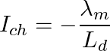
With the characteristic current (the value of $id$at which the back-EMF of the motor is exactly cancelled) being:

  - MTPA (Maximum Torque Per Ampere)
In this region, voltage reserve is sufficient and so current is the only active constraint. The objective is therefore to minimize current magnitude for a required torque (T_request).
By using Lagrange Multiplier approach :
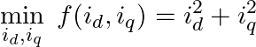
We tend to:

Subject to:
(We tend to assure that Te=T_request)

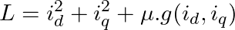
Then:

From it we end up with two equations forming a system :
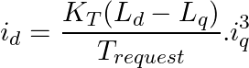
From these two equations, we can get the MTPA curve (for validation later) :

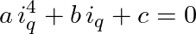
Substituting it in the Torque equation gives us a quadratic equation in (i_q):

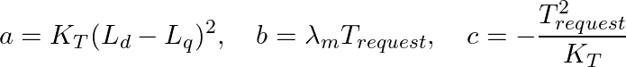
With

This quadratic equation is thus solved numerically (Newton-Raphson algorithmic method). Then (i_d*) is recovered from the cubic relation above. Sign behavior is enforced naturally by:
- (i_q*>0) motoring, (i_q*<0) regeneration,
- (i_d*<0) for IPMSM operation regardless of mode.

  - Field-Weakening (FW)
    - MTPA – FW transition
Upon reaching a certain base speed, the voltage constraint becomes a concern.
This speed corresponds to the MTPA point (i_d MTPA, i_q MTPA) that first touches the voltage limit circle:
With ω_b the MTPA – FW transition speed that we’re looking for

    - Field – Weakening optimization statement
When speed rises above ω_b (transition speed), the operating point must satisfy both current and voltage boundaries simultaneously. And thus from that speed the stator resistance (R_s) term in the voltage expressions becomes too small to even be considered and so :

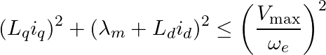
And so the voltage limit becomes and ellipse in dq-current frame :

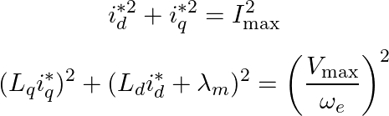
Following the transition approach, FW is obtained from the intersection of the voltage ellipse and the current circle:
(Current circle)

(Voltage ellipse in the boundary)

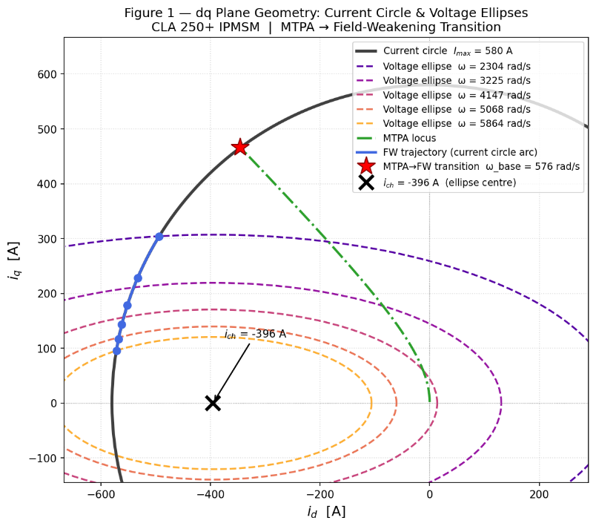
Figure 8: dq plane geometry: Current circle & Voltage Ellipse for FW case

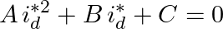
From that intersection, we end up with a 2nd degree equation:

Where:

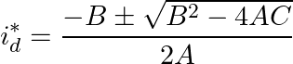
From it we get:
(take the most negative among the two possible solutions)

Accordingly, and after getting (i_q*) through substituting the (i_d*) that we get into the current circle we can then get the achievable Torque since as we presented the FW, and different than the MTPA, the torque request is deducted not passed as an input at first. With that being said, the Achievable Torque is deduced by :
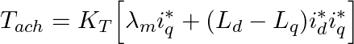

  - MTPV (Maximum Torque Per Voltage)
As we increase the speed and accordingly make i_d* more negative, we could reach a certain point that the back-EMF and speed-dependent terms are so large that the operating point hits the inverter voltage limit first (|v|=V_max) , also once that happens, the fact that increasing the current arbitrarily can no longer increase torque because simply the extra current would require extra voltage which is physically impossible (voltage saturation before current), making from the current a non-binding constraint while voltage becomes the dominant constraint.
And so the reference generation focus becomes trying to maximize torque for a fixed available voltage magnitude (instead of minimizing the current).

    - Optimization statement

For a given ω_e (above MTPV-FW transition speed) we tend to :
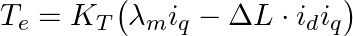
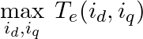
With
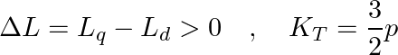
And

Subject to :
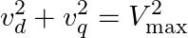
With
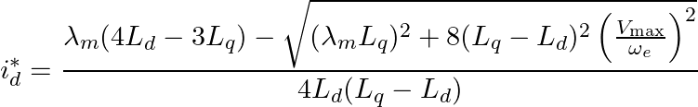
After applying the same Langrangien approach we end up with :
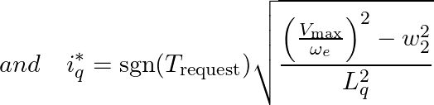

And so the achievable torque equivalent to request is :
(In normal consequences (FW), the achievable torque is normally equal to the requested torque yet in MTPV T_arch is usually less than T_request)

    - MTPV – FW transition speed
The transition speed logic starts from computing a function ‘f’ subject to with a given speed ω_e:

From that onward if:
- f>0 (|i|>I_max): violation of current limit so we’re not in the MTPV region yet, therefore region must remain FW (both constraints active)
- f=0 (|i|=I_max): MTPV operating point exactly on current circle and so this is the transition speed between MTPV-FW
- f<0 (|i|< I_max): operating point inside the current circle (
- part of voltage ellipse inside the current circle) making from current a non-binding constraint
Region becomes MTPV (voltage-dominated operation).
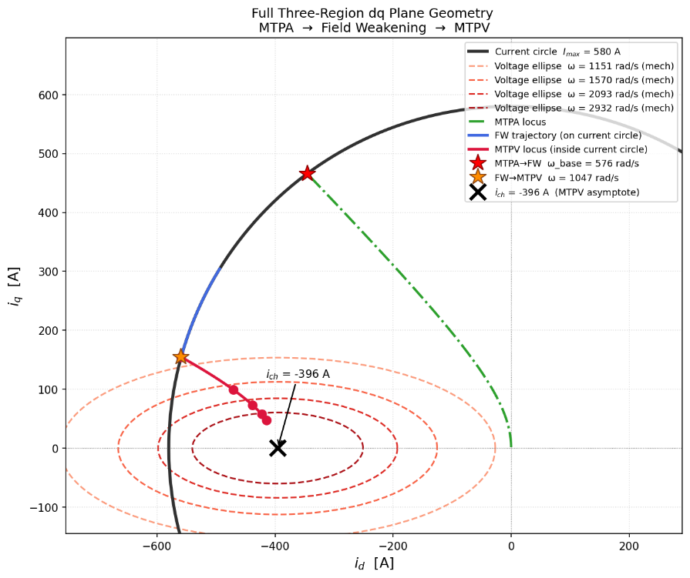
Figure 9: different dq plane regions

- Current Control – Pi controller
  - Control Pipeline
From the reference generator in FOC, the current targets are (i_d*,i_q*) and with the measured currents (i_d,i_q) we can well define the error in dq frame by :

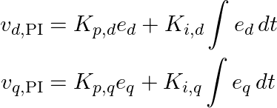
From it the PI regulators would generate corrective voltages as:

Then, adding the decoupling feedforward terms, we got the fully corrected voltages:
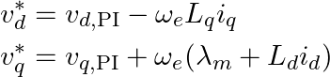

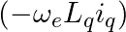
With :
compensates d-axis cross-coupling voltage term
compensates q-axis back-EMF and coupling.

These voltages (v_d*,v_q*) are the corrected voltages commands that would be sent later to the inverter

- The Inverter Modulation (SVPWM)
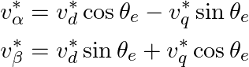
After generating the voltage references (v_d*, v_q*) by the PI controller, these voltages would subdue an inverse Park transformation to (vα∗​,vβ∗​) :

In order then to be received by the Space Vector Pulse Width Modulation (SVPWM) digital block, which converts them into inverter switching duty cycles (d_a,d_b,d_c) under the DC-bus voltage limit.

  - Why using SVPWM ?
Space Vector PWM (SVPWM) is used in this context to convert the voltage commands (v_d*, v_q*) from the current controller into inverter switching duty cycles (d_a,d_b,d_c).
Its main practical advantage is a very good DC-bus voltage utilization. This is important in traction drives, especially at high speeds, where voltage becomes a concerning constraint (limited) (FW and MTPV regions). Better utilization means the inverter can generate a larger fundamental AC voltage from the same (V_dc), improving usable speed/torque capability.
  - Space Vector Sectors
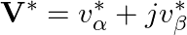
After the PI current control and inverse Park transformation providing (vα∗​,vβ∗​) in the αβ rotating frame, the voltage components can define a reference voltage voltage vector in the same frame :

Moreover, in SVPWM, the αβ rotating frame is divided into 6 sectors of (60∘) each where, at every PWM period (T_s), the reference vector (V*) lies in one sector.
Inside a sector, the inverter synthesizes (V*) by combining:
- Two adjacent active vectors (T_1 , T_2)
- One zero vector (T_0)
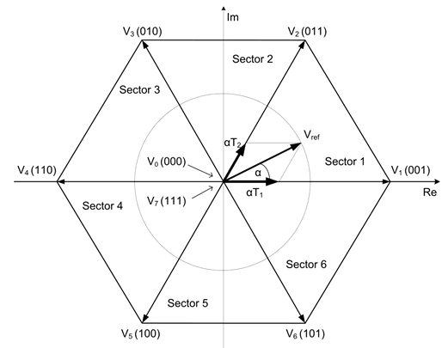
And so, the inverter would apply a discrete switching states operation.
Figure 10: SVPWM theory hexagone

  - Dwell-time Computation
For a given sector, the reference voltage vector is synthesized using the time duration vectors (T_1), (T_2) and (T_0) (dwelling times) as:

From this system we can get the dwelling times :
- (T_1): time spent on first adjacent active vector
- (T_2): time spent on second adjacent active vector
- (T_0): remaining zero-vector time
  - Duty-cycle generation
From the computed dwell-times, phase ON-times (dwell times equivalent to inverter legs) are then computed:

Which are then used to compute the inverter Duty-cyles :
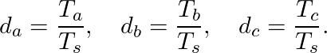

Then, the inverter takes these three duty cycles and uses them to control the three phase legs with PWM :
In each switching period (T_s), a phase upper switch stays ON for (d_xT_s) (x in [a, b, c]) , while the lower switch stays ON for the rest of the period. Because this switching is very fast, each phase sees an average voltage that depends on its duty cycle. By repeating this every control step, the inverter builds the voltage vector requested (V*) by the controller. Finally, the motor inductance main role is naturally filtering high-frequency switching ripple, so the phase currents become smooth and track the current references (i_d*, i_q*).
- In motoring mode, control sets (i_q*) sign to produce electromagnetic torque in the direction of rotation (positive i_q*), so power flows from battery to inverter then to motor (to work as a normal motor)
- In regenerative mode, the controller reverses torque-producing current sign (i_q* becomes negative), so the same SVPWM process generates voltages/currents that oppose rotation and power flows from motor (now as a generator) to inverter then into DC bus (battery charging).
Thus, the modulation mechanism is identical in both modes with only the change of current sign to identify the power flow direction.

- Simulink Modulation
  - Model Architecture and Top – level Overview
The complete RBS modulation is organized into 7 functional layers, each implemented as a distinct subsystem as a MATLAB script and a Simulink model, where these layers would communicate through shared state variables, ensuring modularity, testability, and alignment with the standardized production ECU software structures (AUTOSAR).
The top-level signal flow follows the classical FOC pipeline, starting from driver input from the brake and accelerator pedals, passing through vehicle data control for torque command generation, proceeding through mode selection and current reference generation (FOC), then through PI current controllers that produce voltage commands, then SVPWM modulation to generate inverter gate signals, and finally through the motor and battery models to close the feedback loop.
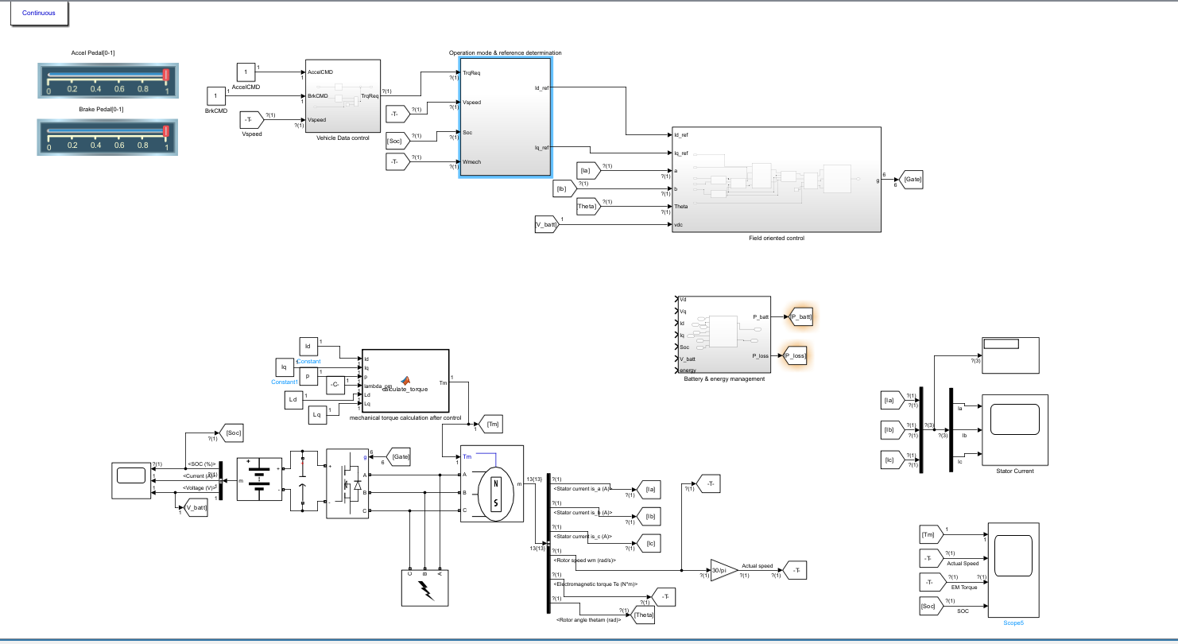
Figure 11: General System Overview

    - Functional Layers
The seven functional layers form a hierarchical control structure in accordance with the previously mentioned requirements:
- Layer 1 handles vehicle dynamics including speed calculation and rolling resistance.
- Layer 2 implements regen availability checking to determine whether conditions permit energy recovery.
- Layer 3 applies torque limitations based on current constraints and battery charging current limits (in connection with layer 2).
- Layer 4 is the mode selection logic that switches between different FOC region strategies.
- Layer 5 contains the FOC control with PI controllers and anti-windup protection.
- Layer 6 models the motor electrical dynamics in the dq reference frame (electrical transformations in the dq frame).
- Layer 7 manages battery state of charge (SoC), cumulative energy recovery tracking and different energy behavior of the battery.

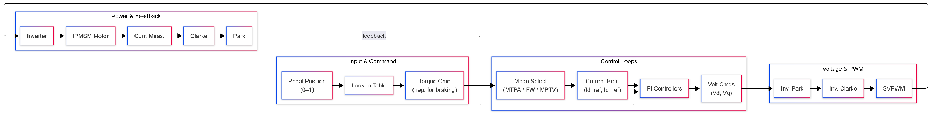
    - General Control Loop

  - Requirement 2 satisfied “Architecture-level standards alignment” !

  - This layered functional architecture provides a solid structural foundation by supporting the 4th requirement implementing the separation of concerns principle mandated by ISO 26262 Part 4, where safety-related functions are isolated into dedicated layers (Layer 2 for regen availability, Layer 3 for torque limitation for instance) that can be independently verified and certified at the required ASIL level later.

  - System Parameters and operating point initialization
All system parameters are centralized in the data.m initialization file and loaded into MATLAB base workspace before simulation. This standardized parameter architecture allows all modulation blocks to share a single source of truth for all physical constants. The parameters are thus organized into four groups: vehicle parameters, motor parameters, battery parameters, and inverter/controller parameters.
Before any simulation loop begins, 2critical operating points (Base speed (W_mtpa) and characteristic current (I_ch) and the maximum MTPA torque) are calculated analytically from the motor and inverter parameters. These constants govern the entire control strategy and mode switching logic throughout the simulation.

    - Vehicle Parameters
The vehicle parameters model a mid-size electric Mercedes-Benz EQ CLA class 2026 model (to be noted that many vehicle parameters are just deduced and estimated due to Mercedes confidential policy toward its products).
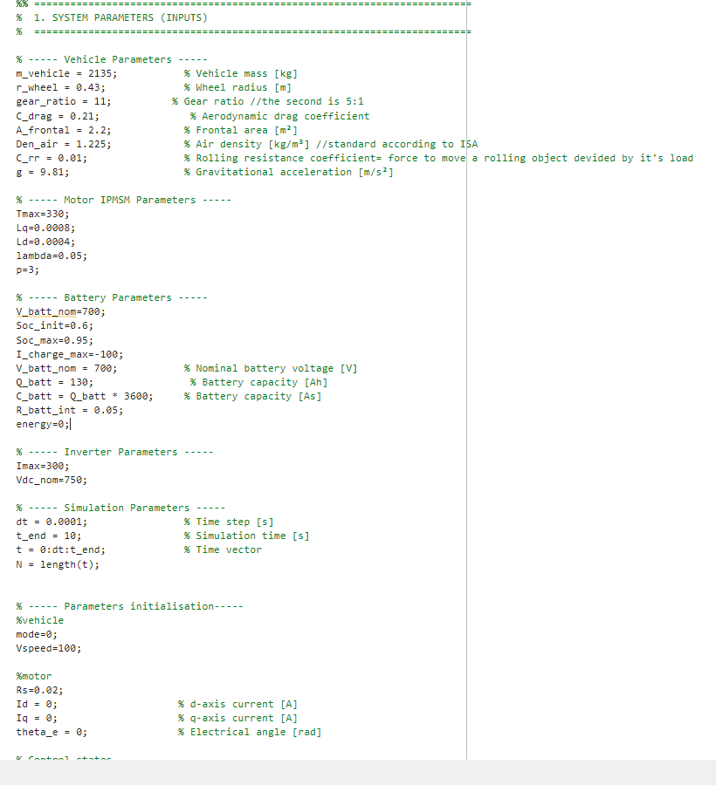
Figure 12: vehicle parameters inside the data.m

    - Motor Parameters
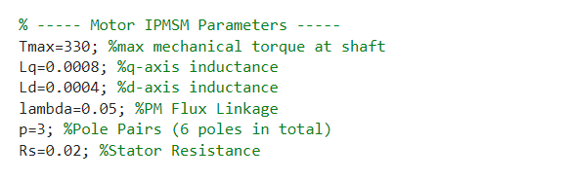
The Interior Permanent Magnet Synchronous Motor (IPMSM) parameters are estimated for an estimated 200 kW class traction moto. In an IPMSM, the magnets are embedded inside the rotor iron core. The d-axis magnetic flux passes through the permanent magnets which have low permeability, resulting in lower inductance (Ld). The q-axis magnetic flux passes between the magnets through the iron core, resulting in higher inductance (Lq). This saliency enables reluctance torque contribution, which accounts for approximately 15 to 25 % of total torque in MTPA operation (low speed).
Figure 13: Motor parameters in data.m

    - Battery Parameters
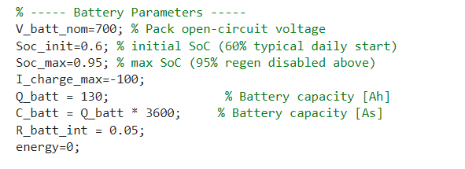
The battery model represents a 700 V nominal lithium-ion pack with 130 Ah capacity, yielding a total energy storage of 91 kWh.
Figure 14: battery parameters in data.m

    - Inverter and Controller Parameters
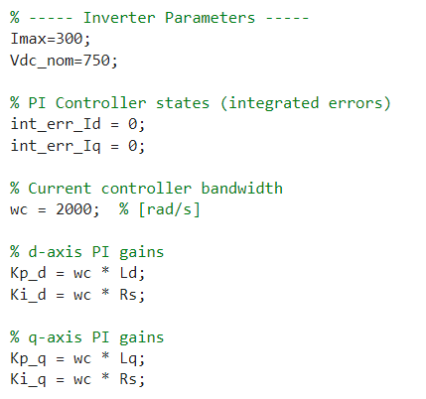
The inverter parameters define the hardware constraints of the power electronics stage, while, the PI controller parameters define the regulating operation he’s responsible of.
Figure 15: inverter & controller parameters in data.m

    - Base speed
The base speed is the boundary between MTPA and FW operating regions. At this speed, the back-EMF voltage equals the maximum available inverter voltage, meaning the motor can no longer maintain the MTPA current trajectory without exceeding the voltage limit. And so below this speed, the motor operates in MTPA mode for maximum efficiency. Above this speed, field weakening must be applied to reduce the effective flux linkage and keep the voltage within the inverter limit.
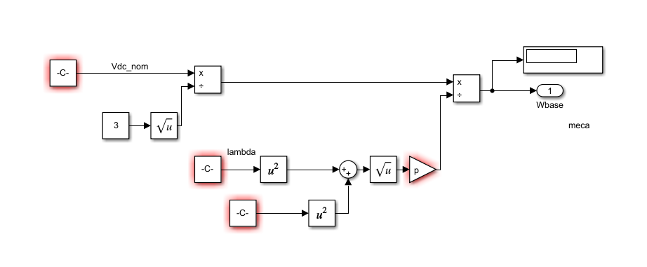
Figure 16: base speed calculation block

    - Characteristic Current
The characteristic current (I_ch) is the specific d-axis current value at which the effective flux linkage (magnetic voltage term in voltage magnitude) approaches zero, eliminating the back-EMF dependence on speed and theoretically enabling infinite speed range. In practice, this current defines the deepest possible field weakening operating point and serves as the starting condition for MPTV calculations, as the MPTV operating point always lies near this current value.
    - Maximum MTPA torque
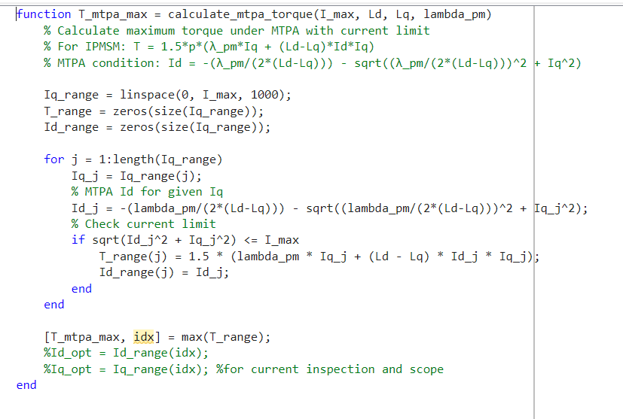
The estimated result with the motor parameters yields T_max_mtpa of approximately 250 to 280 Nm, which represents the peak regenerative braking torque available below base speed.
Figure 17: Maximum MTPA torque calculation block (MATLAB function)

  - Braking profile and torque reference generation
The next step is the vehicle-level dynamics and the driver braking input model (layer 1) to produce a torque reference or request (T_request).
    - Braking profile
A time-varying braking profile is defined to simulate a realistic deceleration event over the 10-second simulation window divided into 6 distinct phases :

Time Interval | Intensity | Phase Description | Torque Request
0.0 – 1.0 s | 0.0 | Free rolling | 0 Nm
1.0 – 2.0 s | 0 → 0.3 | Gradual engagement | 0 → -60 Nm
2.0 – 5.0 s | 0.3 | Mild sustained | -60 Nm
5.0 – 6.0 s | 0.3 → 0.8 | Progressive increase | -60 → -160 Nm
6.0 – 8.0 s | 0.8 | Strong braking | -160 Nm
8.0 – 9.0 s | 0.8 → 0.3 | Gradual release | -160 → -60 Nm
9.0 – 10.0 s | 0.3 | Light residual | -60 Nm
Figure 18 : braking profiles across the 10ms test interval
Thus, the pressing intensity is thus converted into torque request which uses a scale factor of 200, so T_brake_request = -brake_profile x 200, producing torque requests ranging from 0 Nm during free rolling to -160 Nm during strong braking.
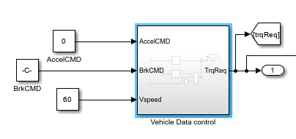
All of this was implemented inside the “vehicle Data Control” block

Figure 19: Vehicle Data Control Block

  - Regenerative Braking Control Logic
This section interests in implementing the basic safety and protection logic that determines whether regenerative braking is permitted or not and so limits the generated torque command to safer values.
It consists of two sub-stages: the regen availability check and the reference torque limitation.
    - Regen Availability Check
Before applying any requested torque to the motor, the system must check two major safety conditions where if at least one of them fails, regenerative braking is completely disabled, and the torque reference is set to zero.
- The first condition: the battery SoC must not reach the maximum threshold of 95 percent (risk of overcharge and thermal damage)
- The second condition: the vehicle speed must not fall below 12km/h when requesting negative torque because at such very low speeds, regenerative braking torque becomes unstable due to the reduced back-EMF and the control system's inability to accurately regulate current (risk of misbehavior and battery damage)
  - Requirement RBS01 satisfied “Low speed Cutoff threshold”!

  - The second condition assure that the vehicle speed does not fall below the regenerative braking limiting speed.
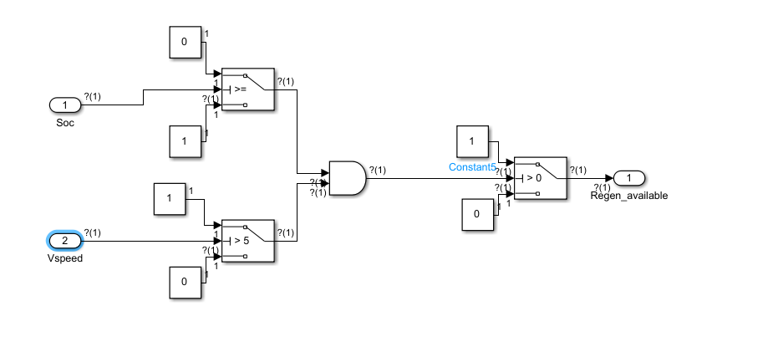
Figure 20: regen availibility check block

    - Reference Torque Limitation
Even when regenerative braking is within limit, two additional protection limits are applied to the torque reference.
- The first limit constrains the braking torque based on the maximum motor current.
- The second limit protects the battery from excessive charging current by estimating the battery current that would result from the requested torque at the current speed and efficiency, and if this estimated current exceeds the -100 A limit, the torque is reduced proportionally.

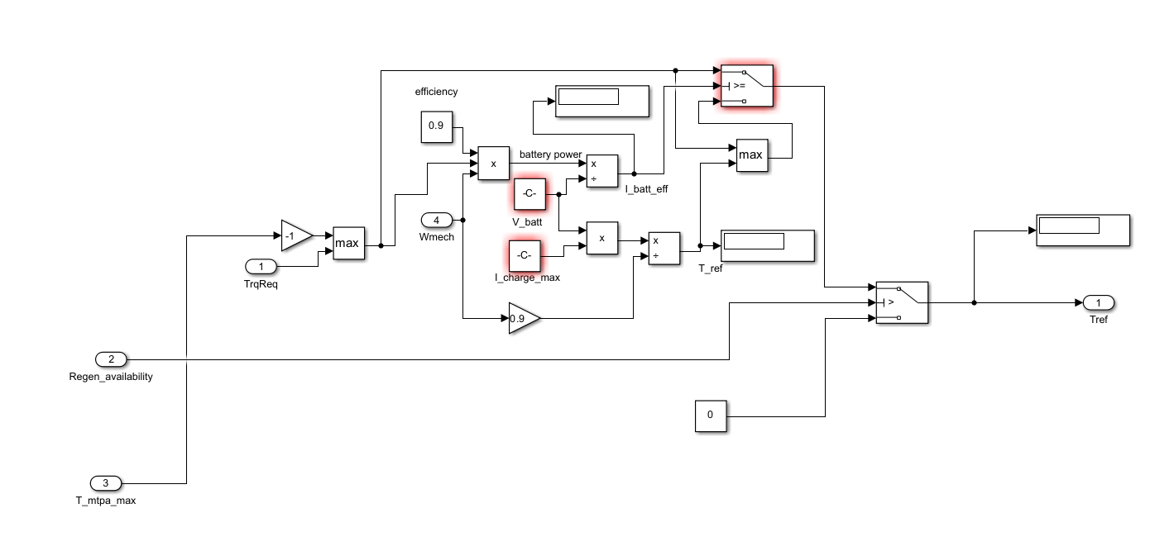
Figure 21:Reference Torque Limitation Block

  - Requirement RBS03 satisfied “Battery Constrained regeneration”!

  - This safety and protection logic ensures the eligibility of the requested torque facing current and battery constraints limiting the regenerative braking operation in case of violation and non-respect for any constraint.

  - Mode Selection and Current Reference Generation
This section presents the core of the entire system. It basically simulates the workflow of the Field-Oriented Control logic by determining which control strategy to use based on the motor speed and calculates the reference currents for the PI controllers.
The mode selection logic operates as a cascade of decisions, evaluating from the most efficient strategy (MTPA) to the most constrained (MPTV), and selecting the appropriate strategy based on voltage feasibility.

    - Mode Decision Logic

The mode decision follows a clear hierarchical logic:
- If electrical speed <= base speed (transition speed between MTPA – FW): the system operates in Mode 1 (MTPA) for maximum efficiency.
- If electrical speed above base speed, the Mode 2 (FW) is activated to reduce the flux linkage while maintaining the requested torque.
- At very high speeds (electrical speed proceeded the FW – MTPV transition speed), the system would activate Mode 3 (MPTV) to maximize torque per volt within the constrained voltage ellipse.

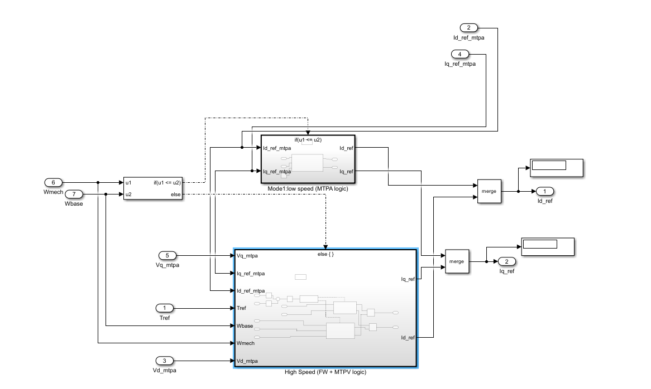
Figure 22: Mode Decision Logic block

    - Mode 1 : MTPA
For a given torque request, and under the speed constraint, the MTPA function solves for the optimal reference (I_d*, I_q*) pair that produces the required torque with minimum total current magnitude respecting the only active current magnitude constraint.
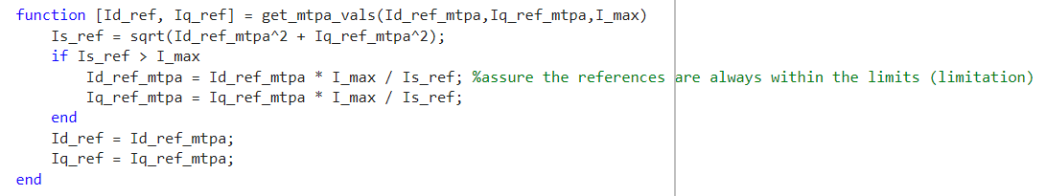
Figure 23: the MTPA algorithm

    - Mode 2 : Field Weakening (FW)
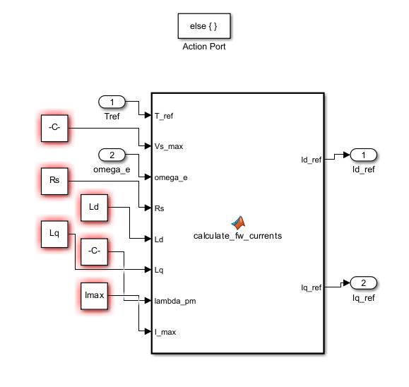
When the motor exceeds base speed, MTPA would require voltage beyond the inverter limit. The Field Weakening algorithm from that point onward takes in trying to find the reference (I_d*, I_q*) pair that satisfies both the torque equation and the voltage constraint simultaneously.
Figure 24: Field Weakening MATLAB function block

    - Mode 3 : MTPV
At very high speeds (when exceeding the transition speed between FW – MTPV), the optimal strategy shifts to Maximum Torque Per Voltage, which maximizes the torque produced per unit of available voltage to not violate the voltage constraint.
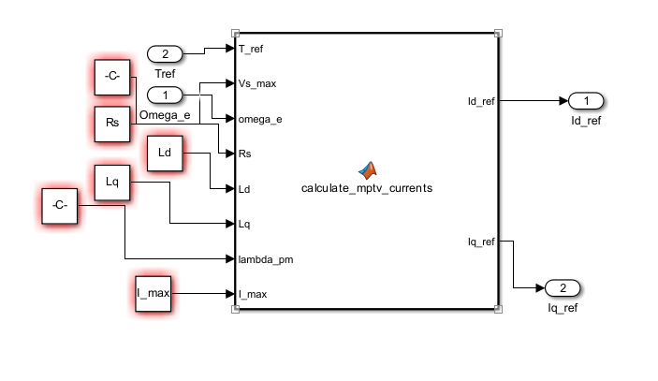
Figure 25: MTPV MATLAB function block

  - Requirement RBS04 satisfied “Multi-region reference generation”!

  - The decision logic and transition speed concept implementation ensure the right and valid generation of reference current in dq frame while respecting all electronic constraints .

  - FOC Current Control and inverter gate signals
The Field-Oriented Control layer (layer 5) converts current references (I_d*, I_q*) into voltage commands (Vd, Vq) using two independent PI controllers with anti-windup protection, then it would send these voltage commands to the inverter that converts them into three-phase duty cycles that affects directly the functionality of the IPMSM.
    - PI Current Control and Anti-windup implementation
Integrator windup occurs when the PI output saturates but the integrator continues to accumulate errors, leading to slow recovery after saturation events. The implementation uses back-calculation anti-windup: after computing the PI output, if the absolute value exceeds the maximum voltage, the integration step is reverted by subtracting the error accumulation, and the output is clamped to the maximum value.

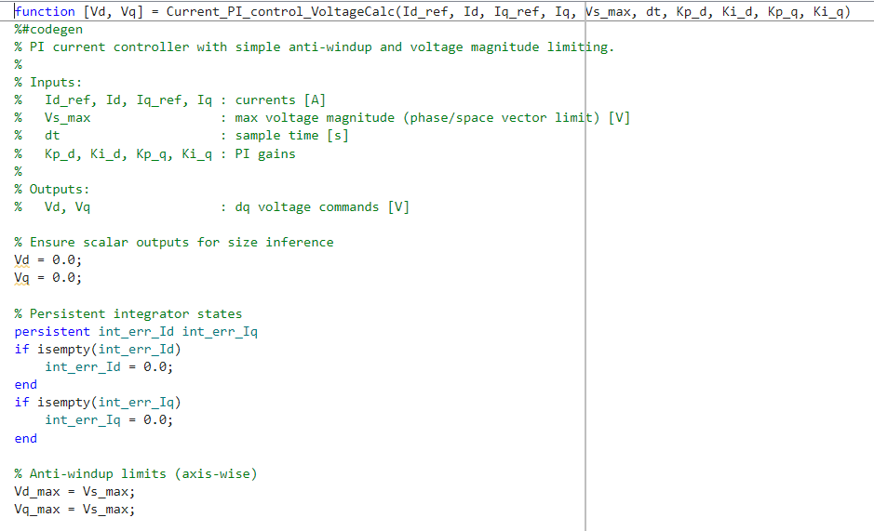
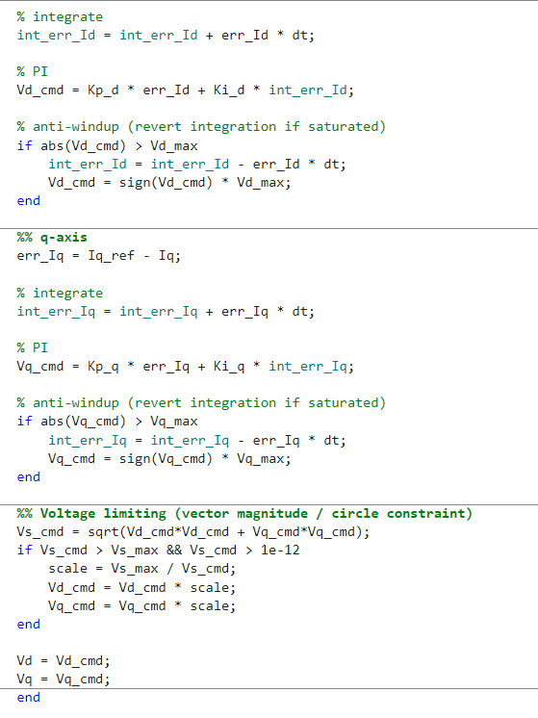
Figure 26: PI control tuning MATLAB code

    - Space Vector PWM Implementation
The Space Vector PWM algorithm converts dq-frame voltage references into three-phase duty cycles for the inverter gate signals.
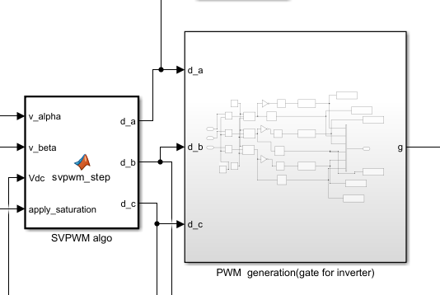
Figure 27: SVPWM implementation

  - Motor Electrical Dynamics Sybsystem (IPMSM)
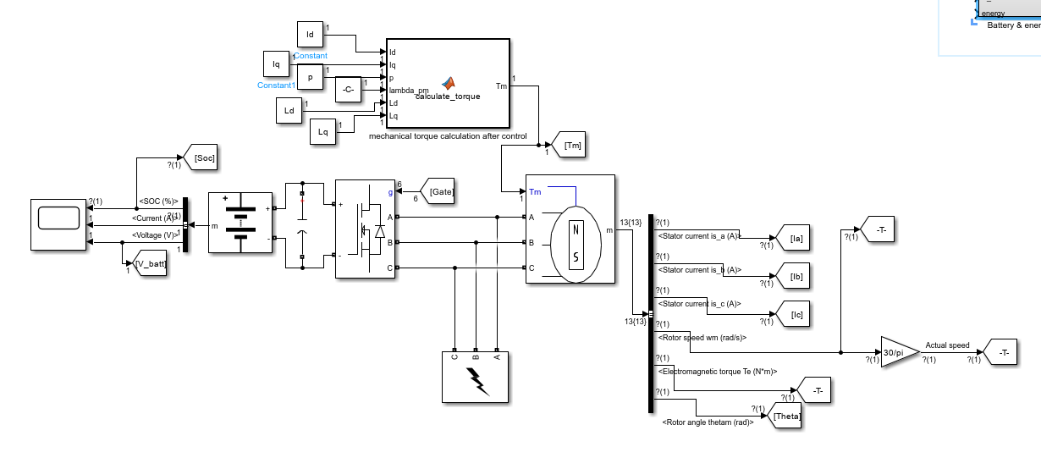
The IPMSM electrical model is implemented in the synchronous rotating dq reference frame. The dq frame model significantly simplifies the motor equations by transforming the time-varying three-phase AC quantities into DC quantities in the rotating reference frame, enabling straightforward PI control later.
Figure 28: IPMSM electrical modulation

  - Battery and Energy Management
The battery and energy management block tracks the power flow from the motor terminals through the inverter to the battery, accounting for all loss mechanisms and updating the battery State of Charge in real time.
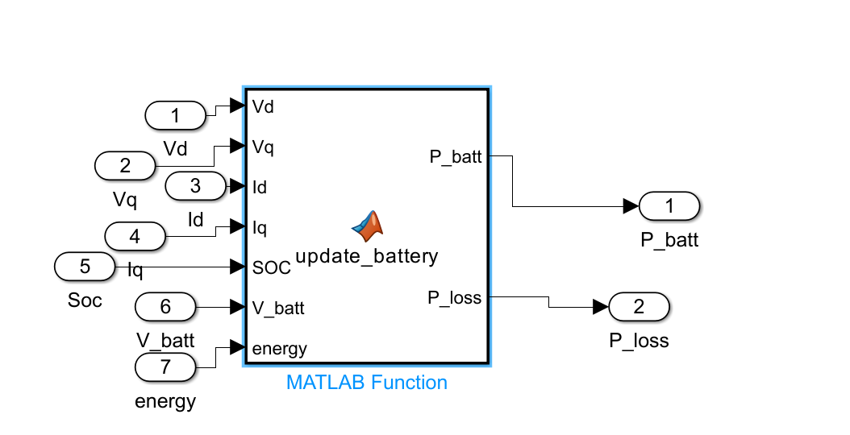
Figure 29: Battery and energy management block

- Problems encountered and potential solutions
During the development of the Regenerative Braking System as a whole , ten significant problems were encountered that needs to be addressed and studied each individually for future improvements of the whole system.

  - MATLAB Simulation too slow
Even when using MATLAB in “accelerator” mode and even after using pre-computing reference lookup tables in the project, the simulation as a whole took a lot of time to tune its functions and discover and correct faults making from using MATLAB from simulation and modulation purposes a living hell especially in complex and multi-layered projects.
  - Python implementation vs MATLAB implementation
We started the first project studies in paper and tried to implement the full pipeline in python trying to implement the actual algorithmic pipeline for the FOC and battery and motor control modules. These studies showed fruitful results especially when validating the work and trying to compute the general performance of the implemented code.
Yet all of this was in vain, as when jumping to MATLAB to actually start the real modulation we faced tons of unskippable errors that has no physical or real concept violation to the regenerative braking system, just a bunch of random errors related to compatibility and connection, making the testing phase for the whole system a huge burden that we couldn’t finalize properly.
  - Estimated Values lead to immense errors
One of the major problems that we encountered was the lack of real data related to the functional operations of the whole system, making us do some estimation that could align with the limited system data available online. These estimation led to many calculation errors that may in a way or another touch one or several critical functional or non-functional requirements.

- Model limitations and Future improvements
While the current implementation provides a comprehensive and functional simulation of the regenerative braking system, several areas have been identified where the model could be enhanced to improve accuracy, add functionality, or align more closely with production vehicle implementations:
- Better implementation of the one-pedal braking concept in accordance with the brake pedal, for a far better torque request blending
- Better implementation of the IPMS motor and add the physical constraints that may affect in one way or another its work
- Build a complete battery control and management interface to better apply the different constraints provided by the battery, through implementing a full power estimation layer and a better connection with the Battery Management System (BMS)
- Conclusion
This project provided a complete study and implementation workflow for EV traction and regenerative braking control, combining bibliographical analysis with MATLAB/Simulink-based modeling and validation. Starting from machine modeling and control-region logic, the work developed practical current control and SVPWM modulation blocks to ensure feasible operation across regenerative mode with different speeds. Simulation results confirmed that the proposed architecture can track references, respect voltage/current constraints, and maintain stable behavior over a wide operating range. Overall, the study highlights how advanced control strategies improve both drive performance and energy efficiency, while also providing a solid foundation for future real-time implementation and experimental validation.

Figure 1: friction brakes diagram 8
Figure 2: Newton's Second Law of Motion 8
Figure 3: recovered energy in regenerative braking 9
Figure 4:energy flow in motoring mode 10
Figure 5: EV motor 12
Figure 6: Diagram of an Interior Permanent Magnet Synchronous Motor 14
Figure 7: motor stator phase currents 15
Figure 8: dq plane geometry: Current circle & Voltage Ellipse for FW case 23
Figure 9: different dq plane regions 25
Figure 10: SVPWM theory hexagone 27
Figure 11: General System Overview 29
Figure 12: vehicle parameters inside the data.m 31
Figure 13: Motor parameters in data.m 31
Figure 14: battery parameters in data.m 32
Figure 15: inverter & controller parameters in data.m 32
Figure 16: base speed calculation block 32
Figure 17: Maximum MTPA torque calculation block (MATLAB function) 33
Figure 18 : braking profiles across the 10ms test interval 34
Figure 19: Vehicle Data Control Block 34
Figure 19: Vehicle Data Control Block 34
Figure 20: regen availibility check block 35
Figure 20: regen availibility check block 35
Figure 21:Reference Torque Limitation Block 36
Figure 21:Reference Torque Limitation Block 36
Figure 22: Mode Decision Logic block 37
Figure 22: Mode Decision Logic block 37
Figure 23: the MTPA algorithm 37
Figure 23: the MTPA algorithm 37
Figure 24: Field Weakening MATLAB function block 37
Figure 24: Field Weakening MATLAB function block 37
Figure 25: MTPV MATLAB function block 38
Figure 25: MTPV MATLAB function block 38
Figure 26: PI control tuning MATLAB code 39
Figure 26: PI control tuning MATLAB code 39
Figure 27: SVPWM implementation 39
Figure 27: SVPWM implementation 39
Figure 28: IPMSM electrical modulation 40
Figure 28: IPMSM electrical modulation 40
Figure 29: Battery and energy management block 40
Figure 29: Battery and energy management block 40

