Requirements Analysis Document
Group F
Revision History:
Version 1 Created – 22nd August, 2011
Preface:
This document is designed to outline the expectations of Kwik Browser rewrite for the developers and client.
Target Audience:
Client, Developers
Members:
Thomas Bruining
Haydn Muir
David Kucsai
David Turnbull
Basimah Aljhne
Abdulraham Qasem
MILESTONES
- 22nd August – Created Initial R.A.D.

1.0 General Goals

Purpose of the System:
To provide a cross platform, easy to use, quick and easy to learn Web Browser based on the existing Kwik Browser implementation.

Scope of the system:
Must: Basic web browser and navigation
Cross platform at least for Windows and OS X.
Search bar built in
History and Favourites
Self contained (No installer)
Should: In-built text based dynamic advertising (The functionality for advertising will be built, we will not build the advertisement serving platform)
Popup Blocker

Could: Tabbed browsing
Keyboard Shortcuts

2.0 Current System

We have a functioning web browser written in Visual Basic. However the current source code is unlikely to facilitate the building of the new browser in a major way.

3.0 Proposed System
3.1 Overview
We propose to build a web browser using SWT, Java and rendering via the Operating System’s default web browser engine.

3.2 Functional Requirements
Browses the internet.
Javascript functionality.
History
Favourites
Navigation
Search Bar
Cookies
Security (Pop up blocker)
HTTPS support
3.3 Nonfunctional Requirements
Interface redesign
Fast startup, fast interface changes/switches/feedback
Portability – No install, self contained.

3.3.1 User Interface and Human Factors
Novice users/Target Audience
Obvious feedback
simple to understand tooltips/descriptions
Static toolbars
Minimal menus/options
3.3.2 Documentation

How to/tutorial document on changing dynamic advertising
How to manual for use of browser
Acceptance Tests
Project Plan
3.3.3 Hardware Consideration
Slow/Old Hardware
Recommended to be running current java version
Low resolution screens – Working on the lowest of 800x600
Assumption that default browser already exists
Minimum operating system Windows XP and Mac OS X

3.3.4 Performance Characteristics
Start up time on par with most common Internet Browsers.
Average startup time over 10 tests within at least 30% of Kwik Browser start up time.
The speed of web page rendering will be limited by the Operating System’s default web browser and the users internet connection.
We can not optimise the web page renderer as it is not within our scope.

3.3.5 Error Handling and Extreme Conditions
“This page cannot be found” – The loaded page will have a link redirecting them to their chosen search engine with the user inputted URL as it’s search term.
No network connection – The user will be alerted to the fact that their network connection is not connected.
Automatically correct user input in URL bar for simple issues such as missing http:// or www.

3.3.6 System Interfacing
The system will interface with the operating systems default web browser.
It is expected that the user will have typical input devices (Mouse, keyboard)

3.3.7 Quality Issues
The browser must be portable and self contained. (No installer)
The system should be capable of supporting secure websites.

3.3.8 System Modifications
Dynamic text based advertising
History – Clearable
Favourites – User added
Set home page
Set search engine
Popup Blocker On/Off

3.3.9 Physical Environment
Refer to system requirements.

3.3.10 Security Issues
Must support HTTPS and have a functioning popup blocker.
The system will not save passwords.

3.3.11 Resource Issues
The browser should be small enough to download quickly from a webserver with a standard home interenet connection

3.4 Constraints

We have decided that Java will be the language we use to build the system using a set of libraries freely available to the public.

3.5 System Model
INSERT DIAGRAM HERE

3.5.1 Scenarios
For this section, think about all the possible ways which the users will interact with your subsystem. Present them in a "story" format.

3.5.2 Use Case Models
TO BE ADDED

3.5.3 Object Models
INSERT HERE

3.5.4 Dynamic Models

3.5.5 User Interface - Navigational Paths and Screen Mockups

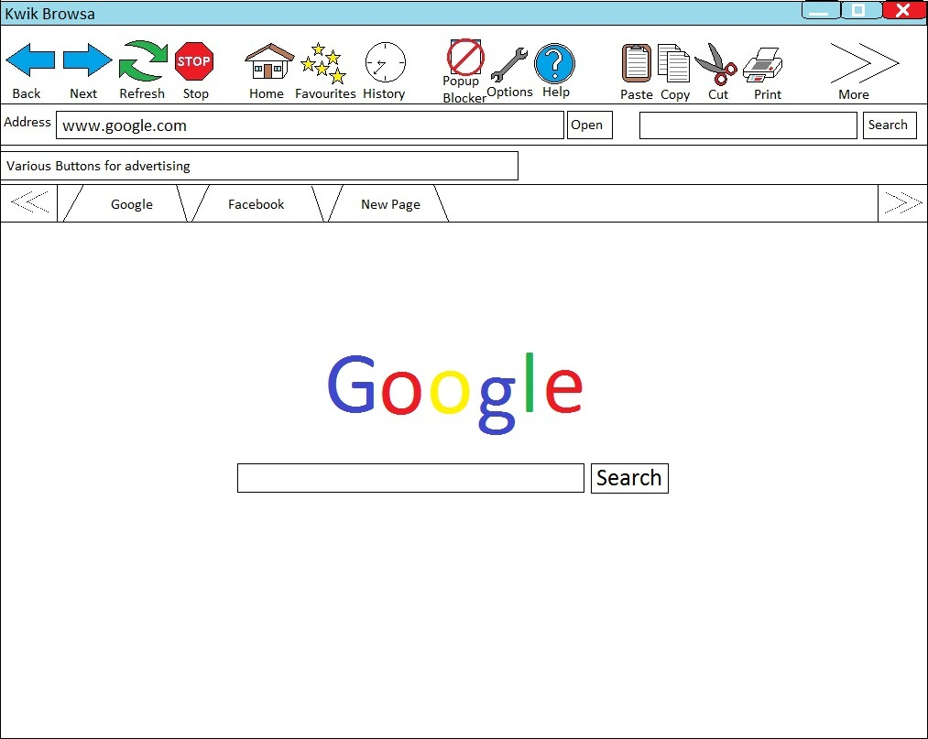
Notes on how the UI works:
- Favourites and history will have small pop out sections to save, load and modify as required for each. (as shown below)

- The ‘more’ button on the far right of the icons will only appear when a window has been made smaller to provide access to buttons that would otherwise appear off screen.

- The ‘New Page’ tab will always be available and all a user has to do to open a new tab is to select this page and start operating as normal.

- ‘Back’ and ‘Forward’ buttons grey out when the function is not available (eg. The user is currently navigated to the furthest forward page visited)

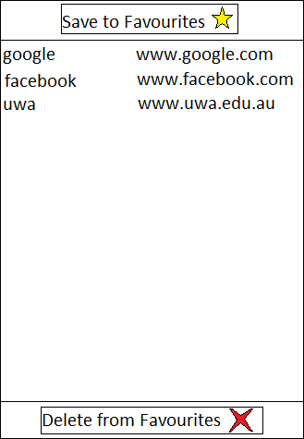
This is the page for the favourites section. It will appear just under the ‘favourites’ button when the button is pressed. The history page will work and appear in a similar fashion.

