WEBSITE PROJECT PROPOSAL
WEDE5020 - Web Development (Introduction)

Full name: Basim Ubaid Akhtar
Student number: ST10516576
Group: Group 3
Date: 1 September 2026

Table of Contents
Proposal 1: VoltStream Plumbing and Electrical (Pty) Ltd 3
1. Organisation Overview 3
2. Website Goals and Objectives 3
3. Current Website Analysis 3
4. Proposed Website Features and Functionality 3
5. Design and User Experience 4
6. Technical Requirements 5
7. Timeline and Milestones 6
8. Budget 6
9. References 6
Proposal 2: Paws of Hope Animal Shelter (NPO) 7
1. Organisation Overview 7
2. Website Goals and Objectives 7
3. Current Website Analysis 7
4. Proposed Website Features and Functionality 7
5. Design and User Experience 8
6. Technical Requirements 9
7. Timeline and Milestones 10
8. Budget 10
9. References 10

Proposal 1: VoltStream Plumbing and Electrical (Pty) Ltd

1. Organisation Overview
Name: VoltStream Plumbing and Electrical (Pty) Ltd.
VoltStream is a family-owned services company in Sandton, Johannesburg. Founded in 2011 as a one-van plumbing service, it added electrical work in 2016, a Randburg branch in 2020 and a 24/7 emergency line in 2023. Fourteen licensed artisans complete around 900 jobs a year. (Fictional organisation presented with realistic content.)
Mission: To keep South African homes and businesses safe, powered and flowing through dependable plumbing and electrical services delivered with honesty, speed and transparent pricing.
Vision: To become Gauteng's most trusted plumbing and electrical services provider.
Target audience: Homeowners, body corporates and small businesses in Sandton, Randburg, Fourways, Bryanston and Midrand who value fast response and fixed pricing.

2. Website Goals and Objectives
The website must generate quote requests, build credibility, promote the 24/7 emergency line and support local search rankings. Key performance indicators (KPIs):
- 20+ enquiry-form submissions per month by month 3;
- 60% enquiry-to-booking conversion;
- 10+ web-originated emergency call-outs per month;
- first-page Google ranking for five target keywords by December 2026;
- home-page bounce rate below 45%.

3. Current Website Analysis
VoltStream has no website today. Strengths: strong Facebook reviews and repeat clients. Weaknesses: no Google search presence, no public pricing information and emergency leads lost after hours. The website counters these with search-optimised pages, transparent pricing and click-to-call.

4. Proposed Website Features and Functionality
Five pages, one navigation menu:
- Home (index.html): hero, service summary cards, testimonials, call-to-action banner;
- About Us (about.html): history, mission, vision, values, team;
- Services (services.html): service lists, maintenance-plan pricing table, service area;
- Enquiry (enquiry.html): quote request form;
- Contact (contact.html): contact details and both branches (Sandton and Randburg), each with an embedded Google Map.
Part 3 adds JavaScript client-side form validation.

5. Design and User Experience
Colour scheme: deep blue (#0B4F8A) for trust, bright orange (#F5A623) for urgency, off-white (#F7F9FB) backgrounds.
Typography: Aptos body text with bold condensed headings for a clear hierarchy.
Layout: mobile-first, card-based design with a hero image and sticky navigation.
User experience: quotes reachable within two clicks; click-to-call links on every page; descriptive alt text; WCAG AA contrast.
Home page wireframe:
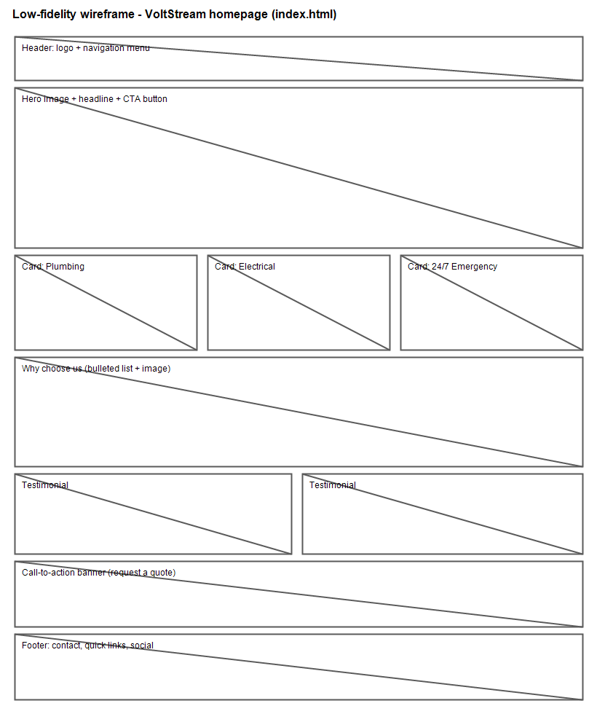Figure 1: Low-fidelity wireframe of the VoltStream home page.

6. Technical Requirements
- Languages: HTML5, CSS3 (Part 2) and JavaScript (Part 3);
- Hosting: shared cPanel hosting with SSL; domain voltstream.co.za;
- Version control: Git with a private GitHub repository;
- Local SEO: Google Business Profile linked to the website.

7. Timeline and Milestones
- 28 Aug 2026: proposals submitted for approval;
- 4 Sep 2026: Part 1 due (HTML structure, folders, repository);
- 25 Sep 2026: Part 2 due (CSS, responsive design);
- 30 Oct 2026: Part 3 due (JavaScript, SEO);
- 6 Nov 2026: final tested website submitted.

8. Budget
Based on current South African market rates:
- Domain (.co.za): R99 per year;
- Shared hosting with SSL: R149 per month (R1,788 per year);
- Development: R18,000 once-off at market rates (delivered as a student project at no cost);
- Logo and branding: R1,500 once-off;
- Maintenance: R600 per month; SEO support: R1,200 per month;
- Estimated year-one total: approximately R24,800.

9. References
- Plumbing Industry Registration Board (PIRB). 2026. Home. [Online] Available at: https://pirb.co.za [Accessed 1 September 2026].
- Department of Employment and Labour (RSA). 2026. Electrical Installation Regulations. [Online] Available at: https://www.labour.gov.za [Accessed 1 September 2026].
- Afrihost. 2026. Shared hosting and domain pricing. [Online] Available at: https://www.afrihost.com [Accessed 1 September 2026].
- Google. 2026. Google Business Profile for local businesses. [Online] Available at: https://www.google.com/business [Accessed 1 September 2026].

Proposal 2: Paws of Hope Animal Shelter (NPO)

1. Organisation Overview
Name: Paws of Hope Animal Shelter.
Paws of Hope is a no-kill shelter founded in 2015 by volunteers in Randburg, Johannesburg. It has rescued, rehabilitated and rehomed more than 400 dogs and cats, operating from donated premises and 30 foster homes, funded by donations, adoption fees and fundraising events. (Fictional organisation presented with realistic content.)
Mission: To rescue, rehabilitate and rehome abandoned animals and educate the community on responsible pet ownership.
Vision: A Gauteng where every adoptable animal finds a loving home.
Target audience: Potential adopters and foster families, volunteers, corporate CSI sponsors, schools and individual donors.

2. Website Goals and Objectives
The website must convert three visitor groups: adopters, volunteers and sponsors. Key performance indicators (KPIs):
- 8+ adoption applications per month;
- 15 volunteer registrations per month;
- R15,000 in recurring monthly donations by month 6;
- 200 newsletter sign-ups by December 2026;
- 3 corporate sponsorship enquiries per quarter.

3. Current Website Analysis
Paws of Hope communicates through Instagram and Facebook only. Strengths: engaging adoption stories and an active community. Weaknesses: no structured adoption process, no single donation or volunteer page, and key information buried in comments.

4. Proposed Website Features and Functionality
Five pages, one navigation menu:
- Home (index.html): hero mission statement, three action cards (Adopt, Volunteer, Sponsor), success stories;
- About Us (about.html): history, mission, vision, values, volunteer team;
- Adopt (services.html equivalent): adoption process, what adoption includes, animal gallery placeholder;
- Enquiry (enquiry.html): one form to enquire about adopting, volunteering or sponsoring;
- Contact (contact.html): shelter details and two locations (main shelter in Randburg, adoption-day venue in Sandton), each with an embedded Google Map.
Part 3 adds JavaScript validation and donation buttons (PayFast or SnapScan).

5. Design and User Experience
Colour scheme: warm teal (#2E8B7A) for compassion, soft amber (#F2B705) for hope, cream (#FBF7EF) backgrounds.
Typography: a rounded, friendly heading font with readable Aptos body text.
Layout: story-first with three action cards and generous white space; mobile-first, as most social-media visitors arrive on phones.
User experience: adoption enquiry within three clicks; one shared form with a purpose selector; descriptive alt text throughout.
Home page wireframe:
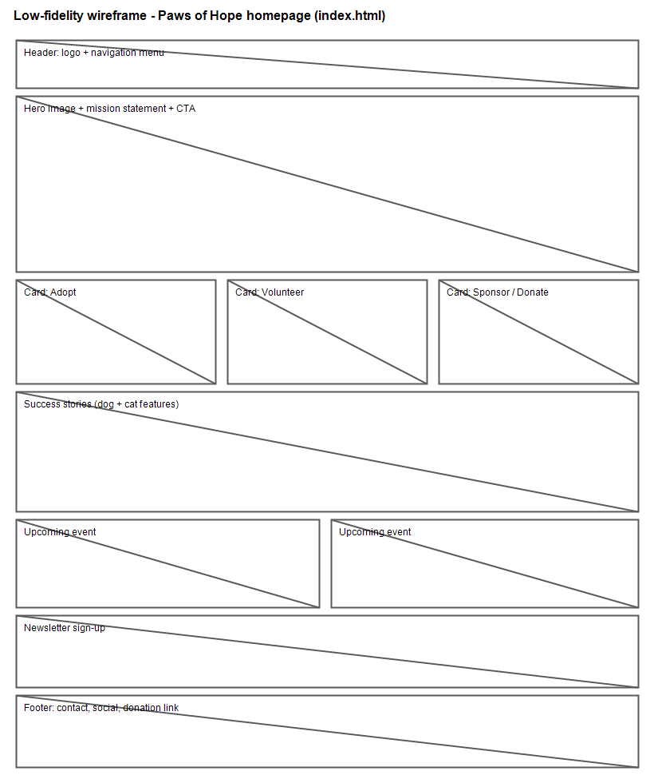Figure 2: Low-fidelity wireframe of the Paws of Hope home page.

6. Technical Requirements
- Languages: HTML5, CSS3 and JavaScript (static site keeps costs low);
- Hosting: shared hosting with SSL; .org.za domain;
- Google for Nonprofits: free Workspace and Ad Grants eligibility to be explored;
- Version control: Git with a private GitHub repository.
- Payments: PayFast or SnapScan donation buttons (Part 3).

7. Timeline and Milestones
- 28 Aug 2026: proposals submitted for approval;
- 4 Sep 2026: Part 1 due (HTML structure, folders, repository);
- 25 Sep 2026: Part 2 due (CSS, responsive design);
- 30 Oct 2026: Part 3 due (JavaScript, donation integration);
- 6 Nov 2026: final tested website submitted.

8. Budget
As a non-profit, the budget targets the lowest viable running costs:
- Domain (.org.za): R75 per year;
- Shared hosting with SSL: R99 per month (R1,188 per year);
- Development: R15,000 once-off at market rates (delivered as a student project at no cost);
- Animal photography: R2,000 once-off;
- Maintenance: R300 per month; payment fees: about 3% of donations;
- Estimated year-one total: approximately R7,000 plus payment fees.

9. References
- National Council of SPCAs South Africa (NSPCA). 2026. Home. [Online] Available at: https://nspca.co.za [Accessed 1 September 2026].
- SPCA Johannesburg. 2026. Volunteer with us. [Online] Available at: https://www.jhbspca.co.za [Accessed 1 September 2026].
- PayFast. 2026. Accept donations online. [Online] Available at: https://www.payfast.co.za [Accessed 1 September 2026].
- Google. 2026. Google for Nonprofits. [Online] Available at: https://www.google.com/nonprofits [Accessed 1 September 2026].

