Document No : 20180823_LUCI_DBD_1.1

Database design and
the API overview
( LUCI project)

2018.08.23
Contents

1. Setting up the environment and importing database 3
1.1 Install xampp 3
1.2 Import MYSQL database from a sql file 3
1.3 Start of Larabel server 3
2. Database design 5
2.1 The list of tables 5
2.2 “users” table 5
2.3 “channel” table 6
3. API Overview 6
3.1 /signup 6
3.2 /signin 7
3.3 /channel/create 7
3.4 /channel/update 7
3.5 /channel/delete 7
3.6 /channel/list 8
3.7 Error List 8

1. Setting up the environment and importing database

1.1 Install xampp
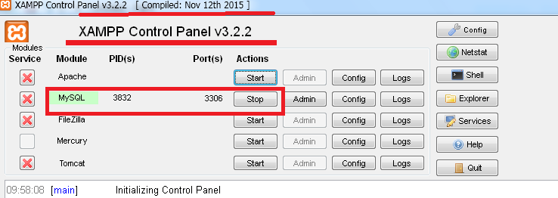

First you need to install xammp as shown in above the picture.
Here you don’t need to start apache service. But you need to start mysql service.

1.2 Import MYSQL database from a sql file
“Sqlyog” is used to manage the database.
Sql file to import: luci-2018-08-21.sql
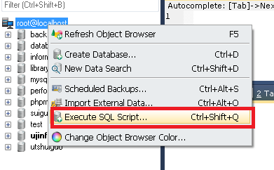

1.3 Start of Larabel server
-Start interactive shell on Xampp control panel.
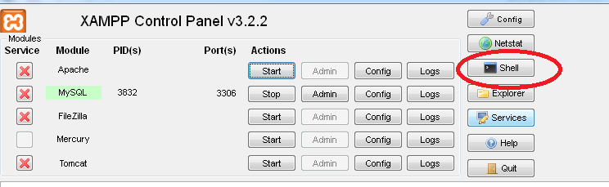
You can see the location of working folder in shell. For example “f:\xampp”.
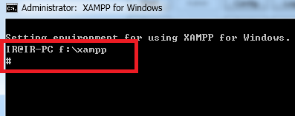
And change your working folder to “F:\work\@LUCI\LUCIServer”, where the source files exist.
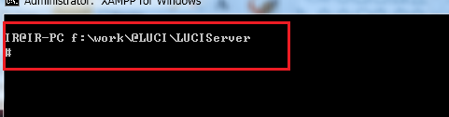

Run Artisan command to start Laravel server.

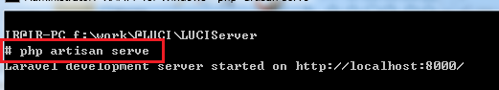

Then LUCI homepage will start on localhost:8000.

4.Start main page on Google Chrome
Input “localhost:8000” to run main page.
5. Setting Laravel Server IP
You need to change “localhost:8000” to “111.111.111.1:8000” in the following file.
vendor\laravel\framework\src\Illuminate\Foundation\Console\ServeCommand.php
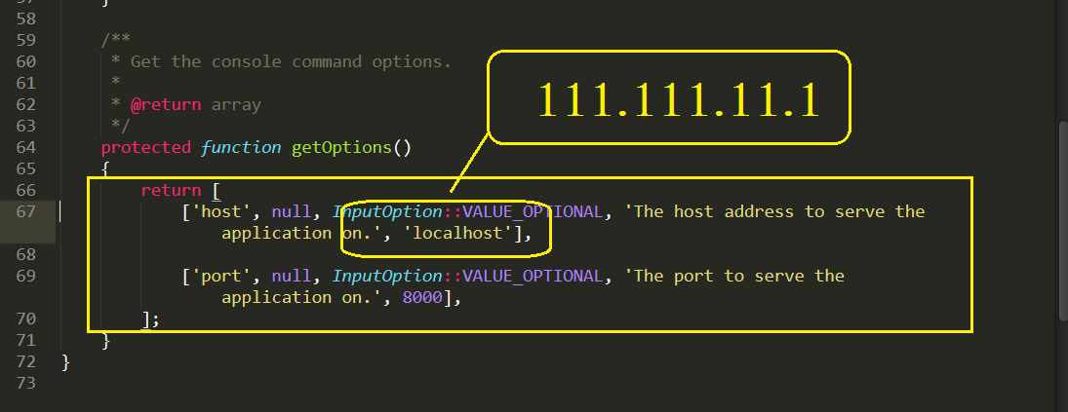

2. Database design

2.1 The list of tables
name | description
users | The table for user information
channel | The table for channels.

2.2 “users” table
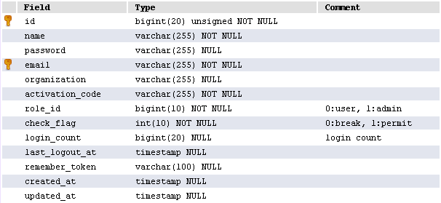

role_id:
0(User), 1(Administator)
By default, this is set to 0(User).
Last_logout_at:
Last logout time.
Login_count:
Numbers of logins.

2.3 “channel” table
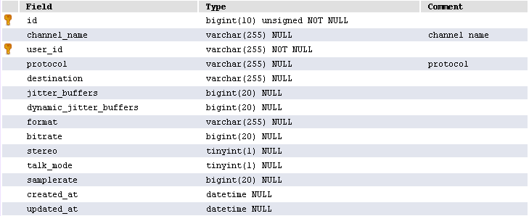
user_id:
user_id equals id in users table
channel name:
channel name that user input.
protocol:
ICECAST, SHOUTCAST, RTP, SIP
destination – talk_mode:
Settings specific for a particular protocol.

A user can have several channels.

3. API Overview

3.1 /signup
signup API registers users.
Type:
post
Parameters:
name, email, password, organization, activation_code
Return value:
'success'=> true/false
If(success = false)
'reason' => errorCode. reference to <3.7 Error List>
For example, you can set post parameter as following:
Name : JangWeiDong
Email : jwd@gmail.com
Organization : IT Company
activation_code : 6d111f7ca6c5c39c7ec6836bbab0bf1c
Required | activation_code is not min 6.
Then, you will receive the “true” if you are a genuine user.

3.2 /signin
signin api is user login API.
Type:
Post
Parameters :
email, password
Return value:
'success' =>true/false

3.3 /channel/create
Create a new channel.
Type:
Post
Parameters:
channel_name, protocol, destination, jitter_buffers, dynamic_jitter_buffers,
format, bitrate, samplerate, stereo, talk_mode
Return:
'success' => true, false
If success=true
'channel_name' => channel name
'created_at' => cretead time

3.4 /channel/update
This API updates channels.
Type:
Post
Parameters :
channel_id, channel_name, protocol, destination, jitter_buffers, dynamic_jitter_buffers, format, bitrate, samplerate, stereo, talk_mode
Return value:
'success' => true, false
If success=true
'channel_name' => channel name
'updated_at' => updated time

Here
channel_id : id in channel table to be updated.

3.5 /channel/delete
Delete a channel.
Type:
Post
Parameters:
channel_id
Return value:
'success' =>
true/false

Here
channel_id : id in channel table to be deleted.

3.6 /channel/list
Get channels.
Type:
Post
Parameters:
sort_channel_name
Return value:
'success' => true, false
If success=true
'count'=> number of channels,
'channels' => $channels

channels = Array{channel1, channel2, channel3, ...}
channel1=Array{id, channel_name, email, protocol, destination, jitter_buffers,
dynamic_jitter_buffers, format, bitrate, samplerate, stereo, talk_mode
created_at, updated_at}

3.7 Error List
-/singup API
ㅇ 100 : name is empty or length of name is greater than 255
ㅇ 101 :
Email is empty
Exist the same email.
Length of email is greater than 255.
Email is incorrect.
ㅇ 102 :
Password is empty or length is less than 6.
ㅇ 103:
activation_code is empty or length is less than 6.

-channel
ㅇ104 : You did not login
ㅇ 105 :
No channel or it is not channel that you made before

