E-CONSTRUCTION DELIVERY



Submitted By

ABDUL BASIT (10041)
ASMAT ULLAH (10139)

BS-SE (7thSemester)
Section: B

Submitted To

MUMTAZ ALI

Department of Computer Sciences
City University of Science and Information Technology
Peshawar – Pakistan
E-CONSTRUCTION DELIVERY
BY
ABDUL BASIT
ASMAT ULLAH
A Final Year Project Proposal submitted to the City University of Science & Information Technology, Peshawar, in partial fulfillment of the requirements for the degree of
BACHELOR OF SCIENCE IN SOFTWARE ENGINEERING

Approved by

Supervisor ___________________ ___________________
Name Signature

Undergraduate Studies Committee

- Committee Convener ___________________

- Coordinator FYP ___________________

- Head of Department (CS) ___________________

DEPARTMENT OF COMPUTER SCIENCE
CITY UNIVERSITY OF SCIENCE & INFORMATION TECHNOLOGY
PESHAWAR – PAKISTAN
SEPTEMBER 2016

Table of Contents
1. Introduction 1
1.1 Overviews 1
1.2 Background 1
1.3 Motivation 2
1.4 Problem Statement 2
1.5 Aims and Objectives 2
1.6 Significance of the Study 3
2. Methodology 4
2.1 Proposed Solution 4
2.2 Tools and Techniques 4
2.2.1 Story book 4
2.2.2 React Native 4
2.2.3 Visual Code 5
2.2.4 Android Studio Emulators 5
2.2.5 Redux 5
2.2.6 Node.js 5
2.2.7 Express.js 5
2.2.8 MongoDB 5
2.3 Work plan 6
3. Conclusion 7
References 8

List of Figures

Figure 2. 1 4

List of Tables
Table 2. 1 6

1. Introduction

1.1 Overviews
E-business is a set of dynamic technologies, applications that link organizations, customers, suppliers, communities through electronic transactions along with electronic exchange of information products and services. It is conducted between businesses and consumers, on the other hand, is referred to as business-to-consumer (B2C). Online shopping is a form of electronic commerce where the buyer is directly connected online to the seller’s computer usually via the internet. The E-business, which is based on the use of Internet technologies, is still being introduced to organizations, and developed in order to meet organizational goals, which are to achieve effectiveness and market competitiveness.
As, known to all, world is evolving rapidly in every sector i.e. information technologies, business, construction and automation etc. There is need of streamlining processes. Targeting construction business, customers often come across different problems i.e. availability of stock, lack of quality stock etc. So, all these problems makes construction process tedious and tiresome.

1.2 Background
Constructing buildings is a not an easy work. As, construction needs lots of materials which risks people in finding the suppliers. To find the materials, find the best quality materials and to carry away it to the place, where the work of construction is in progress.
E-Build [1] application brought out some solutions. The E-Build Pakistan team envisions to be the leading online market place for construction; digitalizing the façade of construction industry; the strategic aim of government and private organization to build communities cross Pakistan. Expending the rich of product and buyer of the construction products. The application was helpful to search construction materials on internet, which works in a specific area, if we find materials, so you will have to order it from really far away. E-Build provides the services like: Construction tools, paints tools, electric tools, bathroom tools, kitchen tools, floor tiling, lightening tools, hardware and wallpapers.
Tameer Ghar [2] is Pakistan’s 1st and Largest Marketplace for Construction and Home Improvement Items. Tameer Ghar is a website, Started on 23rd March 2017, which also provides the services of constructions. But still, it is limited to a specific city (Karachi). Tameer Ghar is not only a marketplace for construction materials but also a benchmark for emerging construction market, helping many to brand an unbranded market. Tameer Ghar is an effort to provide an online market place for construction and renovation related work and material to facilitate the service providers and end user in the most cost effective and efficient manner. Tameer Ghar provides the services like: Construction tools, paints tools, electric tools, bathroom tools, kitchen tools, lightening tools, hardware and wallpapers.
The aforementioned system do not have facility to place order in the locality. They facilitate the users/customer in a different direction. They do not have facility for suppler to sell their goods/material. In addition they do not have solution for transportation.

1.3 Motivation
The motivation for developing the application is primarily an interest in undertaking a challenging tasks in the area of mobile application. Our motivation is increased, with the real life problem found in construction industry.

1.4 Problem Statement
The construction industry people frequently are facing issues like stock availability, lack of quality product, supplier. As a result of these issues, the construction process has become tiresome. Construction projects normally faces shortage of construction material during the project, which causes unwanted delay. Responsible person who is managing construction can undergo harsh situations where they need material for which is already short in market. Therefore, facing such type issues can cause delay in project sometimes lead to contract cancellation. Keeping in view all these problems, a solution is proposed to tackle such issues.

1.5 Aims and Objectives
The aim of the study is to provide a categorize digital access to construction material availability in locality. This system will bring a positive change of in construction industry.
Objectives
- To provide ease in business to customer as well as supplier.
- To ensure/make availability of materials on a single platform.
- To track order and delivery status.

Significance of the Study
The system is really important to digitalize the construction industry using mobile application rather than roaming manually behind each supplier. The system is beneficial for customer to find the availability of nearby material.

2. Methodology
According to the problem and proposed solution we will use an incremental process model for our project because our project will be implemented phase wise.

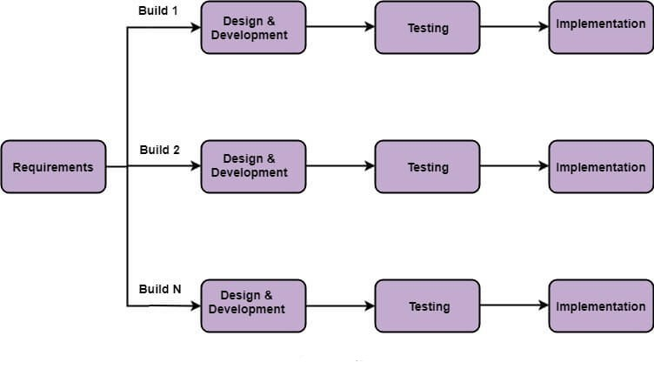
Figure 2. 1

Proposed Solution
To digitalize the construction industry, so that customer can easily find the suppliers. Also, to compare too many suppliers. The system will be able to track the location of truck using maps. Customer can easily find the spare loader to deliver the material on its destination.

Tools and Techniques

Story book
Storybook is an open source tool for building UI components and pages in isolation. It streamlines UI development, testing, and documentation [3].

React Native
React Native is an open-source UI software framework created by Facebook, Inc. It is used to develop applications for Android, Android TV, iOS, macOS, tvOS, Web, Windows and UWP by enabling developers to use the React framework along with native platform capabilities [4].

Visual Code
Visual Studio Code is a free source-code editor made by Microsoft for Windows, Linux and macOS. Features include support for debugging, syntax highlighting, intelligent code completion, snippets, code refactoring, and embedded Git [5].

Android Studio Emulators
The Android Emulator simulates Android devices on your computer so that you can test your application on a variety of devices and Android API levels without needing to have each physical device [6].

Redux
Redux is an open-source JavaScript library for managing and centralizing application state. It is most commonly used with libraries such as React or Angular for building user interfaces.

Node.js
Node.js used for server-side programming, and primarily deployed for non-blocking, event-driven servers, such as traditional web sites and back-end API services, but was originally designed with real-time, push-based architectures in mind [7].

Express.js
Express.js, or simply Express, is a back end web application framework for Node.js, released as free and open-source software under the MIT License. It is designed for building web applications and APIs.

MongoDB
MongoDB is a source-available cross-platform document-oriented database program. Classified as a NoSQL database program, MongoDB uses JSON-like documents with optional schemas. MongoDB is developed by MongoDB Inc.

2.3 Work plan
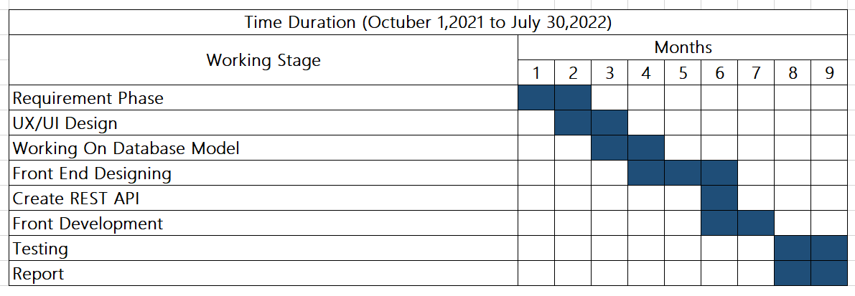
Table 2. 1

Conclusion
Presently construction industry facing a lots of issues in manually placing and receiving orders. Most of the time, limited resources and shortage of material creates hurdles to meet the deadlines. Proposed idea will bring positive change in society. A mobile Application will be developed, which solves problem of both known and unknown customers. They can start and run multiple construction projects at the same time without thinking about availability of products and supplier location. Moreover, our proposed solution can help them to meet the deadline easily. Proposed system has a feedback portion for comment and reviews which help the new as well as existing customers for receiving low quality material in the same price. This system can enhance business opportunities for suppliers as well as transporters. We can materialize this system as a two way handshake between customer and supplier, where both parties feel free to invest their income in future. Proposed system will enhance the business opportunities for both consumer and supplier.

References

[1] E-Build App. Internet: http://www.topapps.net/android/top-androidapps-for-construction-industry.html/, [2021, Sept 25]
[2] Tameerghar website. Internet: https://tameerghar.com/, [2021, Sept 25]
[3] Storybook. Internet: https://storybook.js.org/, [2021, Sept 25].
[4] React Native. Internet: https://reactnative.de. [2021, Sept 25].
[5] Visual Studio Code. Internet. https://code.visualstudio.com/, [2021, Sept 25].
[6] Android Studio. Internet: https://developer.android.com/, [2021, Sept 25].
[7] Node.js. Internet: https://nodejs.org/en/, [2021, Sept 25].

